WhatsApp

From Wikipedia, the free encyclopedia

|  |  |
| --- | --- |
| **WhatsApp** | |
| [https://upload.wikimedia.org/wikipedia/commons/thumb/6/6b/WhatsApp.svg/120px-WhatsApp.svg.png](https://en.wikipedia.org/wiki/File:WhatsApp.svg) | |
| C:\Users\MarkLR\AppData\Local\Packages\Microsoft.Windows.Photos_8wekyb3d8bbwe\TempState\ShareServiceTempFolder\WhatsApp_on_Android_screenshot.jpeg | |
| [**Original author(s)**](https://en.wikipedia.org/wiki/Programmer) | [Brian Acton](https://en.wikipedia.org/wiki/Brian_Acton), [Jan Koum](https://en.wikipedia.org/wiki/Jan_Koum) |
| [**Developer(s)**](https://en.wikipedia.org/wiki/Programmer) | [Meta Platforms](https://en.wikipedia.org/wiki/Meta_Platforms), Will Cathcart (Head of WhatsApp)[[1]](https://en.wikipedia.org/wiki/WhatsApp#cite_note-1)[[2]](https://en.wikipedia.org/wiki/WhatsApp#cite_note-WashingtonPostWhatsAppPushback-2) |
| **Initial release** | February 2009; 15 years ago |
| [**Stable release(s)**](https://en.wikipedia.org/wiki/Software_release_life_cycle)[**[±]**](https://en.wikipedia.org/wiki/Template:Latest_stable_software_release/WhatsApp?action=edit) | |
| |  |  | | --- | --- | | **iOS** | 24.6.77[[3]](https://en.wikipedia.org/wiki/WhatsApp#cite_note-wikidata-c10e374cb3cec7ff81e4a8a97cfc886d71fe03c2-v11-3) [Edit this on Wikidata](https://www.wikidata.org/wiki/Q1049511?uselang=en#P348) / March 25, 2024; 20 days ago | | **Android** | 2.24.6.78[[4]](https://en.wikipedia.org/wiki/WhatsApp#cite_note-wikidata-f1765640aabc5b57cfd179ab3dd356819eb19f69-v11-4) [Edit this on Wikidata](https://www.wikidata.org/wiki/Q1049511?uselang=en#P348) / March 25, 2024; 20 days ago | | **Windows** | 2.2411.4.0[[5]](https://en.wikipedia.org/wiki/WhatsApp#cite_note-wikidata-35ea62b0c39569e6fa8b6d016742df286e5df60d-v11-5) [Edit this on Wikidata](https://www.wikidata.org/wiki/Q1049511?uselang=en#P348) / March 25, 2024; 20 days ago | | **macOS** | 2.24.5.76[[6]](https://en.wikipedia.org/wiki/WhatsApp#cite_note-wikidata-55a9d4402dd3dc9691bf0e0cd030f37346072655-v11-6) [Edit this on Wikidata](https://www.wikidata.org/wiki/Q1049511?uselang=en#P348) / March 14, 2024; 31 days ago | | |
| [**Preview release(s)**](https://en.wikipedia.org/wiki/Software_release_life_cycle#Beta)[**[±]**](https://en.wikipedia.org/wiki/Template:Latest_preview_software_release/WhatsApp?action=edit) | |
| |  |  | | --- | --- | | **Android (**[**Beta**](https://en.wikipedia.org/wiki/Software_release_life_cycle#Beta)**)** | 2.24.7.25[[7]](https://en.wikipedia.org/wiki/WhatsApp#cite_note-wikidata-dd5cd13e2fbf885c7f89d0526ba1801eec9547a3-v11-7) [Edit this on Wikidata](https://www.wikidata.org/wiki/Q1049511?uselang=en#P348) / March 29, 2024; 16 days ago |   9735704368 | |
| **Written in** | [Erlang](https://en.wikipedia.org/wiki/Erlang_(programming_language))[[8]](https://en.wikipedia.org/wiki/WhatsApp#cite_note-fastcompany-8) |
| [**Operating system**](https://en.wikipedia.org/wiki/Operating_system) | [Android](https://en.wikipedia.org/wiki/Android_(operating_system)), [iOS](https://en.wikipedia.org/wiki/IOS), [iPadOS](https://en.wikipedia.org/wiki/IPadOS" \o "IPadOS), [KaiOS](https://en.wikipedia.org/wiki/KaiOS" \o "KaiOS), [macOS](https://en.wikipedia.org/wiki/MacOS" \o "MacOS), [Windows](https://en.wikipedia.org/wiki/Windows), [Windows Phone](https://en.wikipedia.org/wiki/Windows_Phone), [Wear OS](https://en.wikipedia.org/wiki/Wear_OS), [Web](https://en.wikipedia.org/wiki/Web_application), [Meta Quest](https://en.wikipedia.org/wiki/Meta_Quest_3) (The latter two require one-time verification from the mobile app client.) |
| [**Size**](https://en.wikipedia.org/wiki/File_size) | 183.7 [MB](https://en.wikipedia.org/wiki/Megabyte) (iOS)[[9]](https://en.wikipedia.org/wiki/WhatsApp#cite_note-9) 48.02 MB (Android)[[10]](https://en.wikipedia.org/wiki/WhatsApp#cite_note-10) |
| **Available in** | 40 (iOS) and 60 (Android)[[11]](https://en.wikipedia.org/wiki/WhatsApp#cite_note-11) languages |
| [**Type**](https://en.wikipedia.org/wiki/Software_categories#Categorization_approaches) | [Instant messaging](https://en.wikipedia.org/wiki/Instant_messaging), [VoIP](https://en.wikipedia.org/wiki/VoIP) |
| [**License**](https://en.wikipedia.org/wiki/Software_license) | [Proprietary software](https://en.wikipedia.org/wiki/Proprietary_software) with [EULA](https://en.wikipedia.org/wiki/EULA) "European Region"[[12]](https://en.wikipedia.org/wiki/WhatsApp#cite_note-12) "others"[[13]](https://en.wikipedia.org/wiki/WhatsApp#cite_note-13) |
| **Website** | [whatsapp.com](https://whatsapp.com/) |

**WhatsApp** (officially **WhatsApp Messenger**) is an [instant messaging](https://en.wikipedia.org/wiki/Instant_messaging) (IM) and [voice-over-IP](https://en.wikipedia.org/wiki/Voice_over_IP) (VoIP) service owned by technology conglomerate [Meta](https://en.wikipedia.org/wiki/Meta_Platforms).[[14]](https://en.wikipedia.org/wiki/WhatsApp#cite_note-metz-wired-14) It allows users to send [text](https://en.wikipedia.org/wiki/Text_message), [voice messages](https://en.wikipedia.org/wiki/Voice_message) and video messages,[[15]](https://en.wikipedia.org/wiki/WhatsApp" \l "cite_note-15) make voice and video calls, and share images, documents, user locations, and other content.[[16]](https://en.wikipedia.org/wiki/WhatsApp#cite_note-16)[[17]](https://en.wikipedia.org/wiki/WhatsApp#cite_note-WhatsApp's_Voice_Calling-17) WhatsApp's [client](https://en.wikipedia.org/wiki/Client_(computing)) application runs on [mobile devices](https://en.wikipedia.org/wiki/Mobile_device), and can be accessed from computers.[[18]](https://en.wikipedia.org/wiki/WhatsApp#cite_note-18) The service requires a [cellular](https://en.wikipedia.org/wiki/Cellular_network) [mobile telephone number](https://en.wikipedia.org/wiki/Telephone_number) to sign up.[[19]](https://en.wikipedia.org/wiki/WhatsApp#cite_note-19) In January 2018, WhatsApp released a standalone business app called WhatsApp Business which can communicate with the standard WhatsApp client.[[20]](https://en.wikipedia.org/wiki/WhatsApp#cite_note-20)[[21]](https://en.wikipedia.org/wiki/WhatsApp#cite_note-21)

The service was created by WhatsApp Inc. of [Mountain View, California](https://en.wikipedia.org/wiki/Mountain_View,_California), which was acquired by Facebook in February 2014 for approximately [US$](https://en.wikipedia.org/wiki/United_States_dollar)19.3 billion.[[22]](https://en.wikipedia.org/wiki/WhatsApp#cite_note-wsj20140220-22)[[23]](https://en.wikipedia.org/wiki/WhatsApp#cite_note-fb-buyout-23) It became the world's most popular messaging application by 2015,[[24]](https://en.wikipedia.org/wiki/WhatsApp#cite_note-Metz-2016-04-05a-24)[[25]](https://en.wikipedia.org/wiki/WhatsApp#cite_note-25) and had more than 2 billion users worldwide by February 2020.[[26]](https://en.wikipedia.org/wiki/WhatsApp#cite_note-26) By 2016, it had become the primary means of Internet communication in regions including [Latin America](https://en.wikipedia.org/wiki/Latin_America), the [Indian subcontinent](https://en.wikipedia.org/wiki/Indian_subcontinent), and large parts of [Europe](https://en.wikipedia.org/wiki/Europe) and [Africa](https://en.wikipedia.org/wiki/Africa).[[24]](https://en.wikipedia.org/wiki/WhatsApp#cite_note-Metz-2016-04-05a-24)

History

|  |  |
| --- | --- |
| **hideWhatsApp Timeline** | |
| **Feb 24, 2009** | [Jan Koum](https://en.wikipedia.org/wiki/Jan_Koum) incorporates WhatsApp in California.[[27]](https://en.wikipedia.org/wiki/WhatsApp#cite_note-History-27) |
| **Aug 2009** | WhatsApp 2.0 is released on the [App Store for the iPhone](https://en.wikipedia.org/wiki/App_Store_for_the_iPhone).[[28]](https://en.wikipedia.org/wiki/WhatsApp#cite_note-iPhone-28) |
| **Oct 2009** | [Brian Acton](https://en.wikipedia.org/wiki/Brian_Acton) persuades five ex-Yahoo! friends to invest $250,000 in seed funding, and is granted co-founder status.[[27]](https://en.wikipedia.org/wiki/WhatsApp#cite_note-History-27) |
| **Aug 2010** | WhatsApp support for [Android OS](https://en.wikipedia.org/wiki/Android_OS) is added.[[29]](https://en.wikipedia.org/wiki/WhatsApp#cite_note-MyUser_Venturebeat.com_June_5_2016c-29) |
| **Jan 21, 2011** | [WeChat](https://en.wikipedia.org/wiki/WeChat), a messenger app, is founded.[[30]](https://en.wikipedia.org/wiki/WhatsApp#cite_note-MyUser_Https:_June_5_2016c-30) It eventually starts to compete with WhatsApp and becomes very popular in China. |
| **Apr 2011** | In [Series A](https://en.wikipedia.org/wiki/Series_A) round, WhatsApp founders agree to take $7 million from Sequoia Capital on top of their $250,000 seed funding, after months of negotiation with Sequoia partner Jim Goetz.[[27]](https://en.wikipedia.org/wiki/WhatsApp#cite_note-History-27) |
| **May 2011** | [Snapchat](https://en.wikipedia.org/wiki/Snapchat), a competing photo messaging app, is founded.[[31]](https://en.wikipedia.org/wiki/WhatsApp#cite_note-SnapchatCB-31) |
| **Jan 6, 2012** | An unknown hacker publishes a website that makes it possible to change the status of an arbitrary WhatsApp user, as long as the phone number was known.[[32]](https://en.wikipedia.org/wiki/WhatsApp#cite_note-Whatsapp-status-issue-news-item-32)[[33]](https://en.wikipedia.org/wiki/WhatsApp#cite_note-How_whatsappstatus.net_works-33) |
| **Aug 2012** | The WhatsApp support staff announce that messages were encrypted in the "latest version" of the WhatsApp software for iOS and Android (but not BlackBerry, Windows Phone, and Symbian), without specifying the cryptographic method.[[34]](https://en.wikipedia.org/wiki/WhatsApp#cite_note-34) |
| **Feb 2013** | WhatsApp's user base grows to about 200 million active users and its staff to 50.[[27]](https://en.wikipedia.org/wiki/WhatsApp#cite_note-History-27) |
| **Jul 2013** | Sequoia invests another $50 million in [Series B](https://en.wikipedia.org/wiki/Series_B) round, valuing WhatsApp at $1.5 billion.[[35]](https://en.wikipedia.org/wiki/WhatsApp#cite_note-MyUser_Privco.com_May_30_2016c-35) |
| **Jul 16, 2013** | WhatsApp changes its profit model with an annual subscription fee of $1 after a free first year.[[36]](https://en.wikipedia.org/wiki/WhatsApp#cite_note-MyUser_Techcrunch.com_June_8_2016c-36)[[37]](https://en.wikipedia.org/wiki/WhatsApp#cite_note-nyt-free-37) |
| **Aug 2013** | [Telegram](https://en.wikipedia.org/wiki/Telegram_(software)), a cloud-based instant messaging service, launches.[[38]](https://en.wikipedia.org/wiki/WhatsApp#cite_note-MyUser_Reuters.com_June_5_2016c-38) |
| **Aug 2013** | WhatsApp introduces voice messaging.[[39]](https://en.wikipedia.org/wiki/WhatsApp#cite_note-voicemsng-39) |
| **Feb 19, 2014** | [Facebook, Inc.](https://en.wikipedia.org/wiki/Meta_Platforms) announces its acquisition of WhatsApp for US$19 billion, its largest acquisition to date.[[40]](https://en.wikipedia.org/wiki/WhatsApp#cite_note-40) Facebook pays $4 billion in cash, $12 billion in Facebook shares, and an additional $3 billion in [restricted stock](https://en.wikipedia.org/wiki/Restricted_stock) units granted to WhatsApp's founders.[[41]](https://en.wikipedia.org/wiki/WhatsApp#cite_note-MyUser_The_Wall_Street_Journal_August_28_2016c-41) |
| **Mar 2014** | Someone discovers a vulnerability in WhatsApp encryption on the Android application that allows another app to access and read all of a user’s chat conversations within it.[[42]](https://en.wikipedia.org/wiki/WhatsApp#cite_note-TC_Encryption-42) |
| **Nov 2014** | WhatsApp introduces Read Receipts, which show when a message is read by a recipient. Within a week, WhatsApp introduces an update allowing users to disable this feature.[[43]](https://en.wikipedia.org/wiki/WhatsApp#cite_note-43) |
| **Jan 21, 2015** | WhatsApp launches WhatsApp Web, a web client which can be used through a web browser by syncing with the mobile device's connection.[[44]](https://en.wikipedia.org/wiki/WhatsApp#cite_note-44) |
| **Jan 21, 2015** | WhatsApp announces its policy on cracking down on 3rd-party clients, including WhatsApp+.[[45]](https://en.wikipedia.org/wiki/WhatsApp#cite_note-MyUser_Androidauthority.com_June_6_2016c-45) Users would not be able to use WhatsApp’s services at all until the third-party apps are uninstalled.[[46]](https://en.wikipedia.org/wiki/WhatsApp#cite_note-TCBlockThirdParty-46) |
| **Dec 2015** | WhatsApp is briefly shut down in Brazil after it refuses to place wiretaps on certain WhatsApp accounts.[[47]](https://en.wikipedia.org/wiki/WhatsApp#cite_note-nyt-wiretap1-47) It is shut down in Brazil again on May 2016 and in July 2016.[[48]](https://en.wikipedia.org/wiki/WhatsApp#cite_note-nyt-wiretap2-48) |
| **Jan 18, 2016** | Jan Koum announces that WhatsApp will no longer charge its users a $1 annual subscription fee.[[49]](https://en.wikipedia.org/wiki/WhatsApp#cite_note-Fried-18-January-2016-49)[[50]](https://en.wikipedia.org/wiki/WhatsApp#cite_note-wsj-18-January-2016-50) There is still no clear plan for monetizing WhatsApp.[[51]](https://en.wikipedia.org/wiki/WhatsApp#cite_note-MyUser_Forbes_May_30_2016c-51) |
| **Mar 2016** | Diego Dzodan, a Facebook executive, is arrested by Brazilian federal police after Facebook fails to turn over information from his WhatsApp messaging account into a judge's request for a drug trafficking investigation.[[52]](https://en.wikipedia.org/wiki/WhatsApp#cite_note-nyt-arrest-52)[[53]](https://en.wikipedia.org/wiki/WhatsApp#cite_note-twp-arrest-53) |
| **Mar 2, 2016** | WhatsApp introduces its document-sharing feature, initially allowing users to share PDF files with their contacts.[[54]](https://en.wikipedia.org/wiki/WhatsApp#cite_note-54) |
| **Apr 5, 2016** | WhatsApp and [Open Whisper Systems](https://en.wikipedia.org/wiki/Open_Whisper_Systems) announce that they have added [end-to-end encryption](https://en.wikipedia.org/wiki/End-to-end_encryption) to "every form of communication" on WhatsApp, and that users could now verify each other's [keys](https://en.wikipedia.org/wiki/Key_(cryptography)).[[55]](https://en.wikipedia.org/wiki/WhatsApp#cite_note-Metz-2016-04-05-55)[[56]](https://en.wikipedia.org/wiki/WhatsApp#cite_note-56)[[57]](https://en.wikipedia.org/wiki/WhatsApp#cite_note-nyt-endtoend-57) |
| **May 10, 2016** | WhatsApp is introduced for both [Windows](https://en.wikipedia.org/wiki/Windows) and [Mac](https://en.wikipedia.org/wiki/MacOS) operating systems.[[58]](https://en.wikipedia.org/wiki/WhatsApp#cite_note-WAWOS-58) |
| **January 2018** | WhatsApp launches WhatsApp Business, a platform for small enterprises where they can connect with customers.[[59]](https://en.wikipedia.org/wiki/WhatsApp#cite_note-59) |
| **April 2018** | WhatsApp co-founder and CEO Jan Koum announces he’s leaving the company after clashes with Facebook, saying “I sold my users’ privacy”.[[60]](https://en.wikipedia.org/wiki/WhatsApp#cite_note-60) |
| **September 2018** | WhatsApp launches group audio and video calls.[[61]](https://en.wikipedia.org/wiki/WhatsApp#cite_note-61) |
| * [v](https://en.wikipedia.org/wiki/Template:WhatsApp_timeline) * [t](https://en.wikipedia.org/wiki/Template_talk:WhatsApp_timeline) * [e](https://en.wikipedia.org/wiki/Special:EditPage/Template:WhatsApp_timeline) | |

*For a chronological guide, see*[*Timeline of WhatsApp*](https://en.wikipedia.org/wiki/Timeline_of_WhatsApp)*.*

**2009–2014**

WhatsApp was founded in February 2009 by [Brian Acton](https://en.wikipedia.org/wiki/Brian_Acton) and [Jan Koum](https://en.wikipedia.org/wiki/Jan_Koum), former employees of [Yahoo!](https://en.wikipedia.org/wiki/Yahoo!) A month earlier, after Koum purchased an [iPhone](https://en.wikipedia.org/wiki/IPhone), he and Acton decided to create an app for the [App Store](https://en.wikipedia.org/wiki/App_Store_(iOS)). The idea started off as an app that would display statuses in a phone's Contacts menu, showing if a person was at work or on a call.[[62]](https://en.wikipedia.org/wiki/WhatsApp#cite_note-rags-62)

Their discussions often took place at the home of Koum's Russian friend Alex Fishman in West San Jose. They realized that to take the idea further, they would need an iPhone developer. Fishman visited RentACoder.com, found Russian developer Igor Solomennikov, and introduced him to Koum.[[62]](https://en.wikipedia.org/wiki/WhatsApp#cite_note-rags-62)

Koum named the app WhatsApp to sound like "[what's up](https://en.wiktionary.org/wiki/what%27s_up)". On February 24, 2009, he incorporated[[63]](https://en.wikipedia.org/wiki/WhatsApp" \l "cite_note-Article_of_Incorporation-63) WhatsApp Inc. in California. However, when early versions of WhatsApp kept [crashing](https://en.wikipedia.org/wiki/Crash_(computing)), Koum considered giving up and looking for a new job. Acton encouraged him to wait for a "few more months".[[62]](https://en.wikipedia.org/wiki/WhatsApp#cite_note-rags-62)

In June 2009, when the app had been downloaded by only a handful of Fishman's Russian-speaking friends, Apple launched [push notifications](https://en.wikipedia.org/wiki/Push_technology), allowing users to be pinged even when not using the app.

Koum updated WhatsApp so that everyone in the user's network would be notified when a user's status changed. This new facility, to Koum's surprise, was used by users to ping "each other with jokey custom statuses like, 'I woke up late' or 'I'm on my way.'"[[62]](https://en.wikipedia.org/wiki/WhatsApp#cite_note-rags-62)

Fishman said "At some point it sort of became instant messaging".[[62]](https://en.wikipedia.org/wiki/WhatsApp#cite_note-rags-62)

WhatsApp 2.0, released for iPhone in August 2009, featured a purpose-designed messaging component; the number of active users suddenly increased to 250,000.

Although Acton was working on another startup idea, he decided to join the company.[[27]](https://en.wikipedia.org/wiki/WhatsApp#cite_note-History-27) In October 2009, Acton persuaded five former friends at Yahoo! to invest $250,000 in [seed funding](https://en.wikipedia.org/wiki/Seed_funding), and Acton became a co-founder and was given a stake. He officially joined WhatsApp on November 1.[[27]](https://en.wikipedia.org/wiki/WhatsApp#cite_note-History-27) Koum then hired a friend in [Los Angeles](https://en.wikipedia.org/wiki/Los_Angeles), Chris Peiffer, to develop a [BlackBerry](https://en.wikipedia.org/wiki/BlackBerry) version, which arrived two months later.[[27]](https://en.wikipedia.org/wiki/WhatsApp#cite_note-History-27) Subsequently, WhatsApp for Symbian OS was added in May 2010, and for Android OS in August 2010.[[64]](https://en.wikipedia.org/wiki/WhatsApp#cite_note-64) In 2010 Google made multiple acquisition offers for WhatsApp, which were all declined.[[65]](https://en.wikipedia.org/wiki/WhatsApp#cite_note-Neeraj-65)

To cover the cost of sending verification texts to users, WhatsApp was changed from a free service to a paid one. In December 2009, the ability to send photos was added to the iOS version. By early 2011, WhatsApp was one of the top 20 apps in the U.S. Apple App Store.[[27]](https://en.wikipedia.org/wiki/WhatsApp#cite_note-History-27)

In April 2011, [Sequoia Capital](https://en.wikipedia.org/wiki/Sequoia_Capital) invested about $8 million for more than 15% of the company, after months of negotiation by Sequoia partner [Jim Goetz](https://en.wikipedia.org/wiki/Jim_Goetz).[[66]](https://en.wikipedia.org/wiki/WhatsApp#cite_note-66)[[67]](https://en.wikipedia.org/wiki/WhatsApp#cite_note-67)[[68]](https://en.wikipedia.org/wiki/WhatsApp#cite_note-68)

By February 2013, WhatsApp had about 200 million active users and 50 staff members. Sequoia invested another $50 million, and WhatsApp was valued at $1.5 billion.[[27]](https://en.wikipedia.org/wiki/WhatsApp#cite_note-History-27) Some time in 2013[[69]](https://en.wikipedia.org/wiki/WhatsApp#cite_note-69) WhatsApp acquired Santa Clara-based startup SkyMobius, the developers of Vtok,[[70]](https://en.wikipedia.org/wiki/WhatsApp" \l "cite_note-70) a video and voice calling app.[[71]](https://en.wikipedia.org/wiki/WhatsApp#cite_note-71)

In a December 2013 blog post, WhatsApp claimed that 400 million active users used the service each month.[[72]](https://en.wikipedia.org/wiki/WhatsApp#cite_note-72) The year 2013 ended with $148 million in expenses, of which $138 million in losses.[[73]](https://en.wikipedia.org/wiki/WhatsApp#cite_note-73)

**2014–2015**

On February 19, 2014, one year after a venture capital financing round at a $1.5 billion valuation,[[74]](https://en.wikipedia.org/wiki/WhatsApp#cite_note-74) Facebook, Inc. (now [Meta Platforms](https://en.wikipedia.org/wiki/Meta_Platforms)) announced it was acquiring WhatsApp for US$19 billion, its largest acquisition to date.[[23]](https://en.wikipedia.org/wiki/WhatsApp#cite_note-fb-buyout-23) At the time, it was the largest acquisition of a venture-capital-backed company in history.[[22]](https://en.wikipedia.org/wiki/WhatsApp#cite_note-wsj20140220-22) Sequoia Capital received an approximate 5,000% return on its initial investment.[[75]](https://en.wikipedia.org/wiki/WhatsApp#cite_note-75) Facebook, which was advised by Allen & Co, paid $4 billion in cash, $12 billion in Facebook shares, and, advised by [Morgan Stanley](https://en.wikipedia.org/wiki/Morgan_Stanley), an additional $3 billion in [restricted stock](https://en.wikipedia.org/wiki/Restricted_stock) units granted to WhatsApp's founders Koum and Acton.[[76]](https://en.wikipedia.org/wiki/WhatsApp#cite_note-76) Employee stock was scheduled to vest over four years subsequent to closing.[[23]](https://en.wikipedia.org/wiki/WhatsApp#cite_note-fb-buyout-23) Days after the announcement, WhatsApp users experienced a loss of service, leading to anger across social media.[[77]](https://en.wikipedia.org/wiki/WhatsApp#cite_note-77)

The acquisition was influenced by the data provided by [Onavo](https://en.wikipedia.org/wiki/Onavo" \o "Onavo), Facebook's research app for monitoring competitors and trending usage of social activities on mobile phones, as well as startups that were performing "unusually well".[[78]](https://en.wikipedia.org/wiki/WhatsApp#cite_note-78)[[79]](https://en.wikipedia.org/wiki/WhatsApp#cite_note-79)[[80]](https://en.wikipedia.org/wiki/WhatsApp#cite_note-80)

The acquisition caused many users to try, or move to, other message services. [Telegram](https://en.wikipedia.org/wiki/Telegram_(software)) claimed that it acquired 8 million new users;[[81]](https://en.wikipedia.org/wiki/WhatsApp" \l "cite_note-81) and [Line](https://en.wikipedia.org/wiki/Line_(application)), 2 million.[[82]](https://en.wikipedia.org/wiki/WhatsApp#cite_note-82)

At a keynote presentation at the [Mobile World Congress](https://en.wikipedia.org/wiki/Mobile_World_Congress) in [Barcelona](https://en.wikipedia.org/wiki/Barcelona) in February 2014, Facebook CEO [Mark Zuckerberg](https://en.wikipedia.org/wiki/Mark_Zuckerberg) said that Facebook's acquisition of WhatsApp was closely related to the [Internet.org](https://en.wikipedia.org/wiki/Internet.org) vision.[[83]](https://en.wikipedia.org/wiki/WhatsApp#cite_note-techcrunch-whatsapp-io-83)[[84]](https://en.wikipedia.org/wiki/WhatsApp#cite_note-84) A [*TechCrunch*](https://en.wikipedia.org/wiki/TechCrunch) article said about Zuckerberg's vision:

The idea, he said, is to develop a group of basic internet services that would be free of charge to use – "a 911 for the internet". These could be a social networking service like Facebook, a messaging service, maybe search and other things like weather. Providing a bundle of these free of charge to users will work like a gateway drug of sorts – users who may be able to afford data services and phones these days just don't see the point of why they would pay for those data services. This would give them some context for why they are important, and that will lead them to pay for more services like this – or so the hope goes.[[83]](https://en.wikipedia.org/wiki/WhatsApp#cite_note-techcrunch-whatsapp-io-83)

Three days after announcing the Facebook purchase, Koum said they were working to introduce voice calls. He also said that new mobile phones would be sold in Germany with the WhatsApp brand, and that their ultimate goal was to be on all [smartphones](https://en.wikipedia.org/wiki/Smartphone).[[85]](https://en.wikipedia.org/wiki/WhatsApp#cite_note-85)

In August 2014, WhatsApp was the most popular messaging app in the world, with more than 600 million users.[[86]](https://en.wikipedia.org/wiki/WhatsApp#cite_note-Parmy_Olsen-86) By early January 2015, WhatsApp had 700 million monthly users and over 30 billion messages every day.[[87]](https://en.wikipedia.org/wiki/WhatsApp#cite_note-87) In April 2015, [*Forbes*](https://en.wikipedia.org/wiki/Forbes) predicted that between 2012 and 2018, the telecommunications industry would lose $386 billion because of ["over-the-top"](https://en.wikipedia.org/wiki/Over-the-top_media_service) services like WhatsApp and [Skype](https://en.wikipedia.org/wiki/Skype).[[88]](https://en.wikipedia.org/wiki/WhatsApp#cite_note-88) That month, WhatsApp had over 800 million users.[[89]](https://en.wikipedia.org/wiki/WhatsApp#cite_note-89)[[90]](https://en.wikipedia.org/wiki/WhatsApp#cite_note-90) By September 2015, it had grown to 900 million;[[91]](https://en.wikipedia.org/wiki/WhatsApp#cite_note-usatoday.com-91) and by February 2016, one billion.[[92]](https://en.wikipedia.org/wiki/WhatsApp#cite_note-Statt-2016-02-01-92)

On November 30, 2015, the [Android](https://en.wikipedia.org/wiki/Android_(operating_system)) WhatsApp client made links to [messaging service Telegram](https://en.wikipedia.org/wiki/Telegram_(messaging_service)) unclickable and uncopyable.[[93]](https://en.wikipedia.org/wiki/WhatsApp#cite_note-techcrunch-re-Telegram-93)[[94]](https://en.wikipedia.org/wiki/WhatsApp#cite_note-verge-re-Telegram-94)[[95]](https://en.wikipedia.org/wiki/WhatsApp#cite_note-TelegramAndroidPolice-95) Multiple sources confirmed that it was intentional, not a bug,[[95]](https://en.wikipedia.org/wiki/WhatsApp#cite_note-TelegramAndroidPolice-95) and that it had been implemented when the Android [source code](https://en.wikipedia.org/wiki/Source_code) that recognized Telegram URLs had been identified.[[95]](https://en.wikipedia.org/wiki/WhatsApp#cite_note-TelegramAndroidPolice-95) (The word "telegram" appeared in WhatsApp's code.[[95]](https://en.wikipedia.org/wiki/WhatsApp#cite_note-TelegramAndroidPolice-95)) Some considered it an anti-competitive measure;[[93]](https://en.wikipedia.org/wiki/WhatsApp" \l "cite_note-techcrunch-re-Telegram-93)[[94]](https://en.wikipedia.org/wiki/WhatsApp#cite_note-verge-re-Telegram-94)[[95]](https://en.wikipedia.org/wiki/WhatsApp#cite_note-TelegramAndroidPolice-95) WhatsApp offered no explanation.

**2016–2019**

On January 18, 2016, WhatsApp's co-founder Jan Koum announced that it would no longer charge users a $1 annual subscription fee, in an effort to remove a barrier faced by users without [payment cards](https://en.wikipedia.org/wiki/Payment_card).[[96]](https://en.wikipedia.org/wiki/WhatsApp#cite_note-Fried-18-January-2016_b-96)[[97]](https://en.wikipedia.org/wiki/WhatsApp#cite_note-wsj-18-January-2016_2-97) He also said that the app would not display any third-party ads, and that it would have new features such as the ability to communicate with businesses.[[92]](https://en.wikipedia.org/wiki/WhatsApp#cite_note-Statt-2016-02-01-92)[[98]](https://en.wikipedia.org/wiki/WhatsApp#cite_note-Phonearena-18-January-2016-98)

On May 18, 2017, the [European Commission](https://en.wikipedia.org/wiki/European_Commission) announced that it was fining [Facebook](https://en.wikipedia.org/wiki/Facebook) €110 million for "providing misleading information about WhatsApp takeover" in 2014. The Commission said that in 2014 when Facebook acquired the messaging app, it "falsely claimed it was technically impossible to automatically combine user information from Facebook and WhatsApp." However, in the summer of 2016, WhatsApp had begun sharing user information with its parent company, allowing information such as phone numbers to be used for targeted Facebook advertisements. Facebook acknowledged the breach, but said the errors in their 2014 filings were "not intentional".[[99]](https://en.wikipedia.org/wiki/WhatsApp#cite_note-EU-commission-fined-fb-99)

In September 2017, WhatsApp's co-founder Brian Acton left the company to start a nonprofit group,[[100]](https://en.wikipedia.org/wiki/WhatsApp#cite_note-100) later revealed as the [Signal Foundation](https://en.wikipedia.org/wiki/Signal_Foundation), which developed the WhatsApp competitor [Signal](https://en.wikipedia.org/wiki/Signal_(messaging_app)).[[101]](https://en.wikipedia.org/wiki/WhatsApp#cite_note-101) He explained his reasons for leaving in an interview with Forbes a year later.[[102]](https://en.wikipedia.org/wiki/WhatsApp#cite_note-102) WhatsApp also announced a forthcoming business platform to enable companies to provide customer service at scale,[[103]](https://en.wikipedia.org/wiki/WhatsApp#cite_note-103) and airlines [KLM](https://en.wikipedia.org/wiki/KLM) and [Aeroméxico](https://en.wikipedia.org/wiki/Aerom%C3%A9xico" \o "Aeroméxico) announced their participation in the testing.[[104]](https://en.wikipedia.org/wiki/WhatsApp#cite_note-104)[[105]](https://en.wikipedia.org/wiki/WhatsApp#cite_note-105)[[106]](https://en.wikipedia.org/wiki/WhatsApp#cite_note-106)[[107]](https://en.wikipedia.org/wiki/WhatsApp#cite_note-whatsapp.com1-107) Both airlines had previously launched customer services on the [Facebook Messenger](https://en.wikipedia.org/wiki/Facebook_Messenger) platform.

In January 2018, WhatsApp launched WhatsApp Business for small business use.[[108]](https://en.wikipedia.org/wiki/WhatsApp#cite_note-108)

In April 2018, WhatsApp co-founder and CEO Jan Koum announced he would be leaving the company.[[109]](https://en.wikipedia.org/wiki/WhatsApp#cite_note-109) By leaving before November 2018, due to concerns about privacy, advertising, and monetization by Facebook,[[110]](https://en.wikipedia.org/wiki/WhatsApp" \l "cite_note-110) Acton and Koum gave up $1.3 billion in unvested stock options.[[111]](https://en.wikipedia.org/wiki/WhatsApp#cite_note-111) Facebook later announced that Koum's replacement would be Chris Daniels.[[112]](https://en.wikipedia.org/wiki/WhatsApp#cite_note-Wagner-2018-5-8-112)

On November 25, 2019, WhatsApp announced an investment of $250,000 through a partnership with Startup India to provide 500 startups with Facebook ad credits of $500 each.[[113]](https://en.wikipedia.org/wiki/WhatsApp#cite_note-113)

In December 2019, WhatsApp announced that a new update would lock out any Apple users who hadn't updated to iOS 9 or higher and Samsung, Huawei, Sony and Google users who hadn't updated to version 4.0 by February 1, 2020. The company also reported that [Windows Phone](https://en.wikipedia.org/wiki/Windows_Phone) operating systems would no longer be supported after December 31, 2019.[[114]](https://en.wikipedia.org/wiki/WhatsApp#cite_note-114) WhatsApp was announced to be the 3rd most downloaded [mobile phone app](https://en.wikipedia.org/wiki/Mobile_phone_app) of the decade 2010–2019.[[115]](https://en.wikipedia.org/wiki/WhatsApp#cite_note-115)

**2020-present**

In March, WhatsApp partnered with the [World Health Organization](https://en.wikipedia.org/wiki/World_Health_Organization) and [UNICEF](https://en.wikipedia.org/wiki/UNICEF) to provide messaging hotlines for people to get information on the [2019–2020 coronavirus pandemic](https://en.wikipedia.org/wiki/COVID-19_pandemic).[[116]](https://en.wikipedia.org/wiki/WhatsApp#cite_note-116) In the same month WhatsApp began testing a feature to help users find out more information and context about information they receive to help combat misinformation.[[117]](https://en.wikipedia.org/wiki/WhatsApp#cite_note-SearchTheWeb-117)[[118]](https://en.wikipedia.org/wiki/WhatsApp#cite_note-118)[[119]](https://en.wikipedia.org/wiki/WhatsApp#cite_note-119)[[120]](https://en.wikipedia.org/wiki/WhatsApp#cite_note-120)

In January 2021, WhatsApp announced a controversial new Privacy Policy allowing WhatsApp to share data with its parent company, Facebook; users who did not accept by February 8, 2021, would lose access to the app. This led many users to ditch WhatsApp and move to other services such as [Signal](https://en.wikipedia.org/wiki/Signal_(messaging_app)) and [Telegram](https://en.wikipedia.org/wiki/Telegram_(software)).[[121]](https://en.wikipedia.org/wiki/WhatsApp#cite_note-121) However, Facebook said the WhatsApp policy would not apply in the EU, since it violates the principles of [GDPR](https://en.wikipedia.org/wiki/GDPR).[[122]](https://en.wikipedia.org/wiki/WhatsApp#cite_note-:2-122)[[123]](https://en.wikipedia.org/wiki/WhatsApp#cite_note-:3-123) Facing criticism, WhatsApp postponed the update to May 15, 2021,[[124]](https://en.wikipedia.org/wiki/WhatsApp#cite_note-Kharpal-124)[[125]](https://en.wikipedia.org/wiki/WhatsApp#cite_note-125) but said they had no plans to limit functionality of users, nor nag users who did not approve the new terms.[[126]](https://en.wikipedia.org/wiki/WhatsApp#cite_note-effective_date-126)

On October 4, 2021, [Facebook](https://en.wikipedia.org/wiki/Facebook) had its [worst outage since 2008](https://en.wikipedia.org/wiki/2021_Facebook_outage), which also affected other platforms owned by Facebook, such as [Instagram](https://en.wikipedia.org/wiki/Instagram) and WhatsApp.[[127]](https://en.wikipedia.org/wiki/WhatsApp#cite_note-127)[[128]](https://en.wikipedia.org/wiki/WhatsApp#cite_note-128)

In August 2022, WhatsApp launched an integration with [JioMart](https://en.wikipedia.org/wiki/JioMart" \o "JioMart), available only to users in India. Local users can text special numbers in the app to launch an in-app shopping process, where they can order groceries.[[129]](https://en.wikipedia.org/wiki/WhatsApp#cite_note-129)

In March 2024, Meta announced that WhatsApp would let third-party messaging services enable interoperability with WhatsApp, a requirement of the EU's [Digital Markets Act](https://en.wikipedia.org/wiki/Digital_Markets_Act) (DMA). This allows users to send messages between other messaging apps and WhatsApp while maintaining end-to-end encryption.[[130]](https://en.wikipedia.org/wiki/WhatsApp#cite_note-130)[[131]](https://en.wikipedia.org/wiki/WhatsApp#cite_note-131)

Features

In November 2010, a slate of improvements for the iOS version of WhatsApp were released: including the ability to search for messages in your chat history, trimming long videos to a sendable size, the ability to cancel media messages as they upload or download, and previewing photos before sending them.[[132]](https://en.wikipedia.org/wiki/WhatsApp#cite_note-Sending_Places_and_Group_Icons-132)

In March 2012, WhatsApp improved its location-sharing function, allowing users to share not only their location, but also the location of places, such as restaurants or hotels.[[132]](https://en.wikipedia.org/wiki/WhatsApp#cite_note-Sending_Places_and_Group_Icons-132)

In August 2013, WhatsApp added voice messages to their apps, giving users a way to send short audio recordings directly in their chats.[[133]](https://en.wikipedia.org/wiki/WhatsApp#cite_note-133)[[134]](https://en.wikipedia.org/wiki/WhatsApp#cite_note-134)

In January 2015, WhatsApp launched a web client that allowed users to scan a QR code with their mobile app, mirroring their chats to their browser. The web client was not standalone, and required the user's phone to stay on and connected to the internet. It was also not available for iOS users on launch, due to limitations from Apple.[[135]](https://en.wikipedia.org/wiki/WhatsApp#cite_note-135)[[136]](https://en.wikipedia.org/wiki/WhatsApp#cite_note-136)

[Voice calls](https://en.wikipedia.org/wiki/Voice_call) between two accounts were added to the app in March and April 2015.[[137]](https://en.wikipedia.org/wiki/WhatsApp#cite_note-137) By June 2016, the company's blog reported more than 100 million voice calls per day were being placed on WhatsApp.[[138]](https://en.wikipedia.org/wiki/WhatsApp#cite_note-138)

On November 10, 2016, WhatsApp launched a beta version of [two-factor authentication](https://en.wikipedia.org/wiki/Two-factor_authentication) for Android users, which allowed them to use their email addresses for further protection.[[139]](https://en.wikipedia.org/wiki/WhatsApp#cite_note-139) Also in November 2016, Facebook ceased collecting WhatsApp data for advertising in Europe.[[99]](https://en.wikipedia.org/wiki/WhatsApp#cite_note-EU-commission-fined-fb-99) Later that month, [video calls](https://en.wikipedia.org/wiki/Video_call) between two accounts were introduced.[[140]](https://en.wikipedia.org/wiki/WhatsApp#cite_note-140)

On February 24, 2017, (WhatsApp's 8th birthday), WhatsApp launched a new Status feature similar to [Snapchat](https://en.wikipedia.org/wiki/Snapchat) and Facebook stories.[[141]](https://en.wikipedia.org/wiki/WhatsApp#cite_note-141)

In July 2017, WhatsApp added support for file uploads of all file types, with a limit of 100 MB. Previously between March 2016 and May 2017, only limited file types categorised as images (JPG, PNG, GIF), videos (MP4, AVI), and documents (CSV, DOC/DOCX, PDF, PPT/PPTX, RTF, TXT, XLS/XLSX), were allowed to be shared for file attachments.[[142]](https://en.wikipedia.org/wiki/WhatsApp#cite_note-142)[[143]](https://en.wikipedia.org/wiki/WhatsApp#cite_note-143)

Later in September 2018, WhatsApp introduced group audio and video call features.[[144]](https://en.wikipedia.org/wiki/WhatsApp#cite_note-144)[[145]](https://en.wikipedia.org/wiki/WhatsApp#cite_note-145) In October, the "Swipe to Reply" option was added to the Android beta version, 16 months after it was introduced for iOS.[[146]](https://en.wikipedia.org/wiki/WhatsApp#cite_note-146)

On October 25, 2018, WhatsApp announced support for Stickers. But unlike other platforms WhatsApp requires third-party apps to add Stickers to WhatsApp.[[147]](https://en.wikipedia.org/wiki/WhatsApp#cite_note-147)

In October 2019, WhatsApp officially launched a new fingerprint app-locking feature for Android users.[[148]](https://en.wikipedia.org/wiki/WhatsApp#cite_note-148)

In early 2020, WhatsApp launched its "dark mode" for iPhone and Android devices – a new design consisting of a darker palette.[[149]](https://en.wikipedia.org/wiki/WhatsApp#cite_note-149)

In October 2020, WhatsApp rolled out a feature allowing users to mute both individuals and group chats forever. The mute options are "8 hours", "1 week", and "Always". The "Always" option replaced the "1 year" option that was originally part of the settings.[[150]](https://en.wikipedia.org/wiki/WhatsApp#cite_note-150)[[151]](https://en.wikipedia.org/wiki/WhatsApp#cite_note-151)

In March 2021, WhatsApp started rolling out support for third-party animated stickers, initially in Iran, Brazil and Indonesia,[[152]](https://en.wikipedia.org/wiki/WhatsApp" \l "cite_note-152) then worldwide.[[153]](https://en.wikipedia.org/wiki/WhatsApp#cite_note-153)

In July 2021, WhatsApp announced forthcoming support for sending uncompressed images and videos in 3 options: Auto, Best Quality and Data Saver,[[154]](https://en.wikipedia.org/wiki/WhatsApp" \l "cite_note-154) and end-to-end encryption for backups stored in Facebook's cloud.[[155]](https://en.wikipedia.org/wiki/WhatsApp#cite_note-155) The company was also testing multi-device support, allowing Computer users to run WhatsApp without an active phone session.[[156]](https://en.wikipedia.org/wiki/WhatsApp#cite_note-156)

In August 2021, WhatsApp launched a feature that allows chat history to be transferred between mobile operating systems. This was implemented only on Samsung phones, with plans to expand to Android and iOS "soon".[[157]](https://en.wikipedia.org/wiki/WhatsApp#cite_note-157)

WhatsApp has the facility to hide users' online status ("Last Seen"). In December 2021, WhatsApp changed the default setting from "everyone" to only people in the user's contacts or who have been conversed with ("nobody" is also an option).[[158]](https://en.wikipedia.org/wiki/WhatsApp#cite_note-158)

In April 2022, WhatsApp announced undated plans to roll out a Communities feature allowing several group chats to exist in a shared space, getting unified notifications and opening up smaller discussion groups. The company also announced plans to implement reactions, the ability for administrators to delete messages in groups and voice calls up to 32 participants.[[159]](https://en.wikipedia.org/wiki/WhatsApp#cite_note-159)

In May 2022, the file upload limit was raised from 100 MB to 2 GB, and maximum group size increased to 512 members.[[160]](https://en.wikipedia.org/wiki/WhatsApp#cite_note-160)

In April 2023, the app rolled out a feature that would allow account access across multiple phones, in a shift that would make it more like competitors. Messages would still be end-to-end encrypted.[[161]](https://en.wikipedia.org/wiki/WhatsApp#cite_note-161) WhatsApp officially rolled out the Companion mode for Android users, allowing you to link up to five Android phones to a single account. Now, the feature is also made available to iOS users, allowing them to link up to four iPhones.[[162]](https://en.wikipedia.org/wiki/WhatsApp#cite_note-162)

In May 2023, WhatsApp allowed users to edit messages, aligning itself with competitors such as Telegram and Signal which already offered this feature. According to the company, messages could be edited within a 15-minute window after being sent. Edited messages were tagged as "edited" to inform recipients that the content had been modified.[[163]](https://en.wikipedia.org/wiki/WhatsApp#cite_note-163) WhatsApp has rolled out a feature called 'Voice Status Updates', which allows users to record voice notes and share them as their status on the app.[[164]](https://en.wikipedia.org/wiki/WhatsApp#cite_note-164)

In June 2023, a feature called WhatsApp Channels was launched which allows content creators, public figures and organizations to send newsletter-like broadcasts to large numbers of users. Unlike messages in groups or private chats, channels are not end-to-end encrypted.[[165]](https://en.wikipedia.org/wiki/WhatsApp#cite_note-165) Channels were initially only available to users in Colombia and Singapore, then later Egypt, Chile, Malaysia, Morocco, Ukraine, Kenya and Peru before becoming widely available in September 2023.[[166]](https://en.wikipedia.org/wiki/WhatsApp#cite_note-166)[[167]](https://en.wikipedia.org/wiki/WhatsApp#cite_note-167)[[168]](https://en.wikipedia.org/wiki/WhatsApp#cite_note-168)[[169]](https://en.wikipedia.org/wiki/WhatsApp#cite_note-169)

In July 2023, video messages were added to WhatsApp. Similar to voice messages, this feature allows users to record and send short videos directly in a chat. This lets users share videos of themselves more quickly, and without adding anything to their device's gallery. Currently, video messages are limited to 60 seconds.[[170]](https://en.wikipedia.org/wiki/WhatsApp#cite_note-170)[[171]](https://en.wikipedia.org/wiki/WhatsApp#cite_note-171)

In October 2023, support for logging in to multiple accounts was added, allowing users to switch between different WhatsApp accounts in the same app. They also introduced passkey support, where a user can verify their login with on-device biometrics, rather than SMS. Text formatting options like code blocks, quote blocks, and bulleted lists and became available for the first time.[[172]](https://en.wikipedia.org/wiki/WhatsApp#cite_note-172)

In November 2023, WhatsApp added a "voice chat" feature for groups with more than 32 members. Unlike their 32-person group calls, starting a voice chat doesn't call all group members directly; they instead receive a notification to join the voice chat.[[173]](https://en.wikipedia.org/wiki/WhatsApp#cite_note-173) WhatsApp also began rolling out support for sending login codes to a linked email address, rather than via SMS.[[174]](https://en.wikipedia.org/wiki/WhatsApp#cite_note-174) In a later update on November 30, WhatsApp added a Secret Code feature, which allows those who use locked chats to enter a unique password that hides those chats from view when unlocking the app.[[175]](https://en.wikipedia.org/wiki/WhatsApp#cite_note-175)[[176]](https://en.wikipedia.org/wiki/WhatsApp#cite_note-176)

In December 2023, WhatsApp's "View Once" feature expanded to include voice messages. Voice messages sent this way are deleted after the recipient listens to them the first time.[[177]](https://en.wikipedia.org/wiki/WhatsApp#cite_note-177)[[178]](https://en.wikipedia.org/wiki/WhatsApp#cite_note-178)

In September 2023, Meta expanded its artificial intelligence capabilities into various products including WhatsApp, following the deployment of its AI chatbot. Initial AI integrations were observed in Messenger and Instagram; however, WhatsApp's adaptation was gradual. A significant development was reported in November 2023 when WhatsApp first integrated the AI-powered search bar in a limited beta. According to WABetaInfo, this feature, originally confined to specific regions, has now been extended globally. The AI search bar enables users to interact with Meta's AI directly within WhatsApp by tapping a dedicated icon in the Chats tab, a feature that was tested in both iOS and Android versions of the app. WABetaInfo highlighted that the AI does not transmit data to Meta's servers unless explicitly activated by user queries, ensuring privacy. This integration is part of a broader initiative to embed AI tools within WhatsApp, as seen with previous tests involving AI-based photo editing and chat support functionalities. The ongoing developments are part of Meta's strategy to incorporate advanced AI features into its suite of applications, enhancing user interaction and service efficiency.[[179]](https://en.wikipedia.org/wiki/WhatsApp#cite_note-179)

Platform support

**Platform history**

After months at beta stage, the official first release of WhatsApp for iOS launched in November 2009. In January 2010, support for BlackBerry smartphones was added; and subsequently for [Symbian](https://en.wikipedia.org/wiki/Symbian) OS in May 2010, and for Android OS in August 2010. In August 2011, a beta for [Nokia](https://en.wikipedia.org/wiki/Nokia)'s non-smartphone OS [Series 40](https://en.wikipedia.org/wiki/Series_40) was added. A month later, support for [Windows Phone](https://en.wikipedia.org/wiki/Windows_Phone) was added, followed by [BlackBerry 10](https://en.wikipedia.org/wiki/BlackBerry_10) in March 2013.[[180]](https://en.wikipedia.org/wiki/WhatsApp#cite_note-180) In April 2015, support for Samsung's [Tizen](https://en.wikipedia.org/wiki/Tizen" \o "Tizen) OS was added.[[181]](https://en.wikipedia.org/wiki/WhatsApp#cite_note-181) The oldest device capable of running WhatsApp was the Symbian-based [Nokia N95](https://en.wikipedia.org/wiki/Nokia_N95) released in March 2007, but support was later discontinued.

In August 2014, WhatsApp released an update, adding support for [Android Wear](https://en.wikipedia.org/wiki/Android_Wear) smartwatches.[[182]](https://en.wikipedia.org/wiki/WhatsApp#cite_note-:4-182)

On January 21, 2015, WhatsApp launched WhatsApp Web, a browser-based web client that could be used by syncing with a mobile device's connection.[[183]](https://en.wikipedia.org/wiki/WhatsApp#cite_note-183)

On February 26, 2016, WhatsApp announced they would cease support for BlackBerry (including BlackBerry 10), Nokia Series 40, and Symbian S60,[[184]](https://en.wikipedia.org/wiki/WhatsApp#cite_note-Litchfield-184)[[185]](https://en.wikipedia.org/wiki/WhatsApp#cite_note-GSMArenaKalo-185) as well as older versions of [Android (2.2)](https://en.wikipedia.org/wiki/Android_Froyo), [Windows Phone (7.0)](https://en.wikipedia.org/wiki/Windows_Phone_7), and [iOS (6)](https://en.wikipedia.org/wiki/IOS_6), by the end of 2016.[[186]](https://en.wikipedia.org/wiki/WhatsApp#cite_note-186) BlackBerry, Nokia Series 40, and Symbian support was then extended to June 30, 2017.[[187]](https://en.wikipedia.org/wiki/WhatsApp#cite_note-187) In June 2017, support for BlackBerry and Series 40 was once again extended until the end of 2017, while Symbian was dropped.[[188]](https://en.wikipedia.org/wiki/WhatsApp#cite_note-188)

Support for BlackBerry and older (version 8.0) Windows Phone and older (version 6) iOS devices was dropped on January 1, 2018, but was extended to December 2018 for Nokia Series 40.[[189]](https://en.wikipedia.org/wiki/WhatsApp#cite_note-189) In July 2018, it was announced that WhatsApp would soon be available for [KaiOS](https://en.wikipedia.org/wiki/KaiOS" \o "KaiOS) feature phones.[[190]](https://en.wikipedia.org/wiki/WhatsApp#cite_note-190)[[191]](https://en.wikipedia.org/wiki/WhatsApp#cite_note-191)

**Android and iPhone**

WhatsApp's principal platforms, which are fully supported, are devices supporting mobile telephony running Android, and iPhones.[[192]](https://en.wikipedia.org/wiki/WhatsApp#cite_note-iphone-192)

**WhatsApp Web**

WhatsApp was officially made available for PCs through a web client, under the name WhatsApp Web,[[193]](https://en.wikipedia.org/wiki/WhatsApp" \l "cite_note-193) in late January 2015 through an announcement made by Koum on his Facebook page: "Our web client is simply an extension of your phone: the web browser mirrors conversations and messages from your mobile device—this means all of your messages still live on your phone". As of January 21, 2015, the desktop version was only available to Android, BlackBerry, and Windows Phone users. Later on, it also added support for iOS, Nokia Series 40, and Nokia S60 (Symbian).[[194]](https://en.wikipedia.org/wiki/WhatsApp#cite_note-194)[[195]](https://en.wikipedia.org/wiki/WhatsApp#cite_note-195) Previously the WhatsApp user's handset had to be connected to the Internet for the browser application to function but as of an update in October 2021 that is no longer the case.[[196]](https://en.wikipedia.org/wiki/WhatsApp#cite_note-196) All major desktop browsers are supported except for [Internet Explorer](https://en.wikipedia.org/wiki/Internet_Explorer). WhatsApp Web's user interface is based on the default Android one and can be accessed through web.whatsapp.com. Access is granted after the users scan their personal [QR code](https://en.wikipedia.org/wiki/QR_code) through their mobile WhatsApp application.

There are similar solutions for macOS, such as the open-source *ChitChat*, previously known as *WhatsMac*.[[197]](https://en.wikipedia.org/wiki/WhatsApp#cite_note-197)[[198]](https://en.wikipedia.org/wiki/WhatsApp#cite_note-198)[[199]](https://en.wikipedia.org/wiki/WhatsApp#cite_note-199)

In January 2021, the limited Android beta version allowed users to use WhatsApp Web without having to keep the mobile app connected to the Internet. In March 2021, this beta feature was extended to iOS users.[[200]](https://en.wikipedia.org/wiki/WhatsApp#cite_note-200) However, linked devices (using WhatsApp Web, WhatsApp Desktop or [Facebook Portal](https://en.wikipedia.org/wiki/Facebook_Portal)) will become disconnected if people don't use their phone for over 14 days.[[201]](https://en.wikipedia.org/wiki/WhatsApp#cite_note-201) The multi-device beta can only show messages for the last 3 months on the web version, which was not the case without the beta because the web version was syncing with the phone.[[202]](https://en.wikipedia.org/wiki/WhatsApp#cite_note-202) Since April 2022, the multi-device beta is integrated by default in WhatsApp and users cannot check old messages on the web version anymore.[[203]](https://en.wikipedia.org/wiki/WhatsApp#cite_note-203)[[204]](https://en.wikipedia.org/wiki/WhatsApp#cite_note-204)

**Windows and Mac**

On May 10, 2016, the messaging service was introduced for both Microsoft Windows and [macOS](https://en.wikipedia.org/wiki/MacOS" \o "MacOS) operating systems. Support for video and voice calls from desktop clients was later added. Similar to the WhatsApp Web format, the app, which synchronises with a user's mobile device, is available for download on the website. It supported operating systems [Windows 8](https://en.wikipedia.org/wiki/Windows_8) and [OS X 10.10](https://en.wikipedia.org/wiki/OS_X_Yosemite) and higher.[[205]](https://en.wikipedia.org/wiki/WhatsApp#cite_note-WAWOS_2-205)[[206]](https://en.wikipedia.org/wiki/WhatsApp#cite_note-206)[[207]](https://en.wikipedia.org/wiki/WhatsApp#cite_note-207)

In 2023, WhatsApp replaced the Electron-based apps with native versions for their respective platforms.[[208]](https://en.wikipedia.org/wiki/WhatsApp#cite_note-208)[[209]](https://en.wikipedia.org/wiki/WhatsApp#cite_note-209) The Windows version is based on UWP while the Mac version is a port of the iOS version using Catalyst technology.

**Smartwatches**

WhatsApp added support for Android Wear (now called Wear OS) in 2014.[[182]](https://en.wikipedia.org/wiki/WhatsApp#cite_note-:4-182)

**iPad not supported**

As of 2023, WhatsApp does not have an official iPad client.[[192]](https://en.wikipedia.org/wiki/WhatsApp#cite_note-iphone-192) While the majority of iPhone apps can run on the iPad in an iPhone sized window, WhatsApp was one of the very few apps to be completely unavailable on the iPad due to the "telephony" restriction. In a 2022 interview with [*The Verge*](https://en.wikipedia.org/wiki/The_Verge), WhatsApp chief Will Cathcart acknowledged that "[p]eople have wanted an iPad app for a long time" and said that the team would "love to do it."[[210]](https://en.wikipedia.org/wiki/WhatsApp#cite_note-210) In September 2023, a beta version of WhatsApp was released for iPad. No official release date has been announced.[[211]](https://en.wikipedia.org/wiki/WhatsApp#cite_note-211)

iPad users searching for WhatsApp are shown numerous third-party clients. Several top results have names and logos resembling WhatsApp itself, and some users do not realize they are using a third-party client. Per WhatsApp's policy, using third-party clients can result in the account getting permanently banned.[[212]](https://en.wikipedia.org/wiki/WhatsApp#cite_note-212)

Technical

WhatsApp uses a customized version of the open standard [Extensible messaging and presence protocol](https://en.wikipedia.org/wiki/Extensible_messaging_and_presence_protocol) (XMPP).[[213]](https://en.wikipedia.org/wiki/WhatsApp#cite_note-213) Upon installation, it creates a user account using the user's phone number as the username ([Jabber](https://en.wikipedia.org/wiki/Jabber.org) ID: [phone number]@s.whatsapp.net).

WhatsApp software automatically compares all the phone numbers from the device's address book with its central database of WhatsApp users to automatically add contacts to the user's WhatsApp contact list. Previously the Android and Nokia Series 40 versions used an [MD5](https://en.wikipedia.org/wiki/MD5)-hashed, reversed-version of the phone's [IMEI](https://en.wikipedia.org/wiki/International_Mobile_Equipment_Identity) as password,[[214]](https://en.wikipedia.org/wiki/WhatsApp#cite_note-GitHub_venomous0x-214) while the iOS version used the phone's Wi-Fi [MAC address](https://en.wikipedia.org/wiki/MAC_address) instead of IMEI.[[215]](https://en.wikipedia.org/wiki/WhatsApp#cite_note-215)[[216]](https://en.wikipedia.org/wiki/WhatsApp#cite_note-216) A 2012 update implemented generation of a random password on the server side.[[217]](https://en.wikipedia.org/wiki/WhatsApp#cite_note-217) Alternatively a user can send to any contact in the WhatsApp database through the url https://api.whatsapp.com/send/?phone=[phone number] where [phone number] is the number of the contact including the country code.

Some devices using [dual SIMs](https://en.wikipedia.org/wiki/Dual_SIM) may not be compatible with WhatsApp, though there are unofficial workarounds to install the app.[[218]](https://en.wikipedia.org/wiki/WhatsApp#cite_note-218)

In February 2015, WhatsApp implemented [voice calling](https://en.wikipedia.org/wiki/Voice_calling), which helped WhatsApp to attract a different segment of the user population.[[219]](https://en.wikipedia.org/wiki/WhatsApp#cite_note-219)[[220]](https://en.wikipedia.org/wiki/WhatsApp#cite_note-220) WhatsApp's [voice codec](https://en.wikipedia.org/wiki/Voice_codec) is [Opus](https://en.wikipedia.org/wiki/Opus_(audio_format)),[[221]](https://en.wikipedia.org/wiki/WhatsApp#cite_note-Register-221)[[222]](https://en.wikipedia.org/wiki/WhatsApp#cite_note-Hazra-222)[[223]](https://en.wikipedia.org/wiki/WhatsApp#cite_note-Srivastava-223) which uses the [modified discrete cosine transform](https://en.wikipedia.org/wiki/Modified_discrete_cosine_transform) (MDCT) and [linear predictive coding](https://en.wikipedia.org/wiki/Linear_predictive_coding) (LPC) [audio compression](https://en.wikipedia.org/wiki/Audio_compression_(data)) algorithms.[[224]](https://en.wikipedia.org/wiki/WhatsApp#cite_note-224) WhatsApp uses Opus at 8–16 [kHz](https://en.wikipedia.org/wiki/KHz) [sampling rates](https://en.wikipedia.org/wiki/Sampling_rate).[[221]](https://en.wikipedia.org/wiki/WhatsApp#cite_note-Register-221)[[223]](https://en.wikipedia.org/wiki/WhatsApp#cite_note-Srivastava-223) On November 14, 2016, WhatsApp [video calling](https://en.wikipedia.org/wiki/Video_calling) for users using Android, iPhone, and Windows Phone devices.[[225]](https://en.wikipedia.org/wiki/WhatsApp#cite_note-225)[[226]](https://en.wikipedia.org/wiki/WhatsApp#cite_note-226)

In November 2017, WhatsApp implemented a feature giving users seven minutes to delete messages sent by mistake.[[227]](https://en.wikipedia.org/wiki/WhatsApp#cite_note-227)

Multimedia messages are sent by uploading the image, audio or video to be sent to an [HTTP server](https://en.wikipedia.org/wiki/HTTP_server) and then sending a [link](https://en.wikipedia.org/wiki/Hyperlink) to the content along with its [Base64 encoded](https://en.wikipedia.org/wiki/Base64) thumbnail, if applicable.[[228]](https://en.wikipedia.org/wiki/WhatsApp#cite_note-228)

WhatsApp uses a "[store and forward](https://en.wikipedia.org/wiki/Store_and_forward)" mechanism for exchanging messages between two users. When a user sends a message, it is stored on a WhatsApp server, which tries to forward it to the addressee, and repeatedly requests acknowledgement of receipt. When the message is acknowledged, the server deletes it; if undelivered after 30 days, it is also deleted.[[229]](https://en.wikipedia.org/wiki/WhatsApp#cite_note-229)[[*self-published source?*](https://en.wikipedia.org/wiki/Wikipedia:Verifiability#Self-published_sources)]

**End-to-end encryption**

On November 18, 2014, [Open Whisper Systems](https://en.wikipedia.org/wiki/Open_Whisper_Systems) announced a partnership with WhatsApp to provide [end-to-end encryption](https://en.wikipedia.org/wiki/End-to-end_encryption) by incorporating the encryption protocol used in Signal into each WhatsApp client platform.[[230]](https://en.wikipedia.org/wiki/WhatsApp#cite_note-230) Open Whisper Systems said that they had already incorporated the protocol into the latest WhatsApp client for Android, and that support for other clients, group/media messages, and [key](https://en.wikipedia.org/wiki/Key_(cryptography)) verification would be coming soon after.[[231]](https://en.wikipedia.org/wiki/WhatsApp#cite_note-whispersystems-231) WhatsApp confirmed the partnership to reporters, but there was no announcement or documentation about the encryption feature on the official website, and further requests for comment were declined.[[232]](https://en.wikipedia.org/wiki/WhatsApp#cite_note-232) In April 2015, German magazine *[Heise security](https://en.wikipedia.org/wiki/Heise_security" \o "Heise security)* used [ARP spoofing](https://en.wikipedia.org/wiki/ARP_spoofing) to confirm that the protocol had been implemented for Android-to-Android messages, and that WhatsApp messages from or to iPhones running iOS were still not end-to-end encrypted.[[233]](https://en.wikipedia.org/wiki/WhatsApp#cite_note-Heise-April-2015-233) They expressed the concern that regular WhatsApp users still could not tell the difference between end-to-end encrypted messages and regular messages.[[233]](https://en.wikipedia.org/wiki/WhatsApp#cite_note-Heise-April-2015-233)

On April 5, 2016, WhatsApp and Open Whisper Systems announced that they had finished adding end-to-end encryption to "every form of communication" on WhatsApp, and that users could now verify each other's keys.[[55]](https://en.wikipedia.org/wiki/WhatsApp#cite_note-Metz-2016-04-05-55)[[234]](https://en.wikipedia.org/wiki/WhatsApp#cite_note-234) Users were also given the option to enable a [trust on first use](https://en.wikipedia.org/wiki/Trust_on_first_use) mechanism in order to be notified if a correspondent's key changes.[[235]](https://en.wikipedia.org/wiki/WhatsApp#cite_note-235) According to a [white paper](https://en.wikipedia.org/wiki/White_paper) that was released along with the announcement, WhatsApp messages are encrypted with the [Signal Protocol](https://en.wikipedia.org/wiki/Signal_Protocol).[[236]](https://en.wikipedia.org/wiki/WhatsApp#cite_note-white-paper-236) WhatsApp calls are encrypted with [SRTP](https://en.wikipedia.org/wiki/Secure_Real-time_Transport_Protocol), and all client-server communications are "layered within a separate encrypted channel".[[236]](https://en.wikipedia.org/wiki/WhatsApp#cite_note-white-paper-236)

On October 14, 2021, WhatsApp rolled out end-to-end encryption for backups on Android and iOS. The feature has to be turned on by the user and provides the option to encrypt the backup either with a password or a 64-digit encryption key.[[237]](https://en.wikipedia.org/wiki/WhatsApp#cite_note-237)

The application can store encrypted copies of the chat messages onto the SD card, but chat messages are also stored unencrypted in the [SQLite](https://en.wikipedia.org/wiki/SQLite) database file "msgstore.db".[[238]](https://en.wikipedia.org/wiki/WhatsApp#cite_note-238)

**WhatsApp Payments**

WhatsApp Payments (marketed as *WhatsApp Pay*) is a [peer-to-peer](https://en.wikipedia.org/wiki/Peer-to-peer) money transfer feature. The service became generally available in India and Brazil, and in Singapore for WhatsApp Business transactions only.[[239]](https://en.wikipedia.org/wiki/WhatsApp#cite_note-239)[[240]](https://en.wikipedia.org/wiki/WhatsApp#cite_note-240)

**India**

In July 2017, WhatsApp received permission from the [National Payments Corporation of India](https://en.wikipedia.org/wiki/National_Payments_Corporation_of_India) (NPCI) to enter into partnership with multiple Indian banks,[[241]](https://en.wikipedia.org/wiki/WhatsApp#cite_note-241) for transactions over [Unified Payments Interface](https://en.wikipedia.org/wiki/Unified_Payments_Interface) (UPI),[[242]](https://en.wikipedia.org/wiki/WhatsApp#cite_note-242) which relies on mobile phone numbers to make account-to-account transfers.[[243]](https://en.wikipedia.org/wiki/WhatsApp#cite_note-243) In November 2020, UPI payments via WhatsApp were initially restricted to 20 million users,[[244]](https://en.wikipedia.org/wiki/WhatsApp" \l "cite_note-244) and to 100 million users in April 2022,[[245]](https://en.wikipedia.org/wiki/WhatsApp#cite_note-245) and became generally available to everyone in August 2022.[[246]](https://en.wikipedia.org/wiki/WhatsApp#cite_note-246)

**Facebook/WhatsApp cryptocurrency project, 2019–2022**

*See also:*[*Diem (digital currency)*](https://en.wikipedia.org/wiki/Diem_(digital_currency))

On February 28, 2019, [*The New York Times*](https://en.wikipedia.org/wiki/The_New_York_Times) reported that Facebook was "hoping to succeed where [Bitcoin](https://en.wikipedia.org/wiki/Bitcoin) failed" by developing an in-house [cryptocurrency](https://en.wikipedia.org/wiki/Cryptocurrency) that would be incorporated into WhatsApp. The project reportedly involved more than 50 engineers under the direction of former [PayPal](https://en.wikipedia.org/wiki/PayPal) president [David A. Marcus](https://en.wikipedia.org/wiki/David_A._Marcus). This 'Facebook coin' would reportedly be a [stablecoin](https://en.wikipedia.org/wiki/Stablecoin" \o "Stablecoin) pegged to the value of a basket of different foreign currencies.[[247]](https://en.wikipedia.org/wiki/WhatsApp#cite_note-247)

In June 2019, Facebook said that the project would be named [Libra](https://en.wikipedia.org/wiki/Diem_(digital_currency)), and that a [digital wallet](https://en.wikipedia.org/wiki/Digital_wallet) named "Calibra" was to be integrated into Facebook and WhatsApp.[[248]](https://en.wikipedia.org/wiki/WhatsApp#cite_note-248) After financial regulators in many regions raised concerns, Facebook stated that the currency, renamed Diem since December 2020, would require a government-issued ID for verification, and the wallet app would have fraud protection. Calibra was rebranded to Novi in May 2020.[[249]](https://en.wikipedia.org/wiki/WhatsApp#cite_note-249)[[250]](https://en.wikipedia.org/wiki/WhatsApp#cite_note-250)[[251]](https://en.wikipedia.org/wiki/WhatsApp#cite_note-251)

Meta (formerly Facebook) ended its Novi project on September 1, 2022.[[252]](https://en.wikipedia.org/wiki/WhatsApp#cite_note-252)[[253]](https://en.wikipedia.org/wiki/WhatsApp#cite_note-253)

Controversies and criticism

**Misinformation**

WhatsApp has repeatedly imposed limits on message forwarding in response to the spread of misinformation in countries including India and Australia. The measure, first introduced in 2018 to combat spam, was expanded and remained active in 2021. WhatsApp stated that the forwarding limits had helped to curb the spread of [misinformation regarding COVID-19](https://en.wikipedia.org/wiki/COVID-19_misinformation).[[254]](https://en.wikipedia.org/wiki/WhatsApp#cite_note-254)[[255]](https://en.wikipedia.org/wiki/WhatsApp#cite_note-255)[[256]](https://en.wikipedia.org/wiki/WhatsApp#cite_note-256)

**Murders in India**

*Main article:*[*Indian WhatsApp lynchings*](https://en.wikipedia.org/wiki/Indian_WhatsApp_lynchings)

*See also:*[*WhatsApp University*](https://en.wikipedia.org/wiki/WhatsApp_University)

In India, WhatsApp encouraged people to report messages that were fraudulent or incited violence after [lynch mobs](https://en.wikipedia.org/wiki/Lynching) in India murdered innocent people because of malicious WhatsApp messages falsely accusing the victims of intending to abduct children.[[257]](https://en.wikipedia.org/wiki/WhatsApp#cite_note-257) There were a series of incidents between 2017 and 2020, after which WhatsApp announced changes for Indian users of the platform that labels forwarded messages as such.[[258]](https://en.wikipedia.org/wiki/WhatsApp#cite_note-258)

**2018 elections in Brazil**

In an investigation on the use of [social media in politics](https://en.wikipedia.org/wiki/Social_media_in_politics), it was found that WhatsApp was being abused for the spread of [fake news](https://en.wikipedia.org/wiki/Fake_news) in the [2018 presidential elections in Brazil](https://en.wikipedia.org/wiki/2018_presidential_elections_in_Brazil).[[259]](https://en.wikipedia.org/wiki/WhatsApp#cite_note-The_New_York_Times_2018-259) It was reported that US$3 million was spent in illegal concealed contributions related to this practice.[[260]](https://en.wikipedia.org/wiki/WhatsApp#cite_note-Folha_de_S.Paulo_2018-260)

Researchers and journalists called on WhatsApp's parent company, Facebook, to adopt measures similar to those adopted in India and restrict the spread of hoaxes and fake news.[[259]](https://en.wikipedia.org/wiki/WhatsApp#cite_note-The_New_York_Times_2018-259)

**Security and privacy**

*Main article:*[*Reception and criticism of WhatsApp security and privacy features*](https://en.wikipedia.org/wiki/Reception_and_criticism_of_WhatsApp_security_and_privacy_features)

WhatsApp was initially criticized for its lack of encryption, sending information as [plaintext](https://en.wikipedia.org/wiki/Plaintext).[[261]](https://en.wikipedia.org/wiki/WhatsApp#cite_note-261) Encryption was first added in May 2012.[[262]](https://en.wikipedia.org/wiki/WhatsApp#cite_note-262)[[263]](https://en.wikipedia.org/wiki/WhatsApp#cite_note-263)[[264]](https://en.wikipedia.org/wiki/WhatsApp#cite_note-264) End-to-end encryption was only fully implemented in April 2016 after a two-year process. As of September 2021, it is known that WhatsApp makes extensive use of outside contractors and artificial intelligence systems to examine certain user messages, images and videos (those that have been flagged by users as possibly abusive); and turns over to law enforcement metadata including critical account and location information.[[265]](https://en.wikipedia.org/wiki/WhatsApp#cite_note-265)

In 2016, WhatsApp was widely praised for the addition of [end-to-end encryption](https://en.wikipedia.org/wiki/End-to-end_encryption) and earned a 6 out of 7 points on the [Electronic Frontier Foundation's](https://en.wikipedia.org/wiki/Electronic_Frontier_Foundation) "Secure Messaging Scorecard".[[266]](https://en.wikipedia.org/wiki/WhatsApp#cite_note-266) WhatsApp was criticized by security researchers and the Electronic Frontier Foundation for using backups that are not covered by end-to-end encryption and allow messages to be accessed by third-parties.[[267]](https://en.wikipedia.org/wiki/WhatsApp#cite_note-267)[[268]](https://en.wikipedia.org/wiki/WhatsApp#cite_note-268)

In May 2019, a security vulnerability in WhatsApp was found and fixed that allowed a remote person to install spyware by making a call which did not need to be answered.[[269]](https://en.wikipedia.org/wiki/WhatsApp#cite_note-269)[[270]](https://en.wikipedia.org/wiki/WhatsApp#cite_note-270)

In September 2019, WhatsApp was criticized for its implementation of a 'delete for everyone' feature. iOS users can elect to save media to their camera roll automatically. When a user deletes media for everyone, WhatsApp does not delete images saved in the iOS camera roll and so those users are able to keep the images. WhatsApp released a statement saying that "the feature is working properly," and that images stored in the camera roll cannot be deleted due to Apple's security layers.[[271]](https://en.wikipedia.org/wiki/WhatsApp#cite_note-271)

In November 2019, WhatsApp released a new privacy feature that let users decide who can add them to groups.[[272]](https://en.wikipedia.org/wiki/WhatsApp#cite_note-272)

In December 2019, WhatsApp confirmed a security flaw that would allow hackers to use a malicious GIF image file to gain access to the recipient's data. When the recipient opened the gallery within WhatsApp, even if not sending the malicious image, the hack is triggered and the device and its contents become vulnerable. The flaw was patched and users were encouraged to update WhatsApp.[[273]](https://en.wikipedia.org/wiki/WhatsApp#cite_note-273)[[274]](https://en.wikipedia.org/wiki/WhatsApp#cite_note-274)[[275]](https://en.wikipedia.org/wiki/WhatsApp#cite_note-275)

On December 17, 2019, WhatsApp fixed a security flaw that allowed cyber attackers to repeatedly crash the messaging application for all members of group chat, which could only be fixed by forcing the complete uninstall and reinstall of the app.[[276]](https://en.wikipedia.org/wiki/WhatsApp#cite_note-276) The bug was discovered by [Check Point](https://en.wikipedia.org/wiki/Check_Point) in August 2019 and reported to WhatsApp. It was fixed in version 2.19.246 onwards.[[277]](https://en.wikipedia.org/wiki/WhatsApp#cite_note-277)[[278]](https://en.wikipedia.org/wiki/WhatsApp#cite_note-278)

For security purposes, since February 1, 2020, WhatsApp has been made unavailable on smartphones using legacy operating systems like Android 2.3.7 or older and iPhone iOS 8 or older that are no longer updated by their providers.[[279]](https://en.wikipedia.org/wiki/WhatsApp#cite_note-279)

In April 2020, the [NSO Group](https://en.wikipedia.org/wiki/NSO_Group) held its governmental clients accountable for the allegation of [human rights abuses](https://en.wikipedia.org/wiki/Human_rights_abuses) by WhatsApp. In its revelation via documents received from court, the group claimed that the lawsuit brought against the company by WhatsApp threatened to infringe on its clients' "national security and foreign policy concerns". However, the company did not reveal names of the end users, which according to a research by [Citizen Lab](https://en.wikipedia.org/wiki/Citizen_Lab) include, Saudi Arabia, Bahrain, Kazakhstan, Morocco, Mexico and the United Arab Emirates.[[280]](https://en.wikipedia.org/wiki/WhatsApp#cite_note-280)

On December 16, 2020, a claim that WhatsApp gave [Google](https://en.wikipedia.org/wiki/Google) access to private messages was included in the anti-trust case against the latter. As the complaint was heavily redacted due to being an ongoing case, it did not disclose whether this was alleged tampering with the app's end-to-end encryption, or Google accessing user backups.[*[clarification needed](https://en.wikipedia.org/wiki/Wikipedia:Please_clarify" \o "Wikipedia:Please clarify)*][[281]](https://en.wikipedia.org/wiki/WhatsApp#cite_note-281)

In January 2021, WhatsApp announced an update to their Privacy Policy which stated that WhatsApp would share user data with Facebook and its "family of companies" beginning February 2021. Previously, users could opt-out of such data sharing, but the new policy removed this option. The new Privacy Policy would not apply within the EU, as it is illegal under the [GDPR](https://en.wikipedia.org/wiki/General_Data_Protection_Regulation). Facebook and WhatsApp were widely criticized for this move.[[122]](https://en.wikipedia.org/wiki/WhatsApp#cite_note-:2-122)[[123]](https://en.wikipedia.org/wiki/WhatsApp#cite_note-:3-123)[[282]](https://en.wikipedia.org/wiki/WhatsApp#cite_note-282) The enforcement of the privacy policy was postponed from February 8 to May 15, 2021,[[124]](https://en.wikipedia.org/wiki/WhatsApp#cite_note-Kharpal-124)[[283]](https://en.wikipedia.org/wiki/WhatsApp#cite_note-283) WhatsApp announced they had no plans to limit the functionality of the app for those who did not approve the new terms.[[126]](https://en.wikipedia.org/wiki/WhatsApp#cite_note-effective_date-126)

On October 15, 2021, WhatsApp announced that it would begin offering an end-to-end encryption service for chat backups, meaning no third party (including both WhatsApp and the cloud storage vendor) would have access to a user's information. This new encryption feature added an additional layer of protection to chat backups stored either on [Apple iCloud](https://en.wikipedia.org/wiki/ICloud) or [Google Drive](https://en.wikipedia.org/wiki/Google_Drive).[[284]](https://en.wikipedia.org/wiki/WhatsApp#cite_note-284)

On November 29, 2021, an FBI document was uncovered by [Rolling Stone](https://en.wikipedia.org/wiki/Rolling_Stone), revealing that WhatsApp responds to warrants and subpoenas from law enforcement within minutes, providing user metadata to the authorities. The metadata includes the user's contact information and address book.[[285]](https://en.wikipedia.org/wiki/WhatsApp#cite_note-285)

In January 2022, an unsealed surveillance application revealed that WhatsApp started tracking seven users from China and Macau in November 2021, based on a request from US [DEA](https://en.wikipedia.org/wiki/Drug_Enforcement_Administration) investigators. The app collected data on who the users contacted and how often, and when and how they were using the app. This is reportedly not an isolated occurrence, as federal agencies can use the [Electronic Communications Privacy Act](https://en.wikipedia.org/wiki/Electronic_Communications_Privacy_Act) to covertly track users without submitting any probable cause or linking a user's number to their identity.[[286]](https://en.wikipedia.org/wiki/WhatsApp#cite_note-286)

At the beginning of 2022, it was revealed that San Diego-based startup Boldend had developed tools to hack WhatsApp's encryption, gaining access to user data, at some point since the startup's inception in 2017. The vulnerability was reportedly patched in January 2021. Boldend is financed, in part, by [Peter Thiel](https://en.wikipedia.org/wiki/Peter_Thiel), a notable investor in Facebook.[[287]](https://en.wikipedia.org/wiki/WhatsApp#cite_note-287)

In September 2022, a critical security issue in WhatsApp's Android video call feature was reported. An integer overflow bug allowed a malicious user to take full control of the victim's application once a video call between two WhatsApp users was established. The issue was patched on the day it was officially reported.[[288]](https://en.wikipedia.org/wiki/WhatsApp#cite_note-288)

**UK institutions**

As of 2023 WhatsApp is widely used by government institutions in the UK, although such use is viewed as problematical since it hinders the public, including journalists, obtaining accurate government records when making [freedom of information requests](https://en.wikipedia.org/wiki/Freedom_of_information_in_the_United_Kingdom).[[289]](https://en.wikipedia.org/wiki/WhatsApp#cite_note-289)

The [information commissioner](https://en.wikipedia.org/wiki/Information_Commissioner%27s_Office) has said that the use of WhatsApp posed risks for transparency since members of Parliament, government ministers, and officials who wished to avoid scrutiny might use WhatsApp despite there being official channels.[[290]](https://en.wikipedia.org/wiki/WhatsApp#cite_note-290) Transparency campaigners have challenged the practice in court.[[291]](https://en.wikipedia.org/wiki/WhatsApp#cite_note-291)

Notably, during the [COVID-19 pandemic](https://en.wikipedia.org/wiki/COVID-19_pandemic), the UK government routinely made use of WhatsApp to make decisions on managing the crisis, including on personal rather than government issued devices. When the [official inquiry](https://en.wikipedia.org/wiki/UK_Covid-19_Inquiry) into the pandemic began seeking evidence in May 2023 this presented [issues](https://en.wikipedia.org/wiki/UK_Covid-19_Inquiry#RequestforJohnsonMaterial) for its ability to gather the material it sought. A personal device of the former Prime Minister, [Boris Johnson](https://en.wikipedia.org/wiki/Boris_Johnson), had been compromised by a security breach and it was claimed it could not be switched on in order to recover messages.[[292]](https://en.wikipedia.org/wiki/WhatsApp#cite_note-292) Further, the [Cabinet Office](https://en.wikipedia.org/wiki/Cabinet_Office) had claimed that since many messages were not relevant to the inquiry, it only needed to hand over material it had selected as being relevant. The [High Court](https://en.wikipedia.org/wiki/High_Court_of_Justice), in a [judicial review](https://en.wikipedia.org/wiki/Judicial_review_in_English_law) sought by the [Cabinet Office](https://en.wikipedia.org/wiki/Cabinet_Office), declared that all documents sought by the inquiry were to be handed over unredacted.[[293]](https://en.wikipedia.org/wiki/WhatsApp#cite_note-293)

In 2018, it was reported that around 500,000 [National Health Service](https://en.wikipedia.org/wiki/National_Health_Service) (NHS) staff used WhatsApp and other instant messaging systems at work and around 29,000 had faced disciplinary action for doing so. Higher usage was reported by frontline clinical staff to keep up with care needs, even though NHS trust policies do not permit their use.[[294]](https://en.wikipedia.org/wiki/WhatsApp#cite_note-294)

**Mods and fake versions**

In March 2019, WhatsApp released a guide for users who had installed unofficial modified versions of WhatsApp and warned that it may ban those using unofficial clients.[[295]](https://en.wikipedia.org/wiki/WhatsApp#cite_note-295)

**WhatsApp snooping scandal**

*Main article:*[*WhatsApp snooping scandal*](https://en.wikipedia.org/wiki/WhatsApp_snooping_scandal)

In May 2019, WhatsApp was attacked by hackers who installed [spyware](https://en.wikipedia.org/wiki/Spyware) on a number of victims' smartphones.[[296]](https://en.wikipedia.org/wiki/WhatsApp#cite_note-296) The hack, allegedly developed by Israeli surveillance technology firm [NSO Group](https://en.wikipedia.org/wiki/NSO_Group), injected [malware](https://en.wikipedia.org/wiki/Malware) onto WhatsApp users' phones via a [remote-exploit](https://en.wikipedia.org/wiki/Exploit_(computer_security)) bug in the app's [Voice over IP](https://en.wikipedia.org/wiki/Voice_over_IP) calling functions. A [*Wired*](https://en.wikipedia.org/wiki/Wired_(magazine)) report noted the attack was able to inject malware via calls to the targeted phone, even if the user did not answer the call.[[297]](https://en.wikipedia.org/wiki/WhatsApp#cite_note-297)

On October 29, WhatsApp filed a lawsuit against NSO Group in a [San Francisco](https://en.wikipedia.org/wiki/San_Francisco) court, claiming that the alleged cyberattack violated US laws including the [Computer Fraud and Abuse Act](https://en.wikipedia.org/wiki/Computer_Fraud_and_Abuse_Act) (CFAA).[[298]](https://en.wikipedia.org/wiki/WhatsApp#cite_note-298) According to WhatsApp, the exploit "targeted at least 100 human-rights defenders, journalists and other members of civil society" among a total of 1,400 users in 20 countries.[[299]](https://en.wikipedia.org/wiki/WhatsApp#cite_note-299)[[300]](https://en.wikipedia.org/wiki/WhatsApp#cite_note-300)[[301]](https://en.wikipedia.org/wiki/WhatsApp#cite_note-WashingtonPostWhatsAppPushback2-301) On July 16, 2020, a US federal judge ruled that the lawsuit against NSO group could proceed. NSO Group filed a motion to have the lawsuit dismissed, but the judge denied all of its arguments.[[302]](https://en.wikipedia.org/wiki/WhatsApp#cite_note-302)

In April 2020, the [NSO Group](https://en.wikipedia.org/wiki/NSO_Group) held its governmental clients accountable for the allegation of [human rights abuses](https://en.wikipedia.org/wiki/Human_rights_abuses) by WhatsApp. In its revelation via documents received via court, the group claimed that the lawsuit brought against the company by WhatsApp threatened to infringe on its clients' "national security and foreign policy concerns". However, the company did not reveal the names of the end users, which according to research by [Citizen Lab](https://en.wikipedia.org/wiki/Citizen_Lab) include, [Saudi Arabia](https://en.wikipedia.org/wiki/Saudi_Arabia), [Bahrain](https://en.wikipedia.org/wiki/Bahrain), [Kazakhstan](https://en.wikipedia.org/wiki/Kazakhstan), [Morocco](https://en.wikipedia.org/wiki/Morocco), [Mexico](https://en.wikipedia.org/wiki/Mexico) and the [United Arab Emirates](https://en.wikipedia.org/wiki/United_Arab_Emirates).[[303]](https://en.wikipedia.org/wiki/WhatsApp#cite_note-303)

**Jeff Bezos phone hack**

*Main article:*[*Jeff Bezos phone hacking incident*](https://en.wikipedia.org/wiki/Jeff_Bezos_phone_hacking_incident)

In January 2020, a digital forensic analysis revealed that the Amazon founder [Jeff Bezos](https://en.wikipedia.org/wiki/Jeff_Bezos) received an encrypted message on WhatsApp from the official account of [Saudi Arabia](https://en.wikipedia.org/wiki/Saudi_Arabia)'s Crown Prince [Mohammed bin Salman](https://en.wikipedia.org/wiki/Mohammed_bin_Salman). The message reportedly contained a malicious file, the receipt of which resulted in Bezos' phone being hacked. The [United Nations](https://en.wikipedia.org/wiki/United_Nations)' special rapporteur [David Kaye](https://en.wikipedia.org/wiki/David_Kaye_(law_professor)) and [Agnes Callamard](https://en.wikipedia.org/wiki/Agnes_Callamard) later confirmed that Jeff Bezos' phone was hacked through WhatsApp, as he was one of the targets of Saudi's hit list of individuals close to [*The Washington Post*](https://en.wikipedia.org/wiki/The_Washington_Post) journalist [Jamal Khashoggi](https://en.wikipedia.org/wiki/Jamal_Khashoggi).[[304]](https://en.wikipedia.org/wiki/WhatsApp#cite_note-304)

**FBI**

In 2021, an FBI document obtained by *Property of the People, Inc.*, a [501(c)(3)](https://en.wikipedia.org/wiki/501(c)(3)) nonprofit organization, through an [FOIA](https://en.wikipedia.org/wiki/Freedom_of_Information_Act_(United_States)) request, reveals, that WhatsApp and [iMessage](https://en.wikipedia.org/wiki/IMessage" \o "IMessage) are vulnerable to law-enforcement [real-time](https://en.wikipedia.org/wiki/Real-time_web) searches.[[305]](https://en.wikipedia.org/wiki/WhatsApp#cite_note-propertyofthepeople/21114562-305)[[306]](https://en.wikipedia.org/wiki/WhatsApp#cite_note-jpost/687360-306)[[307]](https://en.wikipedia.org/wiki/WhatsApp#cite_note-rollingstone/1261816-307)

**Tek Fog**

In January 2022, an investigation by [*The Wire*](https://en.wikipedia.org/wiki/The_Wire_(India)) found that [BJP](https://en.wikipedia.org/wiki/BJP), an Indian political party allegedly used an app called [Tek Fog](https://en.wikipedia.org/wiki/Tek_Fog" \o "Tek Fog) which was capable of [hacking](https://en.wikipedia.org/wiki/Black_hat_(computer_security)) inactive WhatsApp accounts en masse in order to mass message their contacts with propaganda. According to the Wire, a whistleblower with app access was able to hack a test WhatsApp account controlled by reporters "within minutes."[[308]](https://en.wikipedia.org/wiki/WhatsApp#cite_note-308)[[309]](https://en.wikipedia.org/wiki/WhatsApp#cite_note-Monde-309) Later, it was revealed to be a [hoax](https://en.wikipedia.org/wiki/Hoax) [news](https://en.wikipedia.org/wiki/News) story for which [*The Wire*](https://en.wikipedia.org/wiki/The_Wire_(India)) also issued a formal apology to its readers.[[310]](https://en.wikipedia.org/wiki/WhatsApp#cite_note-310)

**Terrorism**

In December 2015, it was reported that terrorist organization [ISIS](https://en.wikipedia.org/wiki/ISIS) had been using WhatsApp to plot the [November 2015 Paris attacks](https://en.wikipedia.org/wiki/November_2015_Paris_attacks).[[311]](https://en.wikipedia.org/wiki/WhatsApp#cite_note-Perez2017-311) According to [*The Independent*](https://en.wikipedia.org/wiki/The_Independent), ISIS also uses WhatsApp to traffic sex slaves.[[312]](https://en.wikipedia.org/wiki/WhatsApp#cite_note-312)

In March 2017, British Home Secretary [Amber Rudd](https://en.wikipedia.org/wiki/Amber_Rudd) said encryption capabilities of messaging tools like WhatsApp are unacceptable, as news reported that Khalid Masood used the application several minutes before perpetrating the [2017 Westminster attack](https://en.wikipedia.org/wiki/2017_Westminster_attack). Rudd publicly called for police and intelligence agencies to be given access to WhatsApp and other encrypted messaging services to prevent future terror attacks.[[313]](https://en.wikipedia.org/wiki/WhatsApp#cite_note-Sparrow2017-313)

In April 2017, the perpetrator of the [Stockholm truck attack](https://en.wikipedia.org/wiki/Stockholm_truck_attack) reportedly used WhatsApp to exchange messages with an ISIS supporter shortly before and after the incident. The messages involved discussing how to make an explosive device and a confession to the attack.[[314]](https://en.wikipedia.org/wiki/WhatsApp#cite_note-Osborne2017-314)

In April 2017, nearly 300 WhatsApp groups with about 250 members each were reportedly being used to mobilize stone-pelters in [Jammu and Kashmir](https://en.wikipedia.org/wiki/Jammu_and_Kashmir_(state)) to disrupt security forces' operations at encounter sites. According to police, 90% of these groups were closed down after police contacted their admins.[[315]](https://en.wikipedia.org/wiki/WhatsApp#cite_note-315) Further, after a six-month probe which involved the infiltration of 79 WhatsApp groups, the [National Investigation Agency](https://en.wikipedia.org/wiki/National_Investigation_Agency) reported that out of about 6386 members and admins of these groups, about 1000 were residents of [Pakistan](https://en.wikipedia.org/wiki/Pakistan) and gulf nations. Further, for their help in negating anti-terror operations, the Indian stone pelters were getting funded through barter trade from Pakistan and other indirect means.[[316]](https://en.wikipedia.org/wiki/WhatsApp#cite_note-316)

In May 2022, the FBI stated that an ISIS sympathizer, who was plotting to assassinate [George W. Bush](https://en.wikipedia.org/wiki/George_W._Bush), was arrested based on his WhatsApp data. According to the arrest warrant for the suspect, his WhatsApp account was placed under surveillance.[[317]](https://en.wikipedia.org/wiki/WhatsApp#cite_note-317)

**Scams and malware**

There are numerous ongoing scams on WhatsApp that let hackers spread viruses or malware.[[318]](https://en.wikipedia.org/wiki/WhatsApp#cite_note-318) In May 2016, some WhatsApp users were reported to have been tricked into downloading a third-party application called *WhatsApp Gold*, which was part of a [scam](https://en.wikipedia.org/wiki/Scam) that infected the users' phones with [malware](https://en.wikipedia.org/wiki/Malware).[[319]](https://en.wikipedia.org/wiki/WhatsApp#cite_note-Bolton-2016-05-24-319) A message that promises to allow access to their WhatsApp friends' conversations, or their contact lists, has become the most popular hit against anyone who uses the application in Brazil. Clicking on the message actually sends paid text messages. Since December 2016, more than 1.5 million people have clicked and lost money.[[320]](https://en.wikipedia.org/wiki/WhatsApp#cite_note-320)

Another application called *GB WhatsApp* is considered malicious by [cybersecurity](https://en.wikipedia.org/wiki/Cybersecurity) firm [Symantec](https://en.wikipedia.org/wiki/NortonLifeLock) because it usually performs some unauthorized operations on end-user devices.[[321]](https://en.wikipedia.org/wiki/WhatsApp#cite_note-321)

**Bans**

**China**

WhatsApp is owned by [Meta](https://en.wikipedia.org/wiki/Meta_Platforms), whose main social media service [Facebook](https://en.wikipedia.org/wiki/Facebook) has been blocked in China since 2009.[[322]](https://en.wikipedia.org/wiki/WhatsApp#cite_note-322) In September 2017, security researchers reported to *The New York Times* that the WhatsApp service had been completely blocked in [China](https://en.wikipedia.org/wiki/China).[[323]](https://en.wikipedia.org/wiki/WhatsApp#cite_note-323)[[324]](https://en.wikipedia.org/wiki/WhatsApp#cite_note-324)

**Iran**

On May 9, 2014, the government of [Iran](https://en.wikipedia.org/wiki/Iran) announced that it had proposed to block the access to WhatsApp service to Iranian residents. "The reason for this is the assumption of WhatsApp by the Facebook founder Mark Zuckerberg, who is an American Zionist," said Abdolsamad Khorramabadi, head of the country's Committee on Internet Crimes. Subsequently, Iranian president [Hassan Rouhani](https://en.wikipedia.org/wiki/Hassan_Rouhani) issued an order to the Ministry of ICT to stop filtering WhatsApp.[[325]](https://en.wikipedia.org/wiki/WhatsApp#cite_note-325)[[326]](https://en.wikipedia.org/wiki/WhatsApp#cite_note-326) It was blocked permanently until Meta answers September 2022.[[327]](https://en.wikipedia.org/wiki/WhatsApp#cite_note-327)

**Turkey**

[Turkey](https://en.wikipedia.org/wiki/Turkey) temporarily banned WhatsApp in 2016, following the [assassination of the Russian ambassador to Turkey](https://en.wikipedia.org/wiki/Assassination_of_Andrei_Karlov).[[328]](https://en.wikipedia.org/wiki/WhatsApp#cite_note-328)

**Brazil**

On March 1, 2016, Diego Dzodan, Facebook's vice-president for Latin America was arrested in Brazil for not cooperating with an investigation in which WhatsApp conversations were requested.[[329]](https://en.wikipedia.org/wiki/WhatsApp#cite_note-329) On March 2, 2016, at dawn the next day, Dzodan was released because the Court of Appeal held that the arrest was disproportionate and unreasonable.[[330]](https://en.wikipedia.org/wiki/WhatsApp#cite_note-330)

On May 2, 2016, mobile providers in Brazil were ordered to block WhatsApp for 72 hours for the service's second failure to cooperate with criminal court orders.[[331]](https://en.wikipedia.org/wiki/WhatsApp#cite_note-331) Once again, the block was lifted following an appeal, after less than 24 hours.[[332]](https://en.wikipedia.org/wiki/WhatsApp#cite_note-ars-liftedagain-332)

Brazil's Central Bank issued an order to [payment card](https://en.wikipedia.org/wiki/Payment_card) companies [Visa](https://en.wikipedia.org/wiki/Visa_Inc.) and [Mastercard](https://en.wikipedia.org/wiki/Mastercard" \o "Mastercard) on June 23, 2020, to stop working with WhatsApp on its new electronic payment system. A statement from the Bank asserted the decision to block the Facebook-owned company's latest offering was taken in order to "preserve an adequate competitive environment" in the mobile payments space and to ensure "functioning of a payment system that's interchangeable, fast, secure, transparent, open and cheap."[[333]](https://en.wikipedia.org/wiki/WhatsApp#cite_note-333)[[334]](https://en.wikipedia.org/wiki/WhatsApp#cite_note-334)

**Uganda**

The government of [Uganda](https://en.wikipedia.org/wiki/Uganda) banned WhatsApp and Facebook, along with other social media platforms, to enforce a tax on the use of social media.[[335]](https://en.wikipedia.org/wiki/WhatsApp#cite_note-335) Users are to be charged [USh.](https://en.wikipedia.org/wiki/Ugandan_shilling)200/= per day to access these services according to the new law set by parliament.[[336]](https://en.wikipedia.org/wiki/WhatsApp#cite_note-336)

**United Arab Emirates (UAE)**

The [United Arab Emirates](https://en.wikipedia.org/wiki/United_Arab_Emirates) banned WhatsApp video chat and VoIP call applications[[337]](https://en.wikipedia.org/wiki/WhatsApp#cite_note-337)[[338]](https://en.wikipedia.org/wiki/WhatsApp#cite_note-:0-338) in as early as 2013[[339]](https://en.wikipedia.org/wiki/WhatsApp#cite_note-:1-339) due to what is often reported as an effort to protect the commercial interests of their home grown nationally owned telecom providers ([du](https://en.wikipedia.org/wiki/Du_(company)) and [Etisalat](https://en.wikipedia.org/wiki/Etisalat_by_e%26)).[[339]](https://en.wikipedia.org/wiki/WhatsApp#cite_note-:1-339) Their app [ToTok](https://en.wikipedia.org/wiki/ToTok_(app)" \o "ToTok (app)) has received press suggesting it is able to spy on users.[[338]](https://en.wikipedia.org/wiki/WhatsApp#cite_note-:0-338)[[340]](https://en.wikipedia.org/wiki/WhatsApp#cite_note-340)

**Cuba**

In July 2021, the Cuban government blocked access to several social media platforms, including WhatsApp, to curb the spread of information during the [anti-government protests](https://en.wikipedia.org/wiki/2021_Cuban_protests).[[341]](https://en.wikipedia.org/wiki/WhatsApp#cite_note-341)

**Switzerland**

In December 2021, the Swiss army banned the use of WhatsApp and several other non-Swiss encrypted messaging services by army personnel. The ban was prompted by concerns of US authorities potentially accessing user data for such apps because of the [CLOUD Act](https://en.wikipedia.org/wiki/CLOUD_Act). The army recommended that all army personnel use [Threema](https://en.wikipedia.org/wiki/Threema" \o "Threema) instead, as the service is based in Switzerland.[[342]](https://en.wikipedia.org/wiki/WhatsApp#cite_note-342)

**Zambia**

In August 2021, the digital rights organization [Access Now](https://en.wikipedia.org/wiki/Access_Now) reported that WhatsApp along with several other social media apps was being blocked in [Zambia](https://en.wikipedia.org/wiki/Zambia) for the duration of the [general election](https://en.wikipedia.org/wiki/2021_Zambian_general_election). The organization reported a massive drop-off in traffic for the blocked services, though the country's government made no official statements about the block.[[343]](https://en.wikipedia.org/wiki/WhatsApp#cite_note-343)

**Third-party clients**

In mid-2013, WhatsApp Inc. filed for the [DMCA takedown](https://en.wikipedia.org/wiki/DMCA_takedown) of the discussion thread on the [XDA Developers](https://en.wikipedia.org/wiki/XDA_Developers) forums about the then popular third-party [client](https://en.wikipedia.org/wiki/Client_(computing)) "WhatsApp Plus".[[344]](https://en.wikipedia.org/wiki/WhatsApp#cite_note-344)

In 2015, some third-party WhatsApp clients that were [reverse-engineering](https://en.wikipedia.org/wiki/Reverse-engineering) the WhatsApp mobile app, received a [cease and desist](https://en.wikipedia.org/wiki/Cease_and_desist) to stop activities that were violating WhatsApp legal terms. As a result, users of third-party WhatsApp clients were also banned.[[345]](https://en.wikipedia.org/wiki/WhatsApp#cite_note-345)

WhatsApp Business

WhatsApp launched two business-oriented apps in January 2018,[[346]](https://en.wikipedia.org/wiki/WhatsApp" \l "cite_note-346) separated by the intended userbase:

* A **WhatsApp Business app** for small companies[[347]](https://en.wikipedia.org/wiki/WhatsApp#cite_note-347)
* An **Enterprise Solution** for bigger companies with global customer bases, such as airlines, e-commerce retailers and banks, who would be able to offer [customer service](https://en.wikipedia.org/wiki/Customer_service) and [conversational commerce](https://en.wikipedia.org/wiki/Conversational_commerce) ([e-commerce](https://en.wikipedia.org/wiki/E-commerce)) via WhatsApp [chat](https://en.wikipedia.org/wiki/Instant_messaging), using live agents or [chatbots](https://en.wikipedia.org/wiki/Chatbot" \o "Chatbot) (as far back as 2015, companies like Meteordesk[[348]](https://en.wikipedia.org/wiki/WhatsApp" \l "cite_note-348) had provided unofficial solutions for enterprises to attend to large numbers of users, but these were shut down by WhatsApp)

In October 2020, [Facebook](https://en.wikipedia.org/wiki/Facebook) announced the introduction of pricing tiers for services offered via the WhatsApp Business API, charged on a per-message basis.[[349]](https://en.wikipedia.org/wiki/WhatsApp#cite_note-349)[[350]](https://en.wikipedia.org/wiki/WhatsApp#cite_note-350)

User statistics

WhatsApp handled ten billion messages per day in August 2012,[[351]](https://en.wikipedia.org/wiki/WhatsApp" \l "cite_note-351) growing from two billion in April 2012,[[352]](https://en.wikipedia.org/wiki/WhatsApp#cite_note-352) and one billion the previous October.[[353]](https://en.wikipedia.org/wiki/WhatsApp#cite_note-353) On June 13, 2013, WhatsApp announced that they had reached their new daily record by processing 27 billion messages.[[354]](https://en.wikipedia.org/wiki/WhatsApp#cite_note-354) According to the [*Financial Times*](https://en.wikipedia.org/wiki/Financial_Times), WhatsApp "has done to [SMS](https://en.wikipedia.org/wiki/SMS) on mobile phones what Skype did to international calling on landlines".[[355]](https://en.wikipedia.org/wiki/WhatsApp#cite_note-355)

By April 22, 2014, WhatsApp had over 500 million [monthly active users](https://en.wikipedia.org/wiki/Monthly_active_users), 700 million photos and 100 million videos were being shared daily, and the messaging system was handling more than 10 billion messages each day.[[356]](https://en.wikipedia.org/wiki/WhatsApp#cite_note-356)[[357]](https://en.wikipedia.org/wiki/WhatsApp#cite_note-357)

On August 24, 2014, Koum announced on his [Twitter](https://en.wikipedia.org/wiki/Twitter) account that WhatsApp had over 600 million active users worldwide. At that point WhatsApp was adding about 25 million new users every month, or 833,000 active users per day.[[86]](https://en.wikipedia.org/wiki/WhatsApp#cite_note-Parmy_Olsen-86)[[358]](https://en.wikipedia.org/wiki/WhatsApp#cite_note-358)

In May 2017, it was reported that WhatsApp users spend over 340 million minutes on video calls each day on the app. This is the equivalent of roughly 646 years of video calls per day.[[359]](https://en.wikipedia.org/wiki/WhatsApp#cite_note-359)

By February 2017, WhatsApp had over 1.2 billion users globally,[[360]](https://en.wikipedia.org/wiki/WhatsApp" \l "cite_note-360) reaching 1.5 billion monthly active users by the end of 2017.[[361]](https://en.wikipedia.org/wiki/WhatsApp#cite_note-361)

In January 2020, WhatsApp reached over 5 billion installs on Google Play Store making it only the second non-Google app to achieve this milestone.[[362]](https://en.wikipedia.org/wiki/WhatsApp#cite_note-362)

As of February 2020, WhatsApp had over 2 billion users globally.[[363]](https://en.wikipedia.org/wiki/WhatsApp#cite_note-363)[[364]](https://en.wikipedia.org/wiki/WhatsApp#cite_note-364)

**Specific markets**

India is by far WhatsApp's largest market in terms of total number of users. In May 2014, WhatsApp crossed 50 million monthly active users in India, which is also its largest country by the number of monthly active users,[[365]](https://en.wikipedia.org/wiki/WhatsApp" \l "cite_note-365) then 70 million in October 2014, making users in India 10% of WhatsApp's total user base.[[366]](https://en.wikipedia.org/wiki/WhatsApp#cite_note-366) In February 2017, WhatsApp reached 200 million monthly active users in India.[[367]](https://en.wikipedia.org/wiki/WhatsApp#cite_note-367)

[Israel](https://en.wikipedia.org/wiki/Israel) is one of WhatsApp's strongest markets in terms of ubiquitous usage. According to [*Globes*](https://en.wikipedia.org/wiki/Globes_(newspaper)), already by 2013 the application was installed on 92% of all smartphones, with 86% of users reporting daily use.[[368]](https://en.wikipedia.org/wiki/WhatsApp#cite_note-globes2013-368)

**Competition**

WhatsApp competes with a number of messaging services. They include services like [iMessage](https://en.wikipedia.org/wiki/IMessage" \o "IMessage) (estimated 1.3 billion active users[[369]](https://en.wikipedia.org/wiki/WhatsApp#cite_note-369)), [WeChat](https://en.wikipedia.org/wiki/WeChat) (1.26 billion active users[[370]](https://en.wikipedia.org/wiki/WhatsApp#cite_note-370)[[371]](https://en.wikipedia.org/wiki/WhatsApp#cite_note-371)), [Telegram](https://en.wikipedia.org/wiki/Telegram_(software)) (900 million users[[372]](https://en.wikipedia.org/wiki/WhatsApp#cite_note-372)), [Viber](https://en.wikipedia.org/wiki/Viber) (260 million active users[[373]](https://en.wikipedia.org/wiki/WhatsApp#cite_note-373)), [LINE](https://en.wikipedia.org/wiki/LINE_(application)) (217 million active users[[374]](https://en.wikipedia.org/wiki/WhatsApp#cite_note-374)), [KakaoTalk](https://en.wikipedia.org/wiki/KakaoTalk" \o "KakaoTalk) (57 million active users[[375]](https://en.wikipedia.org/wiki/WhatsApp#cite_note-375)), and [Signal](https://en.wikipedia.org/wiki/Signal_(messaging_app)) (40 million active users[[376]](https://en.wikipedia.org/wiki/WhatsApp#cite_note-376)). Both Telegram and Signal in particular were reported to get registration spikes during WhatsApp outages and controversies.[[377]](https://en.wikipedia.org/wiki/WhatsApp#cite_note-377)[[378]](https://en.wikipedia.org/wiki/WhatsApp#cite_note-378)[[379]](https://en.wikipedia.org/wiki/WhatsApp#cite_note-379)

WhatsApp has increasingly drawn its innovation from competing services,[[380]](https://en.wikipedia.org/wiki/WhatsApp" \l "cite_note-380) such as a Telegram-inspired web version[[381]](https://en.wikipedia.org/wiki/WhatsApp#cite_note-381) and features for groups.[[382]](https://en.wikipedia.org/wiki/WhatsApp#cite_note-382) In 2016, WhatsApp was accused of copying features from a then-unreleased version of iMessage.[[383]](https://en.wikipedia.org/wiki/WhatsApp#cite_note-383)

References

* 1. [**^**](https://en.wikipedia.org/wiki/WhatsApp#cite_ref-1) *Horwitz, Jeff (February 12, 2020).*[*"As WhatsApp Tops 2 Billion Users, Its Boss Vows to Defend Encryption"*](https://www.wsj.com/articles/as-whatsapp-tops-2-billion-users-ceo-vows-to-defend-encryption-11581516000)*.*[*The Wall Street Journal*](https://en.wikipedia.org/wiki/The_Wall_Street_Journal)*.*[*Archived*](https://web.archive.org/web/20200317001048/https:/www.wsj.com/articles/as-whatsapp-tops-2-billion-users-ceo-vows-to-defend-encryption-11581516000)*from the original on March 17, 2020. Retrieved April 2, 2020.*
  2. [**^**](https://en.wikipedia.org/wiki/WhatsApp#cite_ref-WashingtonPostWhatsAppPushback_2-0) *Cathcart, Will.*[*"Why WhatsApp is pushing back on NSO Group hacking"*](https://www.washingtonpost.com/opinions/2019/10/29/why-whatsapp-is-pushing-back-nso-group-hacking/)*.*[*The Washington Post*](https://en.wikipedia.org/wiki/The_Washington_Post)*.*[*Archived*](https://web.archive.org/web/20191030001047/https:/www.washingtonpost.com/opinions/2019/10/29/why-whatsapp-is-pushing-back-nso-group-hacking/)*from the original on October 30, 2019. Retrieved October 30, 2019.*
  3. [**^**](https://en.wikipedia.org/wiki/WhatsApp#cite_ref-wikidata-c10e374cb3cec7ff81e4a8a97cfc886d71fe03c2-v11_3-0) [*"iOS: Version History 23.19.0; Sep 20, 2023"*](https://apps.apple.com/us/app/whatsapp-messenger/id310633997)*. March 25, 2024. Retrieved March 29, 2024.*
  4. [**^**](https://en.wikipedia.org/wiki/WhatsApp#cite_ref-wikidata-f1765640aabc5b57cfd179ab3dd356819eb19f69-v11_4-0) [*"WhatsApp apk mirror repo"*](https://www.apkmirror.com/apk/whatsapp-inc/whatsapp/)*. March 29, 2024. Retrieved March 29, 2024.*
  5. [**^**](https://en.wikipedia.org/wiki/WhatsApp#cite_ref-wikidata-35ea62b0c39569e6fa8b6d016742df286e5df60d-v11_5-0) [*"WhatsApp Win Uptodown Repo"*](https://whatsapp-desktop.en.uptodown.com/windows)*. March 25, 2024. Retrieved March 29, 2024.*
  6. [**^**](https://en.wikipedia.org/wiki/WhatsApp#cite_ref-wikidata-55a9d4402dd3dc9691bf0e0cd030f37346072655-v11_6-0) [*"mac:Version History 2.2338.12; Sep 22, 2023"*](https://apps.apple.com/us/app/whatsapp-desktop/id1147396723?mt=12)*. March 14, 2024. Retrieved March 29, 2024.*
  7. [**^**](https://en.wikipedia.org/wiki/WhatsApp#cite_ref-wikidata-dd5cd13e2fbf885c7f89d0526ba1801eec9547a3-v11_7-0) [*"WhatsApp apk"*](https://www.apkmirror.com/apk/whatsapp-inc/whatsapp)*. March 29, 2024. Retrieved March 29, 2024.*
  8. [**^**](https://en.wikipedia.org/wiki/WhatsApp#cite_ref-fastcompany_8-0) *O'Connell, Ainsley (February 21, 2014).*[*"Inside Erlang, The Rare Programming Language Behind WhatsApp's Success"*](https://www.fastcompany.com/3026758/inside-erlang-the-rare-programming-language-behind-whatsapps-success)*. Fast Company.*[*Archived*](https://web.archive.org/web/20180202171209/https:/www.fastcompany.com/3026758/inside-erlang-the-rare-programming-language-behind-whatsapps-success)*from the original on February 2, 2018. Retrieved December 20, 2017.*
  9. [**^**](https://en.wikipedia.org/wiki/WhatsApp#cite_ref-9) [*"WhatsApp Messenger"*](https://apps.apple.com/app/id310633997)*. App Store.*[*Archived*](https://web.archive.org/web/20210430022747/https:/apps.apple.com/app/id310633997)*from the original on April 30, 2021. Retrieved June 9, 2021.*
  10. [**^**](https://en.wikipedia.org/wiki/WhatsApp#cite_ref-10) [*"WhatsApp Messenger APKs"*](https://play.google.com/store/apps/details?id=com.whatsapp/)*. APKMirror. Retrieved April 14, 2024.*
  11. [**^**](https://en.wikipedia.org/wiki/WhatsApp#cite_ref-11) [*"WhatsApp Help Center - How to change WhatsApp's language"*](https://faq.whatsapp.com/general/account-and-profile/how-to-change-whatsapps-language/?lang=en)*. whatsapp.com.*[*Archived*](https://web.archive.org/web/20220703094938/https:/faq.whatsapp.com/general/account-and-profile/how-to-change-whatsapps-language?lang=en)*from the original on July 3, 2022. Retrieved March 26, 2021.*
  12. [**^**](https://en.wikipedia.org/wiki/WhatsApp#cite_ref-12) [*"WhatsApp"*](https://www.whatsapp.com/legal/?lang=en)*. whatsapp.com.*[*Archived*](https://web.archive.org/web/20231022115919/https:/www.whatsapp.com/legal?lang=en)*from the original on October 22, 2023. Retrieved June 23, 2022.*
  13. [**^**](https://en.wikipedia.org/wiki/WhatsApp#cite_ref-13) [*"WhatsApp Business Terms of Service"*](https://www.whatsapp.com/legal/business-terms/?lang=en)*. whatsapp.com.*[*Archived*](https://web.archive.org/web/20230805095124/http:/www.whatsapp.com/legal/business-terms/?lang=en)*from the original on August 5, 2023. Retrieved June 23, 2022.*
  14. [**^**](https://en.wikipedia.org/wiki/WhatsApp#cite_ref-metz-wired_14-0) *Metz, Cade (April 5, 2016).*[*"Forget Apple vs. the FBI: WhatsApp Just Switched on Encryption for a Billion People"*](https://www.wired.com/2016/04/forget-apple-vs-fbi-whatsapp-just-switched-encryption-billion-people/)*. Wired.*[*ISSN*](https://en.wikipedia.org/wiki/ISSN_(identifier))[*1059-1028*](https://www.worldcat.org/issn/1059-1028)*.*[*Archived*](https://web.archive.org/web/20170409122905/https:/www.wired.com/2016/04/forget-apple-vs-fbi-whatsapp-just-switched-encryption-billion-people/)*from the original on April 9, 2017. Retrieved May 13, 2016.*
  15. [**^**](https://en.wikipedia.org/wiki/WhatsApp#cite_ref-15) [*"Features"*](https://www.whatsapp.com/features/)*. whatsapp.com.*[*Archived*](https://web.archive.org/web/20190528133052/https:/www.whatsapp.com/features/)*from the original on May 28, 2019. Retrieved May 31, 2019.*
  16. [**^**](https://en.wikipedia.org/wiki/WhatsApp#cite_ref-16) [*Voice calling*](http://gadgets.ndtv.com/apps/news/whatsapp-voice-calling-now-open-to-all-android-users-report-669693)*, March 12, 2015,*[*archived*](https://web.archive.org/web/20150317074148/http:/gadgets.ndtv.com/apps/news/whatsapp-voice-calling-now-open-to-all-android-users-report-669693)*from the original on March 17, 2015, retrieved March 16, 2015*
  17. [**^**](https://en.wikipedia.org/wiki/WhatsApp#cite_ref-WhatsApp's_Voice_Calling_17-0) [*"WhatsApp Voice Calling"*](https://www.forbes.com/sites/parmyolson/2015/04/07/facebooks-whatsapp-voice-calling)*.*[*Forbes*](https://en.wikipedia.org/wiki/Forbes)*. April 4, 2015.*[*Archived*](https://web.archive.org/web/20171019073323/https:/www.forbes.com/sites/parmyolson/2015/04/07/facebooks-whatsapp-voice-calling)*from the original on October 19, 2017. Retrieved September 18, 2017.*
  18. [**^**](https://en.wikipedia.org/wiki/WhatsApp#cite_ref-18) [*"WhatsApp Desktop Client for Windows & Mac Is Only Second Best"*](https://www.makeuseof.com/tag/whatsapp-desktop-client-windows-mac-second-best/)*. MakeUseOf. February 20, 2018.*[*Archived*](https://web.archive.org/web/20190227185839/https:/www.makeuseof.com/tag/whatsapp-desktop-client-windows-mac-second-best/)*from the original on February 27, 2019. Retrieved June 18, 2019.*
  19. [**^**](https://en.wikipedia.org/wiki/WhatsApp#cite_ref-19) [*"WhatsApp FAQ – Using one WhatsApp account on multiple phones, or with multiple phone numbers"*](https://faq.whatsapp.com/en/general/21009863/?category=5245245)*. whatsapp.com.*[*Archived*](https://web.archive.org/web/20180510051542/https:/faq.whatsapp.com/en/general/21009863/?category=5245245)*from the original on May 10, 2018. Retrieved May 9, 2018.*
  20. [**^**](https://en.wikipedia.org/wiki/WhatsApp#cite_ref-20) [*"There's a new version of WhatsApp"*](http://www.independent.co.uk/life-style/gadgets-and-tech/news/whatsapp-business-app-download-android-google-play-iphone-features-a8167631.html)*. The Independent. January 19, 2018.*[*Archived*](https://web.archive.org/web/20190805075019/https:/www.independent.co.uk/life-style/gadgets-and-tech/news/whatsapp-business-app-download-android-google-play-iphone-features-a8167631.html)*from the original on August 5, 2019. Retrieved June 18, 2019.*
  21. [**^**](https://en.wikipedia.org/wiki/WhatsApp#cite_ref-21) *Armstrong, Paul.*[*"How To Know If Your Business Should Use The New WhatsApp Business App"*](https://www.forbes.com/sites/paularmstrongtech/2019/04/06/how-to-know-if-your-business-should-use-the-new-whatsapp-business-app/)*. Forbes.*[*Archived*](https://web.archive.org/web/20190408201512/https:/www.forbes.com/sites/paularmstrongtech/2019/04/06/how-to-know-if-your-business-should-use-the-new-whatsapp-business-app/)*from the original on April 8, 2019. Retrieved June 18, 2019.*
  22. ^ [Jump up to:***a***](https://en.wikipedia.org/wiki/WhatsApp#cite_ref-wsj20140220_22-0) [***b***](https://en.wikipedia.org/wiki/WhatsApp#cite_ref-wsj20140220_22-1) *Albergotti, Reed; MacMillan, Douglas; Rusli, Evelyn M. (February 20, 2014).*[*"Facebook to Pay $19 Billion for WhatsApp"*](https://www.wsj.com/articles/facebook-to-buy-whatsapp-for-16-billion-1392847766)*.*[*The Wall Street Journal*](https://en.wikipedia.org/wiki/The_Wall_Street_Journal)*. pp. A1, A6.*[*ISSN*](https://en.wikipedia.org/wiki/ISSN_(identifier))[*0099-9660*](https://www.worldcat.org/issn/0099-9660)*.*[*Archived*](https://web.archive.org/web/20191002220233/https:/www.wsj.com/articles/facebook-to-buy-whatsapp-for-16-billion-1392847766)*from the original on October 2, 2019. Retrieved September 20, 2019.*
  23. ^ [Jump up to:***a***](https://en.wikipedia.org/wiki/WhatsApp#cite_ref-fb-buyout_23-0) [***b***](https://en.wikipedia.org/wiki/WhatsApp#cite_ref-fb-buyout_23-1) [***c***](https://en.wikipedia.org/wiki/WhatsApp#cite_ref-fb-buyout_23-2) [*"Facebook to Acquire WhatsApp"*](http://newsroom.fb.com/News/805/Facebook-to-Acquire-WhatsApp)*(Press release). February 19, 2014.*[*Archived*](https://web.archive.org/web/20140220020357/http:/newsroom.fb.com/News/805/Facebook-to-Acquire-WhatsApp)*from the original on February 20, 2014. Retrieved February 19, 2014.*
  24. ^ [Jump up to:***a***](https://en.wikipedia.org/wiki/WhatsApp#cite_ref-Metz-2016-04-05a_24-0) [***b***](https://en.wikipedia.org/wiki/WhatsApp#cite_ref-Metz-2016-04-05a_24-1) *Metz, Cade (April 5, 2016).*[*"Forget Apple vs. the FBI: WhatsApp Just Switched on Encryption for a Billion People"*](https://www.wired.com/2016/04/forget-apple-vs-fbi-whatsapp-just-switched-encryption-billion-people/)*. Wired.*[*Archived*](https://web.archive.org/web/20160405164942/http:/www.wired.com/2016/04/forget-apple-vs-fbi-whatsapp-just-switched-encryption-billion-people/)*from the original on April 5, 2016.*
  25. [**^**](https://en.wikipedia.org/wiki/WhatsApp#cite_ref-25) *Sun, Leo (September 11, 2015).*[*"Facebook Inc.'s WhatsApp Hits 900 Million Users: What Now?"*](http://www.fool.com/investing/general/2015/09/11/facebook-incs-whatsapp-hits-900-million-users-what.aspx)*. The Motley Fool.*[*Archived*](https://web.archive.org/web/20151014235930/http:/www.gb-whatsapp.website/investing/general/2015/09/11/facebook-incs-whatsapp-hits-900-million-users-what.aspx)*from the original on October 14, 2015. Retrieved October 21, 2015.*
  26. [**^**](https://en.wikipedia.org/wiki/WhatsApp#cite_ref-26) [*"WhatsApp Blog"*](https://blog.whatsapp.com/10000666/Two-Billion-Users--Connecting-the-World-Privately)*. whatsapp.com.*[*Archived*](https://web.archive.org/web/20200214043828/https:/blog.whatsapp.com/10000666/Two-Billion-Users--Connecting-the-World-Privately)*from the original on February 14, 2020. Retrieved February 14, 2020.*
  27. ^ [Jump up to:***a***](https://en.wikipedia.org/wiki/WhatsApp#cite_ref-History_27-0) [***b***](https://en.wikipedia.org/wiki/WhatsApp#cite_ref-History_27-1) [***c***](https://en.wikipedia.org/wiki/WhatsApp#cite_ref-History_27-2) [***d***](https://en.wikipedia.org/wiki/WhatsApp#cite_ref-History_27-3) [***e***](https://en.wikipedia.org/wiki/WhatsApp#cite_ref-History_27-4) [***f***](https://en.wikipedia.org/wiki/WhatsApp#cite_ref-History_27-5) [***g***](https://en.wikipedia.org/wiki/WhatsApp#cite_ref-History_27-6) [***h***](https://en.wikipedia.org/wiki/WhatsApp#cite_ref-History_27-7) ***[i](https://en.wikipedia.org/wiki/WhatsApp" \l "cite_ref-History_27-8)*** *Parmy Olsen (February 2, 2014).*[*"Exclusive: The Rags-To-Riches Tale Of How Jan Koum Built WhatsApp Into Facebook's New $19 Billion Baby"*](https://www.forbes.com/sites/parmyolson/2014/02/19/exclusive-inside-story-how-jan-koum-built-whatsapp-into-facebooks-new-19-billion-baby/)*.*[*Forbes*](https://en.wikipedia.org/wiki/Forbes)*. Retrieved January 14, 2015.*
  28. [**^**](https://en.wikipedia.org/wiki/WhatsApp#cite_ref-iPhone_28-0) [*"WhatsApp 2.0 is submitted - WhatsApp Blog"*](https://blog.whatsapp.com/72/WhatsApp-2.0-is-submitted)*. Retrieved June 5, 2016.*
  29. [**^**](https://en.wikipedia.org/wiki/WhatsApp#cite_ref-MyUser_Venturebeat.com_June_5_2016c_29-0) [*"Three-quarters of WhatsApp users are on Android, 22% on iOS (study)"*](https://venturebeat.com/2015/08/27/three-quarters-of-whatsapp-users-are-on-android-study-finds/)*. Venturebeat.com. Retrieved June 5, 2016.*
  30. [**^**](https://en.wikipedia.org/wiki/WhatsApp#cite_ref-MyUser_Https:_June_5_2016c_30-0) [*"5 years of WeChat"*](https://www.techinasia.com/5-years-of-wechat)*. Retrieved June 5, 2016.*
  31. [**^**](https://en.wikipedia.org/wiki/WhatsApp#cite_ref-SnapchatCB_31-0) [*"Snapchat"*](https://www.crunchbase.com/organization/snapchat#/entity)*. Retrieved June 5, 2016.*
  32. [**^**](https://en.wikipedia.org/wiki/WhatsApp#cite_ref-Whatsapp-status-issue-news-item_32-0) *Schellevis, Joost (January 12, 2012).*[*"What's app status: van Anderen os nog steeds te wĳzigen"*](https://tweakers.net/nieuws/79321/whatsapp-status-van-anderen-is-nog-steeds-te-wijzigen.html)*(in Dutch). Tweakers. Retrieved January 12, 2012.*
  33. [**^**](https://en.wikipedia.org/wiki/WhatsApp#cite_ref-How_whatsappstatus.net_works_33-0) *rvdm (January 12, 2012).*[*"How What's app net works"*](http://www.wiretrip.org/2012/01/12/how-whatsappstatus-net-works/)*. Wire trip. Retrieved April 7, 2013.*
  34. [**^**](https://en.wikipedia.org/wiki/WhatsApp#cite_ref-34) [*"Are my messages secure?"*](https://whatsapp.zendesk.com/entries/21864047-are-my-messages-secure)*. WhatsApp (FAQ). [Zendesk](https://en.wikipedia.org/wiki/Zendesk.com" \o "Zendesk.com). August 15, 2012. Retrieved January 29, 2013.*
  35. [**^**](https://en.wikipedia.org/wiki/WhatsApp#cite_ref-MyUser_Privco.com_May_30_2016c_35-0) [*"PrivCo"*](http://www.privco.com/private-company/whatsapp-inc/funding/whatsapp-inc-receives-venture-capital-investment-from-sequoia-capital-july-2013)*. Privco.com. Retrieved May 30, 2016.*
  36. [**^**](https://en.wikipedia.org/wiki/WhatsApp#cite_ref-MyUser_Techcrunch.com_June_8_2016c_36-0) [*"The Granddaddy Of Messaging Apps, WhatsApp, Finally Goes For A Subscription Model on iOS"*](https://techcrunch.com/2013/07/16/whatsapp-free/)*. Techcrunch.com. Retrieved June 8, 2016.*
  37. [**^**](https://en.wikipedia.org/wiki/WhatsApp#cite_ref-nyt-free_37-0) [*"WhatsApp, the Internet Messenger, to Become Free"*](http://bits.blogs.nytimes.com/2016/01/18/whatsapp-the-internet-messenger-to-become-free/?_r=0)*. The New York Times. Retrieved August 28, 2016.*
  38. [**^**](https://en.wikipedia.org/wiki/WhatsApp#cite_ref-MyUser_Reuters.com_June_5_2016c_38-0) [*"Russia's Zuckerberg launches Telegram, a new instant messenger service"*](https://www.reuters.com/article/idUS74722569420130830)*. Reuters.com. Retrieved June 5, 2016.*
  39. [**^**](https://en.wikipedia.org/wiki/WhatsApp#cite_ref-voicemsng_39-0) [*"Voice Messaging Comes To Whatsapp"*](https://techcrunch.com/2013/08/07/voice-messaging-comes-to-whatsapp/)*. Techcrunch.com. Retrieved June 6, 2016.*
  40. [**^**](https://en.wikipedia.org/wiki/WhatsApp#cite_ref-40) [*"WhatsApp Was Valued At ~$1.5B In Final Round Before Sale"*](https://techcrunch.com/2014/02/21/whatsapp/)*. Techcrunch. Retrieved February 22, 2014.*
  41. [**^**](https://en.wikipedia.org/wiki/WhatsApp#cite_ref-MyUser_The_Wall_Street_Journal_August_28_2016c_41-0) [*"Facebook to Buy WhatsApp for $19 Billion"*](https://www.wsj.com/articles/SB10001424052702304914204579393452029288302)*. The Wall Street Journal. Retrieved August 28, 2016.*
  42. [**^**](https://en.wikipedia.org/wiki/WhatsApp#cite_ref-TC_Encryption_42-0) [*"Hole In WhatsApp For Android Lets Hackers Steal Your Conversations"*](https://techcrunch.com/2014/03/12/hole-in-whatsapp-for-android-lets-hackers-steal-your-conversations/)*. Techcrunch.com. Retrieved June 6, 2016.*
  43. [**^**](https://en.wikipedia.org/wiki/WhatsApp#cite_ref-43) [*"Whatsapp now lets you disable Read notifications"*](http://www.phonehorn.com/2014/11/whatsapp-now-lets-disable-read-notifications/)*. November 15, 2014.*
  44. [**^**](https://en.wikipedia.org/wiki/WhatsApp#cite_ref-44) [*"WhatsApp Web"*](https://blog.whatsapp.com/614/WhatsApp-Web)*. January 21, 2015.*
  45. [**^**](https://en.wikipedia.org/wiki/WhatsApp#cite_ref-MyUser_Androidauthority.com_June_6_2016c_45-0) [*"(Updated) WhatsApp begins crackdown on unlicensed 3rd party clients"*](http://www.androidauthority.com/whatsapp-ban-3rd-party-clients-581708/)*. Androidauthority.com. Retrieved June 6, 2016.*
  46. [**^**](https://en.wikipedia.org/wiki/WhatsApp#cite_ref-TCBlockThirdParty_46-0) [*"WhatsApp Says It's Not "Permanently" Banning Users From Its Service, Just Blocking Third-Party Clients"*](https://techcrunch.com/2015/03/06/whatsapp-says-its-not-permanently-banning-users-from-its-service-just-blocking-third-party-clients/)*. Techcrunch.com. Retrieved June 6, 2016.*
  47. [**^**](https://en.wikipedia.org/wiki/WhatsApp#cite_ref-nyt-wiretap1_47-0) [*"Brazil Restores WhatsApp Service After Brief Blockade Over Wiretap Request"*](https://www.nytimes.com/2015/12/18/world/americas/brazil-whatsapp-facebook.html)*. The New York Times. December 17, 2015. Retrieved August 28, 2016.*
  48. [**^**](https://en.wikipedia.org/wiki/WhatsApp#cite_ref-nyt-wiretap2_48-0) [*"WhatsApp Is Briefly Shut Down in Brazil for a Third Time"*](https://www.nytimes.com/2016/07/20/technology/whatsapp-is-briefly-shut-down-in-brazil-for-a-third-time.html)*. The New York Times. July 19, 2016. Retrieved August 28, 2016.*
  49. [**^**](https://en.wikipedia.org/wiki/WhatsApp#cite_ref-Fried-18-January-2016_49-0) *Ina Fried (January 18, 2016).*[*"Facebook's Whatsapp is Now Free"*](http://recode.net/2016/01/18/facebook-owned-whatsapp-to-drop-subscription-fees-for-its-popular-messaging-service/)*. Re Code. Vox Media, Inc. Retrieved January 18, 2016.*
  50. [**^**](https://en.wikipedia.org/wiki/WhatsApp#cite_ref-wsj-18-January-2016_50-0) [*"Whatsapp to Drop Subscription Fee"*](https://www.wsj.com/articles/whatsapp-to-drop-subscription-fee-1453115467)*. Wall Street Journal. Dow Jones & Company, Inc. January 18, 2016. Retrieved January 18, 2016.*
  51. [**^**](https://en.wikipedia.org/wiki/WhatsApp#cite_ref-MyUser_Forbes_May_30_2016c_51-0) [*"No Subscription Charges For WhatsApp: Does Facebook Have A Monetization Strategy In Place?"*](https://www.forbes.com/sites/greatspeculations/2016/01/21/no-subscription-charges-for-whatsapp-does-facebook-have-a-monetization-strategy-in-place/#5f8b4bf813d9)*. Forbes. Retrieved May 30, 2016.*
  52. [**^**](https://en.wikipedia.org/wiki/WhatsApp#cite_ref-nyt-arrest_52-0) [*"Brazil Arrests Facebook Executive in WhatsApp Data Access Case"*](https://www.nytimes.com/2016/03/02/technology/brazil-arrests-facebook-executive-in-data-access-case.html)*. The New York Times. March 1, 2016. Retrieved August 28, 2016.*
  53. [**^**](https://en.wikipedia.org/wiki/WhatsApp#cite_ref-twp-arrest_53-0) [*"Senior Facebook executive arrested in Brazil after police denied access to data"*](https://www.washingtonpost.com/world/national-security/senior-facebook-executive-arrested-in-brazil-after-police-denied-access-to-data/2016/03/01/f66d114c-dfe5-11e5-9c36-e1902f6b6571_story.html)*. The Washington Post. March 2, 2016. Retrieved March 21, 2021.*
  54. [**^**](https://en.wikipedia.org/wiki/WhatsApp#cite_ref-54) [*"WhatsApp adds support for document sharing, but only PDFs at launch"*](https://techcrunch.com/2016/03/02/whatsapp-adds-support-for-document-sharing-but-only-pdfs-at-launch/)*. TechCrunch. March 2, 2016. Retrieved March 2, 2016.*
  55. ^ [Jump up to:***a***](https://en.wikipedia.org/wiki/WhatsApp#cite_ref-Metz-2016-04-05_55-0) [***b***](https://en.wikipedia.org/wiki/WhatsApp#cite_ref-Metz-2016-04-05_55-1) *Metz, Cade (April 5, 2016).*[*"Forget Apple vs. the FBI: WhatsApp Just Switched on Encryption for a Billion People"*](https://www.wired.com/2016/04/forget-apple-vs-fbi-whatsapp-just-switched-encryption-billion-people/)*. Wired. Condé Nast. Retrieved April 5, 2016.*
  56. [**^**](https://en.wikipedia.org/wiki/WhatsApp#cite_ref-56) *Lomas, Natasha (April 5, 2016).*[*"WhatsApp completes end-to-end encryption rollout"*](https://techcrunch.com/2016/04/05/whatsapp-completes-end-to-end-encryption-rollout/)*. TechCrunch. AOL Inc. Retrieved April 5, 2016.*
  57. [**^**](https://en.wikipedia.org/wiki/WhatsApp#cite_ref-nyt-endtoend_57-0) [*"WhatsApp Introduces End-to-End Encryption"*](https://www.nytimes.com/2016/04/06/technology/whatsapp-messaging-service-introduces-full-encryption.html)*. The New York Times. April 5, 2016. Retrieved August 28, 2016.*
  58. [**^**](https://en.wikipedia.org/wiki/WhatsApp#cite_ref-WAWOS_58-0) [*"Introducing WhatsApp's desktop app"*](https://blog.whatsapp.com/10000621/Introducing-WhatsApps-desktop-app)*, WhatsApp Blog, May 10, 2016, retrieved May 11, 2016*
  59. [**^**](https://en.wikipedia.org/wiki/WhatsApp#cite_ref-59) *Ong, Thuy (January 19, 2018).*[*"WhatsApp launches a separate app for small businesses"*](https://www.theverge.com/2018/1/19/16908810/whatsapp-business-app-launch-small-businesses)*.*[*The Verge*](https://en.wikipedia.org/wiki/The_Verge)*.*[*Archived*](https://web.archive.org/web/20180119113437/https:/www.theverge.com/2018/1/19/16908810/whatsapp-business-app-launch-small-businesses)*from the original on January 19, 2018. Retrieved May 26, 2021.*
  60. [**^**](https://en.wikipedia.org/wiki/WhatsApp#cite_ref-60) *Nieva, Richard (September 26, 2018).*[*"WhatsApp co-founder: 'I sold my users' privacy' with Facebook acquisition"*](https://www.cnet.com/news/whatsapp-cofounder-i-sold-my-users-privacy-with-facebook-acquisition/)*.*[*CNET*](https://en.wikipedia.org/wiki/CNET)*. Retrieved May 26, 2021.*
  61. [**^**](https://en.wikipedia.org/wiki/WhatsApp#cite_ref-61) *Chowdhry, Amit.*[*"WhatsApp's Group Audio And Video Calling Features Arrive On iPhone And Android"*](https://www.forbes.com/sites/amitchowdhry/2018/07/31/whatsapp-group-calling/#3373ecfc736e)*. Forbes.*[*Archived*](https://web.archive.org/web/20180920161731/https:/www.forbes.com/sites/amitchowdhry/2018/07/31/whatsapp-group-calling/#3373ecfc736e)*from the original on September 20, 2018. Retrieved May 26, 2021.*
  62. ^ [Jump up to:***a***](https://en.wikipedia.org/wiki/WhatsApp#cite_ref-rags_62-0) [***b***](https://en.wikipedia.org/wiki/WhatsApp#cite_ref-rags_62-1) [***c***](https://en.wikipedia.org/wiki/WhatsApp#cite_ref-rags_62-2) [***d***](https://en.wikipedia.org/wiki/WhatsApp#cite_ref-rags_62-3) [***e***](https://en.wikipedia.org/wiki/WhatsApp#cite_ref-rags_62-4) *Olsen, Parmy (February 2, 2014).*[*"Exclusive: The Rags-To-Riches Tale Of How Jan Koum Built WhatsApp Into Facebook's New $19 Billion Baby"*](https://www.forbes.com/sites/parmyolson/2014/02/19/exclusive-inside-story-how-jan-koum-built-whatsapp-into-facebooks-new-19-billion-baby/)*.*[*Forbes*](https://en.wikipedia.org/wiki/Forbes)*.*[*Archived*](https://web.archive.org/web/20140220081845/http:/www.forbes.com/sites/parmyolson/2014/02/19/exclusive-inside-story-how-jan-koum-built-whatsapp-into-facebooks-new-19-billion-baby/)*from the original on February 20, 2014. Retrieved January 14, 2015.*
  63. [**^**](https://en.wikipedia.org/wiki/WhatsApp#cite_ref-Article_of_Incorporation_63-0) [*"Article of Incorporation on California's Secretary Of State website"*](https://web.archive.org/web/20220318054743/https:/businesssearch.sos.ca.gov/Document/RetrievePDF?Id=03107761-5735434)*. February 24, 2009. Archived from*[*the original*](https://businesssearch.sos.ca.gov/Document/RetrievePDF?Id=03107761-5735434)*on March 18, 2022. Retrieved December 20, 2020.*
  64. [**^**](https://en.wikipedia.org/wiki/WhatsApp#cite_ref-64) *Sawers, Paul (August 27, 2015).*[*"Three-quarters of WhatsApp users are on Android, 22% on iOS (study)"*](https://venturebeat.com/2015/08/27/three-quarters-of-whatsapp-users-are-on-android-study-finds/)*.*[*Archived*](https://web.archive.org/web/20210119160420/https:/venturebeat.com/2015/08/27/three-quarters-of-whatsapp-users-are-on-android-study-finds/)*from the original on January 19, 2021. Retrieved May 7, 2021.*
  65. [**^**](https://en.wikipedia.org/wiki/WhatsApp#cite_ref-Neeraj_65-0) *Neeraj Arora (July 3, 2020). [Neeraj Arora on learnings from his WhatsApp journey](https://www.youtube.com/watch?v=qJl27KvUDn0). [Accel India](https://en.wikipedia.org/wiki/Accel_India" \o "Accel India). Event occurs at 19m.*[*Archived*](https://web.archive.org/web/20230228152823/https:/www.youtube.com/watch?v=qJl27KvUDn0)*from the original on February 28, 2023. Retrieved October 19, 2020.*
  66. [**^**](https://en.wikipedia.org/wiki/WhatsApp#cite_ref-66) *Levy, Ari (February 19, 2014).*[*"Sequoia Said to Reap $3.5 Billion in Deal"*](https://www.bloomberg.com/news/articles/2014-02-20/sequoia-s-whatsapp-stake-said-worth-about-3-5-billion)*. Bloomberg.com.*[*Archived*](https://web.archive.org/web/20171018235715/https:/www.bloomberg.com/news/articles/2014-02-20/sequoia-s-whatsapp-stake-said-worth-about-3-5-billion)*from the original on October 18, 2017. Retrieved June 16, 2016.*
  67. [**^**](https://en.wikipedia.org/wiki/WhatsApp#cite_ref-67) *McBride, Sarah (February 21, 2014).*[*"With WhatsApp deal, Sequoia Capital burnishes reputation"*](https://www.reuters.com/article/us-whatsapp-facebook-sequoia-idUSBREA1K04720140221#vA3wxFHSqy1OIRZI.97)*. Reuters.*[*Archived*](https://web.archive.org/web/20170521011300/http:/www.reuters.com/article/us-whatsapp-facebook-sequoia-idUSBREA1K04720140221#vA3wxFHSqy1OIRZI.97)*from the original on May 21, 2017. Retrieved June 16, 2016.*
  68. [**^**](https://en.wikipedia.org/wiki/WhatsApp#cite_ref-68) *Wauters, Robin (April 8, 2011).*[*"Sequoia Invests $8 Million In Messaging App Maker WhatsApp"*](https://techcrunch.com/2011/04/08/sequoia-whatsapp-funding/)*. TechCrunch.com.*[*Archived*](https://web.archive.org/web/20170504160125/https:/techcrunch.com/2011/04/08/sequoia-whatsapp-funding/)*from the original on May 4, 2017. Retrieved June 16, 2016.*
  69. [**^**](https://en.wikipedia.org/wiki/WhatsApp#cite_ref-69) *Vengurlekar, Ankit (November 15, 2016).*[*"Why WhatsApp's Global Launch of Video Calling in India Is Big"*](https://web.archive.org/web/20210115232418/https:/www.thequint.com/tech-and-auto/tech-news/whatsapp-video-calling-global-launch-new-delhi-facetime-facebook-messenger-google-apple-technology-social-media#bypass-sw)*.*[*The Quint*](https://en.wikipedia.org/wiki/The_Quint)*. Archived from*[*the original*](https://www.thequint.com/tech-and-auto/tech-news/whatsapp-video-calling-global-launch-new-delhi-facetime-facebook-messenger-google-apple-technology-social-media)*on January 15, 2021. Retrieved January 13, 2021.*
  70. [**^**](https://en.wikipedia.org/wiki/WhatsApp#cite_ref-70) [*"SkyMobius: Voice messaging app developer"*](https://web.archive.org/web/20210121222726/https:/tracxn.com/d/companies/skymobius.com)*. tracxn.com. December 19, 2019. Archived from the original on January 21, 2021. Retrieved January 13, 2021.*
  71. [**^**](https://en.wikipedia.org/wiki/WhatsApp#cite_ref-71) [*"Vtok"*](https://archive.today/20210115233233/https:/twitter.com/vtokapp)*. Archived from the original on January 15, 2021. Retrieved January 15, 2021 – via Twitter.*
  72. [**^**](https://en.wikipedia.org/wiki/WhatsApp#cite_ref-72) *Koum, Jan (December 19, 2013).*[*"400 Million Stories"*](https://blog.whatsapp.com/index.php/2013/12/400-million-stories/?lang=de)*. WhatsApp Blog. WhatsApp.*[*Archived*](https://web.archive.org/web/20140412064444/http:/blog.whatsapp.com/index.php/2013/12/400-million-stories/?lang=de)*from the original on April 12, 2014. Retrieved January 17, 2014.*
  73. [**^**](https://en.wikipedia.org/wiki/WhatsApp#cite_ref-73) [*"Exhibit 99.1 AuditedWhatsAppIncFY13"*](https://www.sec.gov/Archives/edgar/data/1326801/000132680114000047/exhibit991auditedwhatsappi.htm)*. sec.gov.*[*Archived*](https://web.archive.org/web/20221207144812/https:/www.sec.gov/Archives/edgar/data/1326801/000132680114000047/exhibit991auditedwhatsappi.htm)*from the original on December 7, 2022. Retrieved May 6, 2023.*
  74. [**^**](https://en.wikipedia.org/wiki/WhatsApp#cite_ref-74) *Tsotsis, Alexia (February 22, 2014).*[*"WhatsApp Was Valued At ~$1.5B In Final Round Before Sale"*](https://techcrunch.com/2014/02/21/whatsapp/)*.*[*TechCrunch*](https://en.wikipedia.org/wiki/TechCrunch)*.*[*Archived*](https://web.archive.org/web/20140222044523/http:/techcrunch.com/2014/02/21/whatsapp/)*from the original on February 22, 2014. Retrieved February 22, 2014.*
  75. [**^**](https://en.wikipedia.org/wiki/WhatsApp#cite_ref-75) *Neal, Ryan W. (February 20, 2014).*[*"WhatsApp Investors Make Billions From Facebook Acquisition: Sequoia Capital Sees 50x Return on $1.3 Billion Investment"*](https://www.ibtimes.com/whatsapp-investors-make-billions-facebook-acquisition-sequoia-capital-sees-50x-return-13-billion)*. International Business Times.*[*Archived*](https://web.archive.org/web/20180801124712/https:/www.ibtimes.com/whatsapp-investors-make-billions-facebook-acquisition-sequoia-capital-sees-50x-return-13-billion)*from the original on August 1, 2018. Retrieved June 16, 2016.*
  76. [**^**](https://en.wikipedia.org/wiki/WhatsApp#cite_ref-76) [*"WhatsApp's Founder Goes From Food Stamps to Billionaire"*](https://www.bloomberg.com/news/2014-02-20/whatsapp-s-founder-goes-from-food-stamps-to-billionaire.html)*. Bloomberg.com. Bloomberg News. February 20, 2014.*[*Archived*](https://web.archive.org/web/20140220072216/http:/www.bloomberg.com/news/2014-02-20/whatsapp-s-founder-goes-from-food-stamps-to-billionaire.html)*from the original on February 20, 2014. Retrieved February 20, 2014.*
  77. [**^**](https://en.wikipedia.org/wiki/WhatsApp#cite_ref-77) *Dassanayake, Dion (February 23, 2014).*[*"Twitter outrage as users claim WhatsApp has gone down days after Facebook purchase"*](https://www.express.co.uk/entertainment/gaming/461289/Twitter-outrage-as-users-claim-WhatsApp-has-gone-down-days-after-Facebook-purchase)*.*[*Daily Express*](https://en.wikipedia.org/wiki/Daily_Express)*.*[*Archived*](https://web.archive.org/web/20150608041110/http:/www.express.co.uk/entertainment/gaming/461289/Twitter-outrage-as-users-claim-WhatsApp-has-gone-down-days-after-Facebook-purchase)*from the original on June 8, 2015. Retrieved February 22, 2014.*
  78. [**^**](https://en.wikipedia.org/wiki/WhatsApp#cite_ref-78) *Morris, Betsy; Seetharaman, Deepa (August 9, 2017).*[*"The New Copycats: How Facebook Squashes Competition From Startups"*](https://www.wsj.com/articles/the-new-copycats-how-facebook-squashes-competition-from-startups-1502293444)*.*[*The Wall Street Journal*](https://en.wikipedia.org/wiki/The_Wall_Street_Journal)*.*[*ISSN*](https://en.wikipedia.org/wiki/ISSN_(identifier))[*0099-9660*](https://www.worldcat.org/issn/0099-9660)*.*[*Archived*](https://web.archive.org/web/20210107213832/https:/www.wsj.com/articles/the-new-copycats-how-facebook-squashes-competition-from-startups-1502293444)*from the original on January 7, 2021. Retrieved August 15, 2017.*
  79. [**^**](https://en.wikipedia.org/wiki/WhatsApp#cite_ref-79) [*"The New Copycats: How Facebook Squashes -2-"*](http://www.foxbusiness.com/features/2017/08/09/new-copycats-how-facebook-squashes-2.html)*. Fox Business. August 9, 2017.*[*Archived*](https://web.archive.org/web/20171219061505/http:/www.foxbusiness.com/features/2017/08/09/new-copycats-how-facebook-squashes-2.html)*from the original on December 19, 2017. Retrieved August 15, 2017.*
  80. [**^**](https://en.wikipedia.org/wiki/WhatsApp#cite_ref-80) [*"Facebook knew about Snap's struggles months before the public"*](https://www.engadget.com/2017/08/13/facebook-knew-about-snap-struggles-through-app-tracking/)*. Engadget. August 13, 2017.*[*Archived*](https://web.archive.org/web/20191217125922/https:/www.engadget.com/2017/08/13/facebook-knew-about-snap-struggles-through-app-tracking/)*from the original on December 17, 2019. Retrieved August 15, 2017.*
  81. [**^**](https://en.wikipedia.org/wiki/WhatsApp#cite_ref-81) *Tsotsis, Alexia (February 25, 2014).*[*"Telegram Saw 8M Downloads After WhatsApp Got Acquired"*](https://techcrunch.com/2014/02/24/telegram-saw-8m-downloads-after-whatsapp-got-acquired/)*.*[*TechCrunch*](https://en.wikipedia.org/wiki/TechCrunch)*.*[*Archived*](https://web.archive.org/web/20140226134422/http:/techcrunch.com/2014/02/24/telegram-saw-8m-downloads-after-whatsapp-got-acquired/)*from the original on February 26, 2014. Retrieved February 27, 2014.*
  82. [**^**](https://en.wikipedia.org/wiki/WhatsApp#cite_ref-82) *Lomas, Natasha (February 25, 2014).*[*"Line saw 2m new users after the outage of Whatsapp"*](https://techcrunch.com/2014/02/25/line-gets-whatsapp-outage-bump/)*.*[*TechCrunch*](https://en.wikipedia.org/wiki/TechCrunch)*.*[*Archived*](https://web.archive.org/web/20140226180212/http:/techcrunch.com/2014/02/25/line-gets-whatsapp-outage-bump/)*from the original on February 26, 2014. Retrieved February 27, 2014.*
  83. ^ [Jump up to:***a***](https://en.wikipedia.org/wiki/WhatsApp#cite_ref-techcrunch-whatsapp-io_83-0) [***b***](https://en.wikipedia.org/wiki/WhatsApp#cite_ref-techcrunch-whatsapp-io_83-1) *Lunden, Ingrid (February 24, 2014).*[*"WhatsApp Is Actually Worth More Than $19B, Says Facebook's Zuckerberg, And It Was Internet.org That Sealed The Deal"*](https://techcrunch.com/2014/02/24/whatsapp-is-actually-worth-more-than-19b-says-facebooks-zuckerberg/)*.*[*TechCrunch*](https://en.wikipedia.org/wiki/TechCrunch)*.*[*Archived*](https://web.archive.org/web/20140225004524/http:/techcrunch.com/2014/02/24/whatsapp-is-actually-worth-more-than-19b-says-facebooks-zuckerberg/)*from the original on February 25, 2014. Retrieved February 24, 2014.*
  84. [**^**](https://en.wikipedia.org/wiki/WhatsApp#cite_ref-84) *Fitzsimmons, Michelle (February 24, 2014).*[*"Mark Zuckerberg: WhatsApp is worth more than $19 billion"*](http://www.techradar.com/news/internet/web/mark-zuckerberg-whatsapp-is-worth-more-than-19-billion-1227925)*. [TechRadar](https://en.wikipedia.org/wiki/TechRadar" \o "TechRadar).*[*Archived*](https://web.archive.org/web/20140227234130/http:/www.techradar.com/news/internet/web/mark-zuckerberg-whatsapp-is-worth-more-than-19-billion-1227925)*from the original on February 27, 2014. Retrieved February 24, 2014.*
  85. [**^**](https://en.wikipedia.org/wiki/WhatsApp#cite_ref-85) [*"WhatsApp permitirá llamadas de voz"*](http://www.expansion.com/2014/02/24/empresas/digitech/1393246645.html)*. [Expansión](https://en.wikipedia.org/wiki/Expansi%C3%B3n_(Spanish_newspaper)" \o "Expansión (Spanish newspaper)) (in Spanish). February 24, 2014.*[*Archived*](https://web.archive.org/web/20140714230237/http:/www.expansion.com/2014/02/24/empresas/digitech/1393246645.html)*from the original on July 14, 2014. Retrieved July 2, 2014.*
  86. ^ [Jump up to:***a***](https://en.wikipedia.org/wiki/WhatsApp#cite_ref-Parmy_Olsen_86-0) [***b***](https://en.wikipedia.org/wiki/WhatsApp#cite_ref-Parmy_Olsen_86-1) *Olsen, Parmy (August 25, 2014).*[*"WhatsApp Hits 600 Million Active Users, Founder Says"*](https://www.forbes.com/sites/parmyolson/2014/08/25/whatsapp-hits-600-million-active-users-founder-says/)*.*[*Forbes*](https://en.wikipedia.org/wiki/Forbes)*.*[*Archived*](https://web.archive.org/web/20140929193100/http:/www.forbes.com/sites/parmyolson/2014/08/25/whatsapp-hits-600-million-active-users-founder-says/)*from the original on September 29, 2014. Retrieved October 2, 2014.*
  87. [**^**](https://en.wikipedia.org/wiki/WhatsApp#cite_ref-87) *Kim, Eugene (January 7, 2015).*[*"WhatsApp's Insane Growth Continues: 100 Million New Users in 4 Months"*](https://www.businessinsider.in/WhatsApps-Insane-Growth-Continues-100-Million-New-Users-in-4-Months/articleshow/45786867.cms)*.*[*Business Insider*](https://en.wikipedia.org/wiki/Business_Insider)*.*[*Archived*](https://web.archive.org/web/20150110040710/http:/www.businessinsider.in/WhatsApps-Insane-Growth-Continues-100-Million-New-Users-in-4-Months/articleshow/45786867.cms)*from the original on January 10, 2015. Retrieved January 13, 2015.*
  88. [**^**](https://en.wikipedia.org/wiki/WhatsApp#cite_ref-88) *Olsen, Parmy (April 7, 2015).*[*"Facebook's Phone Company: WhatsApp Goes To The Next Level With Its Voice Calling Service"*](https://www.forbes.com/sites/parmyolson/2015/04/07/facebooks-whatsapp-voice-calling/?linkId=13374701)*.*[*Forbes*](https://en.wikipedia.org/wiki/Forbes)*.*[*Archived*](https://web.archive.org/web/20171019081118/https:/www.forbes.com/sites/parmyolson/2015/04/07/facebooks-whatsapp-voice-calling/?linkId=13374701)*from the original on October 19, 2017. Retrieved April 18, 2015.*
  89. [**^**](https://en.wikipedia.org/wiki/WhatsApp#cite_ref-89) *Seetharaman, Deepa (April 17, 2015).*[*"WhatsApp Hits 800 Million Users — 1 Billion by Year-End?"*](https://wayback.archive-it.org/all/20171018165539/https:/blogs.wsj.com/digits/2015/04/17/whatsapp-hits-800000-users-1-billion-by-year-end/)*.*[*The Wall Street Journal*](https://en.wikipedia.org/wiki/The_Wall_Street_Journal)*. Archived from*[*the original*](https://www.wsj.com/articles/BL-DGB-41359)*on October 18, 2017. Retrieved April 18, 2015.*
  90. [**^**](https://en.wikipedia.org/wiki/WhatsApp#cite_ref-90) *Ralph, Nate (April 18, 2015).*[*"WhatsApp touts 800M monthly active users"*](https://www.cnet.com/news/whatsapp-touts-800m-monthly-active-users/)*. CNET.*[*Archived*](https://web.archive.org/web/20150419212616/http:/www.cnet.com/news/whatsapp-touts-800m-monthly-active-users/)*from the original on April 19, 2015. Retrieved April 20, 2015.*
  91. [**^**](https://en.wikipedia.org/wiki/WhatsApp#cite_ref-usatoday.com_91-0) *Guynn, Jessica (September 4, 2015).*[*"Facebook's WhatsApp hits 900 million users, aims for 1 billion"*](https://www.usatoday.com/story/tech/2015/09/04/whatsapp-facebook-900-million-mark-zuckerberg-jan-koum-messenger/71704760/)*. USA Today.*[*Archived*](https://web.archive.org/web/20171018162226/https:/www.usatoday.com/story/tech/2015/09/04/whatsapp-facebook-900-million-mark-zuckerberg-jan-koum-messenger/71704760/)*from the original on October 18, 2017. Retrieved September 18, 2017.*
  92. ^ [Jump up to:***a***](https://en.wikipedia.org/wiki/WhatsApp#cite_ref-Statt-2016-02-01_92-0) [***b***](https://en.wikipedia.org/wiki/WhatsApp#cite_ref-Statt-2016-02-01_92-1) *Statt, Nick (February 1, 2016).*[*"WhatsApp has grown to 1 billion users"*](https://www.theverge.com/2016/2/1/10889534/whats-app-1-billion-users-facebook-mark-zuckerberg)*. The Verge. [Vox Media, Inc.](https://en.wikipedia.org/wiki/Vox_Media,_Inc." \o "Vox Media, Inc.)*[*Archived*](https://web.archive.org/web/20160413090531/http:/www.theverge.com/2016/2/1/10889534/whats-app-1-billion-users-facebook-mark-zuckerberg)*from the original on April 13, 2016. Retrieved April 6, 2016.*
  93. ^ [Jump up to:***a***](https://en.wikipedia.org/wiki/WhatsApp#cite_ref-techcrunch-re-Telegram_93-0) [***b***](https://en.wikipedia.org/wiki/WhatsApp#cite_ref-techcrunch-re-Telegram_93-1) *Lomas, Natasha (December 1, 2015).*[*"WhatsApp Is Blocking Links To Rival App Telegram On Android"*](https://techcrunch.com/2015/12/01/whatsapp-is-blocking-links-to-rival-app-telegram-on-android/)*.*[*TechCrunch*](https://en.wikipedia.org/wiki/TechCrunch)*.*[*Archived*](https://web.archive.org/web/20151206124316/http:/techcrunch.com/2015/12/01/whatsapp-is-blocking-links-to-rival-app-telegram-on-android/)*from the original on December 6, 2015. Retrieved December 7, 2015.*
  94. ^ [Jump up to:***a***](https://en.wikipedia.org/wiki/WhatsApp#cite_ref-verge-re-Telegram_94-0) [***b***](https://en.wikipedia.org/wiki/WhatsApp#cite_ref-verge-re-Telegram_94-1) *Brandom, Russell (November 30, 2015).*[*"WhatsApp is blocking links to a competing messenger app"*](https://www.theverge.com/2015/11/30/9819460/whatsapp-telegram-link-block-copy-paste)*.*[*The Verge*](https://en.wikipedia.org/wiki/The_Verge)*.*[*Archived*](https://web.archive.org/web/20151208020939/http:/www.theverge.com/2015/11/30/9819460/whatsapp-telegram-link-block-copy-paste)*from the original on December 8, 2015. Retrieved December 7, 2015.*
  95. ^ [Jump up to:***a***](https://en.wikipedia.org/wiki/WhatsApp#cite_ref-TelegramAndroidPolice_95-0) [***b***](https://en.wikipedia.org/wiki/WhatsApp#cite_ref-TelegramAndroidPolice_95-1) [***c***](https://en.wikipedia.org/wiki/WhatsApp#cite_ref-TelegramAndroidPolice_95-2) [***d***](https://en.wikipedia.org/wiki/WhatsApp#cite_ref-TelegramAndroidPolice_95-3) [***e***](https://en.wikipedia.org/wiki/WhatsApp#cite_ref-TelegramAndroidPolice_95-4) *Lobao, Martim (December 1, 2015).*[*"[Update: Smoking Gun] WhatsApp Is Blocking Telegram Links In Its Android App"*](https://www.androidpolice.com/2016/09/09/whatsapp-is-blocking-telegram-links-in-the-android-app/)*. Android Police.*[*Archived*](https://web.archive.org/web/20160909182414/http:/www.androidpolice.com/2016/09/09/whatsapp-is-blocking-telegram-links-in-the-android-app/)*from the original on September 9, 2016. Retrieved December 7, 2015.*
  96. [**^**](https://en.wikipedia.org/wiki/WhatsApp#cite_ref-Fried-18-January-2016_b_96-0) *Fried, Ina (January 18, 2016).*[*"Facebook's Whatsapp is Now Free"*](https://www.recode.net/2016/1/18/11588896/facebook-owned-whatsapp-to-drop-subscription-fees-for-its-popular)*. Re Code. [Vox Media, Inc.](https://en.wikipedia.org/wiki/Vox_Media,_Inc." \o "Vox Media, Inc.)*[*Archived*](https://web.archive.org/web/20160519195620/http:/www.recode.net/2016/1/18/11588896/facebook-owned-whatsapp-to-drop-subscription-fees-for-its-popular)*from the original on May 19, 2016. Retrieved January 18, 2016.*
  97. [**^**](https://en.wikipedia.org/wiki/WhatsApp#cite_ref-wsj-18-January-2016_2_97-0) *Drozdiak, Natalia (January 18, 2016).*[*"Whatsapp to Drop Subscription Fee"*](https://web.archive.org/web/20160118142257/http:/www.wsj.com/articles/whatsapp-to-drop-subscription-fee-1453115467)*. The Wall Street Journal. Archived from*[*the original*](https://www.wsj.com/articles/whatsapp-to-drop-subscription-fee-1453115467)*on January 18, 2016. Retrieved January 18, 2016.*
  98. [**^**](https://en.wikipedia.org/wiki/WhatsApp#cite_ref-Phonearena-18-January-2016_98-0) [*"Finally! Whatsapp removes $1 annual subscription fee"*](https://www.phonearena.com/news/Finally-Whatsapp-removes-1-annual-subscription-fee_id77505)*. Phonearena.com. Phone Arena. January 18, 2016.*[*Archived*](https://web.archive.org/web/20180801094427/https:/www.phonearena.com/news/Finally-Whatsapp-removes-1-annual-subscription-fee_id77505)*from the original on August 1, 2018.*
  99. ^ [Jump up to:***a***](https://en.wikipedia.org/wiki/WhatsApp#cite_ref-EU-commission-fined-fb_99-0) [***b***](https://en.wikipedia.org/wiki/WhatsApp#cite_ref-EU-commission-fined-fb_99-1) [*"Facebook fined €110m by European Commission over WhatsApp deal"*](https://ec.europa.eu/commission/presscorner/api/files/document/print/en/ip_17_1369/IP_17_1369_EN.pdf)*(PDF). European Commission. May 18, 2017.*[*Archived*](https://web.archive.org/web/20200911214229/https:/ec.europa.eu/commission/presscorner/api/files/document/print/en/ip_17_1369/IP_17_1369_EN.pdf)*(PDF) from the original on September 11, 2020. Retrieved August 1, 2020.*
  100. [**^**](https://en.wikipedia.org/wiki/WhatsApp#cite_ref-100) *Russell, Jon (September 13, 2017).*[*"WhatsApp co-founder Brian Acton is leaving to start a non-profit"*](https://techcrunch.com/2017/09/13/whatsapp-co-founder-brian-acton-is-leaving-to-start-a-non-profit/)*. TechCrunch.*[*Archived*](https://web.archive.org/web/20181016135421/https:/techcrunch.com/2017/09/13/whatsapp-co-founder-brian-acton-is-leaving-to-start-a-non-profit/)*from the original on October 16, 2018. Retrieved October 18, 2018.*
  101. [**^**](https://en.wikipedia.org/wiki/WhatsApp#cite_ref-101) *Greenberg, Andy (February 21, 2018).*[*"WhatsApp Co-Founder Puts $50M Into Signal To Supercharge Encrypted Messaging"*](https://www.wired.com/story/signal-foundation-whatsapp-brian-acton/)*. Wired.*[*Archived*](https://web.archive.org/web/20180915050519/https:/www.wired.com/story/signal-foundation-whatsapp-brian-acton/)*from the original on September 15, 2018. Retrieved October 18, 2018.*
  102. [**^**](https://en.wikipedia.org/wiki/WhatsApp#cite_ref-102) *Acton, Brian (September 26, 2018).*[*"Exclusive: WhatsApp Cofounder Brian Acton Gives The Inside Story On #DeleteFacebook And Why He Left $850 Million Behind"*](https://www.forbes.com/sites/parmyolson/2018/09/26/exclusive-whatsapp-cofounder-brian-acton-gives-the-inside-story-on-deletefacebook-and-why-he-left-850-million-behind/)*. Forbes (Interview). Interviewed by Parmy Olson.*[*Archived*](https://web.archive.org/web/20200502002043/https:/www.forbes.com/sites/parmyolson/2018/09/26/exclusive-whatsapp-cofounder-brian-acton-gives-the-inside-story-on-deletefacebook-and-why-he-left-850-million-behind/)*from the original on May 2, 2020. Retrieved January 5, 2022.*
  103. [**^**](https://en.wikipedia.org/wiki/WhatsApp#cite_ref-103) [*"Building for People, and Now Businesses"*](https://blog.whatsapp.com/10000633/Building-for-People-and-Now-Businesses)*. whatsapp.com.*[*Archived*](https://web.archive.org/web/20170908180722/http:/blog.whatsapp.com/10000633/Building-for-People-and-Now-Businesses)*from the original on September 8, 2017. Retrieved September 17, 2017.*
  104. [**^**](https://en.wikipedia.org/wiki/WhatsApp#cite_ref-104) *Garcia, Marisa (September 5, 2017).*[*"KLM claims airline first with WhatsApp Business Platform"*](https://www.phocuswire.com/KLM-claims-airline-first-with-WhatsApp-Business-Platform)*. Phocuswire.*[*Archived*](https://web.archive.org/web/20200205211831/https:/www.phocuswire.com/KLM-claims-airline-first-with-WhatsApp-Business-Platform)*from the original on February 5, 2020. Retrieved January 19, 2020.*
  105. [**^**](https://en.wikipedia.org/wiki/WhatsApp#cite_ref-105) [*"Aeroméxico te atenderá por WhatsApp durante 2018"*](https://www.forbes.com.mx/aeromexico-te-respondera-por-whatsapp-durante-2018/)*.*[*Forbes México*](https://en.wikipedia.org/wiki/Forbes)*(in Spanish). October 26, 2017.*[*Archived*](https://web.archive.org/web/20180702180522/https:/www.forbes.com.mx/aeromexico-te-respondera-por-whatsapp-durante-2018/)*from the original on July 2, 2018. Retrieved March 10, 2018.*
  106. [**^**](https://en.wikipedia.org/wiki/WhatsApp#cite_ref-106) *Redacción (October 27, 2017).*[*"Podrás hacer 'check in' y consultar tu vuelo con Aeroméxico a través de WhatsApp"*](https://web.archive.org/web/20180310135702/https:/www.huffingtonpost.com.mx/2017/10/27/podras-hacer-check-in-y-consultar-tu-vuelo-con-aeromexico-a-traves-de-whatsapp_a_23258181/)*. HuffPost. Archived from*[*the original*](https://www.huffingtonpost.com.mx/2017/10/27/podras-hacer-check-in-y-consultar-tu-vuelo-con-aeromexico-a-traves-de-whatsapp_a_23258181/)*on March 10, 2018. Retrieved March 10, 2018.*
  107. [**^**](https://en.wikipedia.org/wiki/WhatsApp#cite_ref-whatsapp.com1_107-0) [*"Building for People, and Now Businesses"*](https://blog.whatsapp.com/10000633/Building-for-People-and-Now-Businesses)*. WhatsApp Blog. September 5, 2017.*[*Archived*](https://web.archive.org/web/20180209031529/https:/blog.whatsapp.com/10000633/Building-for-People-and-Now-Businesses)*from the original on February 9, 2018. Retrieved March 10, 2018.*
  108. [**^**](https://en.wikipedia.org/wiki/WhatsApp#cite_ref-108) *Ong, Thuy (January 19, 2018).*[*"WhatsApp launches a separate app for small businesses"*](https://www.theverge.com/2018/1/19/16908810/whatsapp-business-app-launch-small-businesses)*.*[*The Verge*](https://en.wikipedia.org/wiki/The_Verge)*.*[*Archived*](https://web.archive.org/web/20180119113437/https:/www.theverge.com/2018/1/19/16908810/whatsapp-business-app-launch-small-businesses)*from the original on January 19, 2018. Retrieved January 19, 2018.*
  109. [**^**](https://en.wikipedia.org/wiki/WhatsApp#cite_ref-109) *Dwoskin, Elizabeth (April 30, 2018).*[*"WhatsApp founder plans to leave after broad clashes with parent Facebook"*](https://www.washingtonpost.com/business/economy/whatsapp-founder-plans-to-leave-after-broad-clashes-with-parent-facebook/2018/04/30/49448dd2-4ca9-11e8-84a0-458a1aa9ac0a_story.html)*. The Washington Post.*[*Archived*](https://web.archive.org/web/20180930064717/https:/www.washingtonpost.com/business/economy/whatsapp-founder-plans-to-leave-after-broad-clashes-with-parent-facebook/2018/04/30/49448dd2-4ca9-11e8-84a0-458a1aa9ac0a_story.html)*from the original on September 30, 2018. Retrieved October 18, 2018.*
  110. [**^**](https://en.wikipedia.org/wiki/WhatsApp#cite_ref-110) *Lomas, Natasha (September 26, 2018).*[*"WhatsApp founder, Brian Acton, says Facebook used him to get its acquisition past EU regulators"*](https://techcrunch.com/2018/09/26/whatsapp-founder-brian-acton-says-facebook-used-him-to-get-its-acquisition-past-eu-regulators/)*. TechCrunch.*[*Archived*](https://web.archive.org/web/20220107035319/https:/techcrunch.com/2018/09/26/whatsapp-founder-brian-acton-says-facebook-used-him-to-get-its-acquisition-past-eu-regulators/)*from the original on January 7, 2022. Retrieved January 5, 2022.*
  111. [**^**](https://en.wikipedia.org/wiki/WhatsApp#cite_ref-111) *Stangel, Luke (June 6, 2018).*[*"WhatsApp founders Jan Koum and Brian Acton, desperate to quit Facebook, reportedly left $1.3 billion in stock options behind"*](https://www.bizjournals.com/sanjose/news/2018/06/06/whatsapp-koum-acton-quit-facebook-disagreement.html)*. Silicon Valley Business Journal.*[*Archived*](https://web.archive.org/web/20220223175917/https:/www.bizjournals.com/sanjose/news/2018/06/06/whatsapp-koum-acton-quit-facebook-disagreement.html)*from the original on February 23, 2022. Retrieved January 5, 2022.*
  112. [**^**](https://en.wikipedia.org/wiki/WhatsApp#cite_ref-Wagner-2018-5-8_112-0) *Wagner, Kurt (May 8, 2018).*[*"WhatsApp has a new boss: Chris Daniels, the guy who's been running Internet.org"*](https://www.recode.net/2018/5/8/17329524/whatsapp-new-ceo-facebook-cofounder-jan-koum-departs)*. Recode.*[*Archived*](https://web.archive.org/web/20181018161836/https:/www.recode.net/2018/5/8/17329524/whatsapp-new-ceo-facebook-cofounder-jan-koum-departs)*from the original on October 18, 2018. Retrieved October 18, 2018.*
  113. [**^**](https://en.wikipedia.org/wiki/WhatsApp#cite_ref-113) [*"Whatsapp to support Indian startups through ad credits"*](https://economictimes.indiatimes.com/small-biz/startups/newsbuzz/whatsapp-to-support-indian-startups-through-ad-credits/articleshow/72222458.cms)*. The Economic Times. November 25, 2019.*[*Archived*](https://web.archive.org/web/20200109120624/https:/economictimes.indiatimes.com/small-biz/startups/newsbuzz/whatsapp-to-support-indian-startups-through-ad-credits/articleshow/72222458.cms)*from the original on January 9, 2020. Retrieved January 7, 2020.*
  114. [**^**](https://en.wikipedia.org/wiki/WhatsApp#cite_ref-114) [*"WhatsApp is about to stop working on millions of phones"*](https://www.independent.co.uk/life-style/gadgets-and-tech/news/whatsapp-latest-version-android-iphone-update-ios-not-working-a9240286.html)*. The Independent. December 10, 2019.*[*Archived*](https://web.archive.org/web/20191212031112/https:/www.independent.co.uk/life-style/gadgets-and-tech/news/whatsapp-latest-version-android-iphone-update-ios-not-working-a9240286.html)*from the original on December 12, 2019. Retrieved December 12, 2019.*
  115. [**^**](https://en.wikipedia.org/wiki/WhatsApp#cite_ref-115) *Miller, Chance (December 17, 2019).*[*"These were the most-downloaded apps and games of the decade"*](https://9to5mac.com/2019/12/16/apps-and-games-of-the-decade/)*. 9to5Mac.*[*Archived*](https://web.archive.org/web/20191217130013/https:/9to5mac.com/2019/12/16/apps-and-games-of-the-decade/)*from the original on December 17, 2019. Retrieved December 17, 2019.*
  116. [**^**](https://en.wikipedia.org/wiki/WhatsApp#cite_ref-116) *Singh, Manish (March 18, 2020).*[*"WhatsApp unveils $1M grant, info hub to fight coronavirus rumors"*](https://web.archive.org/web/20201214094532/https:/social.techcrunch.com/2020/03/18/whatsapp-unveils-1m-grant-and-info-hub-to-fight-coronavirus-rumors/)*. TechCrunch. Archived from*[*the original*](https://social.techcrunch.com/2020/03/18/whatsapp-unveils-1m-grant-and-info-hub-to-fight-coronavirus-rumors/)*on December 14, 2020. Retrieved May 11, 2020.*
  117. [**^**](https://en.wikipedia.org/wiki/WhatsApp#cite_ref-SearchTheWeb_117-0) *Singh, Manish (March 21, 2020).*[*"WhatsApp tests new feature to fight misinformation: Search the web"*](https://web.archive.org/web/20201214213331/https:/social.techcrunch.com/2020/03/21/whatsapp-search-web-coronavirus/)*. TechCrunch. Archived from*[*the original*](https://social.techcrunch.com/2020/03/21/whatsapp-search-web-coronavirus/)*on December 14, 2020. Retrieved May 11, 2020.*
  118. [**^**](https://en.wikipedia.org/wiki/WhatsApp#cite_ref-118) [*"How to do an internet search on forwarded WhatsApp messages | WhatsApp Help Center"*](https://faq.whatsapp.com/959164027834664/?locale=en_US)*.*[*Archived*](https://web.archive.org/web/20220920171757/https:/faq.whatsapp.com/959164027834664/?locale=en_US)*from the original on September 20, 2022. Retrieved September 19, 2022.*
  119. [**^**](https://en.wikipedia.org/wiki/WhatsApp#cite_ref-119) [*"Search the Web"*](https://blog.whatsapp.com/search-the-web)*.*[*Archived*](https://web.archive.org/web/20220920175613/https:/blog.whatsapp.com/search-the-web)*from the original on September 20, 2022. Retrieved September 19, 2022.*
  120. [**^**](https://en.wikipedia.org/wiki/WhatsApp#cite_ref-120) [*"WhatsApp new 'Search the web' feature: How it works"*](https://www.livemint.com/technology/apps/whatsapp-new-search-the-web-feature-how-it-works-11596531975628.html)*. August 4, 202.*[*Archived*](https://web.archive.org/web/20220920173121/https:/www.livemint.com/technology/apps/whatsapp-new-search-the-web-feature-how-it-works-11596531975628.html)*from the original on September 20, 2022. Retrieved September 19, 2022.*
  121. [**^**](https://en.wikipedia.org/wiki/WhatsApp#cite_ref-121) [*"WhatsApp users are increasingly moving to other platforms"*](https://www.techradar.com/news/heres-why-whatsapp-users-are-fleeing-for-other-platforms)*. January 18, 2021.*[*Archived*](https://web.archive.org/web/20230520070633/https:/www.techradar.com/news/heres-why-whatsapp-users-are-fleeing-for-other-platforms)*from the original on May 20, 2023. Retrieved May 20, 2023.*
  122. ^ [Jump up to:***a***](https://en.wikipedia.org/wiki/WhatsApp#cite_ref-:2_122-0) [***b***](https://en.wikipedia.org/wiki/WhatsApp#cite_ref-:2_122-1) [*"WhatsApp Will Delete Your Account If You Don't Agree Sharing Data With Facebook"*](https://thehackernews.com/2021/01/whatsapp-will-delete-your-account-if.html)*. The Hacker News.*[*Archived*](https://web.archive.org/web/20210112121245/https:/thehackernews.com/2021/01/whatsapp-will-delete-your-account-if.html)*from the original on January 12, 2021. Retrieved January 6, 2021.*
  123. ^ [Jump up to:***a***](https://en.wikipedia.org/wiki/WhatsApp#cite_ref-:3_123-0) [***b***](https://en.wikipedia.org/wiki/WhatsApp#cite_ref-:3_123-1) [*"Mandatory WhatsApp Privacy Policy Update Allows User Data to be Shared With Facebook"*](https://www.macrumors.com/2021/01/06/whatsapp-privacy-policy-data-sharing-facebook/)*. MacRumors. January 6, 2021.*[*Archived*](https://web.archive.org/web/20210111172125/https:/www.macrumors.com/2021/01/06/whatsapp-privacy-policy-data-sharing-facebook/)*from the original on January 11, 2021. Retrieved January 6, 2021.*
  124. ^ [Jump up to:***a***](https://en.wikipedia.org/wiki/WhatsApp#cite_ref-Kharpal_124-0) [***b***](https://en.wikipedia.org/wiki/WhatsApp#cite_ref-Kharpal_124-1) *Kharpal, Arjun (January 18, 2021).*[*"WhatsApp delays privacy update over user 'confusion' and backlash about Facebook data sharing"*](https://www.cnbc.com/2021/01/18/whatsapp-delays-privacy-update-amid-facebook-data-sharing-confusion.html)*. CNBC.*[*Archived*](https://web.archive.org/web/20210119133043/https:/www.cnbc.com/2021/01/18/whatsapp-delays-privacy-update-amid-facebook-data-sharing-confusion.html)*from the original on January 19, 2021. Retrieved January 18, 2021.*
  125. [**^**](https://en.wikipedia.org/wiki/WhatsApp#cite_ref-125) [*"WhatsApp loses millions of users after terms update"*](https://www.theguardian.com/technology/2021/jan/24/whatsapp-loses-millions-of-users-after-terms-update)*. The Guardian. January 24, 2021.*[*Archived*](https://web.archive.org/web/20230614203812/https:/www.theguardian.com/technology/2021/jan/24/whatsapp-loses-millions-of-users-after-terms-update)*from the original on June 14, 2023. Retrieved January 25, 2021.*
  126. ^ [Jump up to:***a***](https://en.wikipedia.org/wiki/WhatsApp#cite_ref-effective_date_126-0) [***b***](https://en.wikipedia.org/wiki/WhatsApp#cite_ref-effective_date_126-1) [*"About the effective date"*](https://faq.whatsapp.com/general/security-and-privacy/what-happens-when-our-terms-and-privacy-policy-updates-take-effect/)*. whatsapp.com.*[*Archived*](https://web.archive.org/web/20220707170606/https:/faq.whatsapp.com/general/security-and-privacy/what-happens-when-our-terms-and-privacy-policy-updates-take-effect)*from the original on July 7, 2022. Retrieved November 17, 2021.*
  127. [**^**](https://en.wikipedia.org/wiki/WhatsApp#cite_ref-127) *Subin, Samantha (October 4, 2021).*[*"Facebook is suffering its worst outage since 2008"*](https://www.cnbc.com/2021/10/04/facebook-instagram-and-whatsapp-are-down.html)*.*[*CNBC*](https://en.wikipedia.org/wiki/CNBC)*.*[*Archived*](https://web.archive.org/web/20211004212815/https:/www.cnbc.com/2021/10/04/facebook-instagram-and-whatsapp-are-down.html)*from the original on October 4, 2021. Retrieved October 4, 2021.*
  128. [**^**](https://en.wikipedia.org/wiki/WhatsApp#cite_ref-128) [*"Facebook, WhatsApp, Instagram suffer worldwide outage"*](https://apnews.com/article/facebook-whatsapp-instagram-outage-8b9d3862ed957029e545182a595fdce1)*.*[*Associated Press News*](https://en.wikipedia.org/wiki/Associated_Press_News)*. October 4, 2021.*[*Archived*](https://web.archive.org/web/20211008174023/https:/apnews.com/article/facebook-whatsapp-instagram-outage-8b9d3862ed957029e545182a595fdce1)*from the original on October 8, 2021. Retrieved October 4, 2021.*
  129. [**^**](https://en.wikipedia.org/wiki/WhatsApp#cite_ref-129) *Pierce, David (August 29, 2022).*[*"WhatsApp's super app ambitions are starting to come true in India"*](https://www.theverge.com/2022/8/29/23326687/whatsapp-jiomart-india-super-app-grocery-shopping)*. The Verge.*[*Archived*](https://web.archive.org/web/20220829133415/https:/www.theverge.com/2022/8/29/23326687/whatsapp-jiomart-india-super-app-grocery-shopping)*from the original on August 29, 2022. Retrieved August 29, 2022.*
  130. [**^**](https://en.wikipedia.org/wiki/WhatsApp#cite_ref-130) [*"Making messaging interoperability with third parties safe for users in Europe"*](https://engineering.fb.com/2024/03/06/security/whatsapp-messenger-messaging-interoperability-eu/)*. Engineering at Meta. March 6, 2024. Retrieved March 15, 2024.*
  131. [**^**](https://en.wikipedia.org/wiki/WhatsApp#cite_ref-131) *Perez, Sarah (March 6, 2024).*[*"To comply with DMA, WhatsApp and Messenger will become interoperable via Signal protocol"*](https://techcrunch.com/2024/03/06/to-comply-with-dma-whatsapp-and-messenger-will-become-interoperable-via-signal/)*. TechCrunch. Retrieved March 15, 2024.*
  132. ^ [Jump up to:***a***](https://en.wikipedia.org/wiki/WhatsApp#cite_ref-Sending_Places_and_Group_Icons_132-0) [***b***](https://en.wikipedia.org/wiki/WhatsApp#cite_ref-Sending_Places_and_Group_Icons_132-1) [*"Sending Places and Group Icons"*](https://blog.whatsapp.com/sending-places-and-group-icons)*. WhatsApp.com.*[*Archived*](https://web.archive.org/web/20230526132750/https:/blog.whatsapp.com/sending-places-and-group-icons)*from the original on May 26, 2023. Retrieved May 26, 2023.*
  133. [**^**](https://en.wikipedia.org/wiki/WhatsApp#cite_ref-133) [*"Introducing Voice Messages"*](https://blog.whatsapp.com/introducing-voice-messages)*. WhatsApp.com.*[*Archived*](https://web.archive.org/web/20230526132751/https:/blog.whatsapp.com/introducing-voice-messages)*from the original on May 26, 2023. Retrieved May 26, 2023.*
  134. [**^**](https://en.wikipedia.org/wiki/WhatsApp#cite_ref-134) *Olivarez-Giles, Nathan (August 6, 2013).*[*"WhatsApp adds voice messaging as it hits 300 million monthly active users"*](https://www.theverge.com/2013/8/6/4595496/whatsapp-300-million-active-users-voice-messaging-update)*. The Verge.*[*Archived*](https://web.archive.org/web/20230526132750/https:/www.theverge.com/2013/8/6/4595496/whatsapp-300-million-active-users-voice-messaging-update)*from the original on May 26, 2023. Retrieved May 26, 2023.*
  135. [**^**](https://en.wikipedia.org/wiki/WhatsApp#cite_ref-135) *Brandom, Russell (January 21, 2015).*[*"WhatsApp launches a web client for Chrome and Android"*](https://www.theverge.com/2015/1/21/7867529/whatsapp-is-coming-to-the-web)*. The Verge.*[*Archived*](https://web.archive.org/web/20230526132754/https:/www.theverge.com/2015/1/21/7867529/whatsapp-is-coming-to-the-web)*from the original on May 26, 2023. Retrieved May 26, 2023.*
  136. [**^**](https://en.wikipedia.org/wiki/WhatsApp#cite_ref-136) [*"WhatsApp Web"*](https://blog.whatsapp.com/whats-app-web)*. WhatsApp.com.*[*Archived*](https://web.archive.org/web/20230526053252/https:/blog.whatsapp.com/whats-app-web)*from the original on May 26, 2023. Retrieved May 26, 2023.*
  137. [**^**](https://en.wikipedia.org/wiki/WhatsApp#cite_ref-137) [WhatsApp finally adds voice calls for all Android users, iOS coming soon](https://www.theverge.com/2015/3/31/8318821/whatsapp-voice-calls-android-ios) [Archived](https://web.archive.org/web/20200612154645/https:/www.theverge.com/2015/3/31/8318821/whatsapp-voice-calls-android-ios) June 12, 2020, at the [Wayback Machine](https://en.wikipedia.org/wiki/Wayback_Machine" \o "Wayback Machine) – James Vincent, The Verge, March 31, 2015
  138. [**^**](https://en.wikipedia.org/wiki/WhatsApp#cite_ref-138) *Perez, Sarah (June 24, 2016).*[*"WhatsApp hits 100 million calls per day"*](https://techcrunch.com/2016/06/24/whatsapp-hits-100-million-calls-per-day/)*.*[*TechCrunch*](https://en.wikipedia.org/wiki/TechCrunch)*.*[*Archived*](https://web.archive.org/web/20160625162117/https:/techcrunch.com/2016/06/24/whatsapp-hits-100-million-calls-per-day/)*from the original on June 25, 2016. Retrieved June 24, 2016.*
  139. [**^**](https://en.wikipedia.org/wiki/WhatsApp#cite_ref-139) [*"WhatsApp brings Two-step verification for Android 'beta' users: How to enable"*](http://indianexpress.com/article/technology/social/whatsapp-two-step-verification-for-android-beta-users-how-to-enable-4369792/)*. November 11, 2016.*[*Archived*](https://web.archive.org/web/20161111194130/http:/indianexpress.com/article/technology/social/whatsapp-two-step-verification-for-android-beta-users-how-to-enable-4369792/)*from the original on November 11, 2016. Retrieved November 11, 2016.*
  140. [**^**](https://en.wikipedia.org/wiki/WhatsApp#cite_ref-140) [WhatsApp Is Now Rolling Out Video Calling For iPhone, Android And Windows Phone](https://www.forbes.com/sites/amitchowdhry/2016/11/15/whatsapp-video-calling-launches/) [Archived](https://web.archive.org/web/20200612132618/https:/www.forbes.com/sites/amitchowdhry/2016/11/15/whatsapp-video-calling-launches/) June 12, 2020, at the [Wayback Machine](https://en.wikipedia.org/wiki/Wayback_Machine" \o "Wayback Machine) – Amit Chowdhry, November 15, 2016
  141. [**^**](https://en.wikipedia.org/wiki/WhatsApp#cite_ref-141) [*"WhatsApp Status: What is This New Snapchat-Like Feature?"*](http://www.news18.com/news/tech/whatsapp-status-what-is-this-new-snapchat-like-feature-1352784.html)*. February 24, 2017.*[*Archived*](https://web.archive.org/web/20170225134524/http:/www.news18.com/news/tech/whatsapp-status-what-is-this-new-snapchat-like-feature-1352784.html)*from the original on February 25, 2017. Retrieved February 24, 2017.*
  142. [**^**](https://en.wikipedia.org/wiki/WhatsApp#cite_ref-142) [*"WhatsApp Supports All Kinds Of File Formats Now - Online file conversion blog"*](https://blog.online-convert.com/whatsapp-supports-all-kinds-of-file-formats-now/)*. August 2, 2017.*[*Archived*](https://web.archive.org/web/20231123055117/https:/blog.online-convert.com/whatsapp-supports-all-kinds-of-file-formats-now/)*from the original on November 23, 2023. Retrieved November 23, 2023.*
  143. [**^**](https://en.wikipedia.org/wiki/WhatsApp#cite_ref-143) [*"WhatsApp is rolling out sharing of all file types! - WABetaInfo"*](https://wabetainfo.com/rolling-out-sharing-all-file-types/)*. June 22, 2017.*[*Archived*](https://web.archive.org/web/20231123055118/https:/wabetainfo.com/rolling-out-sharing-all-file-types/)*from the original on November 23, 2023. Retrieved November 23, 2023.*
  144. [**^**](https://en.wikipedia.org/wiki/WhatsApp#cite_ref-144) *Chowdhry, Amit.*[*"WhatsApp's Group Audio And Video Calling Features Arrive On iPhone And Android"*](https://www.forbes.com/sites/amitchowdhry/2018/07/31/whatsapp-group-calling/)*. Forbes.*[*Archived*](https://web.archive.org/web/20180920161731/https:/www.forbes.com/sites/amitchowdhry/2018/07/31/whatsapp-group-calling/#3373ecfc736e)*from the original on September 20, 2018. Retrieved September 20, 2018.*
  145. [**^**](https://en.wikipedia.org/wiki/WhatsApp#cite_ref-145) [*"WhatsApp group video call feature finally rolls out; step by step guide for beginners"*](https://www.businesstoday.in/technology/news/whatsapp-group-video-call-feature-guide-for-beginners/story/279377.html)*. businesstoday.in. June 21, 2018.*[*Archived*](https://web.archive.org/web/20180920161112/https:/www.businesstoday.in/technology/news/whatsapp-group-video-call-feature-guide-for-beginners/story/279377.html)*from the original on September 20, 2018. Retrieved September 20, 2018.*
  146. [**^**](https://en.wikipedia.org/wiki/WhatsApp#cite_ref-146) *Singh, Jagmeet (October 3, 2018).*[*"WhatsApp for Android Gets 'Swipe to Reply' Gesture Support; Ability to Download External Sticker Packs Tipped"*](https://gadgets.ndtv.com/apps/news/whatsapp-android-new-feature-swipe-to-reply-gesture-download-stickers-1926026)*.*[*NDTV*](https://en.wikipedia.org/wiki/NDTV)*.*[*Archived*](https://web.archive.org/web/20181007223306/https:/gadgets.ndtv.com/apps/news/whatsapp-android-new-feature-swipe-to-reply-gesture-download-stickers-1926026)*from the original on October 7, 2018. Retrieved October 7, 2018.*
  147. [**^**](https://en.wikipedia.org/wiki/WhatsApp#cite_ref-147) [*"Introducing Stickers"*](https://blog.whatsapp.com/introducing-stickers)*. October 25, 2018.*[*Archived*](https://web.archive.org/web/20200611222555/https:/blog.whatsapp.com/introducing-stickers)*from the original on June 11, 2020. Retrieved June 22, 2020.*
  148. [**^**](https://en.wikipedia.org/wiki/WhatsApp#cite_ref-148) [*"WhatsApp Brings Fingerprint Lock Feature to Android, Months After iPhone"*](https://gadgets.ndtv.com/apps/news/whatsapp-fingerprint-lock-android-ios-iphone-user-privacy-2125391)*. NDTV Gadgets 360. October 31, 2019.*[*Archived*](https://web.archive.org/web/20191210212609/https:/gadgets.ndtv.com/apps/news/whatsapp-fingerprint-lock-android-ios-iphone-user-privacy-2125391)*from the original on December 10, 2019. Retrieved September 16, 2020.*
  149. [**^**](https://en.wikipedia.org/wiki/WhatsApp#cite_ref-149) *March 2020, Cat Ellis 04.*[*"How to get WhatsApp dark mode"*](https://www.techradar.com/how-to/whatsapp-dark-mode)*. TechRadar.*[*Archived*](https://web.archive.org/web/20200307162445/https:/www.techradar.com/how-to/whatsapp-dark-mode)*from the original on March 7, 2020. Retrieved March 4, 2020.*
  150. [**^**](https://en.wikipedia.org/wiki/WhatsApp#cite_ref-150) [*"Whatsapp on Twitter"*](https://twitter.com/WhatsApp/status/1319461499354509313)*. October 2020.*[*Archived*](https://web.archive.org/web/20201023021231/https:/twitter.com/WhatsApp/status/1319461499354509313)*from the original on October 23, 2020. Retrieved October 23, 2020 – via Twitter.*
  151. [**^**](https://en.wikipedia.org/wiki/WhatsApp#cite_ref-151) *New feature, (October 23, 2020) (October 24, 2020).*[*"You can now mute a WhatsApp chat forever"*](https://indianexpress.com/article/technology/tech-news-technology/you-can-now-mute-a-whatsapp-chat-forever-6851637/)*. The Indian Express.*[*Archived*](https://web.archive.org/web/20201115192200/https:/indianexpress.com/article/technology/tech-news-technology/you-can-now-mute-a-whatsapp-chat-forever-6851637/)*from the original on November 15, 2020. Retrieved October 23, 2020.*
  152. [**^**](https://en.wikipedia.org/wiki/WhatsApp#cite_ref-152) [*"Rolling out possibility to import animated sticker packs"*](https://github.com/WhatsApp/stickers/wiki/Animated-Stickers/520afc928cc0b1a5f7609ad7e6b30fe954825339)*.*[*GitHub*](https://en.wikipedia.org/wiki/GitHub)*. March 1, 2021.*[*Archived*](https://web.archive.org/web/20230408194354/https:/github.com/WhatsApp/stickers/wiki/Animated-Stickers/520afc928cc0b1a5f7609ad7e6b30fe954825339)*from the original on April 8, 2023. Retrieved March 26, 2020.*
  153. [**^**](https://en.wikipedia.org/wiki/WhatsApp#cite_ref-153) [*"Animated stickers enabled worldwide"*](https://github.com/WhatsApp/stickers/wiki/Animated-Stickers/2479ea37e92b1af27292d4d57e470fa42f8d659d)*.*[*GitHub*](https://en.wikipedia.org/wiki/GitHub)*. March 2, 2021.*[*Archived*](https://web.archive.org/web/20230408213557/https:/github.com/WhatsApp/stickers/wiki/Animated-Stickers/2479ea37e92b1af27292d4d57e470fa42f8d659d)*from the original on April 8, 2023. Retrieved March 26, 2020.*
  154. [**^**](https://en.wikipedia.org/wiki/WhatsApp#cite_ref-154) *Porter, Jon (July 9, 2021).*[*"WhatsApp will let you send images and videos in their 'best quality'"*](https://www.theverge.com/2021/7/9/22569744/whatsapp-image-video-compression-quality-updates)*. The Verge.*[*Archived*](https://web.archive.org/web/20210719070155/https:/www.theverge.com/2021/7/9/22569744/whatsapp-image-video-compression-quality-updates)*from the original on July 19, 2021. Retrieved July 11, 2021.*
  155. [**^**](https://en.wikipedia.org/wiki/WhatsApp#cite_ref-155) *Lawler, Richard (July 16, 2021).*[*"WhatsApp tests encrypted cloud backups on Android"*](https://www.theverge.com/2021/7/16/22580800/icloud-google-drive-encrypted-whatsapp-cloud-backup)*. The Verge.*[*Archived*](https://web.archive.org/web/20210717012327/http:/www.theverge.com/2021/7/16/22580800/icloud-google-drive-encrypted-whatsapp-cloud-backup)*from the original on July 17, 2021. Retrieved July 17, 2021.*
  156. [**^**](https://en.wikipedia.org/wiki/WhatsApp#cite_ref-156) *Lawler, Richard (July 14, 2021).*[*"WhatsApp multi-device beta allows four devices at once even without a phone"*](https://www.theverge.com/2021/7/14/22577594/whatsapp-multi-device-e2e-facebook)*. The Verge.*[*Archived*](https://web.archive.org/web/20211217150209/https:/www.theverge.com/2021/7/14/22577594/whatsapp-multi-device-e2e-facebook)*from the original on December 17, 2021. Retrieved July 18, 2021.*
  157. [**^**](https://en.wikipedia.org/wiki/WhatsApp#cite_ref-157) [*"WhatsApp gains the ability to transfer chat history between mobile operating systems"*](https://social.techcrunch.com/2021/08/11/whatsapp-gains-the-ability-to-transfer-chat-history-between-mobile-operating-systems/)*. TechCrunch. August 11, 2021. Retrieved August 12, 2021.*[[*permanent dead link*](https://en.wikipedia.org/wiki/Wikipedia:Link_rot)]
  158. [**^**](https://en.wikipedia.org/wiki/WhatsApp#cite_ref-158) *Roth, Emma (December 13, 2021).*[*"WhatsApp will hide your 'last seen' status from strangers by default"*](https://www.theverge.com/2021/12/13/22832943/whatsapp-privacy-last-seen-status)*. The Verge.*[*Archived*](https://web.archive.org/web/20211220024609/https:/www.theverge.com/2021/12/13/22832943/whatsapp-privacy-last-seen-status)*from the original on December 20, 2021. Retrieved December 14, 2021.*
  159. [**^**](https://en.wikipedia.org/wiki/WhatsApp#cite_ref-159) [*"WhatsApp announces long-awaited Reactions and Community features"*](https://9to5mac.com/2022/04/14/whatsapp-announces-long-awaited-reactions-and-community-features/)*. 9to5Mac. April 14, 2022.*[*Archived*](https://web.archive.org/web/20220415233559/https:/9to5mac.com/2022/04/14/whatsapp-announces-long-awaited-reactions-and-community-features/)*from the original on April 15, 2022. Retrieved April 16, 2022.*
  160. [**^**](https://en.wikipedia.org/wiki/WhatsApp#cite_ref-160) [*"WhatsApp gets 2GB file sharing, 512 people groups"*](http://tribune.com.pk/story/2355558/whatsapp-gets-2gb-file-sharing-512-people-groups)*. The Express Tribune. May 7, 2022.*[*Archived*](https://web.archive.org/web/20220507175307/https:/tribune.com.pk/story/2355558/whatsapp-gets-2gb-file-sharing-512-people-groups)*from the original on May 7, 2022. Retrieved May 8, 2022.*
  161. [**^**](https://en.wikipedia.org/wiki/WhatsApp#cite_ref-161) [*"WhatsApp just added this long-requested feature"*](https://www.washingtonpost.com/technology/2023/04/25/whatsapp-multiple-phones/)*. The Washington Post.*[*ISSN*](https://en.wikipedia.org/wiki/ISSN_(identifier))[*0190-8286*](https://www.worldcat.org/issn/0190-8286)*.*[*Archived*](https://web.archive.org/web/20230427114704/https:/www.washingtonpost.com/technology/2023/04/25/whatsapp-multiple-phones/)*from the original on April 27, 2023. Retrieved April 28, 2023.*
  162. [**^**](https://en.wikipedia.org/wiki/WhatsApp#cite_ref-162) [*"WhatsApp rolls out Companion mode for iOS, you can link up to four iPhones"*](https://www.gsmarena.com/whatsapp_rolls_out_companion_mode_for_ios_you_can_link_up_to_4_iphones-news-58722.php)*. gsmarena.com. May 30, 2023.*[*Archived*](https://web.archive.org/web/20230606163022/https:/www.gsmarena.com/whatsapp_rolls_out_companion_mode_for_ios_you_can_link_up_to_4_iphones-news-58722.php)*from the original on June 6, 2023. Retrieved May 31, 2023.*
  163. [**^**](https://en.wikipedia.org/wiki/WhatsApp#cite_ref-163) [*"WhatsApp to allow users to edit messages within 15 minutes"*](https://www.bbc.com/news/business-65679356)*. BBC News. May 23, 2023.*[*Archived*](https://web.archive.org/web/20230523024216/https:/www.bbc.com/news/business-65679356)*from the original on May 23, 2023. Retrieved May 23, 2023.*
  164. [**^**](https://en.wikipedia.org/wiki/WhatsApp#cite_ref-164) [*"WhatsApp will now let you share voice status, here's how to post one"*](https://www.business-standard.com/technology/apps/whatsapp-will-now-let-you-share-voice-status-here-s-how-to-post-one-123053100420_1.html)*.*[*Business Standard*](https://en.wikipedia.org/wiki/Business_Standard)*. May 31, 2023.*[*Archived*](https://web.archive.org/web/20230531141401/https:/www.business-standard.com/technology/apps/whatsapp-will-now-let-you-share-voice-status-here-s-how-to-post-one-123053100420_1.html)*from the original on May 31, 2023. Retrieved May 31, 2023.*
  165. [**^**](https://en.wikipedia.org/wiki/WhatsApp#cite_ref-165) *Pierce, David (June 8, 2023).*[*"WhatsApp's new Channels feature brings social media to your messaging app"*](https://www.theverge.com/2023/6/8/23753404/whatsapp-channels-broadcasts-app)*. The Verge.*[*Archived*](https://web.archive.org/web/20230609000911/https:/www.theverge.com/2023/6/8/23753404/whatsapp-channels-broadcasts-app)*from the original on June 9, 2023. Retrieved June 9, 2023.*
  166. [**^**](https://en.wikipedia.org/wiki/WhatsApp#cite_ref-166) *Mehta, Ivan (June 8, 2023).*[*"WhatsApp launches Channels feature for broadcast messages"*](https://techcrunch.com/2023/06/08/whatsapp-launches-channels-feature-for-broadcast-messages/)*. TechCrunch.*[*Archived*](https://web.archive.org/web/20230608070255/https:/techcrunch.com/2023/06/08/whatsapp-launches-channels-feature-for-broadcast-messages/)*from the original on June 8, 2023. Retrieved June 8, 2023.*
  167. [**^**](https://en.wikipedia.org/wiki/WhatsApp#cite_ref-167) [*"Meta introduces broadcast tool Channels on WhatsApp"*](https://www.reuters.com/technology/meta-introduces-broadcast-tool-channels-whatsapp-2023-06-08/)*. Reuters. June 8, 2023.*[*Archived*](https://web.archive.org/web/20230608073812/https:/www.reuters.com/technology/meta-introduces-broadcast-tool-channels-whatsapp-2023-06-08/)*from the original on June 8, 2023. Retrieved June 8, 2023.*
  168. [**^**](https://en.wikipedia.org/wiki/WhatsApp#cite_ref-168) *Mathur, Chandraveer (September 13, 2023).*[*"WhatsApp Channels are ready for prime time"*](https://www.androidpolice.com/whatsapp-channels-ready-prime-time-rolling-out-worldwide/)*. Android Police.*[*Archived*](https://web.archive.org/web/20230916093617/https:/www.androidpolice.com/whatsapp-channels-ready-prime-time-rolling-out-worldwide/)*from the original on September 16, 2023. Retrieved September 16, 2023.*
  169. [**^**](https://en.wikipedia.org/wiki/WhatsApp#cite_ref-169) *Wright, Arol (July 25, 2023).*[*"WhatsApp Channels slowly begins its international spread"*](https://www.androidpolice.com/whatsapp-channels-international-spread/)*. Android Police.*[*Archived*](https://web.archive.org/web/20230913040435/https:/www.androidpolice.com/whatsapp-channels-international-spread/)*from the original on September 13, 2023. Retrieved September 16, 2023.*
  170. [**^**](https://en.wikipedia.org/wiki/WhatsApp#cite_ref-170) [*"Introducing Instant Video Messages"*](https://blog.whatsapp.com/introducing-instant-video-messages)*. WhatsApp.com.*[*Archived*](https://web.archive.org/web/20230821152847/https:/blog.whatsapp.com/introducing-instant-video-messages)*from the original on August 21, 2023. Retrieved August 21, 2023.*
  171. [**^**](https://en.wikipedia.org/wiki/WhatsApp#cite_ref-171) *Porter, Jon (July 27, 2023).*[*"WhatsApp adds a quicker way to send short videos to your friends"*](https://www.theverge.com/2023/7/27/23809857/whatsapp-video-messages-announced-meta)*. The Verge.*[*Archived*](https://web.archive.org/web/20230821152845/https:/www.theverge.com/2023/7/27/23809857/whatsapp-video-messages-announced-meta)*from the original on August 21, 2023. Retrieved August 21, 2023.*
  172. [**^**](https://en.wikipedia.org/wiki/WhatsApp#cite_ref-172) *Mathur, Chandraveer (October 27, 2023).*[*"Here's everything WhatsApp changed in October 2023"*](https://www.androidpolice.com/new-whatsapp-features-october-2023-beta-stable-updates/)*. Android Police.*[*Archived*](https://web.archive.org/web/20231029113235/https:/www.androidpolice.com/new-whatsapp-features-october-2023-beta-stable-updates/)*from the original on October 29, 2023. Retrieved October 31, 2023.*
  173. [**^**](https://en.wikipedia.org/wiki/WhatsApp#cite_ref-173) *Porter, Jon (November 13, 2023).*[*"WhatsApp is adding a new way to voice chat with large groups"*](https://www.theverge.com/2023/11/13/23958889/whatsapp-voice-chat-feature-ios-android-32-users)*. The Verge.*[*Archived*](https://web.archive.org/web/20231114021659/https:/www.theverge.com/2023/11/13/23958889/whatsapp-voice-chat-feature-ios-android-32-users)*from the original on November 14, 2023. Retrieved November 14, 2023.*
  174. [**^**](https://en.wikipedia.org/wiki/WhatsApp#cite_ref-174) *WABetaInfo (November 21, 2023).*[*"WhatsApp for iOS 23.24.70: what's new?"*](https://wabetainfo.com/whatsapp-for-ios-23-24-70-whats-new/)*. WABetaInfo.*[*Archived*](https://web.archive.org/web/20231121235754/https:/wabetainfo.com/whatsapp-for-ios-23-24-70-whats-new/)*from the original on November 21, 2023. Retrieved November 22, 2023.*
  175. [**^**](https://en.wikipedia.org/wiki/WhatsApp#cite_ref-175) [*"Introducing Secret Code for Chat Lock"*](https://blog.whatsapp.com/introducing-secret-code-for-chat-lock)*. WhatsApp.com.*[*Archived*](https://web.archive.org/web/20231201000527/https:/blog.whatsapp.com/introducing-secret-code-for-chat-lock)*from the original on December 1, 2023. Retrieved December 1, 2023.*
  176. [**^**](https://en.wikipedia.org/wiki/WhatsApp#cite_ref-176) *Roth, Emma (November 30, 2023).*[*"WhatsApp now lets you hide your locked chats behind a secret code"*](https://www.theverge.com/2023/11/30/23982403/whatsapp-secret-code-hide-locked-chats)*. The Verge.*[*Archived*](https://web.archive.org/web/20231130202628/https:/www.theverge.com/2023/11/30/23982403/whatsapp-secret-code-hide-locked-chats)*from the original on November 30, 2023. Retrieved December 1, 2023.*
  177. [**^**](https://en.wikipedia.org/wiki/WhatsApp#cite_ref-177) [*"Voice messages just got more private"*](https://blog.whatsapp.com/voice-messages-just-got-more-private)*. WhatsApp.com.*[*Archived*](https://web.archive.org/web/20231214173052/https:/blog.whatsapp.com/voice-messages-just-got-more-private)*from the original on December 14, 2023. Retrieved December 14, 2023.*
  178. [**^**](https://en.wikipedia.org/wiki/WhatsApp#cite_ref-178) *Porter, Jon (December 7, 2023).*[*"WhatsApp is rolling out self-destructing voice messages"*](https://www.theverge.com/2023/12/7/23992008/whatsapp-view-once-voice-notes-messages-self-destruct-privacy)*. The Verge.*[*Archived*](https://web.archive.org/web/20231214173051/https:/www.theverge.com/2023/12/7/23992008/whatsapp-view-once-voice-notes-messages-self-destruct-privacy)*from the original on December 14, 2023. Retrieved December 14, 2023.*
  179. [**^**](https://en.wikipedia.org/wiki/WhatsApp#cite_ref-179) *Rao, Chethan (April 13, 2024).*[*"WhatsApp's Meta AI experiment is now live for more users"*](https://www.androidpolice.com/whatsapp-meta-ai-search-bar-widely-available/)*. Android Police. Retrieved April 14, 2024.*
  180. [**^**](https://en.wikipedia.org/wiki/WhatsApp#cite_ref-180) [*"WhatsApp messenger for BlackBerry – Free Download"*](http://blog.getspool.com/145/download-free-whatsapp-messenger-blackberry/)*. GetSpool – Jailbreak Tweaks, iOS News. May 22, 2015.*[*Archived*](https://web.archive.org/web/20140625053511/http:/blog.getspool.com/145/download-free-whatsapp-messenger-blackberry/)*from the original on June 25, 2014. Retrieved June 12, 2014.*
  181. [**^**](https://en.wikipedia.org/wiki/WhatsApp#cite_ref-181) *Ash (April 9, 2015).*[*"[Application] NEW Native WhatsApp clients hits the Tizen Store, Goodbye ACL WhatsApp Messenger"*](http://www.tizenexperts.com/2015/04/application-new-native-whatsapp-clients-hits-the-tizen-store-goodbye-acl-whatsapp-messenger/)*. Tizen Experts.*[*Archived*](https://web.archive.org/web/20151009163325/http:/www.tizenexperts.com/2015/04/application-new-native-whatsapp-clients-hits-the-tizen-store-goodbye-acl-whatsapp-messenger/)*from the original on October 9, 2015. Retrieved October 21, 2015.*
  182. ^ [Jump up to:***a***](https://en.wikipedia.org/wiki/WhatsApp#cite_ref-:4_182-0) [***b***](https://en.wikipedia.org/wiki/WhatsApp#cite_ref-:4_182-1) *Page, Carly (August 5, 2014).*[*"Whatsapp update adds support for Android Wear smartwatches"*](https://web.archive.org/web/20140811045417/http:/www.theinquirer.net/inquirer/news/2358851/whatsapp-update-adds-support-for-android-wear-smartwatches)*.*[*The Inquirer*](https://en.wikipedia.org/wiki/The_Inquirer)*. Archived from the original on August 11, 2014.*
  183. [**^**](https://en.wikipedia.org/wiki/WhatsApp#cite_ref-183) [*"WhatsApp Web"*](https://blog.whatsapp.com/614/WhatsApp-Web)*. WhatsApp Blog. January 21, 2015.*[*Archived*](https://web.archive.org/web/20150122061225/http:/blog.whatsapp.com/614/WhatsApp-Web)*from the original on January 22, 2015.*
  184. [**^**](https://en.wikipedia.org/wiki/WhatsApp#cite_ref-Litchfield_184-0) *Litchfield, Steve (July 11, 2016).*[*"Whatsapp to stop working on Symbian at the end of 2016"*](https://www.allaboutsymbian.com/flow/item/21554_Whatsapp_to_stop_working_on_Sy.php)*. All About Windows Phone. All About Symbian.*[*Archived*](https://web.archive.org/web/20230619143654/http:/www.allaboutsymbian.com/flow/item/21554_Whatsapp_to_stop_working_on_Sy.php)*from the original on June 19, 2023. Retrieved November 12, 2021.*
  185. [**^**](https://en.wikipedia.org/wiki/WhatsApp#cite_ref-GSMArenaKalo_185-0) *Kaloyan (July 11, 2016).*[*"WhatsApp drops support for Symbian, app to stop working on Dec 31"*](https://m.gsmarena.com/whatsapp_drops_support_for_symbian_app_to_stop_working_on_dec_31-blog-19328.php)*. GSMArena. GSMArena.com.*[*Archived*](https://web.archive.org/web/20230412090006/https:/m.gsmarena.com/whatsapp_drops_support_for_symbian_app_to_stop_working_on_dec_31-blog-19328.php)*from the original on April 12, 2023. Retrieved November 12, 2021.*
  186. [**^**](https://en.wikipedia.org/wiki/WhatsApp#cite_ref-186) [*"WhatsApp support for mobile devices"*](https://blog.whatsapp.com/10000617/WhatsApp-support-for-mobile-devices)*. WhatsApp Blog. February 26, 2016.*[*Archived*](https://web.archive.org/web/20160303204613/http:/blog.whatsapp.com/10000617/WhatsApp-support-for-mobile-devices)*from the original on March 3, 2016. Retrieved July 16, 2016.*
  187. [**^**](https://en.wikipedia.org/wiki/WhatsApp#cite_ref-187) [*"WhatsApp support for mobile devices"*](https://www.whatsapp.com/faq/en/general/26000006)*. WhatsApp Blog.*[*Archived*](https://web.archive.org/web/20161231080210/https:/www.whatsapp.com/faq/en/general/26000006)*from the original on December 31, 2016.*
  188. [**^**](https://en.wikipedia.org/wiki/WhatsApp#cite_ref-188) [*"WhatsApp extends Nokia S40, BlackBerry support till end of 2017, drops Symbian support"*](https://web.archive.org/web/20180801094246/https:/nokiapoweruser.com/whatsapp-extends-nokia-s40-blackberry-support-till-end-2017-drops-symbian-support/)*. Nokiapoweruser. June 16, 2017. Archived from*[*the original*](https://nokiapoweruser.com/whatsapp-extends-nokia-s40-blackberry-support-till-end-2017-drops-symbian-support/)*on August 1, 2018.*
  189. [**^**](https://en.wikipedia.org/wiki/WhatsApp#cite_ref-189) [*"WhatsApp FAQ – Support for older operating systems"*](https://faq.whatsapp.com/en/android/26000006/)*. whatsapp.com.*[*Archived*](https://web.archive.org/web/20180803225338/https:/faq.whatsapp.com/en/android/26000006/)*from the original on August 3, 2018. Retrieved August 3, 2018.*
  190. [**^**](https://en.wikipedia.org/wiki/WhatsApp#cite_ref-190) *Snelling, David (July 11, 2018).*[*"The WhatsApp news we have been waiting for will transform these popular phones"*](https://www.express.co.uk/life-style/science-technology/986492/WhatsApp-update-Nokia-8810-download)*.*[*Archived*](https://web.archive.org/web/20180803223845/https:/www.express.co.uk/life-style/science-technology/986492/WhatsApp-update-Nokia-8810-download)*from the original on August 3, 2018. Retrieved August 3, 2018.*
  191. [**^**](https://en.wikipedia.org/wiki/WhatsApp#cite_ref-191) [*"\*Update\* KaiOS officially getting Whatsapp"*](http://nokiamob.net/2018/07/05/kaios-officially-getting-whatsapp/)*. July 5, 2018.*[*Archived*](https://web.archive.org/web/20180803194854/http:/nokiamob.net/2018/07/05/kaios-officially-getting-whatsapp/)*from the original on August 3, 2018. Retrieved August 3, 2018.*
  192. ^ [Jump up to:***a***](https://en.wikipedia.org/wiki/WhatsApp#cite_ref-iphone_192-0) [***b***](https://en.wikipedia.org/wiki/WhatsApp#cite_ref-iphone_192-1) [*"WhatsApp Messenger"*](https://apps.apple.com/us/app/whatsapp-messenger/id310633997)*.*[*Archived*](https://web.archive.org/web/20200321210951/https:/apps.apple.com/us/app/whatsapp-messenger/id310633997)*from the original on March 21, 2020. Retrieved March 24, 2023. Compatibility: iPhone, iOS 12.0 or later*
  193. [**^**](https://en.wikipedia.org/wiki/WhatsApp#cite_ref-193) *Woods, Ben (January 21, 2015).*[*"WhatsApp finally launches on the Web"*](https://thenextweb.com/apps/2015/01/21/whatsapp-finally-launches-web/)*. The Next Web.*[*Archived*](https://web.archive.org/web/20210304041242/http:/thenextweb.com/apps/2015/01/21/whatsapp-finally-launches-web/)*from the original on March 4, 2021. Retrieved March 16, 2021.*
  194. [**^**](https://en.wikipedia.org/wiki/WhatsApp#cite_ref-194) *Gander, Kashmira (January 21, 2015).*[*"WhatsApp web: messaging client now available on internet browsers"*](https://www.independent.co.uk/life-style/gadgets-and-tech/news/whatsapp-now-available-on-web-browsers-9993675.html)*. The Independent.*[*Archived*](https://web.archive.org/web/20150122121804/http:/www.independent.co.uk/life-style/gadgets-and-tech/news/whatsapp-now-available-on-web-browsers-9993675.html)*from the original on January 22, 2015. Retrieved January 23, 2015.*
  195. [**^**](https://en.wikipedia.org/wiki/WhatsApp#cite_ref-195) *Tweedie, Steven.*[*"WhatsApp Is Now Accessible On The Web, But iPhone Users Are Out Of Luck"*](http://www.businessinsider.com/how-to-set-up-whatsapp-web-browser-version-2015-1)*. Business Insider.*[*Archived*](https://web.archive.org/web/20150204080223/http:/www.businessinsider.com/how-to-set-up-whatsapp-web-browser-version-2015-1)*from the original on February 4, 2015. Retrieved February 2, 2015.*
  196. [**^**](https://en.wikipedia.org/wiki/WhatsApp#cite_ref-196) [*"WhatsApp Help Center - About linked devices"*](https://faq.whatsapp.com/general/download-and-installation/about-linked-devices/?lang=en)*. whatsapp.com.*[*Archived*](https://web.archive.org/web/20211105062357/https:/faq.whatsapp.com/general/download-and-installation/about-linked-devices/?lang=en)*from the original on November 5, 2021. Retrieved November 5, 2021.*
  197. [**^**](https://en.wikipedia.org/wiki/WhatsApp#cite_ref-197) *stonesam92 (October 2, 2018).*[*"Chit Chat A Mac app wrapper around WhatsApp's web client"*](https://github.com/stonesam92/ChitChat/)*.*[*GitHub*](https://en.wikipedia.org/wiki/GitHub)*.*[*Archived*](https://web.archive.org/web/20160726035049/https:/github.com/stonesam92/ChitChat)*from the original on July 26, 2016.*
  198. [**^**](https://en.wikipedia.org/wiki/WhatsApp#cite_ref-198) [*"WhatsApp for Mac"*](http://osxdaily.com/2015/05/25/whatsapp-for-mac-whatsmac-app/)*. OSXDaily. May 25, 2015.*[*Archived*](https://web.archive.org/web/20160411184504/http:/osxdaily.com/2015/05/25/whatsapp-for-mac-whatsmac-app/)*from the original on April 11, 2016.*
  199. [**^**](https://en.wikipedia.org/wiki/WhatsApp#cite_ref-199) [*"ChitChat for Mac"*](https://www.macupdate.com/app/mac/54316/chitchat)*. MacUpdate. October 5, 2015.*[*Archived*](https://web.archive.org/web/20171018160325/https:/www.macupdate.com/app/mac/54316/chitchat)*from the original on October 18, 2017.*
  200. [**^**](https://en.wikipedia.org/wiki/WhatsApp#cite_ref-200) [*"WhatsApp Messenger beta for iOS 2.21.60.11: what's new?"*](https://wabetainfo.com/whatsapp-messenger-beta-for-ios-2-21-60-11-whats-new/)*. March 19, 2021.*[*Archived*](https://web.archive.org/web/20230109122314/https:/wabetainfo.com/whatsapp-messenger-beta-for-ios-2-21-60-11-whats-new/)*from the original on January 9, 2023. Retrieved July 5, 2021.*
  201. [**^**](https://en.wikipedia.org/wiki/WhatsApp#cite_ref-201) [*"WhatsApp Help Center - About multi-device beta"*](https://faq.whatsapp.com/general/download-and-installation/about-multi-device-beta/?lang=en)*. whatsapp.com.*[*Archived*](https://web.archive.org/web/20220205103716/https:/faq.whatsapp.com/general/download-and-installation/about-multi-device-beta/?lang=en)*from the original on February 5, 2022. Retrieved January 7, 2022.*
  202. [**^**](https://en.wikipedia.org/wiki/WhatsApp#cite_ref-202) [*"How to Use WhatsApp on Multiple Devices"*](https://beebom.com/how-use-whatsapp-multiple-devices/)*. July 16, 2021.*[*Archived*](https://web.archive.org/web/20230606001230/https:/beebom.com/how-use-whatsapp-multiple-devices/)*from the original on June 6, 2023. Retrieved October 10, 2021.*
  203. [**^**](https://en.wikipedia.org/wiki/WhatsApp#cite_ref-203) [*"WhatsApp Help Center - About message history on linked devices"*](https://faq.whatsapp.com/web/chats/about-message-history-on-linked-devices/?lang=en)*. whatsapp.com.*[*Archived*](https://web.archive.org/web/20220702003556/https:/faq.whatsapp.com/web/chats/about-message-history-on-linked-devices?lang=en)*from the original on July 2, 2022. Retrieved April 23, 2022.*
  204. [**^**](https://en.wikipedia.org/wiki/WhatsApp#cite_ref-204) Archive link showing the end of beta in April 2022 with a redirect in the FAQ page: [*"About linked devices"*](https://web.archive.org/web/20220405090019/https:/faq.whatsapp.com/general/download-and-installation/about-multi-device-beta/)*. Archived from*[*the original*](https://faq.whatsapp.com/general/download-and-installation/about-multi-device-beta/)*on April 5, 2022.*
  205. [**^**](https://en.wikipedia.org/wiki/WhatsApp#cite_ref-WAWOS_2_205-0) [*"Introducing WhatsApp's desktop app"*](https://blog.whatsapp.com/10000621/Introducing-WhatsApps-desktop-app)*. WhatsApp Blog. May 10, 2016.*[*Archived*](https://web.archive.org/web/20160511113236/https:/blog.whatsapp.com/10000621/Introducing-WhatsApps-desktop-app)*from the original on May 11, 2016. Retrieved May 11, 2016.*
  206. [**^**](https://en.wikipedia.org/wiki/WhatsApp#cite_ref-206) *Swanner, Nate (May 11, 2016).*[*"WhatsApp now has an official desktop app for Windows and Mac"*](https://thenextweb.com/apps/2016/05/11/whatsapp-desktop-app-windows-mac/)*. The Next Web.*[*Archived*](https://web.archive.org/web/20160511005125/http:/thenextweb.com/apps/2016/05/11/whatsapp-desktop-app-windows-mac/)*from the original on May 11, 2016. Retrieved May 11, 2016.*
  207. [**^**](https://en.wikipedia.org/wiki/WhatsApp#cite_ref-207) [*"WhatsApp Desktop on the Mac App Store"*](https://apps.apple.com/us/app/whatsapp-desktop/id1147396723?mt=12)*.*[*Archived*](https://web.archive.org/web/20200103163538/https:/apps.apple.com/us/app/whatsapp-desktop/id1147396723?mt=12)*from the original on January 3, 2020. Retrieved December 27, 2019.*
  208. [**^**](https://en.wikipedia.org/wiki/WhatsApp#cite_ref-208) [*"Faster speeds and improved calling for WhatsApp Desktop"*](https://blog.whatsapp.com/faster-speeds-and-improved-calling-for-whatsapp-desktop)*. WhatsApp.com.*[*Archived*](https://web.archive.org/web/20231111235620/https:/blog.whatsapp.com/faster-speeds-and-improved-calling-for-whatsapp-desktop)*from the original on November 11, 2023. Retrieved November 11, 2023.*
  209. [**^**](https://en.wikipedia.org/wiki/WhatsApp#cite_ref-209) [*"New WhatsApp app for Mac; now with group calling"*](https://blog.whatsapp.com/new-whatsapp-app-for-mac-now-with-group-calling)*. WhatsApp.com.*[*Archived*](https://web.archive.org/web/20231111234114/https:/blog.whatsapp.com/new-whatsapp-app-for-mac-now-with-group-calling)*from the original on November 11, 2023. Retrieved November 11, 2023.*
  210. [**^**](https://en.wikipedia.org/wiki/WhatsApp#cite_ref-210) *Heath, Alex (January 28, 2022).*[*"Head of WhatsApp on releasing an iPad app: 'We'd love to do it'"*](https://www.theverge.com/2022/1/28/22906747/whatsapp-ipad-app-release)*. The Verge.*[*Archived*](https://web.archive.org/web/20231008080048/https:/www.theverge.com/2022/1/28/22906747/whatsapp-ipad-app-release)*from the original on October 8, 2023. Retrieved September 18, 2022.*
  211. [**^**](https://en.wikipedia.org/wiki/WhatsApp#cite_ref-211) *Vermes, Krystle (September 19, 2023).*[*"WhatsApp is finally working on an official iPad app"*](https://www.androidpolice.com/whatsapp-ipad-ios-app-compatible-syncing/)*. Android Police.*[*Archived*](https://web.archive.org/web/20231008233141/https:/www.androidpolice.com/whatsapp-ipad-ios-app-compatible-syncing/)*from the original on October 8, 2023. Retrieved September 25, 2023.*
  212. [**^**](https://en.wikipedia.org/wiki/WhatsApp#cite_ref-212) [*"Use a third-party WhatsApp client and you could be banned for life"*](https://www.cultofmac.com/314343/use-a-third-party-whatsapp-client-and-you-could-be-banned-for-life/)*. March 5, 2015.*[*Archived*](https://web.archive.org/web/20200321211547/https:/www.cultofmac.com/314343/use-a-third-party-whatsapp-client-and-you-could-be-banned-for-life/)*from the original on March 21, 2020. Retrieved March 21, 2020.*
  213. [**^**](https://en.wikipedia.org/wiki/WhatsApp#cite_ref-213) *Shakal (March 22, 2011).*[*"WhatsApp? Nicht ohne Risiken"*](https://web.archive.org/web/20150626111834/http:/shakal.blog.de/2011/03/22/whatsapp-risiken-10872342/)*[WhatsApp? Not without risks] (*[*World Wide Web*](https://en.wikipedia.org/wiki/World_Wide_Web)*log) (in German). Germany. Archived from*[*the original*](http://shakal.blog.de/2011/03/22/whatsapp-risiken-10872342/)*(*[*Google Translate*](https://en.wikipedia.org/wiki/Google_Translate)*) on June 26, 2015. Retrieved January 29, 2013.*.
  214. [**^**](https://en.wikipedia.org/wiki/WhatsApp#cite_ref-GitHub_venomous0x_214-0) *Team Venomous (venomous0x) (September 29, 2018).*[*"Interface to WhatsApp Messenger"*](https://github.com/venomous0x/WhatsAPI)*(blog).*[*GitHub*](https://en.wikipedia.org/wiki/GitHub)*.*[*Archived*](https://web.archive.org/web/20130526120342/https:/github.com/venomous0x/WhatsAPI)*from the original on May 26, 2013. Retrieved January 26, 2013.*
  215. [**^**](https://en.wikipedia.org/wiki/WhatsApp#cite_ref-215) *Amodio, Ezio (September 11, 2012).*[*"Whatsapp – iOS password generation"*](https://web.archive.org/web/20130129050300/http:/www.ezioamodio.it/?p=29)*. Italy. Archived from*[*the original*](http://www.ezioamodio.it/?p=29)*on January 29, 2013. Retrieved January 29, 2013.*
  216. [**^**](https://en.wikipedia.org/wiki/WhatsApp#cite_ref-216) *Granger, Sam (September 5, 2012).*[*"WhatsApp is using IMEI numbers as passwords"*](https://web.archive.org/web/20120911002603/http:/samgranger.com/whatsapp-is-using-imei-numbers-as-passwords/)*. Archived from*[*the original*](http://samgranger.com/whatsapp-is-using-imei-numbers-as-passwords/)*on September 11, 2012. Retrieved January 29, 2013.*
  217. [**^**](https://en.wikipedia.org/wiki/WhatsApp#cite_ref-217) [*"Wassapp login issues"*](https://web.archive.org/web/20121220094529/http:/lowlevel-studios.com/wassapp-login-issues)*(blog). Lowlevel Studios. December 11, 2012. Archived from*[*the original*](http://lowlevel-studios.com/wassapp-login-issues)*on December 20, 2012. Retrieved January 29, 2013. Wassapp is a PC application developed to be a non-official client for WhatsApp Messenger*
  218. [**^**](https://en.wikipedia.org/wiki/WhatsApp#cite_ref-218) *Emenike, Kelechi (September 16, 2013).*[*"Download WhatsApp on non-compatible Dual-SIM Phones"*](https://web.archive.org/web/20131026045419/http:/echo.com.ng/2013/howto-download-whatsapp-dual-sim-nokia-phones/)*(blog). NG: ECHO. Archived from*[*the original*](http://echo.com.ng/2013/howto-download-whatsapp-dual-sim-nokia-phones/)*on October 26, 2013. Retrieved September 29, 2013.*
  219. [**^**](https://en.wikipedia.org/wiki/WhatsApp#cite_ref-219) *Chowdhry, Amit (March 26, 2015).*[*"WhatsApp For iOS Will Receive Voice Calling Feature In A Few Weeks"*](https://www.forbes.com/sites/amitchowdhry/2015/03/26/whatsapp-calling-ios/)*. Forbes.*[*Archived*](https://web.archive.org/web/20171009145427/https:/www.forbes.com/sites/amitchowdhry/2015/03/26/whatsapp-calling-ios/#2e779d5321fe)*from the original on October 9, 2017. Retrieved October 9, 2017.*
  220. [**^**](https://en.wikipedia.org/wiki/WhatsApp#cite_ref-220) *Perez, Sarah (February 2, 2015).*[*"WhatsApp Voice-Calling Feature Spotted In The Wild"*](https://techcrunch.com/2015/02/02/whatsapp-voice-calling-feature-spotted-in-the-wild/)*. TechCrunch.*[*Archived*](https://web.archive.org/web/20171019041954/https:/techcrunch.com/2015/02/02/whatsapp-voice-calling-feature-spotted-in-the-wild/)*from the original on October 19, 2017. Retrieved October 9, 2017.*
  221. ^ [Jump up to:***a***](https://en.wikipedia.org/wiki/WhatsApp#cite_ref-Register_221-0) [***b***](https://en.wikipedia.org/wiki/WhatsApp#cite_ref-Register_221-1) *Leyden, John (October 27, 2015).*[*"WhatsApp laid bare: Info-sucking app's innards probed"*](https://www.theregister.co.uk/2015/10/27/whatsapp_forensic_analysis/)*.*[*The Register*](https://en.wikipedia.org/wiki/The_Register)*.*[*Archived*](https://web.archive.org/web/20191019111806/https:/www.theregister.co.uk/2015/10/27/whatsapp_forensic_analysis/)*from the original on October 19, 2019. Retrieved October 19, 2019.*
  222. [**^**](https://en.wikipedia.org/wiki/WhatsApp#cite_ref-Hazra_222-0) *Hazra, Sudip; Mateti, Prabhaker (September 13–16, 2017).*[*"Challenges in Android Forensics"*](https://books.google.com/books?id=1u09DwAAQBAJ&pg=PA290)*. In Thampi, Sabu M.; Pérez, Gregorio Martínez; Westphall, Carlos Becker; Hu, Jiankun; Fan, Chun I.; Mármol, Félix Gómez (eds.). Security in Computing and Communications: 5th International Symposium, SSCC 2017. Springer. pp. 286–299 (290).*[*doi*](https://en.wikipedia.org/wiki/Doi_(identifier))*:*[*10.1007/978-981-10-6898-0\_24*](https://doi.org/10.1007%2F978-981-10-6898-0_24)*.*[*ISBN*](https://en.wikipedia.org/wiki/ISBN_(identifier))[*9789811068980*](https://en.wikipedia.org/wiki/Special:BookSources/9789811068980)*.*
  223. ^ [Jump up to:***a***](https://en.wikipedia.org/wiki/WhatsApp#cite_ref-Srivastava_223-0) [***b***](https://en.wikipedia.org/wiki/WhatsApp#cite_ref-Srivastava_223-1) *Srivastava, Saurabh Ranjan; Dube, Sachin; Shrivastaya, Gulshan; Sharma, Kavita (2019).*[*"Smartphone Triggered Security Challenges: Issues, Case Studies and Prevention"*](https://books.google.com/books?id=FzGtDwAAQBAJ&pg=PA200)*. In Le, Dac-Nhuong; Kumar, Raghvendra; Mishra, Brojo Kishore; Chatterjee, Jyotir Moy; Khari, Manju (eds.). Cyber Security in Parallel and Distributed Computing: Concepts, Techniques, Applications and Case Studies. John Wiley & Sons. pp. 187–206 (200).*[*doi*](https://en.wikipedia.org/wiki/Doi_(identifier))*:*[*10.1002/9781119488330.ch12*](https://doi.org/10.1002%2F9781119488330.ch12)*.*[*ISBN*](https://en.wikipedia.org/wiki/ISBN_(identifier))[*9781119488057*](https://en.wikipedia.org/wiki/Special:BookSources/9781119488057)*.*[*S2CID*](https://en.wikipedia.org/wiki/S2CID_(identifier))[*214034702*](https://api.semanticscholar.org/CorpusID:214034702)*.*[*Archived*](https://web.archive.org/web/20231226155817/https:/books.google.com/books?id=FzGtDwAAQBAJ&pg=PA200#v=onepage&q&f=false)*from the original on December 26, 2023. Retrieved October 19, 2019.* {{[cite book](https://en.wikipedia.org/wiki/Template:Cite_book)}}: |journal= ignored ([help](https://en.wikipedia.org/wiki/Help:CS1_errors#periodical_ignored))
  224. [**^**](https://en.wikipedia.org/wiki/WhatsApp#cite_ref-224) *Valin, Jean-Marc; Maxwell, Gregory; Terriberry, Timothy B.; Vos, Koen (October 2013). High-Quality, Low-Delay Music Coding in the Opus Codec. 135th AES Convention.*[*Audio Engineering Society*](https://en.wikipedia.org/wiki/Audio_Engineering_Society)*.*[*arXiv*](https://en.wikipedia.org/wiki/ArXiv_(identifier))*:*[*1602.04845*](https://arxiv.org/abs/1602.04845)*.*
  225. [**^**](https://en.wikipedia.org/wiki/WhatsApp#cite_ref-225) [*"Whatsapp Video Calling"*](https://blog.whatsapp.com/10000629/WhatsApp-Video-Calling?l=en)*(blog). November 14, 2016.*[*Archived*](https://web.archive.org/web/20161118172200/https:/blog.whatsapp.com/10000629/WhatsApp-Video-Calling?l=en)*from the original on November 18, 2016. Retrieved November 18, 2016.*
  226. [**^**](https://en.wikipedia.org/wiki/WhatsApp#cite_ref-226) *Alawadhi, Neha (November 15, 2016).*[*"Whatsapp Video Calling"*](http://economictimes.indiatimes.com/magazines/panache/whatsapp-rolls-out-video-calling-from-its-biggest-market-india/articleshow/55431148.cms)*. The Economic Times (News).*[*Archived*](https://web.archive.org/web/20161119000540/http:/economictimes.indiatimes.com/magazines/panache/whatsapp-rolls-out-video-calling-from-its-biggest-market-india/articleshow/55431148.cms)*from the original on November 19, 2016. Retrieved November 18, 2016.*
  227. [**^**](https://en.wikipedia.org/wiki/WhatsApp#cite_ref-227) [*"WhatsApp Now Lets You Delete Messages Sent by Mistake"*](https://smattgeeksmedia.com/news/whatsapp-delete-messages-sent-by-mistake/)*. Smatt Geeks Media. November 1, 2017.*[*Archived*](https://web.archive.org/web/20180308232538/https:/smattgeeksmedia.com/news/whatsapp-delete-messages-sent-by-mistake/)*from the original on March 8, 2018. Retrieved March 8, 2018.*
  228. [**^**](https://en.wikipedia.org/wiki/WhatsApp#cite_ref-228) *Team Venomous (venomous0x) (November 28, 2012) [May 29, 2012].*[*"WhatsAPI / README.md"*](https://github.com/venomous0x/WhatsAPI/blob/master/README.md)*(blog).*[*GitHub*](https://en.wikipedia.org/wiki/GitHub)*.*[*Archived*](https://web.archive.org/web/20150622220422/https:/github.com/venomous0x/WhatsAPI/blob/master/README.md)*from the original on June 22, 2015. Retrieved January 29, 2013.*
  229. [**^**](https://en.wikipedia.org/wiki/WhatsApp#cite_ref-229) *Rathee, Gaurav (June 25, 2015) [June 25, 2015].*[*"How WhatsApp Works"*](http://digitalperiod.com/explore-whatsapp-clock-sign-and-tick/)*(blog).*[*Archived*](https://web.archive.org/web/20150630212039/http:/digitalperiod.com/explore-whatsapp-clock-sign-and-tick/)*from the original on June 30, 2015. Retrieved June 25, 2015.*
  230. [**^**](https://en.wikipedia.org/wiki/WhatsApp#cite_ref-230) *Evans, Jon (November 18, 2014).*[*"WhatsApp Partners With Open WhisperSystems To End-To-End Encrypt Billions Of Messages A Day"*](https://techcrunch.com/2014/11/18/end-to-end-for-everyone/)*.*[*TechCrunch*](https://en.wikipedia.org/wiki/TechCrunch)*.*[*Archived*](https://web.archive.org/web/20141118220338/http:/techcrunch.com/2014/11/18/end-to-end-for-everyone/)*from the original on November 18, 2014. Retrieved November 19, 2014.*
  231. [**^**](https://en.wikipedia.org/wiki/WhatsApp#cite_ref-whispersystems_231-0) [*"Open Whisper Systems partners with WhatsApp to provide end-to-end encryption"*](https://whispersystems.org/blog/whatsapp/)*.*[*Open Whisper Systems*](https://en.wikipedia.org/wiki/Open_Whisper_Systems)*. November 18, 2014.*[*Archived*](https://web.archive.org/web/20141118161936/https:/www.whispersystems.org/blog/whatsapp/)*from the original on November 18, 2014. Retrieved November 18, 2014.*
  232. [**^**](https://en.wikipedia.org/wiki/WhatsApp#cite_ref-232) *Snyder, Benjamin (November 18, 2014).*[*"Facebook's messaging service WhatsApp gets a security boost"*](https://fortune.com/2014/11/18/facebooks-messaging-service-whatsapp-gets-a-security-boost/)*.*[*Forbes*](https://en.wikipedia.org/wiki/Forbes)*.*[*Archived*](https://web.archive.org/web/20141120193716/http:/fortune.com/2014/11/18/facebooks-messaging-service-whatsapp-gets-a-security-boost/)*from the original on November 20, 2014. Retrieved November 21, 2014.*
  233. ^ [Jump up to:***a***](https://en.wikipedia.org/wiki/WhatsApp#cite_ref-Heise-April-2015_233-0) [***b***](https://en.wikipedia.org/wiki/WhatsApp#cite_ref-Heise-April-2015_233-1) *Scherschel, Fabian A. (April 30, 2015).*[*"Keeping Tabs on WhatsApp's Encryption"*](https://www.heise.de/ct/artikel/Keeping-Tabs-on-WhatsApp-s-Encryption-2630361.html)*. [Heise Security](https://en.wikipedia.org/wiki/Heise_Security" \o "Heise Security).*[*Archived*](https://web.archive.org/web/20150430172636/http:/www.heise.de/ct/artikel/Keeping-Tabs-on-WhatsApp-s-Encryption-2630361.html)*from the original on April 30, 2015. Retrieved April 30, 2015.*
  234. [**^**](https://en.wikipedia.org/wiki/WhatsApp#cite_ref-234) *Lomas, Natasha (April 5, 2016).*[*"WhatsApp completes end-to-end encryption rollout"*](https://techcrunch.com/2016/04/05/whatsapp-completes-end-to-end-encryption-rollout/)*.*[*TechCrunch*](https://en.wikipedia.org/wiki/TechCrunch)*.*[*Archived*](https://web.archive.org/web/20160406010346/http:/techcrunch.com/2016/04/05/whatsapp-completes-end-to-end-encryption-rollout/)*from the original on April 6, 2016. Retrieved April 5, 2016.*
  235. [**^**](https://en.wikipedia.org/wiki/WhatsApp#cite_ref-235) *Budington, Bill (April 7, 2016).*[*"WhatsApp Rolls Out End-To-End Encryption to its Over One Billion Users"*](https://www.eff.org/deeplinks/2016/04/whatsapp-rolls-out-end-end-encryption-its-1bn-users)*. Deeplinks Blog.*[*Electronic Frontier Foundation*](https://en.wikipedia.org/wiki/Electronic_Frontier_Foundation)*.*[*Archived*](https://web.archive.org/web/20160912010025/https:/www.eff.org/deeplinks/2016/04/whatsapp-rolls-out-end-end-encryption-its-1bn-users)*from the original on September 12, 2016. Retrieved April 21, 2016.*
  236. ^ [Jump up to:***a***](https://en.wikipedia.org/wiki/WhatsApp#cite_ref-white-paper_236-0) [***b***](https://en.wikipedia.org/wiki/WhatsApp#cite_ref-white-paper_236-1) [*"WhatsApp Encryption Overview – Technical white paper"*](https://www.whatsapp.com/security/WhatsApp-Security-Whitepaper.pdf)*(PDF). WhatsApp Inc. April 4, 2016.*[*Archived*](https://web.archive.org/web/20160405210216/https:/www.whatsapp.com/security/WhatsApp-Security-Whitepaper.pdf)*(PDF) from the original on April 5, 2016. Retrieved April 5, 2016.*
  237. [**^**](https://en.wikipedia.org/wiki/WhatsApp#cite_ref-237) *Peters, Jay (October 14, 2021).*[*"Facebook starts rolling out end-to-end encrypted backups to WhatsApp"*](https://www.theverge.com/2021/10/14/22726803/facebook-whatsapp-end-to-end-encrypted-backups)*. The Verge.*[*Archived*](https://web.archive.org/web/20230602005200/https:/www.theverge.com/2021/10/14/22726803/facebook-whatsapp-end-to-end-encrypted-backups)*from the original on June 2, 2023. Retrieved October 14, 2021.*
  238. [**^**](https://en.wikipedia.org/wiki/WhatsApp#cite_ref-238) [*"How to Extract Unencrypted Whatsapp Chat Messages"*](https://stackpointer.io/security/extract-whatsapp-unencrypted-chat-messages/311/)*. June 2014.*[*Archived*](https://web.archive.org/web/20230408094910/https:/stackpointer.io/security/extract-whatsapp-unencrypted-chat-messages/311/)*from the original on April 8, 2023. Retrieved April 23, 2022.*
  239. [**^**](https://en.wikipedia.org/wiki/WhatsApp#cite_ref-239) *Mehta, Ivan (April 11, 2023).*[*"WhatsApp users in Brazil can now pay merchants through the app"*](https://techcrunch.com/2023/04/11/whatsapp-users-in-brazil-can-now-pay-merchants-through-the-app/)*. TechCrunch.*[*Archived*](https://web.archive.org/web/20231101031033/https:/techcrunch.com/2023/04/11/whatsapp-users-in-brazil-can-now-pay-merchants-through-the-app/)*from the original on November 1, 2023. Retrieved May 16, 2023.*
  240. [**^**](https://en.wikipedia.org/wiki/WhatsApp#cite_ref-240) *Espósito, Filipe (May 12, 2023).*[*"WhatsApp users in Singapore can now pay merchants directly from the app"*](https://9to5mac.com/2023/05/12/whatsapp-pay-singapore-merchants/)*. 9to5Mac.*[*Archived*](https://web.archive.org/web/20230518192748/https:/9to5mac.com/2023/05/12/whatsapp-pay-singapore-merchants/)*from the original on May 18, 2023. Retrieved May 16, 2023.*
  241. [**^**](https://en.wikipedia.org/wiki/WhatsApp#cite_ref-241) *Mishra, Digbijay (July 11, 2017).*[*"WhatsApp gets nod for UPI payments through multi bank partnerships"*](https://timesofindia.indiatimes.com/companies/whatsapp-gets-nod-for-upi-payments-through-multi-bank-partnerships/articleshow/59537607.cms)*.*[*The Times of India*](https://en.wikipedia.org/wiki/The_Times_of_India)*.*[*Archived*](https://web.archive.org/web/20170712021535/http:/timesofindia.indiatimes.com/companies/whatsapp-gets-nod-for-upi-payments-through-multi-bank-partnerships/articleshow/59537607.cms)*from the original on July 12, 2017. Retrieved July 11, 2017.*
  242. [**^**](https://en.wikipedia.org/wiki/WhatsApp#cite_ref-242) *Mishra, Digbijay (July 11, 2017).*[*"WhatsApp gets nod for UPI payments"*](https://timesofindia.indiatimes.com/business/india-business/whatsapp-gets-nod-for-upi-payments/articleshow/59537161.cms)*.*[*The Times of India*](https://en.wikipedia.org/wiki/The_Times_of_India)*.*[*Archived*](https://web.archive.org/web/20170712041644/http:/timesofindia.indiatimes.com/business/india-business/whatsapp-gets-nod-for-upi-payments/articleshow/59537161.cms)*from the original on July 12, 2017. Retrieved July 11, 2017.*
  243. [**^**](https://en.wikipedia.org/wiki/WhatsApp#cite_ref-243) *Russell, Jon (April 4, 2017).*[*"WhatsApp will reportedly launch peer-to-peer payments in India within 6 months"*](https://techcrunch.com/2017/04/03/whatsapp-india-peer-to-peer-payments/)*.*[*TechCrunch*](https://en.wikipedia.org/wiki/TechCrunch)*.*[*Archived*](https://web.archive.org/web/20170706050957/https:/techcrunch.com/2017/04/03/whatsapp-india-peer-to-peer-payments/)*from the original on July 6, 2017. Retrieved July 11, 2017.*
  244. [**^**](https://en.wikipedia.org/wiki/WhatsApp#cite_ref-244) *Bhargava, Yuthika (November 6, 2020).*[*"WhatsApp payment service goes live in India"*](https://www.thehindu.com/business/payments-on-whatsapp-go-live-in-india/article33037143.ece)*. The Hindu.*[*Archived*](https://web.archive.org/web/20201215134019/https:/www.thehindu.com/business/payments-on-whatsapp-go-live-in-india/article33037143.ece)*from the original on December 15, 2020. Retrieved November 7, 2020.*
  245. [**^**](https://en.wikipedia.org/wiki/WhatsApp#cite_ref-245) *Singh, Manish (April 13, 2022).*[*"WhatsApp permitted to extend payments service to 100 million users in India"*](https://archive.today/20221203075506/https:/techcrunch.com/2022/04/13/whatsapp-permitted-to-extend-payments-service-to-100-million-users-in-india/)*. TechCrunch. Archived from*[*the original*](https://techcrunch.com/2022/04/13/whatsapp-permitted-to-extend-payments-service-to-100-million-users-in-india/)*on December 3, 2022.*
  246. [**^**](https://en.wikipedia.org/wiki/WhatsApp#cite_ref-246) [*"WhatsApp Pay now available to all users in India"*](https://archive.today/20230512150422/https:/tech.hindustantimes.com/tech/news/whatsapp-pay-now-available-to-all-users-in-india-71604629561156.html)*. Hindustan Times. August 20, 2022. Archived from*[*the original*](https://tech.hindustantimes.com/tech/news/whatsapp-pay-now-available-to-all-users-in-india-71604629561156.html)*on May 12, 2023.*
  247. [**^**](https://en.wikipedia.org/wiki/WhatsApp#cite_ref-247) *Popper, Nathaniel; Isaac, Mike (February 28, 2019).*[*"Facebook and Telegram Are Hoping to Succeed Where Bitcoin Failed"*](https://www.nytimes.com/2019/02/28/technology/cryptocurrency-facebook-telegram.html)*. The New York Times.*[*Archived*](https://web.archive.org/web/20190305190944/https:/www.nytimes.com/2019/02/28/technology/cryptocurrency-facebook-telegram.html)*from the original on March 5, 2019. Retrieved March 5, 2019.*
  248. [**^**](https://en.wikipedia.org/wiki/WhatsApp#cite_ref-248) *Boorstin, Julia (June 18, 2019).*[*"Facebook launches a new cryptocurrency called Libra"*](https://www.cnbc.com/2019/06/17/facebook-announces-libra-digital-currency-calibra-digital-wallet.html)*. CNBC.*[*Archived*](https://web.archive.org/web/20210421201002/https:/www.cnbc.com/2019/06/17/facebook-announces-libra-digital-currency-calibra-digital-wallet.html)*from the original on April 21, 2021. Retrieved April 21, 2021.*
  249. [**^**](https://en.wikipedia.org/wiki/WhatsApp#cite_ref-249) *Lecher, Colin (June 18, 2019).*[*"European regulators are already pressing Facebook about its cryptocurrency"*](https://www.theverge.com/2019/6/18/18683574/facebook-libra-cryptocurrency-regulation-europe-france-germany)*. The Verge.*[*Archived*](https://web.archive.org/web/20230602173736/https:/www.theverge.com/2019/6/18/18683574/facebook-libra-cryptocurrency-regulation-europe-france-germany)*from the original on June 2, 2023. Retrieved April 22, 2021.*
  250. [**^**](https://en.wikipedia.org/wiki/WhatsApp#cite_ref-250) *Bursztynsky, Jessica (December 1, 2020).*[*"Facebook-backed Libra Association has been renamed Diem"*](https://www.cnbc.com/2020/12/01/facebook-backed-libra-digital-currency-has-been-renamed-diem.html)*. CNBC.*[*Archived*](https://web.archive.org/web/20230408194357/https:/www.cnbc.com/2020/12/01/facebook-backed-libra-digital-currency-has-been-renamed-diem.html)*from the original on April 8, 2023. Retrieved April 21, 2021.*
  251. [**^**](https://en.wikipedia.org/wiki/WhatsApp#cite_ref-251) *Bursztynsky, Jessica (May 26, 2020).*[*"Facebook renames its service that will let people send Libra digital currency to one another"*](https://www.cnbc.com/2020/05/26/facebook-novi-is-new-name-for-libra-digital-wallet.html)*. CNBC.*[*Archived*](https://web.archive.org/web/20230609104512/https:/www.cnbc.com/2020/05/26/facebook-novi-is-new-name-for-libra-digital-wallet.html)*from the original on June 9, 2023. Retrieved April 21, 2021.*
  252. [**^**](https://en.wikipedia.org/wiki/WhatsApp#cite_ref-252) [*"The Novi pilot has ended"*](https://www.facebook.com/help/1388094248345081)*.*[*Archived*](https://web.archive.org/web/20231106155716/https:/www.facebook.com/help/1388094248345081/)*from the original on November 6, 2023. Retrieved September 23, 2022 – via Facebook.*
  253. [**^**](https://en.wikipedia.org/wiki/WhatsApp#cite_ref-253) *Vanian, Jonathan (July 1, 2022).*[*"The last remnant of Facebook's crypto project shuts down September 1"*](https://www.cnbc.com/2022/07/01/the-last-remnant-of-facebooks-crypto-project-shuts-down-september-1.html)*. CNBC.*[*Archived*](https://web.archive.org/web/20230513212327/https:/www.cnbc.com/2022/07/01/the-last-remnant-of-facebooks-crypto-project-shuts-down-september-1.html)*from the original on May 13, 2023. Retrieved September 23, 2022.*
  254. [**^**](https://en.wikipedia.org/wiki/WhatsApp#cite_ref-254) *Russell, Jon (July 20, 2018).*[*"WhatsApp limits message forwarding in bid to reduce spam and misinformation"*](https://techcrunch.com/2018/07/19/whatsapp-limits-message-forwarding/)*. TechCrunch.*[*Archived*](https://web.archive.org/web/20231012190531/http:/techcrunch.com/2018/07/19/whatsapp-limits-message-forwarding/)*from the original on October 12, 2023. Retrieved July 26, 2021.*
  255. [**^**](https://en.wikipedia.org/wiki/WhatsApp#cite_ref-255) *Porter, Jon (April 27, 2020).*[*"WhatsApp says its forwarding limits have cut the spread of viral messages by 70 percent"*](https://www.theverge.com/2020/4/27/21238082/whatsapp-forward-message-limits-viral-misinformation-decline)*. The Verge.*[*Archived*](https://web.archive.org/web/20230820112244/https:/www.theverge.com/2020/4/27/21238082/whatsapp-forward-message-limits-viral-misinformation-decline)*from the original on August 20, 2023. Retrieved July 26, 2021.*
  256. [**^**](https://en.wikipedia.org/wiki/WhatsApp#cite_ref-256) *Taylor, Josh (July 23, 2021).*[*"Facebook forced to limit misinformation spread via WhatsApp amid Sydney lockdown"*](https://www.theguardian.com/australia-news/2021/jul/24/facebook-forced-to-limit-sydney-lockdown-misinformation-spread-via-whatsapp)*. The Guardian.*[*Archived*](https://web.archive.org/web/20230408170256/https:/www.theguardian.com/australia-news/2021/jul/24/facebook-forced-to-limit-sydney-lockdown-misinformation-spread-via-whatsapp)*from the original on April 8, 2023. Retrieved July 26, 2021.*
  257. [**^**](https://en.wikipedia.org/wiki/WhatsApp#cite_ref-257) *Bassi, Simi; Sengupta, Joyita (July 8, 2018).*[*"WhatsApp cracks down on fake content after child-kidnap rumours spark killings across India"*](http://www.cbc.ca/news/world/india-child-kidnap-abduction-video-rumours-killings-1.4737041)*.*[*CBC News*](https://en.wikipedia.org/wiki/CBC_News)*.*[*Archived*](https://web.archive.org/web/20180709115019/https:/www.cbc.ca/news/world/india-child-kidnap-abduction-video-rumours-killings-1.4737041)*from the original on July 9, 2018.*
  258. [**^**](https://en.wikipedia.org/wiki/WhatsApp#cite_ref-258) *Rahman, Shaikh Azizur (July 13, 2018).*[*"'Fake news often goes viral': WhatsApp ads warn India after mob lynchings"*](https://www.theguardian.com/world/2018/jul/13/fake-news-whatsapp-ads-india-mob-lynchings)*. The Guardian.*[*Archived*](https://web.archive.org/web/20180730170619/https:/www.theguardian.com/world/2018/jul/13/fake-news-whatsapp-ads-india-mob-lynchings)*from the original on July 30, 2018. Retrieved July 30, 2018.*
  259. ^ [Jump up to:***a***](https://en.wikipedia.org/wiki/WhatsApp#cite_ref-The_New_York_Times_2018_259-0) [***b***](https://en.wikipedia.org/wiki/WhatsApp#cite_ref-The_New_York_Times_2018_259-1) [*"Opinion – Fake News Is Poisoning Brazilian Politics. WhatsApp Can Stop It"*](https://www.nytimes.com/2018/10/17/opinion/brazil-election-fake-news-whatsapp.html)*. The New York Times. October 17, 2018.*[*Archived*](https://web.archive.org/web/20181018125853/https:/www.nytimes.com/2018/10/17/opinion/brazil-election-fake-news-whatsapp.html)*from the original on October 18, 2018. Retrieved October 18, 2018.*
  260. [**^**](https://en.wikipedia.org/wiki/WhatsApp#cite_ref-Folha_de_S.Paulo_2018_260-0) [*"Businessmen Fund WhatsApp Campaign Against PT"*](https://www1.folha.uol.com.br/internacional/en/brazil/2018/10/businessmen-fund-whatsapp-campaign-against-pt.shtml)*. Folha de S.Paulo. October 18, 2018.*[*Archived*](https://web.archive.org/web/20181018201820/https:/www1.folha.uol.com.br/internacional/en/brazil/2018/10/businessmen-fund-whatsapp-campaign-against-pt.shtml)*from the original on October 18, 2018. Retrieved October 18, 2018.*
  261. [**^**](https://en.wikipedia.org/wiki/WhatsApp#cite_ref-261) *Brookehoven, Corey (May 19, 2011).*[*"WhatsApp leaks usernames, telephone numbers and messages | Your Daily Mac"*](https://web.archive.org/web/20110523235136/http:/www.yourdailymac.net/2011/05/whatsapp-leaks-usernames-telephone-numbers-and-messages/)*. Archived from*[*the original*](http://www.yourdailymac.net/2011/05/whatsapp-leaks-usernames-telephone-numbers-and-messages/)*on May 23, 2011. Retrieved August 8, 2019.*
  262. [**^**](https://en.wikipedia.org/wiki/WhatsApp#cite_ref-262) [*"Whatsapp ya cifra los mensajes"*](https://web.archive.org/web/20150408070915/http:/blogs.itpro.es/miequipoestaloco/whatsapp-ya-cifra-los-mensajes/)*[WhatsApp already encrypts messages] (in Spanish). IT Pro. May 11, 2012. Archived from*[*the original*](http://blogs.itpro.es/miequipoestaloco/whatsapp-ya-cifra-los-mensajes/)*on April 8, 2015.*
  263. [**^**](https://en.wikipedia.org/wiki/WhatsApp#cite_ref-263) *Barrera, David (May 8, 2012).*[*"preliminary protocol inspection shows that @WhatsApp has turned on some kind of encryption in the latest Android version (2.7.7532)"*](https://twitter.com/davidbb/status/199861196365639680)*. @davidbb.*[*Archived*](https://web.archive.org/web/20191007051543/https:/twitter.com/davidbb/status/199861196365639680)*from the original on October 7, 2019. Retrieved August 8, 2019.*
  264. [**^**](https://en.wikipedia.org/wiki/WhatsApp#cite_ref-264) *ægis [@ae\_g\_i\_s] (May 10, 2012).*[*"Oh look. The key to WhatsApp's new encryption is at least a strong random one. Guess how I know? :D"*](https://twitter.com/ae_g_i_s/status/200579125818298370)*(*[*Tweet*](https://en.wikipedia.org/wiki/Tweet_(social_media))*). Retrieved August 8, 2019 – via*[*Twitter*](https://en.wikipedia.org/wiki/Twitter)*.*
  265. [**^**](https://en.wikipedia.org/wiki/WhatsApp#cite_ref-265) *Elkind, Peter; Gillum, Jack; Silverman, Craig (September 8, 2021).*[*"How Facebook Undermines Privacy Protections for Its 2 Billion WhatsApp Users"*](https://www.propublica.org/article/how-facebook-undermines-privacy-protections-for-its-2-billion-whatsapp-users)*. ProPublica.*[*Archived*](https://web.archive.org/web/20221023170039/https:/www.propublica.org/article/how-facebook-undermines-privacy-protections-for-its-2-billion-whatsapp-users)*from the original on October 23, 2022. Retrieved November 1, 2021.*
  266. [**^**](https://en.wikipedia.org/wiki/WhatsApp#cite_ref-266) *Portnoy, Nate Cardozo, Gennie Gebhart, and Erica (March 26, 2018).*[*"Secure Messaging? More Like A Secure Mess"*](https://www.eff.org/deeplinks/2018/03/secure-messaging-more-secure-mess)*. Electronic Frontier Foundation.*[*Archived*](https://web.archive.org/web/20190808031200/https:/www.eff.org/deeplinks/2018/03/secure-messaging-more-secure-mess)*from the original on August 8, 2019. Retrieved August 8, 2019.*
  267. [**^**](https://en.wikipedia.org/wiki/WhatsApp#cite_ref-267) *Mak, Aaron (June 5, 2018).*[*"How Did the FBI Access Paul Manafort's Encrypted Messages?"*](https://slate.com/technology/2018/06/paul-manafort-how-did-fbi-access-whatsapp-messages.html)*. Slate.*[*Archived*](https://web.archive.org/web/20190712191232/https:/slate.com/technology/2018/06/paul-manafort-how-did-fbi-access-whatsapp-messages.html)*from the original on July 12, 2019. Retrieved August 8, 2019.*
  268. [**^**](https://en.wikipedia.org/wiki/WhatsApp#cite_ref-268) *Gebhart, Bill Budington and Gennie (October 13, 2016).*[*"Where WhatsApp Went Wrong: EFF's Four Biggest Security Concerns"*](https://www.eff.org/deeplinks/2016/10/where-whatsapp-went-wrong-effs-four-biggest-security-concerns)*. Electronic Frontier Foundation.*[*Archived*](https://web.archive.org/web/20190731163459/https:/www.eff.org/deeplinks/2016/10/where-whatsapp-went-wrong-effs-four-biggest-security-concerns)*from the original on July 31, 2019. Retrieved August 8, 2019.*
  269. [**^**](https://en.wikipedia.org/wiki/WhatsApp#cite_ref-269) *Tung, Liam.*[*"Update WhatsApp now: Bug lets snoopers put spyware on your phone with just a call"*](https://www.zdnet.com/article/update-whatsapp-now-bug-lets-snoopers-put-spyware-on-your-phone-with-just-a-call/)*. ZDNet.*[*Archived*](https://web.archive.org/web/20190607180022/https:/www.zdnet.com/article/update-whatsapp-now-bug-lets-snoopers-put-spyware-on-your-phone-with-just-a-call/)*from the original on June 7, 2019. Retrieved August 8, 2019.*
  270. [**^**](https://en.wikipedia.org/wiki/WhatsApp#cite_ref-270) *Satter, Raphael.*[*"WhatsApp sues Israel's NSO for allegedly helping spies hack phones around the world"*](https://www.reuters.com/article/us-facebook-cyber-whatsapp-nsogroup/whatsapp-sues-israels-nso-for-allegedly-helping-spies-hack-phones-around-the-world-idUSKBN1X82BE)*. U.S.*[*Archived*](https://web.archive.org/web/20191029215504/https:/www.reuters.com/article/us-facebook-cyber-whatsapp-nsogroup/whatsapp-sues-israels-nso-for-allegedly-helping-spies-hack-phones-around-the-world-idUSKBN1X82BE)*from the original on October 29, 2019. Retrieved August 8, 2019.*
  271. [**^**](https://en.wikipedia.org/wiki/WhatsApp#cite_ref-271) *Doffman, Zak.*[*"WhatsApp Warning For Millions Of iPhone Users As 'Delete For Everyone' Fails To Work"*](https://www.forbes.com/sites/zakdoffman/2019/09/18/nasty-whatsapp-privacy-surprise-delete-for-everyone-doesnt-delete-for-everyone/)*. Forbes.*[*Archived*](https://web.archive.org/web/20190924152633/https:/www.forbes.com/sites/zakdoffman/2019/09/18/nasty-whatsapp-privacy-surprise-delete-for-everyone-doesnt-delete-for-everyone/)*from the original on September 24, 2019. Retrieved September 24, 2019.*
  272. [**^**](https://en.wikipedia.org/wiki/WhatsApp#cite_ref-272) [*"How To Enable New WhatsApp Feature That Lets You Decide Who Can Add You To Groups"*](https://www.huffingtonpost.in/entry/whatsapps-new-privacy-feature-lets-users-decide-who-can-add-them-to-groups_in_5dc283d9e4b0f5dcf8fd677f)*. HuffPost India. November 6, 2019.*[*Archived*](https://web.archive.org/web/20191201175620/https:/www.huffingtonpost.in/entry/whatsapps-new-privacy-feature-lets-users-decide-who-can-add-them-to-groups_in_5dc283d9e4b0f5dcf8fd677f)*from the original on December 1, 2019. Retrieved November 21, 2019.*
  273. [**^**](https://en.wikipedia.org/wiki/WhatsApp#cite_ref-273) *Valinsky, Jordan (October 7, 2019).*[*"WhatsApp had a bug that let hackers take over phones with a GIF"*](https://www.cnn.com/2019/10/07/tech/whatsapp-gif-bug-trnd/index.html)*. CNN Digital.*[*Archived*](https://web.archive.org/web/20200809014158/https:/www.cnn.com/2019/10/07/tech/whatsapp-gif-bug-trnd/index.html)*from the original on August 9, 2020. Retrieved December 21, 2020.*
  274. [**^**](https://en.wikipedia.org/wiki/WhatsApp#cite_ref-274) *Doffman, Zak.*[*"New WhatsApp Warning: Security Flaw Confirmed—1 Billion Users Told Update Apps Now"*](https://www.forbes.com/sites/zakdoffman/2019/10/03/new-whatsapp-warning-security-flaw-confirmed1-billion-users-told-update-apps-now/)*. Forbes.*[*Archived*](https://web.archive.org/web/20201208232716/https:/www.forbes.com/sites/zakdoffman/2019/10/03/new-whatsapp-warning-security-flaw-confirmed1-billion-users-told-update-apps-now/)*from the original on December 8, 2020. Retrieved December 21, 2020.*
  275. [**^**](https://en.wikipedia.org/wiki/WhatsApp#cite_ref-275) *Osborne, Charlie.*[*"WhatsApp vulnerability exploited through malicious GIFs to hijack chat sessions"*](https://www.zdnet.com/article/whatsapp-vulnerability-exploited-through-malicious-gifs-to-hijack-chat-sessions/)*. ZDNet.*[*Archived*](https://web.archive.org/web/20201112042322/https:/www.zdnet.com/article/whatsapp-vulnerability-exploited-through-malicious-gifs-to-hijack-chat-sessions/)*from the original on November 12, 2020. Retrieved December 21, 2020.*
  276. [**^**](https://en.wikipedia.org/wiki/WhatsApp#cite_ref-276) *Doffman, Zak.*[*"WhatsApp Update Warning As New 'App Killing' Message Confirmed: Here's What You Need To Know"*](https://www.forbes.com/sites/zakdoffman/2019/12/17/whatsapp-update-warning-as-new-app-killing-message-confirmed-heres-what-you-need-to-know/)*. Forbes.*[*Archived*](https://web.archive.org/web/20200503055911/https:/www.forbes.com/sites/zakdoffman/2019/12/17/whatsapp-update-warning-as-new-app-killing-message-confirmed-heres-what-you-need-to-know/)*from the original on May 3, 2020. Retrieved April 28, 2020.*
  277. [**^**](https://en.wikipedia.org/wiki/WhatsApp#cite_ref-277) [*"BreakingApp – WhatsApp Crash & Data Loss Bug"*](https://research.checkpoint.com/2019/breakingapp-whatsapp-crash-data-loss-bug/)*. Check Point Research. December 17, 2019.*[*Archived*](https://web.archive.org/web/20191221121530/https:/research.checkpoint.com/2019/breakingapp-whatsapp-crash-data-loss-bug/)*from the original on December 21, 2019. Retrieved December 21, 2019.*
  278. [**^**](https://en.wikipedia.org/wiki/WhatsApp#cite_ref-278) *Kraus, Rachel (December 17, 2019).*[*"Crisis averted: WhatsApp fixed a lethal security flaw"*](https://mashable.com/article/whatsapp-security-flaw-checkpoint/)*. Mashable.*[*Archived*](https://web.archive.org/web/20191221121527/https:/mashable.com/article/whatsapp-security-flaw-checkpoint/)*from the original on December 21, 2019. Retrieved December 21, 2019.*
  279. [**^**](https://en.wikipedia.org/wiki/WhatsApp#cite_ref-279) [*"WhatsApp to stop working on millions of phones"*](https://www.bbc.com/news/technology-51329882)*. BBC News. January 31, 2020.*[*Archived*](https://web.archive.org/web/20200203071052/https:/www.bbc.com/news/technology-51329882)*from the original on February 3, 2020.*
  280. [**^**](https://en.wikipedia.org/wiki/WhatsApp#cite_ref-280) [*"NSO Group points finger at state clients in WhatsApp spying case"*](https://www.theguardian.com/world/2020/apr/07/nso-group-points-finger-at-state-clients-in-whatsapp-spying-case)*. The Guardian. April 7, 2020.*[*Archived*](https://web.archive.org/web/20200407181250/https:/www.theguardian.com/world/2020/apr/07/nso-group-points-finger-at-state-clients-in-whatsapp-spying-case)*from the original on April 7, 2020. Retrieved April 7, 2020.*
  281. [**^**](https://en.wikipedia.org/wiki/WhatsApp#cite_ref-281) [*"Prosecutors say Google accessed private WhatsApp messages — but the evidence is thin"*](https://www.theverge.com/2020/12/17/22180258/google-whatsapp-facebook-data-deal-antitrust-case-debunk)*. The Verge. December 17, 2020.*[*Archived*](https://web.archive.org/web/20210117051847/https:/www.theverge.com/2020/12/17/22180258/google-whatsapp-facebook-data-deal-antitrust-case-debunk)*from the original on January 17, 2021. Retrieved December 19, 2020.*
  282. [**^**](https://en.wikipedia.org/wiki/WhatsApp#cite_ref-282) *Goodin, Dan (January 6, 2021).*[*"WhatsApp gives users an ultimatum: Share data with Facebook or stop using the app"*](https://arstechnica.com/tech-policy/2021/01/whatsapp-users-must-share-their-data-with-facebook-or-stop-using-the-app/)*. Ars Technica.*[*Archived*](https://web.archive.org/web/20210119081857/https:/arstechnica.com/tech-policy/2021/01/whatsapp-users-must-share-their-data-with-facebook-or-stop-using-the-app/)*from the original on January 19, 2021. Retrieved January 7, 2021.*
  283. [**^**](https://en.wikipedia.org/wiki/WhatsApp#cite_ref-283) *Statt, Nick (January 15, 2021).*[*"WhatsApp to delay new privacy policy amid mass confusion about Facebook data sharing"*](https://www.theverge.com/2021/1/15/22233257/whatsapp-privacy-policy-update-delayed-three-months)*. The Verge.*[*Archived*](https://web.archive.org/web/20210303184810/https:/www.theverge.com/2021/1/15/22233257/whatsapp-privacy-policy-update-delayed-three-months)*from the original on March 3, 2021. Retrieved March 15, 2021.*
  284. [**^**](https://en.wikipedia.org/wiki/WhatsApp#cite_ref-284) *Khalili, Joel (October 15, 2021).*[*"WhatsApp: New encryption feature protects your chat history from prying eyes"*](https://www.techradar.com/news/whatsapp-new-encryption-feature-protects-your-chat-history-from-prying-eyes)*. TechRadar.*[*Archived*](https://web.archive.org/web/20230604000202/https:/www.techradar.com/news/whatsapp-new-encryption-feature-protects-your-chat-history-from-prying-eyes)*from the original on June 4, 2023. Retrieved October 16, 2021.*
  285. [**^**](https://en.wikipedia.org/wiki/WhatsApp#cite_ref-285) *Kroll, Andy (November 29, 2021).*[*"FBI Document Says the Feds Can Get Your WhatsApp Data — in Real Time"*](https://www.rollingstone.com/politics/politics-features/whatsapp-imessage-facebook-apple-fbi-privacy-1261816/)*. Rolling Stone.*[*Archived*](https://web.archive.org/web/20231114163038/https:/www.rollingstone.com/politics/politics-features/whatsapp-imessage-facebook-apple-fbi-privacy-1261816/)*from the original on November 14, 2023. Retrieved November 30, 2021.*
  286. [**^**](https://en.wikipedia.org/wiki/WhatsApp#cite_ref-286) *Brewster, Thomas (January 17, 2021).*[*"WhatsApp Ordered To Help U.S. Agents Spy On Chinese Phones—No Explanation Required"*](https://www.forbes.com/sites/thomasbrewster/2022/01/17/whatsapp-ordered-to-spy-on-chinese-phones-by-america-no-explanation-given/)*.*[*Forbes*](https://en.wikipedia.org/wiki/Forbes)*.*[*Archived*](https://web.archive.org/web/20230823061741/https:/www.forbes.com/sites/thomasbrewster/2022/01/17/whatsapp-ordered-to-spy-on-chinese-phones-by-america-no-explanation-given/)*from the original on August 23, 2023. Retrieved January 21, 2021.*
  287. [**^**](https://en.wikipedia.org/wiki/WhatsApp#cite_ref-287) *Brewster, Thomas (February 1, 2022).*[*"Billionaire Facebook Investor Peter Thiel Secretly Funded A 'Cyber Warfare' Startup That Hacked WhatsApp"*](https://www.forbes.com/sites/thomasbrewster/2022/02/01/billionaire-facebook-investor-peter-thiel-secretly-funded-a-cyber-warfare-startup-that-hacked-whatsapp/)*.*[*Forbes*](https://en.wikipedia.org/wiki/Forbes)*.*[*Archived*](https://web.archive.org/web/20231020221425/https:/www.forbes.com/sites/thomasbrewster/2022/02/01/billionaire-facebook-investor-peter-thiel-secretly-funded-a-cyber-warfare-startup-that-hacked-whatsapp/)*from the original on October 20, 2023. Retrieved February 4, 2022.*
  288. [**^**](https://en.wikipedia.org/wiki/WhatsApp#cite_ref-288) *Page, Carly (September 27, 2022).*[*"WhatsApp fixes 'critical' security bug that put Android phone data at risk"*](https://techcrunch.com/2022/09/27/whatsapp-critical-security-bug/)*. TechCrunch.*[*Archived*](https://web.archive.org/web/20230612085048/https:/techcrunch.com/2022/09/27/whatsapp-critical-security-bug/)*from the original on June 12, 2023. Retrieved September 30, 2022.*
  289. [**^**](https://en.wikipedia.org/wiki/WhatsApp#cite_ref-289) [*"Archived copy"*](https://www.instituteforgovernment.org.uk/sites/default/files/publications/whatsapp-in-government.pdf)*(PDF).*[*Archived*](https://web.archive.org/web/20221212235623/https:/www.instituteforgovernment.org.uk/sites/default/files/publications/whatsapp-in-government.pdf)*(PDF) from the original on December 12, 2022. Retrieved September 10, 2023.*
  290. [**^**](https://en.wikipedia.org/wiki/WhatsApp#cite_ref-290) *Thomas, Tobi (March 4, 2023).*[*"Whitehall use of WhatsApp poses transparency risks, says data watchdog"*](https://www.theguardian.com/politics/2023/mar/04/whatsapp-whitehall-government-transparency-information-commissioner)*. The Guardian.*[*Archived*](https://web.archive.org/web/20230603051207/https:/www.theguardian.com/politics/2023/mar/04/whatsapp-whitehall-government-transparency-information-commissioner)*from the original on June 3, 2023. Retrieved March 24, 2023.*
  291. [**^**](https://en.wikipedia.org/wiki/WhatsApp#cite_ref-291) *Hall, Rachel (March 22, 2022).*[*"UK ministers accused of 'government by WhatsApp' in court"*](https://www.theguardian.com/law/2022/mar/22/uk-ministers-accused-of-government-by-whatsapp-in-court)*. The Guardian.*[*Archived*](https://web.archive.org/web/20231106124149/https:/www.theguardian.com/law/2022/mar/22/uk-ministers-accused-of-government-by-whatsapp-in-court)*from the original on November 6, 2023. Retrieved September 10, 2023.*
  292. [**^**](https://en.wikipedia.org/wiki/WhatsApp#cite_ref-292) [*"COVID inquiry: Government seeks judicial review over order to hand over Boris Johnson WhatsApp messages"*](https://news.sky.com/story/covid-inquiry-government-seeks-judicial-review-over-order-to-hand-over-johnson-whatsapp-messages-12892475)*.*[*Archived*](https://web.archive.org/web/20230721165309/https:/news.sky.com/story/covid-inquiry-government-seeks-judicial-review-over-order-to-hand-over-johnson-whatsapp-messages-12892475)*from the original on July 21, 2023. Retrieved September 10, 2023.*
  293. [**^**](https://en.wikipedia.org/wiki/WhatsApp#cite_ref-293) [*"Government loses court battle over Boris Johnson's Covid WhatsApps"*](https://www.bbc.co.uk/news/uk-politics-66123656)*. BBC News. July 6, 2023.*[*Archived*](https://web.archive.org/web/20231118090106/https:/www.bbc.co.uk/news/uk-politics-66123656)*from the original on November 18, 2023. Retrieved September 10, 2023.*
  294. [**^**](https://en.wikipedia.org/wiki/WhatsApp#cite_ref-294) [*"NHS staff disciplined due to reliance on WhatsApp, Facebook Messenger and other apps"*](http://practicebusiness.co.uk/nhs-staff-disciplined-due-to-reliance-on-whatsapp-facebook-messenger-and-other-apps/)*. Practice Business. March 13, 2018.*[*Archived*](https://web.archive.org/web/20180415112327/http:/practicebusiness.co.uk/nhs-staff-disciplined-due-to-reliance-on-whatsapp-facebook-messenger-and-other-apps/)*from the original on April 15, 2018. Retrieved October 30, 2018.*
  295. [**^**](https://en.wikipedia.org/wiki/WhatsApp#cite_ref-295) [*"WhatsApp to ban users for using fake apps; here's how to migrate back to the official app"*](https://www.businesstoday.in/technology/internet/whatsapp-to-ban-users-for-using-fake-apps-mod-apk-unofficial-official-app/story/325675.html)*. businesstoday.in. March 8, 2019.*[*Archived*](https://web.archive.org/web/20190331072408/https:/www.businesstoday.in/technology/internet/whatsapp-to-ban-users-for-using-fake-apps-mod-apk-unofficial-official-app/story/325675.html)*from the original on March 31, 2019. Retrieved April 7, 2019.*
  296. [**^**](https://en.wikipedia.org/wiki/WhatsApp#cite_ref-296) [*"WhatsApp Hack Target: I Fear More Victims Are Out There"*](https://www.forbes.com/sites/thomasbrewster/2019/05/14/whatsapp-hack-target-i-fear-more-victims-are-out-there/)*.*[*Forbes*](https://en.wikipedia.org/wiki/Forbes)*. May 14, 2019.*[*Archived*](https://web.archive.org/web/20190514195119/https:/www.forbes.com/sites/thomasbrewster/2019/05/14/whatsapp-hack-target-i-fear-more-victims-are-out-there/#635adb496113)*from the original on May 14, 2019. Retrieved May 14, 2019.*
  297. [**^**](https://en.wikipedia.org/wiki/WhatsApp#cite_ref-297) *Newman, Lily Hay (May 14, 2019).*[*"How Hackers Broke WhatsApp With Just a Phone Call"*](https://www.wired.com/story/whatsapp-hack-phone-call-voip-buffer-overflow/)*. Wired.*[*ISSN*](https://en.wikipedia.org/wiki/ISSN_(identifier))[*1059-1028*](https://www.worldcat.org/issn/1059-1028)*.*[*Archived*](https://web.archive.org/web/20190603212738/https:/www.wired.com/story/whatsapp-hack-phone-call-voip-buffer-overflow/)*from the original on June 3, 2019. Retrieved June 6, 2019.*
  298. [**^**](https://en.wikipedia.org/wiki/WhatsApp#cite_ref-298) [*"WhatsApp sues Israeli firm NSO over cyberespionage"*](https://www.afp.com/en/news/717/whatsapp-sues-israeli-firm-nso-over-cyberespionage-doc-1lu56d1)*. [Agence France-Presse](https://en.wikipedia.org/wiki/Agence_France-Presse" \o "Agence France-Presse). January 16, 2012.*[*Archived*](https://web.archive.org/web/20191030011028/https:/www.afp.com/en/news/717/whatsapp-sues-israeli-firm-nso-over-cyberespionage-doc-1lu56d1)*from the original on October 30, 2019. Retrieved October 30, 2019.*
  299. [**^**](https://en.wikipedia.org/wiki/WhatsApp#cite_ref-299) *Satter, Raphael; Culliford, Elizabeth (October 30, 2019).*[*"WhatsApp sues Israel's NSO for allegedly helping spies hack phones around the world"*](https://www.reuters.com/article/us-facebook-cyber-whatsapp-nsogroup-idUSKBN1X82BE)*.*[*Reuters*](https://en.wikipedia.org/wiki/Reuters)*.*[*Archived*](https://web.archive.org/web/20191030011016/https:/www.reuters.com/article/us-facebook-cyber-whatsapp-nsogroup-idUSKBN1X82BE)*from the original on October 30, 2019. Retrieved October 30, 2019.*
  300. [**^**](https://en.wikipedia.org/wiki/WhatsApp#cite_ref-300) *Bajak, Frank (October 29, 2019).*[*"Facebook sues Israeli company over WhatsApp spyware"*](https://apnews.com/a7ad0788b9e4498a878009d1a8c5a206)*.*[*Associated Press News*](https://en.wikipedia.org/wiki/Associated_Press_News)*.*[*Archived*](https://web.archive.org/web/20191030005205/https:/apnews.com/a7ad0788b9e4498a878009d1a8c5a206)*from the original on October 30, 2019. Retrieved October 30, 2019.*
  301. [**^**](https://en.wikipedia.org/wiki/WhatsApp#cite_ref-WashingtonPostWhatsAppPushback2_301-0) *Cathcart, Will.*[*"Why WhatsApp is pushing back on NSO Group hacking"*](https://www.washingtonpost.com/opinions/2019/10/29/why-whatsapp-is-pushing-back-nso-group-hacking/)*.*[*The Washington Post*](https://en.wikipedia.org/wiki/The_Washington_Post)*.*[*Archived*](https://web.archive.org/web/20191030001047/https:/www.washingtonpost.com/opinions/2019/10/29/why-whatsapp-is-pushing-back-nso-group-hacking/)*from the original on October 30, 2019. Retrieved October 30, 2019.*
  302. [**^**](https://en.wikipedia.org/wiki/WhatsApp#cite_ref-302) [*"Federal court rules WhatsApp and Facebook's malware exploit case against NSO Group can proceed"*](https://techcrunch.com/2020/07/16/federal-court-rules-whatsapp-and-facebooks-malware-exploit-case-against-nso-group-can-proceed/?guccounter=1&guce_referrer=aHR0cHM6Ly93d3cuZ29vZ2xlLmNvbS8&guce_referrer_sig=AQAAAMLb3OXRfu5KdcKFybALpwyFjb8AFMZ-h6dJJ5_TARK8adpKlXycQmUkH6j2X8BCkS9YXe8r8eeR2CYRy92_a0Kte9iV3cK-8d-DXnPlemjnboOUz2NbkwAzSL3QRdj8-Bu6_V_Mf2Cn9E8IGE4iI2o8HeCC4RSIvC07e9ub69Xk)*. TechCrunch.*[*Archived*](https://web.archive.org/web/20210120215631/https:/techcrunch.com/2020/07/16/federal-court-rules-whatsapp-and-facebooks-malware-exploit-case-against-nso-group-can-proceed/?guccounter=1&guce_referrer=aHR0cHM6Ly93d3cuZ29vZ2xlLmNvbS8&guce_referrer_sig=AQAAAMLb3OXRfu5KdcKFybALpwyFjb8AFMZ-h6dJJ5_TARK8adpKlXycQmUkH6j2X8BCkS9YXe8r8eeR2CYRy92_a0Kte9iV3cK-8d-DXnPlemjnboOUz2NbkwAzSL3QRdj8-Bu6_V_Mf2Cn9E8IGE4iI2o8HeCC4RSIvC07e9ub69Xk)*from the original on January 20, 2021. Retrieved July 16, 2020.*
  303. [**^**](https://en.wikipedia.org/wiki/WhatsApp#cite_ref-303) [*"NSO Group points finger at state clients in WhatsApp spying case"*](https://www.theguardian.com/world/2020/apr/07/nso-group-points-finger-at-state-clients-in-whatsapp-spying-case)*. The Guardian. April 7, 2020.*[*Archived*](https://web.archive.org/web/20200407181250/https:/www.theguardian.com/world/2020/apr/07/nso-group-points-finger-at-state-clients-in-whatsapp-spying-case)*from the original on April 7, 2020. Retrieved April 7, 2020.*
  304. [**^**](https://en.wikipedia.org/wiki/WhatsApp#cite_ref-304) [*"Jeff Bezos hack: Amazon boss's phone 'hacked by Saudi crown prince'"*](https://www.theguardian.com/technology/2020/jan/21/amazon-boss-jeff-bezoss-phone-hacked-by-saudi-crown-prince)*. The Guardian. January 22, 2020.*[*Archived*](https://web.archive.org/web/20200229191904/https:/www.theguardian.com/technology/2020/jan/21/amazon-boss-jeff-bezoss-phone-hacked-by-saudi-crown-prince)*from the original on February 29, 2020. Retrieved January 27, 2020.*
  305. [**^**](https://en.wikipedia.org/wiki/WhatsApp#cite_ref-propertyofthepeople/21114562_305-0) [*"January 2021 FBI Infographic re Lawful Access to Secure Messaging Apps Data"*](https://web.archive.org/web/20220827005708mp_/https:/propertyofthepeople.org/document-detail/?doc-id=21114562)*. Property of the People. November 19, 2021. Archived from*[*the original*](https://propertyofthepeople.org/document-detail/?doc-id=21114562)*on August 27, 2022. Retrieved October 9, 2022.*
  306. [**^**](https://en.wikipedia.org/wiki/WhatsApp#cite_ref-jpost/687360_306-0) *Ben Zion Gad (November 30, 2021).*[*"Can the FBI monitor your WhatsApp conversations?"*](https://www.jpost.com/cybertech/authorities-can-track-your-live-whatsapp-info-fbi-document-says-687360)*.*[*The Jerusalem Post*](https://en.wikipedia.org/wiki/The_Jerusalem_Post)*.*[*Archived*](https://web.archive.org/web/20231119210045/https:/www.jpost.com/cybertech/authorities-can-track-your-live-whatsapp-info-fbi-document-says-687360)*from the original on November 19, 2023. Retrieved October 9, 2022.*
  307. [**^**](https://en.wikipedia.org/wiki/WhatsApp#cite_ref-rollingstone/1261816_307-0) *Kroll, Andy (November 29, 2021).*[*"FBI Document Says the Feds Can Get Your WhatsApp Data -- in Real Time"*](https://www.rollingstone.com/politics/politics-features/whatsapp-imessage-facebook-apple-fbi-privacy-1261816/)*.*[*Rolling Stone*](https://en.wikipedia.org/wiki/Rolling_Stone)*.*[*Archived*](https://web.archive.org/web/20231114163038/https:/www.rollingstone.com/politics/politics-features/whatsapp-imessage-facebook-apple-fbi-privacy-1261816/)*from the original on November 14, 2023. Retrieved November 30, 2021.*
  308. [**^**](https://en.wikipedia.org/wiki/WhatsApp#cite_ref-308) [*"Tek Fog: An App With BJP Footprints for Cyber Troops to Automate Hate, Manipulate Trends"*](https://thewire.in/tekfog/en/1.html)*. The Wire. January 6, 2022.*[*Archived*](https://web.archive.org/web/20220106083630/https:/thewire.in/tekfog/en/1.html)*from the original on January 6, 2022. Retrieved January 6, 2022.*
  309. [**^**](https://en.wikipedia.org/wiki/WhatsApp#cite_ref-Monde_309-0) [*"Tek Fog, un vaste système pour manipuler l'opinion sur les réseaux sociaux en Inde"*](https://www.lemonde.fr/pixels/article/2022/01/06/tek-fog-un-vaste-systeme-pour-manipuler-l-opinion-sur-les-reseaux-sociaux-en-inde_6108420_4408996.html)*. Le Monde (in French). January 6, 2022.*[*Archived*](https://web.archive.org/web/20220106135122/https:/www.lemonde.fr/pixels/article/2022/01/06/tek-fog-un-vaste-systeme-pour-manipuler-l-opinion-sur-les-reseaux-sociaux-en-inde_6108420_4408996.html)*from the original on January 6, 2022. Retrieved January 6, 2022.*
  310. [**^**](https://en.wikipedia.org/wiki/WhatsApp#cite_ref-310) [*"The Wire Editorial: To Our Readers, an Apology and a Promise"*](https://thewire.in/media/the-wire-editorial-to-our-readers-an-apology-and-a-promise)*. The Wire.*[*Archived*](https://web.archive.org/web/20230401042849/https:/thewire.in/media/the-wire-editorial-to-our-readers-an-apology-and-a-promise)*from the original on April 1, 2023. Retrieved November 3, 2022.*
  311. [**^**](https://en.wikipedia.org/wiki/WhatsApp#cite_ref-Perez2017_311-0) *Perez, Evan; Prokupecz, Shimon (December 17, 2015).*[*"First on CNN: Paris attackers likely used encrypted apps, officials say"*](http://www.cnn.com/2015/12/17/politics/paris-attacks-terrorists-encryption/)*.*[*CNN*](https://en.wikipedia.org/wiki/CNN)*.*[*Archived*](https://web.archive.org/web/20170328020524/http:/www.cnn.com/2015/12/17/politics/paris-attacks-terrorists-encryption/)*from the original on March 28, 2017. Retrieved March 27, 2017.*
  312. [**^**](https://en.wikipedia.org/wiki/WhatsApp#cite_ref-312) *Agerholm, Harriet (July 7, 2016).*[*"Isis is using Whatsapp to sell 12 year old sex slaves alongside kittens"*](https://www.independent.co.uk/news/world/middle-east/isis-using-whatsapp-telegram-sell-sex-slaves-iraq-facebook-a7125551.html)*.*[*The Independent*](https://en.wikipedia.org/wiki/The_Independent)*.*[*Archived*](https://web.archive.org/web/20180117221100/http:/www.independent.co.uk/news/world/middle-east/isis-using-whatsapp-telegram-sell-sex-slaves-iraq-facebook-a7125551.html)*from the original on January 17, 2018. Retrieved March 10, 2018.*
  313. [**^**](https://en.wikipedia.org/wiki/WhatsApp#cite_ref-Sparrow2017_313-0) *Sparrow, Andrew (March 26, 2017).*[*"WhatsApp must be accessible to authorities, says Amber Rudd"*](https://www.theguardian.com/technology/2017/mar/26/intelligence-services-access-whatsapp-amber-rudd-westminster-attack-encrypted-messaging)*.*[*The Guardian*](https://en.wikipedia.org/wiki/The_Guardian)*.*[*Archived*](https://web.archive.org/web/20170326234809/https:/www.theguardian.com/technology/2017/mar/26/intelligence-services-access-whatsapp-amber-rudd-westminster-attack-encrypted-messaging)*from the original on March 26, 2017. Retrieved March 27, 2017.*
  314. [**^**](https://en.wikipedia.org/wiki/WhatsApp#cite_ref-Osborne2017_314-0) *Osborne, Samuel (April 10, 2017).*[*"Stockholm suspect Rakhmat Akilov 'exchanged Whatsapp messages with Isis supporter before and after attack'"*](https://www.independent.co.uk/news/world/europe/stockholm-attack-rakhmat-akilov-suspect-isis-whatsapp-messages-sweden-lorry-truck-before-after-a7676011.html)*.*[*The Independent*](https://en.wikipedia.org/wiki/The_Independent)*.*[*Archived*](https://web.archive.org/web/20170523113245/http:/www.independent.co.uk/news/world/europe/stockholm-attack-rakhmat-akilov-suspect-isis-whatsapp-messages-sweden-lorry-truck-before-after-a7676011.html)*from the original on May 23, 2017. Retrieved April 10, 2017.*
  315. [**^**](https://en.wikipedia.org/wiki/WhatsApp#cite_ref-315) [*"300 WhatsApp groups used to mobilise stone-pelters in trouble-hit Kashmir: Cop"*](https://www.hindustantimes.com/india-news/300-whatsapp-groups-used-to-mobilise-stone-pelters-in-trouble-hit-kashmir-cop/story-LCHkmAFAh6FgNGAbfbbgDL.html)*. Hindustan Times. April 24, 2017.*[*Archived*](https://web.archive.org/web/20201111193211/https:/www.hindustantimes.com/india-news/300-whatsapp-groups-used-to-mobilise-stone-pelters-in-trouble-hit-kashmir-cop/story-LCHkmAFAh6FgNGAbfbbgDL.html)*from the original on November 11, 2020. Retrieved November 9, 2020.*
  316. [**^**](https://en.wikipedia.org/wiki/WhatsApp#cite_ref-316) [*"WhatsApp used to gather stone pelters, many admins abroad: NIA"*](https://indianexpress.com/article/india/whatsapp-used-to-gather-stone-pelters-many-admins-abroad-nia-4828984/)*. The Indian Express. September 5, 2017.*[*Archived*](https://web.archive.org/web/20201112015425/https:/indianexpress.com/article/india/whatsapp-used-to-gather-stone-pelters-many-admins-abroad-nia-4828984/)*from the original on November 12, 2020. Retrieved November 9, 2020.*
  317. [**^**](https://en.wikipedia.org/wiki/WhatsApp#cite_ref-317) *Vargas, Ramon Antonio (May 24, 2022).*[*"FBI says it foiled Islamic State sympathizer's plot to kill George W Bush"*](https://www.theguardian.com/us-news/2022/may/24/george-w-bush-assassination-plot-islamic-state-fbi)*. The Guardian.*[*Archived*](https://web.archive.org/web/20231015055623/https:/www.theguardian.com/us-news/2022/may/24/george-w-bush-assassination-plot-islamic-state-fbi)*from the original on October 15, 2023. Retrieved May 25, 2022.*
  318. [**^**](https://en.wikipedia.org/wiki/WhatsApp#cite_ref-318) [*"Most Common WhatsApp Scams"*](https://www.techadvisor.co.uk/how-to/software/whatsapp-scams-3331146/)*. techadvisor.co.uk. June 15, 2018.*[*Archived*](https://web.archive.org/web/20180904121145/https:/www.techadvisor.co.uk/how-to/software/whatsapp-scams-3331146/)*from the original on September 4, 2018. Retrieved September 4, 2018.*
  319. [**^**](https://en.wikipedia.org/wiki/WhatsApp#cite_ref-Bolton-2016-05-24_319-0) *Bolton, Doug (May 24, 2016).*[*"WhatsApp Gold: Scammers trick mobile phone users into downloading malware"*](https://www.independent.co.uk/life-style/gadgets-and-tech/news/whatsapp-gold-plus-scam-malware-download-get-message-a7045606.html)*.*[*The Independent*](https://en.wikipedia.org/wiki/The_Independent)*.*[*Archived*](https://web.archive.org/web/20160803112659/http:/www.independent.co.uk/life-style/gadgets-and-tech/news/whatsapp-gold-plus-scam-malware-download-get-message-a7045606.html)*from the original on August 3, 2016. Retrieved August 8, 2016.*
  320. [**^**](https://en.wikipedia.org/wiki/WhatsApp#cite_ref-320) *Filho, Eduardo F. (February 26, 2017).*[*"Novo golpe de Whatsapp atinge 1,5 milhão de vítimas em 3 meses"*](http://veja.abril.com.br/brasil/novo-golpe-de-whatsapp-atinge-15-milhao-de-vitimas-em-3-meses/)*.*[*Archived*](https://web.archive.org/web/20170314154116/http:/veja.abril.com.br/brasil/novo-golpe-de-whatsapp-atinge-15-milhao-de-vitimas-em-3-meses/)*from the original on March 14, 2017.*
  321. [**^**](https://en.wikipedia.org/wiki/WhatsApp#cite_ref-321) [*"Case Study: The Dangerous Journey of a Fake WhatsApp App on OneDrive"*](https://www.symantec.com/blogs/product-insights/case-study-dangerous-journey-fake-whatsapp-app-onedrive)*.*[*symantec.com*](https://en.wikipedia.org/wiki/Symantec.com)*. March 13, 2018.*[*Archived*](https://web.archive.org/web/20180904121125/https:/www.symantec.com/blogs/product-insights/case-study-dangerous-journey-fake-whatsapp-app-onedrive)*from the original on September 4, 2018. Retrieved September 4, 2018.*
  322. [**^**](https://en.wikipedia.org/wiki/WhatsApp#cite_ref-322) *Bradsher, Keith (September 25, 2017).*[*"China Blocks WhatsApp, Broadening Online Censorship"*](https://www.nytimes.com/2017/09/25/business/china-whatsapp-blocked.html)*.*[*The New York Times*](https://en.wikipedia.org/wiki/The_New_York_Times)*.*[*Archived*](https://web.archive.org/web/20180517211402/https:/www.nytimes.com/2017/09/25/business/china-whatsapp-blocked.html)*from the original on May 17, 2018. Retrieved May 24, 2018.*
  323. [**^**](https://en.wikipedia.org/wiki/WhatsApp#cite_ref-323) *Mozur, Paul (July 18, 2017).*[*"China Disrupts WhatsApp Service in Online Clampdown"*](https://www.nytimes.com/2017/07/18/technology/whatsapp-facebook-china-internet.html)*.*[*The New York Times*](https://en.wikipedia.org/wiki/The_New_York_Times)*.*[*Archived*](https://web.archive.org/web/20180517175536/https:/www.nytimes.com/2017/07/18/technology/whatsapp-facebook-china-internet.html)*from the original on May 17, 2018. Retrieved May 24, 2018.*
  324. [**^**](https://en.wikipedia.org/wiki/WhatsApp#cite_ref-324) [*"China cuts Uighur births with IUDs, abortion, sterilization"*](https://apnews.com/269b3de1af34e17c1941a514f78d764c)*.*[*Associated Press News*](https://en.wikipedia.org/wiki/Associated_Press_News)*. June 29, 2020.*[*Archived*](https://web.archive.org/web/20200630193503/https:/apnews.com/269b3de1af34e17c1941a514f78d764c)*from the original on June 30, 2020. Retrieved June 29, 2020.*
  325. [**^**](https://en.wikipedia.org/wiki/WhatsApp#cite_ref-325) [*"President Hassan Rouhani issued order to 'hold WhatsApp service filteration'"*](https://www.bbc.co.uk/persian/iran/2014/05/140506_me_iran_to_block_watsapp.shtml)*.*[*BBC Persian*](https://en.wikipedia.org/wiki/BBC_Persian)*(in Persian).*[*Archived*](https://web.archive.org/web/20140509204208/http:/www.bbc.co.uk/persian/iran/2014/05/140506_me_iran_to_block_watsapp.shtml)*from the original on May 9, 2014. Retrieved May 27, 2014.*
  326. [**^**](https://en.wikipedia.org/wiki/WhatsApp#cite_ref-326) *Daftari, Lisa (May 4, 2014).*[*"Iran bans WhatsApp because of link to 'American Zionist' Mark Zuckerberg"*](http://www.foxnews.com/world/2014/05/04/iran-bans-whatsapp-because-link-to-american-zionist-mark-zuckerberg/)*.*[*Fox News*](https://en.wikipedia.org/wiki/Fox_News)*.*[*Archived*](https://web.archive.org/web/20140514151912/http:/www.foxnews.com/world/2014/05/04/iran-bans-whatsapp-because-link-to-american-zionist-mark-zuckerberg/)*from the original on May 14, 2014. Retrieved May 13, 2014.*
  327. [**^**](https://en.wikipedia.org/wiki/WhatsApp#cite_ref-327) *Dpa.*[*"Iran Threatens To Permanently Block WhatsApp And Instagram"*](https://www.rferl.org/a/iran-block-whatsapp-instagram/32181283.html)*. Radio Free Europe / Radio Liberty.*[*Archived*](https://web.archive.org/web/20230305052350/https:/www.rferl.org/a/iran-block-whatsapp-instagram/32181283.html)*from the original on March 5, 2023. Retrieved December 29, 2022.*
  328. [**^**](https://en.wikipedia.org/wiki/WhatsApp#cite_ref-328) *McGoogan, Cara (December 20, 2016).*[*"Turkey blocks access to Facebook, Twitter and WhatsApp following ambassador's assassination"*](https://www.telegraph.co.uk/technology/2016/12/20/turkey-blocks-access-facebook-twitter-whatsapp-following-ambassadors)*. The Telegraph.*[*Archived*](https://web.archive.org/web/20171207113636/http:/www.telegraph.co.uk/technology/2016/12/20/turkey-blocks-access-facebook-twitter-whatsapp-following-ambassadors/)*from the original on December 7, 2017. Retrieved March 10, 2018.*
  329. [**^**](https://en.wikipedia.org/wiki/WhatsApp#cite_ref-329) [*"PF prende executivo do Facebook por empresa não liberar dados do WhatsApp"*](http://www1.folha.uol.com.br/tec/2016/03/1744973-pf-prende-executivo-do-facebook-por-empresa-nao-liberar-dados-do-whatsapp.shtml)*(in Portuguese). Folha de São Paulo. March 1, 2016.*[*Archived*](https://web.archive.org/web/20160302103948/http:/www1.folha.uol.com.br/tec/2016/03/1744973-pf-prende-executivo-do-facebook-por-empresa-nao-liberar-dados-do-whatsapp.shtml)*from the original on March 2, 2016. Retrieved March 1, 2016.*
  330. [**^**](https://en.wikipedia.org/wiki/WhatsApp#cite_ref-330) [*"'Felizes', diz Facebook sobre soltura de vice-presidente preso em SP"*](http://g1.globo.com/sao-paulo/noticia/2016/03/felizes-diz-facebook-sobre-soltura-de-vice-presidente-preso-em-sp.html)*. March 2, 2016.*[*Archived*](https://web.archive.org/web/20160303095857/http:/g1.globo.com/sao-paulo/noticia/2016/03/felizes-diz-facebook-sobre-soltura-de-vice-presidente-preso-em-sp.html)*from the original on March 3, 2016. Retrieved March 2, 2016.*
  331. [**^**](https://en.wikipedia.org/wiki/WhatsApp#cite_ref-331) [*"Brazil Judge blocks access to WhatsApp messaging service"*](https://www.bbc.com/news/world-latin-america-36187028)*. BBC News. May 3, 2016.*[*Archived*](https://web.archive.org/web/20201108095144/https:/www.bbc.com/news/world-latin-america-36187028)*from the original on November 8, 2020. Retrieved August 1, 2020.*
  332. [**^**](https://en.wikipedia.org/wiki/WhatsApp#cite_ref-ars-liftedagain_332-0) *Farivar, Cyrus (May 3, 2016).*[*"Brazilian appellate judge rescinds WhatsApp block"*](https://arstechnica.com/tech-policy/2016/05/brazilian-judge-blocks-whatsapp-for-72-hours-but-it-still-works-over-vpn-wi-fi/)*. [Ars Technica](https://en.wikipedia.org/wiki/Ars_Technica" \o "Ars Technica).*[*Archived*](https://web.archive.org/web/20160504115056/http:/arstechnica.com/tech-policy/2016/05/brazilian-judge-blocks-whatsapp-for-72-hours-but-it-still-works-over-vpn-wi-fi/)*from the original on May 4, 2016. Retrieved May 4, 2016.*
  333. [**^**](https://en.wikipedia.org/wiki/WhatsApp#cite_ref-333) [*"Brazil Suspends WhatsApp's New Payments System"*](https://www.nytimes.com/reuters/2020/06/23/technology/23reuters-brazil-central-bank-visa-mastercard.html)*. The New York Times. June 23, 2020.*[*Archived*](https://web.archive.org/web/20200626161650/https:/www.nytimes.com/reuters/2020/06/23/technology/23reuters-brazil-central-bank-visa-mastercard.html)*from the original on June 26, 2020. Retrieved June 26, 2020.*
  334. [**^**](https://en.wikipedia.org/wiki/WhatsApp#cite_ref-334) [*"Brazil suspends WhatsApp's payments service"*](https://web.archive.org/web/20201209014521/https:/social.techcrunch.com/2020/06/23/brazil-orders-to-suspend-whatsapp-pay-week-after-rollout/)*. TechCrunch. June 24, 2020. Archived from*[*the original*](https://social.techcrunch.com/2020/06/23/brazil-orders-to-suspend-whatsapp-pay-week-after-rollout/)*on December 9, 2020. Retrieved June 26, 2020.*
  335. [**^**](https://en.wikipedia.org/wiki/WhatsApp#cite_ref-335) *Shaikh, Rafia (May 31, 2018).*[*"Uganda Imposes Daily Social Media Tax to Stop "Gossip" on WhatsApp"*](https://wccftech.com/uganda-imposes-social-media-tax-whatsapp/)*. Wccftech.*[*Archived*](https://web.archive.org/web/20180722110112/https:/wccftech.com/uganda-imposes-social-media-tax-whatsapp/)*from the original on July 22, 2018. Retrieved June 5, 2018.*
  336. [**^**](https://en.wikipedia.org/wiki/WhatsApp#cite_ref-336) [*"Uganda imposes WhatsApp 'gossip' tax"*](https://www.bbc.com/news/world-africa-44315675)*.*[*BBC News*](https://en.wikipedia.org/wiki/BBC_News)*. May 31, 2018.*[*Archived*](https://web.archive.org/web/20180604080431/http:/www.bbc.com/news/world-africa-44315675)*from the original on June 4, 2018. Retrieved June 5, 2018.*
  337. [**^**](https://en.wikipedia.org/wiki/WhatsApp#cite_ref-337) [*"End UAE ban on WhatsApp calls, Khalaf Al Habtoor urges"*](https://www.arabianbusiness.com/technology/404024-end-uae-ban-on-whatsapp-calls-khalaf-al-habtoor-urges)*. Arabian Business. September 9, 2018.*[*Archived*](https://web.archive.org/web/20200410172625/https:/www.arabianbusiness.com/technology/404024-end-uae-ban-on-whatsapp-calls-khalaf-al-habtoor-urges)*from the original on April 10, 2020. Retrieved April 28, 2020.*
  338. ^ [Jump up to:***a***](https://en.wikipedia.org/wiki/WhatsApp#cite_ref-:0_338-0) [***b***](https://en.wikipedia.org/wiki/WhatsApp#cite_ref-:0_338-1) [*"Popular chat app ToTok is actually a spying tool of UAE government – report"*](https://www.theguardian.com/world/2019/dec/23/totok-popular-chat-app-spying-tool-uae-government)*. The Guardian. Associated Press. December 23, 2019.*[*ISSN*](https://en.wikipedia.org/wiki/ISSN_(identifier))[*0261-3077*](https://www.worldcat.org/issn/0261-3077)*.*[*Archived*](https://web.archive.org/web/20200611234926/https:/www.theguardian.com/world/2019/dec/23/totok-popular-chat-app-spying-tool-uae-government)*from the original on June 11, 2020. Retrieved April 28, 2020.*
  339. ^ [Jump up to:***a***](https://en.wikipedia.org/wiki/WhatsApp#cite_ref-:1_339-0) [***b***](https://en.wikipedia.org/wiki/WhatsApp#cite_ref-:1_339-1) [*"Skype, WhatsApp face ban in Saudi Arabia – report"*](https://www.arabianbusiness.com/skype-whatsapp-face-ban-in-saudi-arabia-report-495231.html)*. Arabian Business. March 25, 2013.*[*Archived*](https://web.archive.org/web/20200612081022/https:/www.arabianbusiness.com/skype-whatsapp-face-ban-in-saudi-arabia-report-495231.html)*from the original on June 12, 2020. Retrieved April 28, 2020.*
  340. [**^**](https://en.wikipedia.org/wiki/WhatsApp#cite_ref-340) *Mazzetti, Mark; Perlroth, Nicole; Bergman, Ronen (December 22, 2019).*[*"It Seemed Like a Popular Chat App. It's Secretly a Spy Tool"*](https://www.nytimes.com/2019/12/22/us/politics/totok-app-uae.html)*. The New York Times.*[*ISSN*](https://en.wikipedia.org/wiki/ISSN_(identifier))[*0362-4331*](https://www.worldcat.org/issn/0362-4331)*.*[*Archived*](https://web.archive.org/web/20200501124301/https:/www.nytimes.com/2019/12/22/us/politics/totok-app-uae.html)*from the original on May 1, 2020. Retrieved April 28, 2020.*
  341. [**^**](https://en.wikipedia.org/wiki/WhatsApp#cite_ref-341) [*"Cuba's internet cutoff: A go-to tactic to suppress dissent"*](https://apnews.com/article/business-technology-cuba-ca1ae7975e04481e8cbd56d62a7fb30e)*. Associated Press News. July 13, 2021.*[*Archived*](https://web.archive.org/web/20210713155550/https:/apnews.com/article/business-technology-cuba-ca1ae7975e04481e8cbd56d62a7fb30e)*from the original on July 13, 2021. Retrieved July 14, 2021.*
  342. [**^**](https://en.wikipedia.org/wiki/WhatsApp#cite_ref-342) *Faife, Corin (January 7, 2022).*[*"Swiss Army drops WhatsApp for homegrown messaging service, citing privacy concerns"*](https://www.theverge.com/2022/1/7/22871881/swiss-army-whatsapp-messaging-threema-privacy-concerns-us-jurisdiction)*. The Verge.*[*Archived*](https://web.archive.org/web/20230602174935/https:/www.theverge.com/2022/1/7/22871881/swiss-army-whatsapp-messaging-threema-privacy-concerns-us-jurisdiction)*from the original on June 2, 2023. Retrieved January 7, 2022.*
  343. [**^**](https://en.wikipedia.org/wiki/WhatsApp#cite_ref-343) *Campbell, Ian Carlos (August 12, 2021).*[*"WhatsApp, Twitter, and Facebook are reportedly blocked in Zambia during its presidential election"*](https://www.theverge.com/2021/8/12/22621875/whatsapp-twitter-facebook-blocked-zambia-presidential-election)*. The Verge.*[*Archived*](https://web.archive.org/web/20230530222214/https:/www.theverge.com/2021/8/12/22621875/whatsapp-twitter-facebook-blocked-zambia-presidential-election)*from the original on May 30, 2023. Retrieved August 13, 2021.*
  344. [**^**](https://en.wikipedia.org/wiki/WhatsApp#cite_ref-344) [*"ipla-2013-07-22.md"*](https://github.com/xda/Notices/blob/master/2013/ipla-2013-07-22.md)*. XDA Developers. July 13, 2013.*[*Archived*](https://web.archive.org/web/20230530033054/https:/github.com/xda/Notices/blob/master/2013/ipla-2013-07-22.md)*from the original on May 30, 2023. Retrieved February 8, 2022.*
  345. [**^**](https://en.wikipedia.org/wiki/WhatsApp#cite_ref-345) [*"WhatsApp+ Is Now Officially Dead After Receiving A Cease And Desist From The Real WhatsApp"*](https://www.androidpolice.com/2015/01/21/whatsapp-now-officially-dead-receiving-cease-desist-real-whatsapp/)*. January 21, 2015.*[*Archived*](https://web.archive.org/web/20190512230511/https:/www.androidpolice.com/2015/01/21/whatsapp-now-officially-dead-receiving-cease-desist-real-whatsapp/)*from the original on May 12, 2019. Retrieved June 22, 2021.* See also: [Legal Action Notices Received](https://github.com/tgalal/yowsup/issues/1004) [Archived](https://web.archive.org/web/20230408170301/https:/github.com/tgalal/yowsup/issues/1004) April 8, 2023, at the [Wayback Machine](https://en.wikipedia.org/wiki/Wayback_Machine" \o "Wayback Machine)
  346. [**^**](https://en.wikipedia.org/wiki/WhatsApp#cite_ref-346) *Ong, Thuy (January 19, 2018).*[*"WhatsApp launches a separate app for small businesses"*](https://www.theverge.com/2018/1/19/16908810/whatsapp-business-app-launch-small-businesses)*.*[*The Verge*](https://en.wikipedia.org/wiki/The_Verge)*.*[*Archived*](https://web.archive.org/web/20180119113437/https:/www.theverge.com/2018/1/19/16908810/whatsapp-business-app-launch-small-businesses)*from the original on January 19, 2018. Retrieved December 28, 2020.*
  347. [**^**](https://en.wikipedia.org/wiki/WhatsApp#cite_ref-347) *Lin, Jave (March 8, 2018).*[*"WhatsApp Business App: The Definitive Guide (2018)"*](https://www.linkedin.com/pulse/whatsapp-business-app-definitive-guide-2018-jave-lin/)*.*[*LinkedIn*](https://en.wikipedia.org/wiki/LinkedIn)*. Retrieved March 15, 2018.*
  348. [**^**](https://en.wikipedia.org/wiki/WhatsApp#cite_ref-348) *Días, Ediciones Cinco (September 1, 2015).*[*"MeteorDesk o cómo atender mejor al cliente a través de Whatsapp"*](https://cincodias.elpais.com/cincodias/2015/07/29/tecnologia/1438186298_084563.html)*.*[*Archived*](https://web.archive.org/web/20180327211936/https:/cincodias.elpais.com/cincodias/2015/07/29/tecnologia/1438186298_084563.html)*from the original on March 27, 2018. Retrieved March 26, 2018.*
  349. [**^**](https://en.wikipedia.org/wiki/WhatsApp#cite_ref-349) [*"WhatsApp"*](https://blog.whatsapp.com/shopping-payments-and-customer-service-on-whatsapp/?lang=en)*. whatsapp.com. Retrieved October 23, 2020.*
  350. [**^**](https://en.wikipedia.org/wiki/WhatsApp#cite_ref-350) [*"Facebook adds hosting, shopping features and pricing tiers to WhatsApp Business"*](https://web.archive.org/web/20201210232757/https:/social.techcrunch.com/2020/10/22/facebook-adds-hosting-shopping-features-and-pricing-tiers-to-whatsapp-business/)*. TechCrunch. October 22, 2020. Archived from*[*the original*](https://social.techcrunch.com/2020/10/22/facebook-adds-hosting-shopping-features-and-pricing-tiers-to-whatsapp-business/)*on December 10, 2020. Retrieved October 23, 2020.*
  351. [**^**](https://en.wikipedia.org/wiki/WhatsApp#cite_ref-351) *Olanof, Drew (August 23, 2012).*[*"WhatsApp hits new record with 10 billion total messages in one day"*](https://thenextweb.com/apps/2012/08/23/whatsapp-hits-new-record-10-billion-total-messages-one-day/)*. The Next Web.*[*Archived*](https://web.archive.org/web/20130116033804/http:/thenextweb.com/apps/2012/08/23/whatsapp-hits-new-record-10-billion-total-messages-one-day/)*from the original on January 16, 2013. Retrieved January 29, 2013.*
  352. [**^**](https://en.wikipedia.org/wiki/WhatsApp#cite_ref-352) *Sushma, Parab (April 4, 2012).*[*"WhatsApp founder to operators: 'We're no SMS-killer, we get people hooked on data'"*](https://thenextweb.com/mobile/2012/04/04/whatsapp-founder-to-operators-were-no-sms-killer-we-get-people-hooked-on-data/)*. The Next Web.*[*Archived*](https://web.archive.org/web/20130122021711/http:/thenextweb.com/mobile/2012/04/04/whatsapp-founder-to-operators-were-no-sms-killer-we-get-people-hooked-on-data/)*from the original on January 22, 2013. Retrieved January 29, 2013.*
  353. [**^**](https://en.wikipedia.org/wiki/WhatsApp#cite_ref-353) *Olanoff, Drew (October 31, 2011).*[*"WhatsApp users now send over one billion messages a day"*](https://thenextweb.com/apps/2011/10/31/whatsapp-users-now-send-over-one-billion-messages-a-day/)*. TheNextWeb.*[*Archived*](https://web.archive.org/web/20130127063334/http:/thenextweb.com/apps/2011/10/31/whatsapp-users-now-send-over-one-billion-messages-a-day/)*from the original on January 27, 2013. Retrieved January 29, 2013.*
  354. [**^**](https://en.wikipedia.org/wiki/WhatsApp#cite_ref-354) *WhatsApp (June 12, 2013),*[*27 Billion msgs handled in just 24 hours!*](https://twitter.com/WhatsApp/status/344966710241161216)*(µblog), Tweeter,*[*archived*](https://web.archive.org/web/20131015064218/https:/twitter.com/WhatsApp/status/344966710241161216)*from the original on October 15, 2013, retrieved August 20, 2013, New daily record: 10B+ msgs sent (inbound) and 17B+ msgs received (outbound) by our users*
  355. [**^**](https://en.wikipedia.org/wiki/WhatsApp#cite_ref-355) *Bradshaw, Tim (November 14, 2011).*[*"WhatsApp users get the message"*](https://www.ft.com/intl/cms/s/2/30fd99a2-0c60-11e1-88c6-00144feabdc0.html)*. Financial Times. London.*[*Archived*](https://web.archive.org/web/20130202164647/http:/www.ft.com/intl/cms/s/2/30fd99a2-0c60-11e1-88c6-00144feabdc0.html)*from the original on February 2, 2013. Retrieved January 29, 2013.*
  356. [**^**](https://en.wikipedia.org/wiki/WhatsApp#cite_ref-356) [*"WhatsApp crosses half-a-billion user mark; strong growth in India and Brazil"*](http://indianexpress.com/article/technology/technology-others/whatsapp-crosses-half-a-billion-user-mark-strong-growth-in-india-and-brazil/)*. The Indian Express. April 23, 2014.*[*Archived*](https://web.archive.org/web/20140424174310/http:/indianexpress.com/article/technology/technology-others/whatsapp-crosses-half-a-billion-user-mark-strong-growth-in-india-and-brazil/)*from the original on April 24, 2014. Retrieved April 23, 2014.*
  357. [**^**](https://en.wikipedia.org/wiki/WhatsApp#cite_ref-357) *Chowdhry, Amit (April 22, 2014).*[*"WhatsApp Hits 500 Million Users"*](https://www.forbes.com/sites/amitchowdhry/2014/04/22/whatsapp-hits-500-million-users/)*. Forbes.*[*Archived*](https://web.archive.org/web/20140514222613/http:/www.forbes.com/sites/amitchowdhry/2014/04/22/whatsapp-hits-500-million-users/)*from the original on May 14, 2014. Retrieved May 14, 2014.*
  358. [**^**](https://en.wikipedia.org/wiki/WhatsApp#cite_ref-358) *Christian de Looper (September 6, 2014).*[*"WhatsApp to reach 3 billion users, Zuckerberg to invest billions"*](http://dailydigestnews.com/2014/09/whatsapp-to-reach-3-billion-users-zuckerberg-to-invest-billions/)*. Daily Digest News.*[*Archived*](https://web.archive.org/web/20140907052426/http:/dailydigestnews.com/2014/09/whatsapp-to-reach-3-billion-users-zuckerberg-to-invest-billions/)*from the original on September 7, 2014. Retrieved September 7, 2014.*
  359. [**^**](https://en.wikipedia.org/wiki/WhatsApp#cite_ref-359) [*"Whatsapp users spend an average of 646 years on video calls"*](https://smattgeeksmedia.com/news/whatsapp-users-spend-average-646-years-video-calls/)*. Smatt Geeks Media. May 9, 2017.*[*Archived*](https://web.archive.org/web/20180308232541/https:/smattgeeksmedia.com/news/whatsapp-users-spend-average-646-years-video-calls/)*from the original on March 8, 2018. Retrieved March 8, 2018.*
  360. [**^**](https://en.wikipedia.org/wiki/WhatsApp#cite_ref-360) *Statt, Nick (February 1, 2016).*[*"WhatsApp has grown to 1 billion users"*](https://www.theverge.com/2016/2/1/10889534/whats-app-1-billion-users-facebook-mark-zuckerberg)*. The Verge.*[*Archived*](https://web.archive.org/web/20171007004146/https:/www.theverge.com/2016/2/1/10889534/whats-app-1-billion-users-facebook-mark-zuckerberg)*from the original on October 7, 2017. Retrieved May 23, 2016.*
  361. [**^**](https://en.wikipedia.org/wiki/WhatsApp#cite_ref-361) *Constine, Josh (January 31, 2018).*[*"WhatsApp hits 1.5 billion monthly users. $19B? Not so bad"*](https://techcrunch.com/2018/01/31/whatsapp-hits-1-5-billion-monthly-users-19b-not-so-bad/)*.*[*Archived*](https://web.archive.org/web/20180209063953/https:/techcrunch.com/2018/01/31/whatsapp-hits-1-5-billion-monthly-users-19b-not-so-bad/)*from the original on February 9, 2018. Retrieved February 8, 2018.*
  362. [**^**](https://en.wikipedia.org/wiki/WhatsApp#cite_ref-362) [*"WhatsApp registers over 5 billion installs on Google Play Store"*](https://www.hindustantimes.com/tech/whatsapp-registers-over-5-billion-installs-on-google-play-store/story-jgg9GSYtRWHwZeDIUwK7GL.html)*. Hindustan Times. January 19, 2020.*[*Archived*](https://web.archive.org/web/20200119160023/https:/www.hindustantimes.com/tech/whatsapp-registers-over-5-billion-installs-on-google-play-store/story-jgg9GSYtRWHwZeDIUwK7GL.html)*from the original on January 19, 2020. Retrieved January 19, 2020.*
  363. [**^**](https://en.wikipedia.org/wiki/WhatsApp#cite_ref-363) [*"WhatsApp Blog"*](https://blog.whatsapp.com/10000666/Two-Billion-Users--Connecting-the-World-Privately)*. whatsapp.com.*[*Archived*](https://web.archive.org/web/20200212142339/https:/blog.whatsapp.com/10000666/Two-Billion-Users--Connecting-the-World-Privately)*from the original on February 12, 2020. Retrieved February 12, 2020.*
  364. [**^**](https://en.wikipedia.org/wiki/WhatsApp#cite_ref-364) [*"WhatsApp: number of users 2013-2017"*](https://www.statista.com/statistics/260819/number-of-monthly-active-whatsapp-users/)*. Statista. Retrieved July 21, 2020.*
  365. [**^**](https://en.wikipedia.org/wiki/WhatsApp#cite_ref-365) *Agrawal, Rajat (May 10, 2014).*[*"WhatsApp crosses 50 million monthly active users in India, ties up with Airtel for special data plans"*](http://www.bgr.in/news/whatsapp-crosses-50-million-monthly-active-users-in-india-ties-up-with-airtel-for-special-data-plans/)*.*[*Archived*](https://web.archive.org/web/20140512220453/http:/www.bgr.in/news/whatsapp-crosses-50-million-monthly-active-users-in-india-ties-up-with-airtel-for-special-data-plans/)*from the original on May 12, 2014. Retrieved May 11, 2014.*
  366. [**^**](https://en.wikipedia.org/wiki/WhatsApp#cite_ref-366) *PTI (November 3, 2014).*[*"WhatsApp user-base crosses 70 million in India"*](http://economictimes.indiatimes.com/tech/software/whatsapp-user-base-crosses-70-million-in-india/articleshow/45012742.cms)*. The Economic Times.*[*Archived*](https://web.archive.org/web/20170703113835/http:/economictimes.indiatimes.com/tech/software/whatsapp-user-base-crosses-70-million-in-india/articleshow/45012742.cms)*from the original on July 3, 2017. Retrieved July 25, 2023.*
  367. [**^**](https://en.wikipedia.org/wiki/WhatsApp#cite_ref-367) [*"WhatsApp user-base crosses 200 million in India"*](http://m.gadgets.ndtv.com/apps/news/whatsapp-now-has-200-million-monthly-active-users-in-india-1663332)*. February 25, 2017.*[*Archived*](https://web.archive.org/web/20170303050703/http:/m.gadgets.ndtv.com/apps/news/whatsapp-now-has-200-million-monthly-active-users-in-india-1663332)*from the original on March 3, 2017. Retrieved March 2, 2017.*
  368. [**^**](https://en.wikipedia.org/wiki/WhatsApp#cite_ref-globes2013_368-0) *Hoffman, Tzahi (November 14, 2013).*[*"92% מבעלי הסמארטפונים בישראל משתמשים בוואטסאפ"*](http://www.globes.co.il/news/article.aspx?did=1000893814)*[92% of Israel's smartphones use WhatsApp].*[*Globes*](https://en.wikipedia.org/wiki/Globes_(newspaper))*(in Hebrew).*[*Archived*](https://web.archive.org/web/20171007070218/http:/www.globes.co.il/news/article.aspx?did=1000893814)*from the original on October 7, 2017. Retrieved October 6, 2017.*
  369. [**^**](https://en.wikipedia.org/wiki/WhatsApp#cite_ref-369) *St, Wall.*[*"Information: Facebook's Messenger has overtaken Apple's iMessage"*](https://www.marketwatch.com/story/information-facebooks-messenger-has-overtaken-apples-imessage-2019-01-17)*. MarketWatch.*[*Archived*](https://web.archive.org/web/20190808181717/https:/www.marketwatch.com/story/information-facebooks-messenger-has-overtaken-apples-imessage-2019-01-17)*from the original on August 8, 2019. Retrieved August 8, 2019.*
  370. [**^**](https://en.wikipedia.org/wiki/WhatsApp#cite_ref-370) *Lee, Cyrus.*[*"Daily active users for WeChat exceeds 1 billion"*](https://www.zdnet.com/article/daily-active-user-of-messaging-app-wechat-exceeds-1-billion/)*. ZDNet.*[*Archived*](https://web.archive.org/web/20190708221330/https:/www.zdnet.com/article/daily-active-user-of-messaging-app-wechat-exceeds-1-billion/)*from the original on July 8, 2019. Retrieved August 8, 2019.*
  371. [**^**](https://en.wikipedia.org/wiki/WhatsApp#cite_ref-371) [*"WeChat: active users worldwide"*](https://www.statista.com/statistics/255778/number-of-active-wechat-messenger-accounts/)*. Statista. Retrieved July 21, 2020.*
  372. [**^**](https://en.wikipedia.org/wiki/WhatsApp#cite_ref-372) [*"Telegram hits 900mn users and nears profitability as founder considers IPO"*](https://archive.today/20240312072805/https:/www.ft.com/content/8d6ceb0d-4cdb-4165-bdfa-4b95b3e07b2a)*. Financial Times. Archived from*[*the original*](https://www.ft.com/content/8d6ceb0d-4cdb-4165-bdfa-4b95b3e07b2a)*on March 12, 2024. Retrieved March 12, 2024.*
  373. [**^**](https://en.wikipedia.org/wiki/WhatsApp#cite_ref-373) [*"Mind-Blowing Viber Statistics for 2019"*](https://99firms.com/blog/viber-statistics/)*. 99firms.com.*[*Archived*](https://web.archive.org/web/20190808181716/https:/99firms.com/blog/viber-statistics/)*from the original on August 8, 2019. Retrieved August 8, 2019.*
  374. [**^**](https://en.wikipedia.org/wiki/WhatsApp#cite_ref-374) [*"LINE: number of monthly active users"*](https://www.statista.com/statistics/327292/number-of-monthly-active-line-app-users/)*. Statista. Retrieved July 21, 2020.*
  375. [**^**](https://en.wikipedia.org/wiki/WhatsApp#cite_ref-375) [*"South Korea's President Yoon calls for quick resumption of popular messaging, portal services after fire | the Straits Times"*](https://www.straitstimes.com/asia/east-asia/fire-disrupts-service-for-south-koreas-super-app-kakaotalk)*. The Straits Times. October 16, 2022.*
  376. [**^**](https://en.wikipedia.org/wiki/WhatsApp#cite_ref-376) [*"Signal Revenue & Usage Statistics (2023)"*](https://www.businessofapps.com/data/signal-statistics/)*. Business of Apps. Retrieved May 16, 2023.*
  377. [**^**](https://en.wikipedia.org/wiki/WhatsApp#cite_ref-377) [*"Millions of people flock to Telegram following WhatsApp outage"*](https://www.independent.co.uk/life-style/gadgets-and-tech/news/whatsapp-outage-down-telegram-facebook-messaging-app-a8822501.html)*. The Independent. March 14, 2019.*[*Archived*](https://web.archive.org/web/20190422225829/https:/www.independent.co.uk/life-style/gadgets-and-tech/news/whatsapp-outage-down-telegram-facebook-messaging-app-a8822501.html)*from the original on April 22, 2019. Retrieved August 8, 2019.*
  378. [**^**](https://en.wikipedia.org/wiki/WhatsApp#cite_ref-378) [*"Telegram Saw 8M Downloads After WhatsApp Got Acquired"*](https://web.archive.org/web/20210417183509/http:/techcrunch.com/2014/02/24/telegram-saw-8m-downloads-after-whatsapp-got-acquired/)*. TechCrunch. February 25, 2014. Archived from*[*the original*](http://social.techcrunch.com/2014/02/24/telegram-saw-8m-downloads-after-whatsapp-got-acquired/)*on April 17, 2021. Retrieved August 8, 2019.*
  379. [**^**](https://en.wikipedia.org/wiki/WhatsApp#cite_ref-379) [*"Telegram Gets 1.5M+ Download Spike As Brazil WhatsApp Shutdown Kicks In"*](https://web.archive.org/web/20201125025631/https:/consent.yahoo.com/v2/collectConsent?sessionId=3_cc-session_b645fe75-95b0-450d-b984-9b1556c1b6f6)*. TechCrunch. December 17, 2015. Archived from*[*the original*](http://social.techcrunch.com/2015/12/17/telegram-brazil-spike/)*on November 25, 2020. Retrieved August 8, 2019.*
  380. [**^**](https://en.wikipedia.org/wiki/WhatsApp#cite_ref-380) [*"WhatsApp copies Telegram to add one-way 'broadcast' mode to group chats"*](https://web.archive.org/web/20201026133941/https:/techcrunch.com/2018/06/29/whatsapp-broadcast-groups/)*. TechCrunch. June 30, 2018. Archived from*[*the original*](http://social.techcrunch.com/2018/06/29/whatsapp-broadcast-groups/)*on October 26, 2020. Retrieved August 8, 2019.*
  381. [**^**](https://en.wikipedia.org/wiki/WhatsApp#cite_ref-381) [*"WhatsApp's Android code hints at upcoming browser app"*](http://www.cultofandroid.com/70720/whatsapps-android-code-hints-upcoming-browser-app/)*. Cult of Android. December 12, 2014.*[*Archived*](https://web.archive.org/web/20190808181724/https:/www.cultofandroid.com/70720/whatsapps-android-code-hints-upcoming-browser-app/)*from the original on August 8, 2019. Retrieved August 8, 2019.*
  382. [**^**](https://en.wikipedia.org/wiki/WhatsApp#cite_ref-382) [*"Telegram Claims 50M Monthly Active Users, Seems To Be Attracting Teams"*](https://web.archive.org/web/20210120222335/http:/techcrunch.com/2014/12/08/telegram-claims-50m-monthly-active-users-seems-to-be-attracting-teams/)*. TechCrunch. December 9, 2014. Archived from*[*the original*](http://social.techcrunch.com/2014/12/08/telegram-claims-50m-monthly-active-users-seems-to-be-attracting-teams/)*on January 20, 2021. Retrieved August 8, 2019.*
  383. [**^**](https://en.wikipedia.org/wiki/WhatsApp#cite_ref-383) [*"WhatsApp gets accused of copying features from iMessage in iOS 10"*](https://www.deccanchronicle.com/technology/mobiles-and-tabs/050716/whatsapp-gets-accused-of-copying-features-from-imessage-in-ios-10.html)*. Deccan Chronicle. July 5, 2016.*[*Archived*](https://web.archive.org/web/20190808181717/https:/www.deccanchronicle.com/technology/mobiles-and-tabs/050716/whatsapp-gets-accused-of-copying-features-from-imessage-in-ios-10.html)*from the original on August 8, 2019. Retrieved August 8, 2019.*

 What is WhatsApp?

Many people now use WhatsApp. It's an easy way to stay connected with loved ones – through photos, phone calls and video calls, as well as messages.

How do I get WhatsApp?

If you have a smartphone, you can download the WhatsApp app.

* **If you have an iPhone**, then you'll need to use the App Store.
* **If you have an Android** **phone**, then you'll need to use the Play Store.

WhatsApp is free to download.

[Click here to find out more about how to download apps](https://www.ageuk.org.uk/information-advice/work-learning/technology-internet/downloading-apps/)

You can use WhatsApp on your computer or tablet – this is known as WhatsApp Web. However, because WhatsApp needs a phone number and SIM card to run, you must already have WhatsApp downloaded on your phone first to connect WhatsApp Web up with this. You can't video or audio call on WhatsApp Web.

[Click here to download WhatsApp Web on the WhatsApp website](https://web.whatsapp.com/)

Looking for a computer training class?

Many of our local Age UKs provide computer and IT training, to make getting online straightforward and enjoyable.

* [Click here to find out about computer training near you](https://www.ageuk.org.uk/information-advice/work-learning/technology-internet/computer-training-courses/)

Is WhatsApp free to use?

WhatsApp is free to download from the App Store or Play Store. It uses your phone's internet connection and allows you to send unlimited messages, pictures and videos, so you don't need to worry about using up your allocated text or call allowances.

However, you may end up being charged extra if you go over your data allowance, so it's a good idea to connect to Wi-Fi if you're using WhatsApp, especially if you're using it for things that use a lot of data, like video calls or downloading videos.

The video below shows you how you can check how much data you're using through WhatsApp on the WhatsApp app itself:

How do I use WhatsApp?

WhatsApp is simple to use once you get the hang of it – it functions very similarly to texting on smartphones. This video shows you how to get started on WhatsApp, including how to add contacts from your phone.

How to send messages on WhatsApp:

1. Open WhatsApp on your phone.
2. Click the icon labelled 'chats' from the panel of icons at the bottom of the screen. This will take you to the messages tab.
3. Tap the icon of a notepad and pen on the top right-hand corner of your screen to compose a message.
4. Choose a contact from your list or type the name of the person you want to message in the search bar.
5. Once you've chosen who you want to message, you can type your message into the message box. The messages you send will appear in a green box on the right-hand side of the screen and the messages you receive will appear in a grey box on the left-hand side of your screen.

Once the person you’re chatting with has seen your message, two blue ticks will appear next to it.

There are extra features you can use, like sending photos and videos:

1. Open a conversation with the person you want to send a photo to.
2. Click the '+' icon next to the message box. You can then choose whether you want to take a photo or video to send (by clicking 'camera') or whether you want to send a photo or video you've already taken (by clicking 'photo & video library').

Sharing photos can be a great way to feel closer to people, especially when you're not able to meet up in person.

How do I make phone and video calls over WhatsApp?

You can also use WhatsApp to make phone calls. Using WhatsApp will mean that you don’t use up the minutes you get with your phone contract (or on your pay-as-you-go contract). And because calling over WhatsApp uses the internet, you can even call people who live abroad at no extra cost.

Be careful – if you're using data instead of a Wi-Fi connection, making calls over WhatsApp will use your data allowance.Video calling particularly uses a lot of data. If you go over this allowance, or if data isn't included in your allowance, you may be charged.

If you want to make a phone call using WhatsApp, follow these steps:

1. Open WhatsApp on your phone.
2. Click the icon labelled 'calls' from the panel of icons at the bottom of the screen. This will take you to the calls tab.
3. Tap the icon of a phone with a '+' symbol next to it on the top right-hand corner of your screen to make a call.
4. Choose a contact from your list or type the name of the person you want to call in the search bar.
5. Click the icon that looks like a phone next to their name to start calling them. If you want to video call them, click the icon that looks like a camera instead.
6. To end the call, just click the red phone icon.

What is a WhatsApp group?

You can use WhatsApp groups to message multiple people at once. This is really handy if you want to chat with a few family members, neighbours, or members of a club or group, like a community club or a carers group.

Someone you know might add you to a WhatsApp group if they have your number, or you can set up your own group by following these steps:

1. Open WhatsApp on your phone.
2. Click the icon labelled 'chats' from the panel of icons at the bottom of the screen. This will take you to the messages tab.
3. Tap the icon of a notepad and pen on the top right-hand corner of your screen.
4. Click 'new group'.
5. Choose participants from your contact list by clicking on their names.
6. In the section labelled 'group subject', add a name for the group, such as 'Photography club'.
7. You can even choose an image for the group by tapping on the camera icon.
8. Now you're ready to start chatting. Remember – everyone in the group will be sent the message at the same time.

Is WhatsApp safe?

Your messages and calls are automatically protected by something called 'end-to-end encryption'. This means that only you and the person you're chatting with can read what's sent.

But as with everything online, there are risks to be aware of – including scams, viruses and misinformation. Here are some tips for staying safe when using WhatsApp:

* **Only message people you know**. Anyone with your number can send you a message or add you to a WhatsApp group, so make sure that you know and trust them before chatting to them.
* **Don't click on links or download files sent from people who aren't contacts**. These could contain viruses or take you to fake websites that are set up by scammers to get your personal or financial information.
* **Look out for misinformation**. False claims or fake stories can spread easily online. WhatsApp has created a list of tips to limit the spread of rumours or fake news. [Read the tips on how to prevent the spread of misinformation on WhatsApp's website](https://faq.whatsapp.com/635835027243359/?locale=en_US).
* **Make sure you're using the most up-to-date version**. If you're not sure how to check that you're using the most up-to-date version, or how to download any updates, [visit our page on downloading apps](https://www.ageuk.org.uk/information-advice/work-learning/technology-internet/downloading-apps/).

Want more information?

[Staying safe online (PDF, 68 KB)](https://www.ageuk.org.uk/globalassets/age-uk/blocks/campaigns/think-digital/staying-safe-online.pdf)

[Making the most of your device (PDF, 85 KB)](https://www.ageuk.org.uk/globalassets/age-uk/blocks/campaigns/think-digital/making-the-most-of-your-device.pdf)

[Sending and receiving emails (PDF, 143 KB)](https://www.ageuk.org.uk/globalassets/age-uk/blocks/campaigns/think-digital/sending-and-receiving-emails.pdf)

# How toWhatsApp? A Guide for Beginners

## What is WhatsApp?

* Free communication app which allows you to send messages, make voice and video calls, and share images and documents.
* A useful way to keep in touch with friends and family.

## What you will need

* **Internet connection** (WiFi or Mobile data)
* **Tablet** / **Mobile**

## WARNING

Unless you have unlimited access to the internet , make sure you have enough **data allowance** with your broadband or mobile monthly plan. In doubt, check with your provider.



* WhatsApp has end-to-end encryption, so only you and the person you're communicating with can read what's sent, and nobody in between, not even WhatsApp.
* For more information on security, please access https://www.whatsapp.com/security/

## HOW TO INSTALL?

### For iPhone and android:

STEP 1: Open the app store/ play store

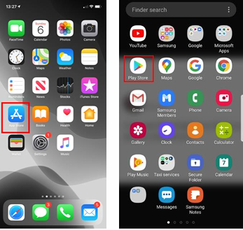

STEP 2: Click the magnifying glass

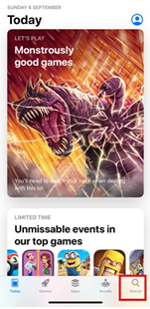

STEP 3: In the search bar type ‘whatsapp’

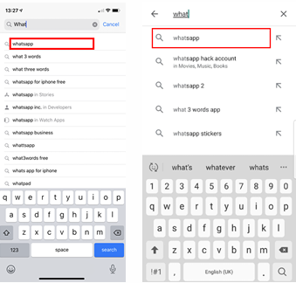

STEP 4: When the ‘WhatsApp Messenger’ box appears click the ‘GET’ / ‘INSTALL’ button on (it should be free)

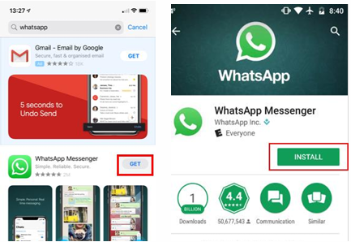

STEP 5: The app will start downloading

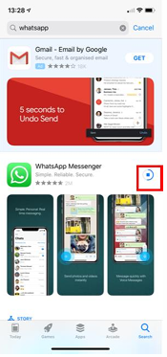

STEP 6: When the app has finished downloading the ‘OPEN’ button will appear.

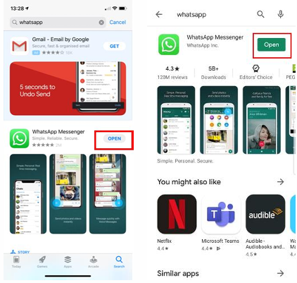

STEP 7: Open the app and click ‘Agree and continue’. This will send you to the next page where you can enter your phone number and begin to use the app.

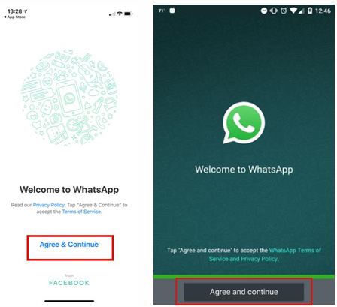

## **HOW TO ADD CONTACTS THROUGH** WHATSAPP?

STEP 1: Click ‘Chats’ at the bottom of your screen

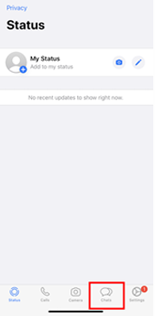

STEP 2: Press the ‘new chat’ icon in the top right

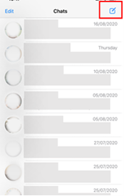

STEP 3: Click the ‘New Contact’ button

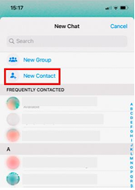

STEP 4: Fill out the details of your new contact and then click save

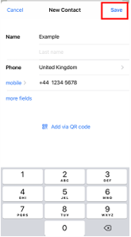

The contact should appear in your address book ready for you to ring/message them.

## HOW TO MESSAGE/TEXT?

STEP 1: Click ‘Chats’ at the bottom of your screen

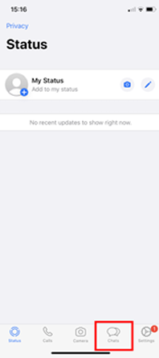

STEP 2: In the search bar type the name of the person you are contacting

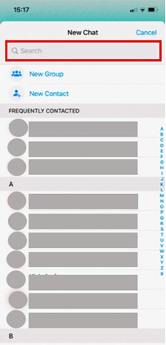

STEP 3: Click their name when it appears

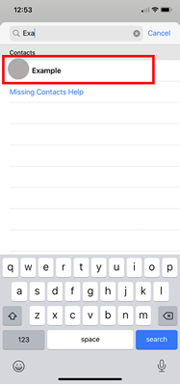

STEP 4: Type out your message on the keyboard. To include an emoji in your message, press the smiley face in the bottom left corner of the screen.

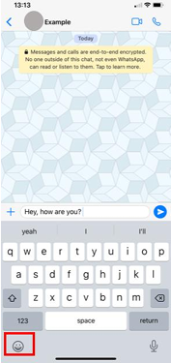

You can scroll through to find an emoji you are looking for and press it when you are ready (to delete the emoji just press the backspace button in the bottom left).

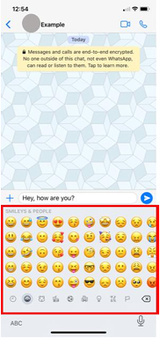

STEP 5: When you are ready to send your message press the blue paper plane button.

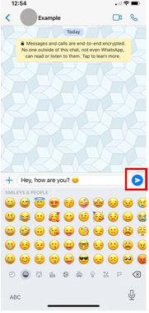

A single grey tick means your message was successfully sent.



Two grey ticks means your message was successfully delivered to your recipient’s phone.



Two blue ticks means the recipient has read your message.



## HOW TO CALL/VIDEO CALL?

STEP 1: Open WhatsApp and click on the ‘Calls’ tab.

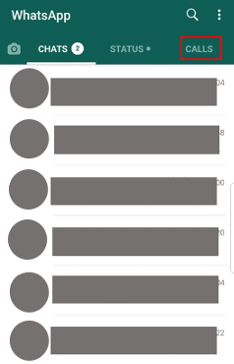

STEP 2: Click on the call icon in the bottom right hand corner.

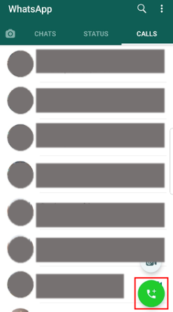

STEP 3: This will show you all your contacts - either search for the contact you want to call by clicking on the search icon or scroll until you find their name.

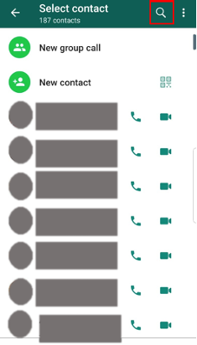

STEP 4: You can voice call them by clicking on the phone icon next to the person’s name.

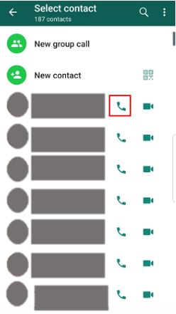

Or you can video call them by clicking on the video icon next to the person’s name.

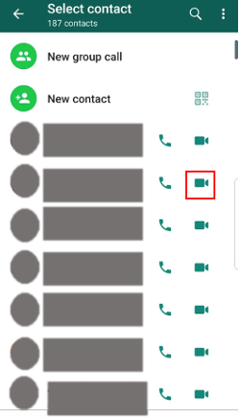

STEP 5: You can mute yourself by clicking on the speakerphone button (and unmute by clicking the same button: muted = , not muted = ).

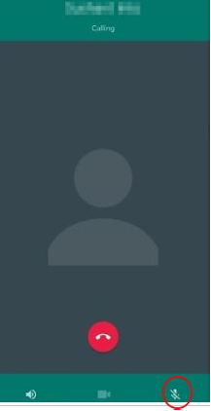

STEP 6: To disconnect the call, click on the red button.

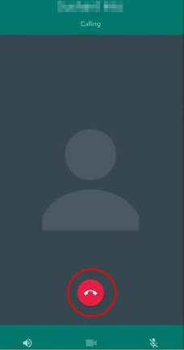

STEP 7: To accept an incoming call click on the green button then swipe up.

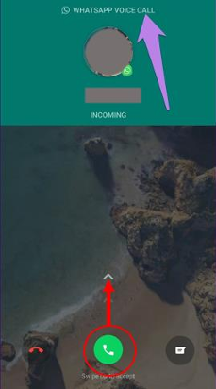

STEP 8: To send a message to the person calling you click on the chats button then send the message (refer to how to message/ text).

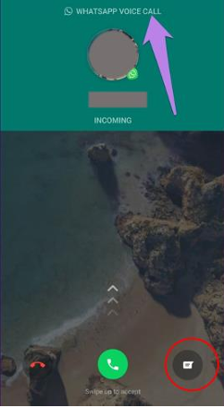

STEP 9: To disconnect the call click on the red button.

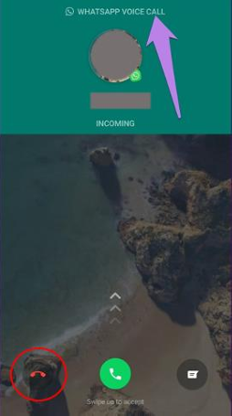

## HOW TO SET UP A PROFILE?

STEP 1: Open WhatsApp and click on the more options button on the right hand side of the screen.

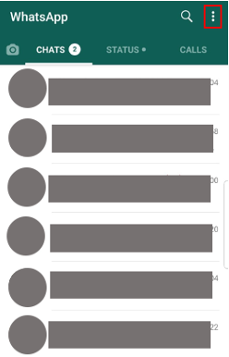

STEP 2: Click on settings then profile option.

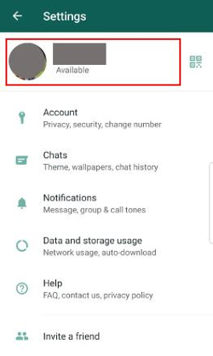

STEP 3: Click on the camera icon to either take a picture using your phone’s camera or select a photo by clicking the gallery option.

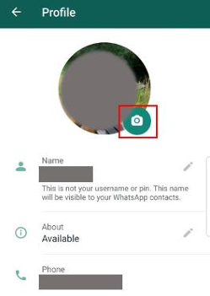

STEP 4: Click on the pen to change your display name.

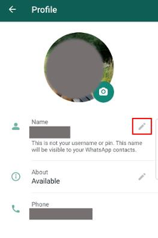

## HOW TO CREATE A GROUP?

STEP 1: Go to the chats tab in WhatsApp and click on the green chat button.

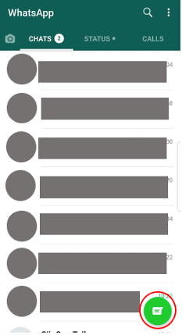

STEP 2: Click ‘New Group’.

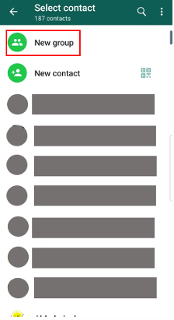

STEP 3: Search for or select the contacts to add to the group, then click ‘Next’.

Enter a group subject - this is the group name, which all the participants will see

You can add a group picture by clicking on the camera icon, where you can choose to take a photo or choose a photo from gallery

Click the tick icon once you are finished.

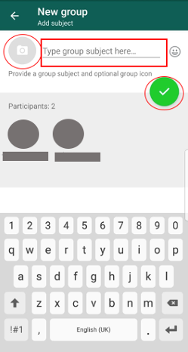

## HOW TO CHANGE PRIVACY SETTINGS?

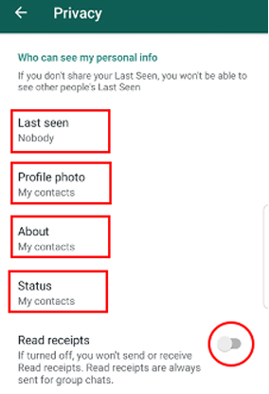STEP 1: Open WhatsApp

STEP 2: Click more options button on the righthand side of the screen

STEP 3: Clicking on settings → click Account → click on privacy

STEP 4: Here you can change when someone can see the last time you have been on WhatsApp, who can view your photo, who can view your status, and if someone can see if you have read the message, by clicking on each of the following…

NOTE: to turn on if someone can view when you have read the message press the button circled

## HOW TO CHANGE HOW YOUR WHATSAPP LOOKS LIKE?

STEP 1: Open WhatsApp

STEP 2: Click more options button on the righthand side of the screen

STEP 3: Clicking on settings → click chats

STEP 4a: If you click on themes, you can change the screen into light and dark mode (see below)

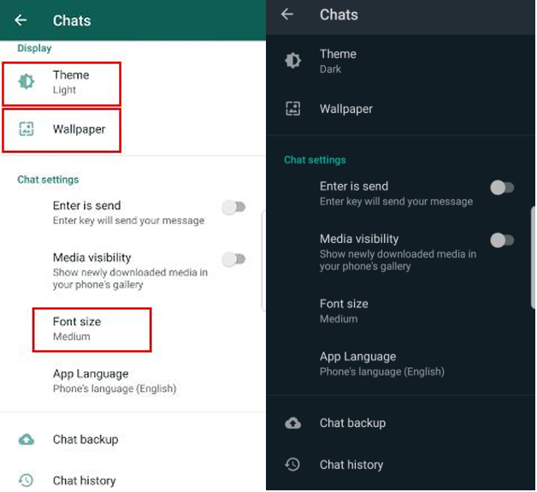

STEP 4b: If you click on wallpaper, you can change the background of your chats

STEP 4c: If you click on font size, you can adjust the size of your text to small, medium or large

## HOW TO CHANGE NOTIFICATION SETTINGS?

STEP 1: Open WhatsApp

STEP 2: Click more options button on the righthand side of the screen

STEP 3: Clicking on settings → click Notifications

STEP 4: Here you can change whether your phone

A. Makes a noise when you get a message from an individual person by clicking on notification tone (you can choose which noise you want by going through the different options)

B. Vibrates when you get a message from an individual person by clicking on vibrates

C. You get a notification on your screen from an individual person by clicking popup notification

D. The above applies to messages from groups under the groups section

E. Makes a noise when you get a call by clicking on ringtone (you can choose which noise you want by going through the different options)

F. Vibrates when you get a call by clicking vibrates under the calls Section

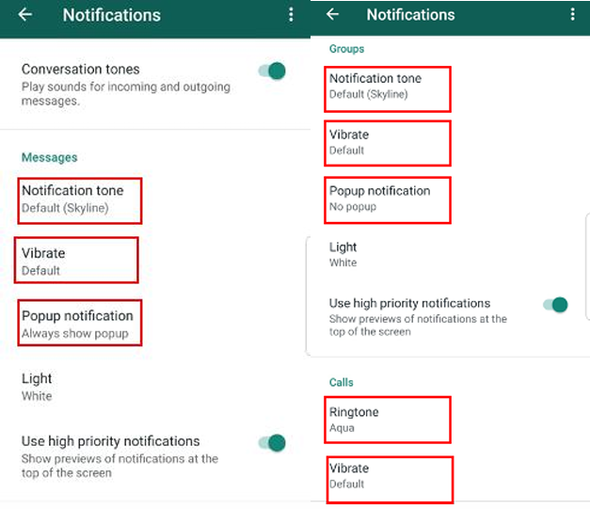

## HOW TO MAKE/VIEW STATUSES?

STEP 1: Open WhatsApp

STEP 2: Click on the status tab

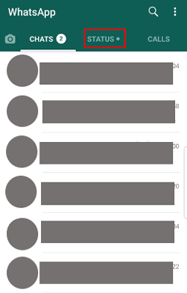

STEP 3: If you want to write something for all your contacts to see, click on the pen.

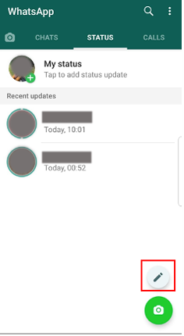

STEP 4: If you want to show a picture for all your contacts to see, click on the camera.

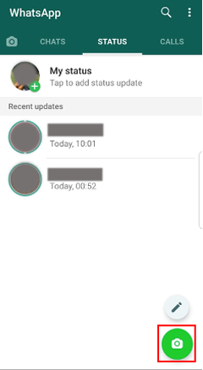

STEP 5: To view statuses, click on the person under recent updates.

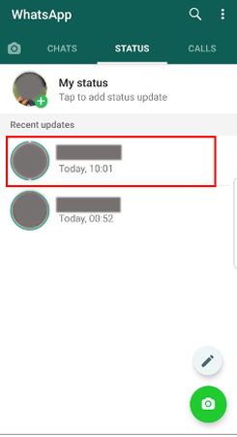

## HOW TO SEARCH FOR SPECIFIC MESSAGES?

STEP 1: Open WhatsApp.

STEP 2: Click on the search icon.

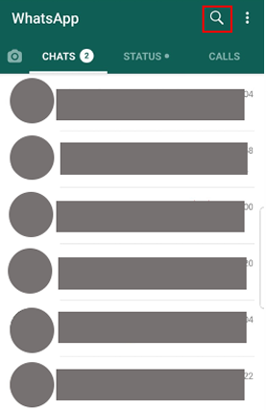

STEP 3: Type what you are looking for, i.e. a specific word like appointment - all messages with that word should come up.

## HOW TO SEND DOCUMENTS/PHOTO/LOCATION?

STEP 1: Open WhatsApp.

STEP 2: Click on chats.

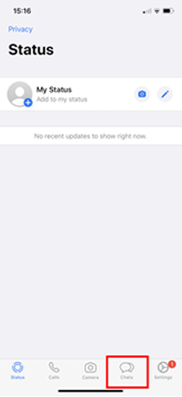

STEP 3: Find the person/group you would like to share your photo/location/document with.

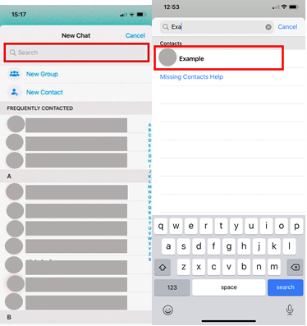

STEP 4: Press the plus sign on the right of the message box.

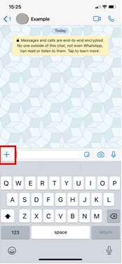

STEP 5: Select ‘Photo & Video Library’.

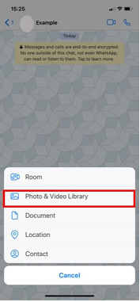

STEP 6.1: Accept the request by pressing the either ’OK’ button and select the photo you would like to send.

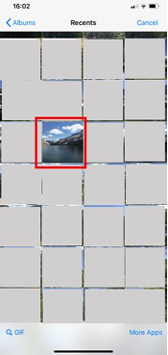

STEP 6.2: Select ‘Location’.

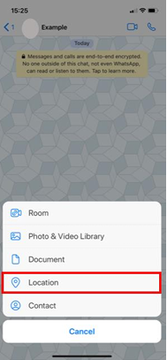

STEP 6.3: Select ‘Document’.

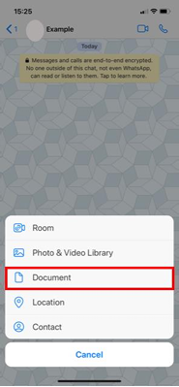

STEP 7.1: You can add a caption if you wish and when you’re ready to send the photo, press the blue paper plane button in the bottom right hand corner.

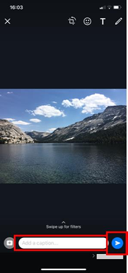

STEP 7.2: Select ‘Allow While Using App’ or ‘Allow Once’.

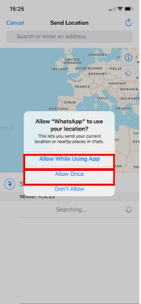

STEP 7.3: Search for the document you are looking for. Then select the document and press the blue paper plane button.

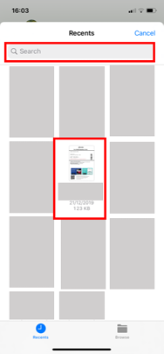

STEP 8: Select ‘Send your current location’.

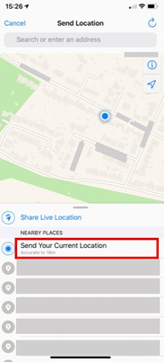

## HOW TO VIEW PHOTOS/ OTHER SHARED MEDIA?

STEP 1: Find the chat/group where the photo, link or document was sent.

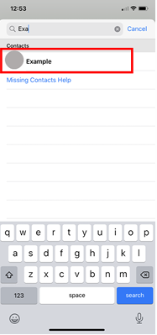

STEP 2: Click on the person’s name/group chat name.

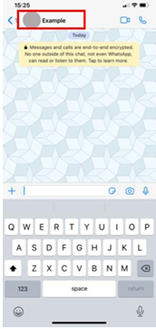

STEP 3: Click ‘Media, Links, and Docs’.

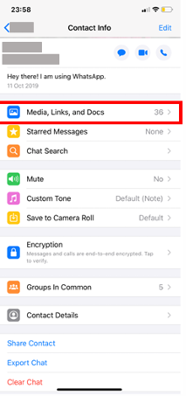

STEP 4: At the top of the screen you can click either Media, Links, or Docs to find what you are looking for. Scroll through to find the shared photo/link/doc.

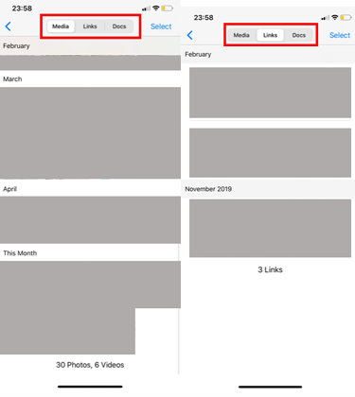

# How to use WhatsApp: A step-by-step beginner's guide

*WhatsApp is the world's most popular chat app, but it can be daunting if you're new. We're here to help!*

**By Nick Fernandez**

•

December 26, 2023

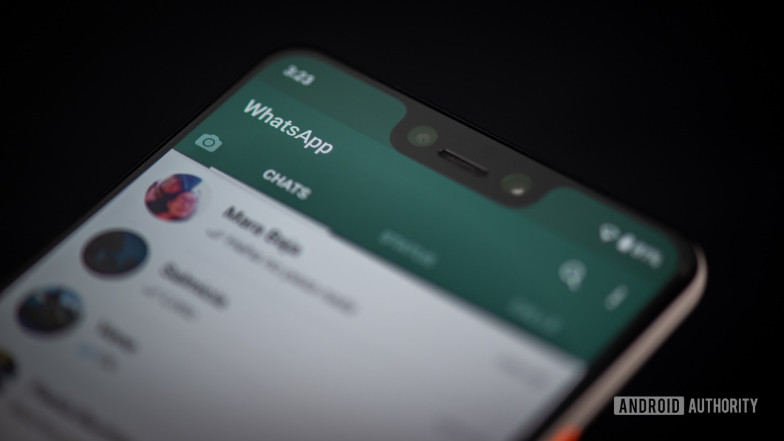

Edgar Cervantes / Android Authority

WhatsApp boasts more than 2 billion users worldwide, but if you don’t live in one of the countries where it’s popular, you may have never used it. Still, if you’re looking for a good messaging platform, it’s one of the [best messaging apps](https://www.androidauthority.com/best-texting-apps-for-android-653970/) available. In this guide, we show you how to use WhatsApp for beginners.

## What is WhatsApp?

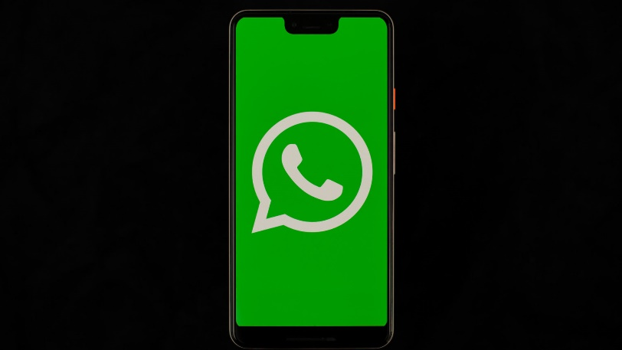

WhatsApp is a free chat app that launched at the dawn of the smartphone era in 2009. It wasn’t until 2015 that it became the most popular communication app worldwide, but nowadays, it’s virtually ubiquitous in most of Europe, Latin America, and the Middle East.

The popularity of WhatsApp is because it’s free, it doesn’t have ads, and of course, it has a huge existing user base. It also features end-to-end encryption, so your messages are private and secure. However, security policy changes in early 2021 mean the app can share some of your data with Facebook.

In addition to standard one-on-one and group chats, you can also do voice or video calls free of charge, [even internationally](https://www.androidauthority.com/free-international-call-whatsapp-3077436/). Remember that this will eat up your data when not connected to Wi-Fi. One small downside is you typically need [a SIM card to use Whatsapp](https://www.androidauthority.com/use-whatsapp-without-sim-card-870736/), though thankfully, there are workarounds.

### Is WhatsApp safe and secure?

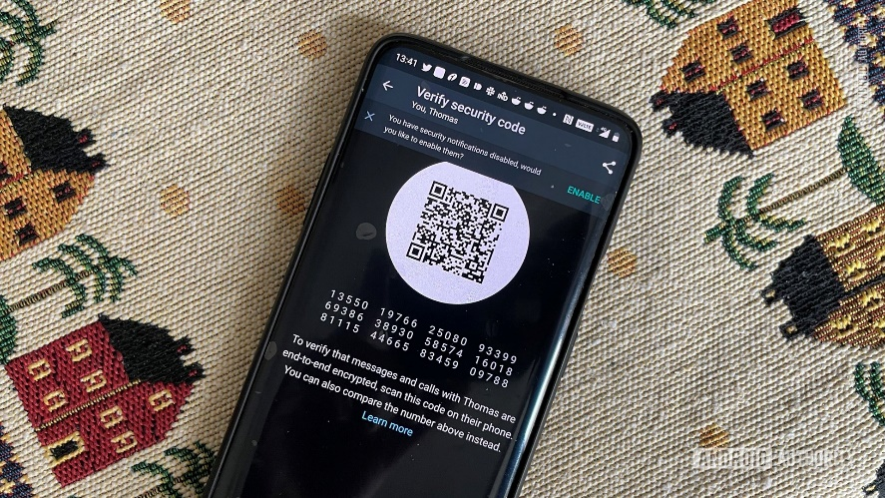

Dhruv Bhutani / Android Authority

With every message and call [end-to-end encrypted by default](https://www.androidauthority.com/whatsapp-encryption-safe-3087607/), WhatsApp is quite secure for virtually all uses. This level of encryption means that not even WhatsApp can see the content of your messages, despite what you might hear online.

Still, you should be wary of phishing attempts. Never give your personal information to someone you don’t know, and don’t be afraid to block or report users you think are trying to scam you. WhatsApp also supports two-step verification in the form of a six-digit PIN.

When it comes to privacy, things are more complicated. An early 2021 privacy policy update stated that WhatsApp might share some of your data with Facebook. This will include your telephone number, location, product interactions, etc. Presumably, this is to improve ad targeting in other Facebook products.

This update was the subject of much debate among users but ultimately rolled out on May 15, 2021. Later in 2021, it was revealed that although WhatsApp cannot see your messages, the company regularly uses contractors to do so as part of a content reviewal system. This is limited to extreme cases of child abuse material or terrorism, but it does fly in the face of WhatsApp’s marketing material.

In other words, if you are concerned with your privacy and don’t want Facebook to access some of your data, WhatsApp might not be for you. Other apps like Telegram and Signal offer better security but don’t boast nearly the same number of users.

## How to install WhatsApp

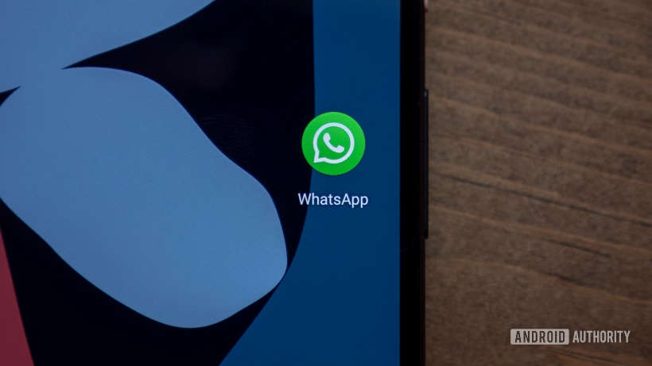

The first step in learning how to use WhatsApp is installing the app, and you can do it in just a few minutes. The app is completely free and only requires a phone number and a mobile device to sign up. Keep in mind Whatsapp is designed for phones, not tablets. If you have a tablet, there are still workarounds for Whatsapp, but we’ll cover those later in this guide.

Without further ado, here’s how to install it for Android or iOS:

* Install the app from the [**Play Store**](https://andauth.co/rhSlvO) (Android) or [**App Store**](https://andauth.co/whatsappios) (iPhone).
* Launch the app and approve the requested permissions.
* Enter your phone number and tap **Confirm**.
* Enter the verification code received via SMS (WhatsApp may do this automatically).
* Import existing contacts into the app (optional).

That’s all there is to it. You’re now ready to start chatting with any of your contacts that have WhatsApp installed. You can also manually add contacts to WhatsApp if you don’t want to import your entire contact list.

## How to set up your WhatsApp profile

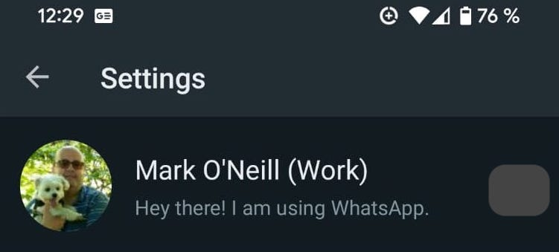

Before you start chatting, there is one more step you may want to take. Creating a profile will help your contacts know who you are, even if they don’t have your number saved in their contacts. You can add a picture, name, and a short bio.

* Tap the three dots in the top-right corner of the app and tap **Settings**.
* Tap your name at the top of the screen.
* To change your picture, tap the camera icon and select a photo.
* To change your name, tap the pencil icon next to **Name**.
* Enter or adjust your bio by tapping the pencil icon next to **About**.

You can also change your phone number from this screen, and the process is the same as when you first set up your account. It will send a verification code via SMS, and once confirmed, WhatsApp will transfer all of your chats and contacts to that number.

## How to start a chat on WhatsApp

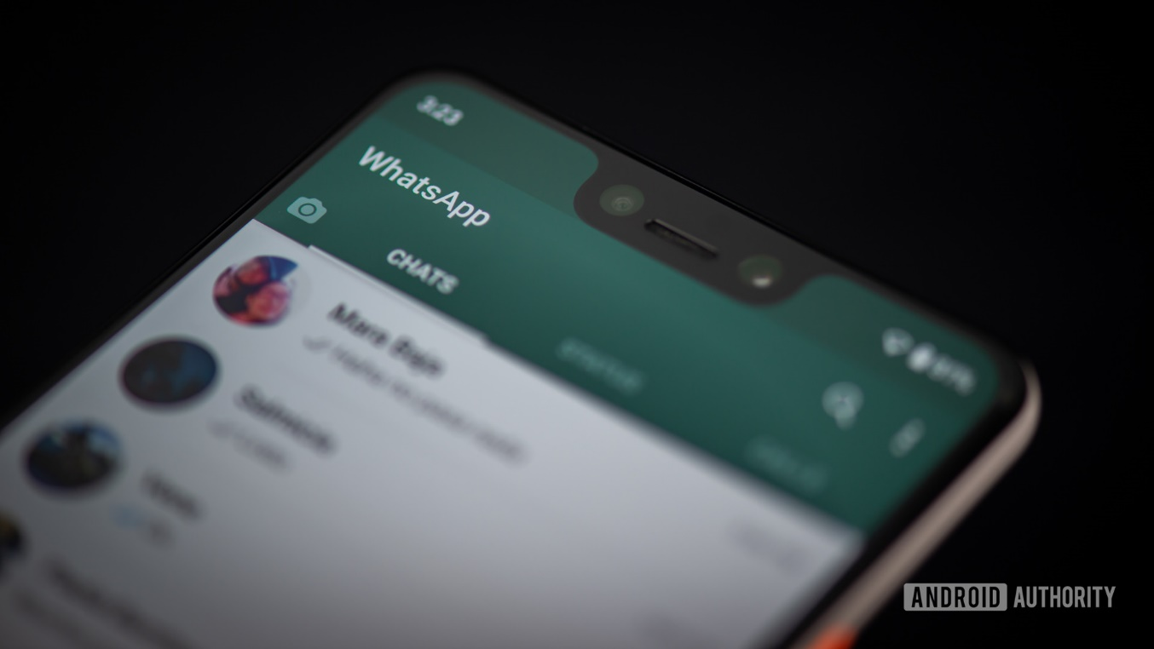

Edgar Cervantes / Android Authority

Now that your profile is set, it’s time to get to the task at hand: chatting! The first time you open the app, you won’t have any chats open, but you can start a new conversation by tapping on the chat bubble in the bottom right.

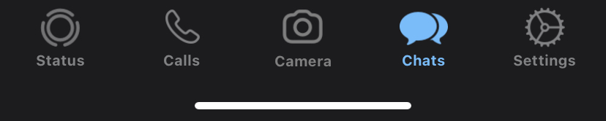

Select the contact you want to chat with from the list. If you already have a previous chat with that contact, it will open that instead of a brand new chat. All that’s left is to type your message at the bottom of the screen. After entering your text, tap the arrow icon alongside the text box to send it.

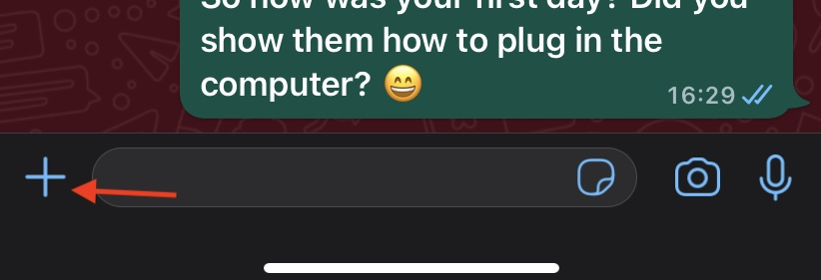

You can also send pictures or files on WhatsApp by tapping the + icon next to the chatbox. WhatsApp has a built-in camera app, but it’s better to use your normal camera app to take the picture and select it in the gallery to send. This will give you more editing options and generally results in higher-quality photos, which you can send without compression with the HD photo quality option.

You can also send pictures or files on WhatsApp by tapping the paperclip or camera icon.

To start a group chat, tap the same chat bubble as before, then tap **New Group**. You can then select the members you want to invite, enter a name for the group, and start chatting.

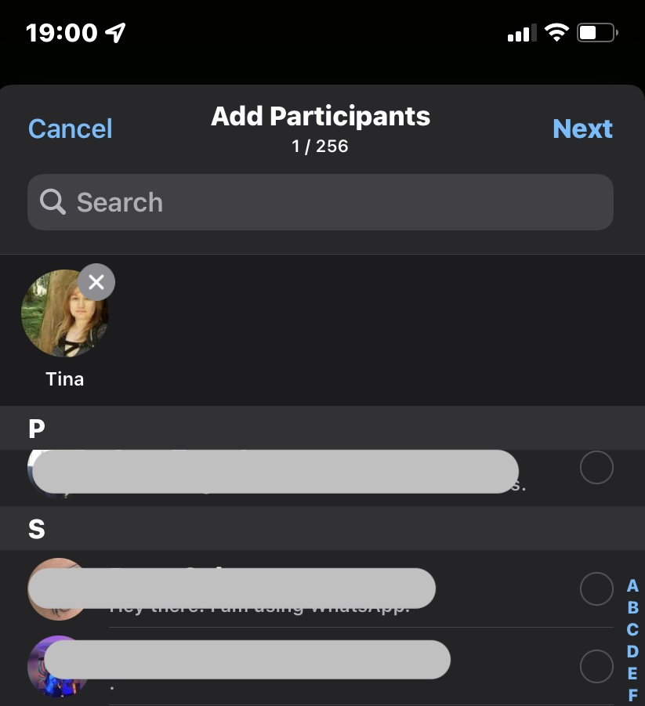

There are many additional features available, so check out our list of [WhatsApp tips and tricks](https://www.androidauthority.com/whatsapp-tricks-tips-867047/) for more information.

## How to use gifs on WhatsApp

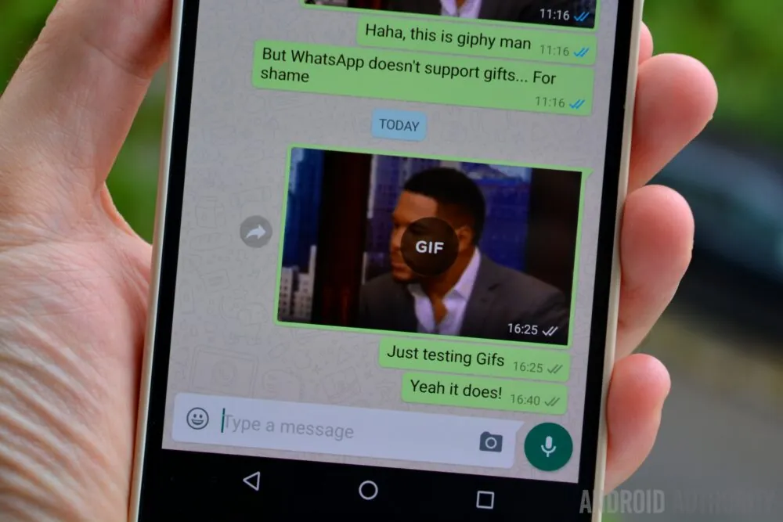

Sending gifs on WhatsApp should be a simple task, but the exact steps are far from obvious. To make matters worse, they differ between iPhones and Android phones.

To send a gif on Android, you first need to open a chat and tap on the smiley face next to the text box. Then, tap the gif text at the bottom of the screen to see a selection of the current most popular gifs. To search for more gifs, tap the magnifying glass at the bottom left and enter your keywords. Once you’ve found and selected your gif, all that’s left is to press send.

It’s worth noting that the process may be easier depending on which brand of phone you have or if you have a different keyboard installed. Often you can tap the gif text above the keyboard instead of the complicated process above.

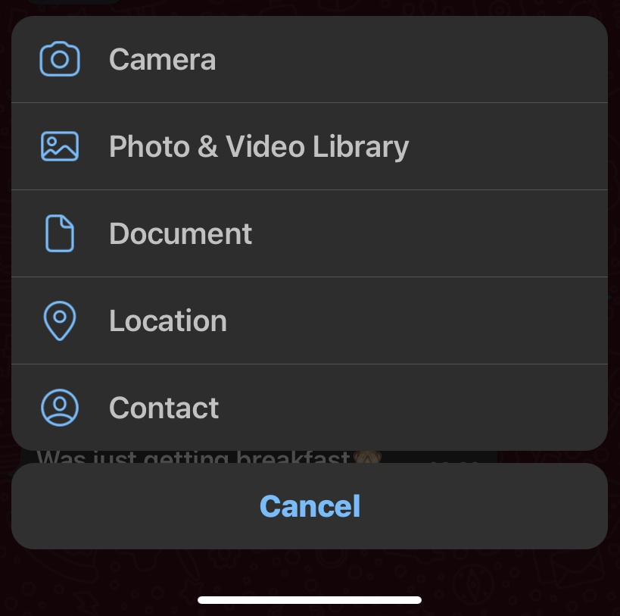

Mark O'Neill / Android Authority

To send a gif on an iPhone, open a chat and tap the plus icon in the bottom left. Then, select **Photo and Video Library** from the menu and tap the magnifying glass icon in the bottom left to search. Once selected, tap **send**.

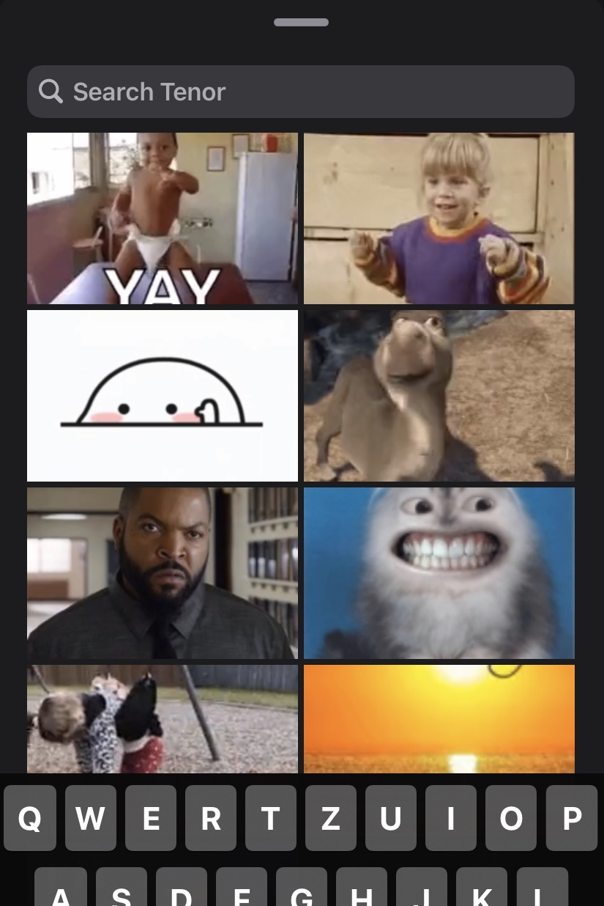

Mark O'Neill / Android Authority

## How to call using WhatsApp

One of the most useful features when using WhatsApp internationally is the ability [to make phone calls](https://www.androidauthority.com/make-whatsapp-call-video-call-3088442/). Unlike standard international voice calls, WhatsApp calls use your internet connection rather than your phone line, so they’re completely free (barring any data overage charges when not on Wi-Fi).

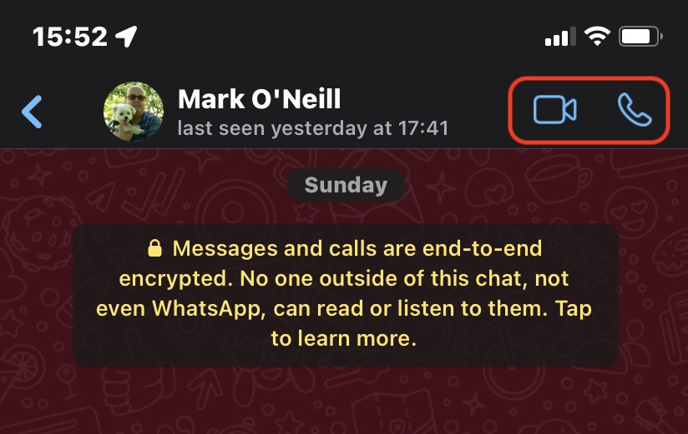

To start a phone call on WhatsApp, all you need to do is open a chat window and tap the phone icon in the top right. If it’s a group, you can even select multiple people to call simultaneously.

The steps for making a video call on WhatsApp are virtually identical. Just tap the video camera icon next to the phone icon.

## How to use WhatsApp on your computer

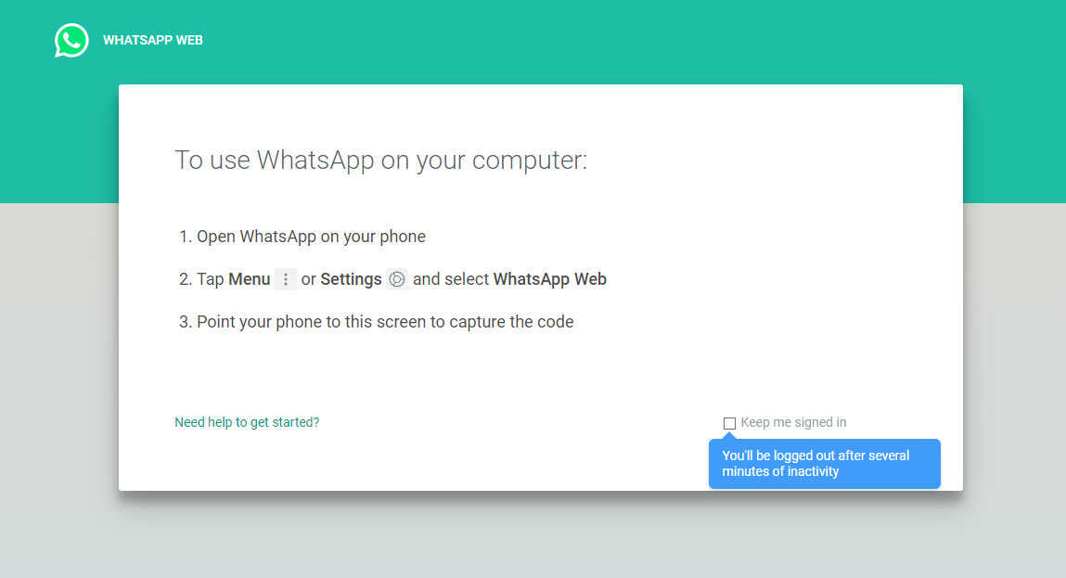

If you prefer typing on a keyboard (or don’t like looking at your phone all day), you can also use [WhatsApp from a computer](https://www.androidauthority.com/whatsapp-web-3076775/). You’ll need to keep your phone nearby, but it can be a convenient way to chat or send files from your PC or Mac.

* On your computer browser, navigate to [**web.whatsapp.com**](https://web.whatsapp.com/).
* Open WhatsApp on your phone, tap the three dots in the top right, then **WhatsApp Web**.
* Tap the plus icon at the top right.
* Point your phone camera at the QR code on your computer screen.
* WhatsApp should instantly log in on your computer.

If you don’t want to use a browser, you can also install the WhatsApp PC client directly on your computer. If you think someone is using WhatsApp Web without your permission, you can remove access from your phone by following the first two steps above.

## How to use WhatsApp on an iPad or Android tablet

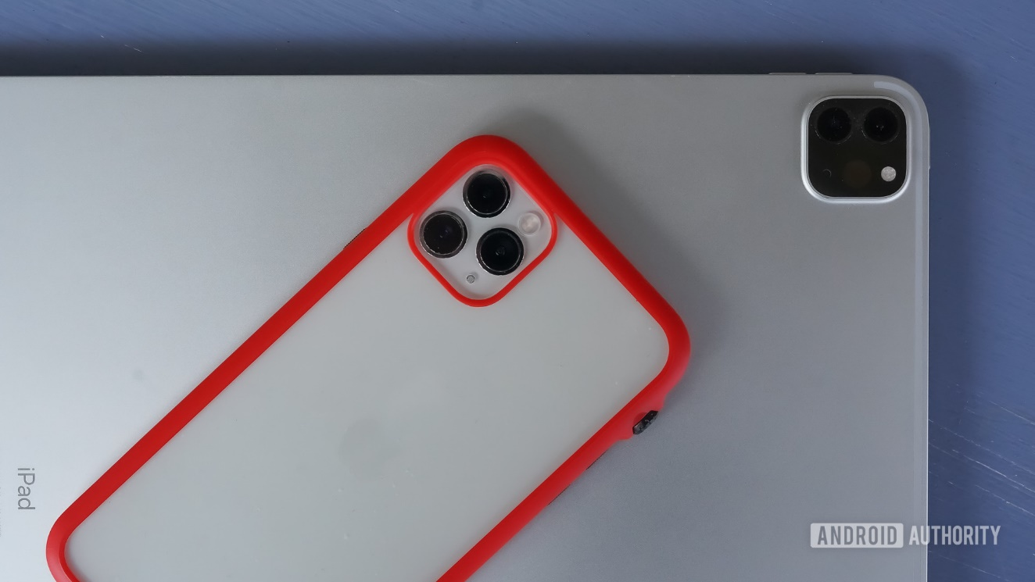

With iPadOS adding lots of new features every year that make it more and more like a computer, it might come as a surprise to learn that using WhatsApp on your iPad is quite difficult. You can install the app directly, but you have to remove it from your phone, which obviously isn’t ideal.

To use [WhatsApp on your iPad,](https://www.androidauthority.com/whatsapp-two-phones-3086688/) you need to use the web portal outlined above. Even then, there’s an extra step involved due to accessing the site from a mobile browser.

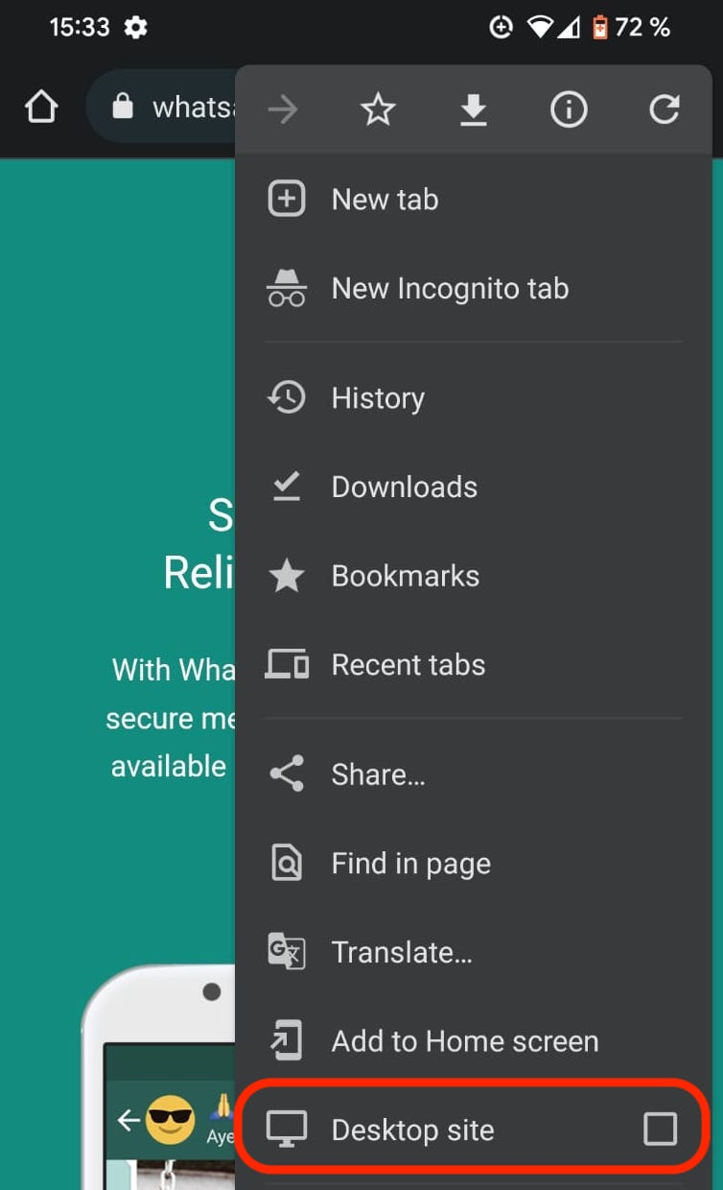

The trick here is to request the desktop version of [web.whatsapp.com](http://web.whatsapp.com/). This will tell WhatsApp that you’re using a computer instead of a mobile device and allow you to connect your phone with the same steps above. How exactly you request the desktop version will depend on which browser you’re using, but we’ve outlined the steps for Safari below.

* Open the Safari browser and navigate to [**web.whatsapp.com**](http://web.whatsapp.com/).
* Tap the three dots next to the URL field, then tap **Request Desktop Site**.
* Open WhatsApp on your phone, tap **Settings**in the top right, then **WhatsApp Web**.
* Tap the plus icon at the top right.
* Point your phone camera at the QR code on your iPad screen.
* WhatsApp should instantly log in on your iPad.

Note that this trick works with Android tablets and iPads of all sizes, and they can be paired with both Android phones and iPhones in any combination.

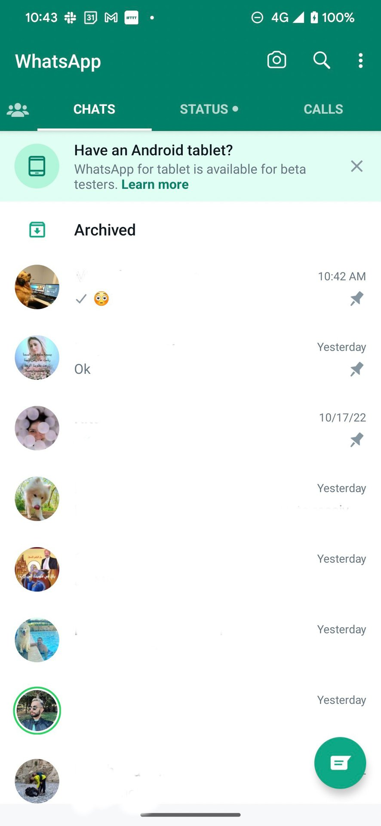

Android users who are signed up for the beta program can also now use a [test version of WhatsApp for Android tablets](https://www.androidauthority.com/whatsapp-for-tablet-3242714/). If you are not in the beta program, you can get the APK file from a third-party source. There’s no word yet on when the tablet version will be rolled out for the iPad.

You can also use this APK file to put [the same WhatsApp account on a second phone](https://www.androidauthority.com/whatsapp-two-phones-2-3242727/) by tricking the APK into thinking the second phone is a tablet.

## Other WhatsApp FAQs

**Are WhatsApp calls free? What about video calls?**

Both calls and video calls are free, but will use data if not connected to Wi-Fi. Be careful not to exceed your mobile data limits, especially with video calls.

**What is WhatsApp Plus? Is it safe?**

WhatsApp Plus is an application developed using stolen code from the official WhatsApp app. It enables a few extra features, but needs to be downloaded and sideloaded to work. It is unsafe to use and may lead to your WhatsApp account being banned, or worse, your information being stolen.

**Does Facebook own WhatsApp?**

Yes, WhatsApp was purchased by Facebook in February of 2014.

**Is WhatsApp social media?**

While some could consider it a social media app, it’s generally considered an instant messaging or communication app. As more business features are added, it may tip further into social media territory.

**Does WhatsApp work in China?**

No. The app has been blocked in China since 2017, although it may still be accessible via [VPN](https://www.androidauthority.com/what-is-a-vpn-2-1098560/).

**Is WhatsApp encrypted?**

Yes. Both calls and messages are encrypted end-to-end, so in most conditions, neither law enforcement nor WhatsApp itself can see them unless they have access to your device.

**What's a status, and how do I use it?**

Your WhatsApp status is pretty much the same as your Instagram, Facebook, or Snapchat story: a way to share a slice of your life with your contacts. You can learn [more about WhatsApp statuses here](https://www.androidauthority.com/whatsapp-status-what-it-is-3084502/).

# Forget FaceTime: The Best Android Video Chat Apps

## You don't need an iPhone for face-to-face video chats. These Android alternatives do anything and everything that Apple's FaceTime can, and more.

**[](https://uk.pcmag.com/u/jordan-minor)[](https://uk.pcmag.com/u/russell-holly)**

**by**[**Jordan Minor**](https://uk.pcmag.com/u/jordan-minor)**,**[**Russell Holly**](https://uk.pcmag.com/u/russell-holly)

**Dec 15, 2023**

If you’re not an iPhone owner, but still want to get in on the smartphone action, that’s totally okay! There are plenty of [great Android phones](https://uk.pcmag.com/smartphones/41662/the-best-android-phones). That said, Apple’s experience in mobile software gives the company the edge in a number of areas, and video chatting is one of them. FaceTime, iOS’s native video app, is a solid program that has been polished to a shine, and it’s quickly becoming a generic verb like Xerox. You don’t video chat someone, you FaceTime them. With an Android phone, though, you can’t. So, what should Android users do?

That’s what’s great about the open marketplace of ideas that is the Google Play store. If you need an Android alternative to FaceTime, you have not one, but several, to choose from. We took the leading candidates for a test drive to compare them with each other, taking into account price, reliability, restrictions, and features.

Developers are constantly improving the experience, too, so you can expect the apps in this feature to see new services and better stability the longer they’re offered. While it’s easy to just stick with Hangouts, there’s certainly a lot to be gained from experimenting with other Android FaceTime alternatives, depending on what friends, family, and co-workers are using. We unreservedly recommend the apps on this list. For more full-featured tools for businesses, you should check out our roundup of the [best video conferencing software](https://uk.pcmag.com/cloud-services/9067/the-best-video-conferencing-software). And pour one out for [Houseparty](https://uk.pcmag.com/video-conferencing-software/130963/houseparty), formerly one of the finest and most enjoyable video chat apps (Epic [shut it down](https://uk.pcmag.com/mobile-apps/135568/houseparty-app-is-shutting-down-next-month)).

## Google Chat

**3.0 Good**

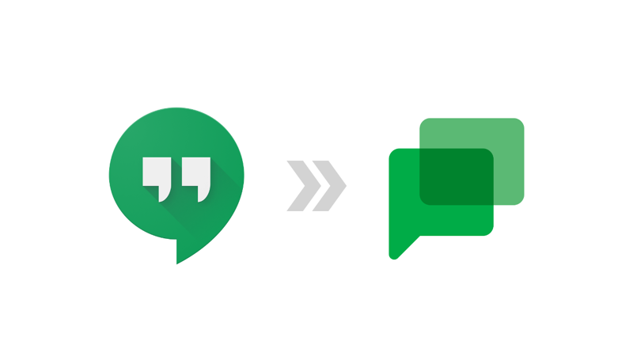

With [video and audio calling](https://uk.pcmag.com/mobile-apps/137529/google-adds-voice-and-video-calls-to-chat-in-the-gmail-app) features, Google Chat on Gmail has [replaced](https://blog.google/products/workspace/hangouts-to-chat/) Google Hangouts as Google's out-of-the-box FaceTime alternative, and it's a pretty good video-chatting and texting tool. One of the best things about it is that it's cross-platform and linked to your Google ID. So, not only does Chat work great on every Android phone, but you can also take it to your desktop—even your Linux or Mac desktop. Gmail's native chat apps have had several different identities over the years (including Google+, but let's not talk about that), and the team has refined it a lot during that time.

Chat offers simple person-to-person connections on Android as well as [iOS](https://uk.pcmag.com/mobile-apps/4332/the-100-best-iphone-apps-for-2020). One advantage that Hangouts has over FaceTime is its data latency management. Apple recommends using FaceTime while connected to a wireless internet connection; Chat handles standard cellular data rates much better. In addition, voice calls to other Chat users are completely free.

If you own an Android phone, you should also have a Google account—it's the key to all of the company's many services, including Chat. Keeping your address book in order lets you merge all your message streams into one easy-to-follow feed.

Alternatively, [Google Meet](https://uk.pcmag.com/video-conferencing-software/132102/google-meet) is Google's more professional video conferencing app and is potentially a better option for teams.

[**Google Chat review**](https://uk.pcmag.com/instant-messaging/124004/google-hangouts-chat)

## Skype



## Skype App

When you think about video chat services, [Skype](https://uk.pcmag.com/internet-telephony-voip/20983/microsoft-skype-for-windows) is the gray-haired grandfather that still manages to hang on. First released in 2003, the system shared a back end with music-sharing system Kazaa (remember music-sharing systems?). It grew steadily until 2011, when it was acquired by Microsoft to replace Windows Live Messenger. Obviously, that makes it the default messaging client for Windows phones, but the Android versions are quite solid.

Early versions of Skype for Android weren’t well-integrated with your mobile device’s address book, making adding contacts a chore. In 2014, the 5.0 update finally brought it into harmony with the Android ecosystem, letting it access your existing contents. This simple change rocketed Skype into the upper echelon of Android video chat services.

Skype’s video chat services work in a variety of bandwidth situations, and keeps a constant monitor of a call's quality. You are able to score the call afterwards, and depending on what hardware you are using to make the video call, the video can be transmitted in HD.

Basic Skype accounts are free and give you unlimited, one-on-one video chat across any supported platform. Skype used to charge a subscription fee for multi-user video chats, but now group chats are included in the basic service. It still charges for calls to phone users outside the Skype service, either by the minute or a monthly subscription.

## Tango



## Tango (for Android)

If you’re looking for a full-service FaceTime alternative for Android, and you have friends willing to jump ship, check out Tango. The app debuted in 2009, and unlike the other offerings on this list, Android is Tango’s primary platform. Although there are builds for iOS and Windows phones, Google’s OS is its native element. That means that hardware optimization is at its peak, leading to a smoother user experience and better call quality.

On a Wi-Fi device, you can interact with any of Tango’s 200 million users without needing a cellular connection. The service supports voice calls, video calls, text, and image chat. Accounts are free, and the signup process is quick and painless. If you want to try and get your friends onboard with you, Tango lets you send text messages and emails to your friends to try and get them to sign up for the service. As long as everyone you want to talk to is using Tango, it’s a solid all-purpose communication tool. Note that, unlike other services, Tango’s video chats are strictly one-on-one affairs.

Tango's developers present their app as not only as a communication tool, but as a full-fledged social network, too. That means a public profile and news feed, games, stickers, and other bells and whistles. If you’re looking for something that does video calls like FaceTime, but offers a whole lot more, Tango might be your jam.

## Viber



## Viber (for Android)

**4.0 Excellent**

Viber began as a text and audio messaging app, but the dev team quickly realized that it would need to add features to compete in a crowded marketplace. First, the crew added audio chat, and then, in 2014, introduced video-chat functionality.

One of Viber's best aspects is its clean and intuitive design. Whereas Skype and Hangouts seem like desktop legacy apps that awkwardly transitioned to mobile experiences, Viber was built from the ground up with your phone screen in mind. In 2013, Viber received a desktop app, but the company's clear focus is still on mobile.

Viber's biggest weakness is that it has no way to communicate with users outside of its service. Unlike other platforms that utilize SMS protocol, Viber doesn't let you you send messages to contacts who aren’t Viber users. Hopefully, Viber fixes this issue; the service has more than 280 million users around the world, so it’s not a niche product.

[**Viber (for Android) review**](https://uk.pcmag.com/android-apps/2085/viber-for-android)

## Zoom Meetings



## Zoom One

**4.5 Excellent**

It doesn't get better than this. [Zoom Meetings](https://uk.pcmag.com/video-conferencing/125660/zoom-meetings) is our Editors' Choice pick for video conferencing tools. Our review praises its "stellar performance at a reasonable price." Anyone working from home is already probably pretty used to hopping on a Zoom call multiple times per day from their computer. Fortunately, Zoom Meeting is also available on Android, where it's known as Zoom Cloud Meetings. It's easy to use, offers a generous free account, and offers stellar performance.

In addition to our exhaustive review of Zoom Meeting, we have written a handy guide to getting started with the services, [Top Zoom Tips for Better Video Conferencing in a Locked-Down World](https://uk.pcmag.com/how-to-work-from-home/125677/top-zoom-tips-for-better-videoconferencing-in-a-locked-down-world).

If you are just getting started with Zoom Meeting, the other thing you’ll want to know is how to lock down your meetings so that you can stop people from Zoom-bombing, or filling your video conference with spam, porn, or worse. For that, you should read [How to Prevent Zoom-Bombing](https://uk.pcmag.com/how-to-work-from-home/125678/how-to-prevent-zoom-bombing).

[**Zoom One review**](https://uk.pcmag.com/video-conferencing-software/149167/zoom-one)

#### Latest deals on top tech

[See all deals](https://www.androidauthority.com/deals)

* [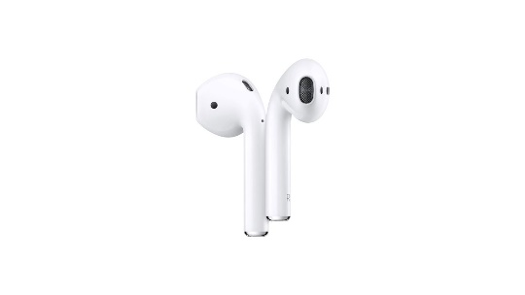](https://clearbuy.com/redirect/cd944fedd76cc5ce731632f4baa017587c0a5594?pId=399)

[**Apple AirPods (2nd Generation)**](https://clearbuy.com/redirect/cd944fedd76cc5ce731632f4baa017587c0a5594?pId=399)

**31% off**

[**See price at Amazon**](https://clearbuy.com/redirect/cd944fedd76cc5ce731632f4baa017587c0a5594?pId=399)

* [](https://clearbuy.com/redirect/0b378d561fa305bc9a2dd235e0111d1402665083?pId=3822)

[**Motorola Moto G Play (2023)**](https://clearbuy.com/redirect/0b378d561fa305bc9a2dd235e0111d1402665083?pId=3822)

**41% off**

[**See price at Amazon**](https://clearbuy.com/redirect/0b378d561fa305bc9a2dd235e0111d1402665083?pId=3822)

[](https://clearbuy.com/redirect/9c5a8c831dbf74632d78b0fd6c96433912b7f748?pId=3277)

[**Samsung 50-Inch The Frame QLED 4K Smart TV**](https://clearbuy.com/redirect/9c5a8c831dbf74632d78b0fd6c96433912b7f748?pId=3277)

**30% off**

[**See price at Amazon**](https://clearbuy.com/redirect/9c5a8c831dbf74632d78b0fd6c96433912b7f748?pId=3277)

* [](https://clearbuy.com/redirect/964e7b01cbdfd283f1d0d8ad5ae5c1921c3905cc?pId=5185)

[**Motorola Edge (2023)**](https://clearbuy.com/redirect/964e7b01cbdfd283f1d0d8ad5ae5c1921c3905cc?pId=5185)

**41% off**

[**See price at Amazon**](https://clearbuy.com/redirect/964e7b01cbdfd283f1d0d8ad5ae5c1921c3905cc?pId=5185)

[](https://clearbuy.com/redirect/2ce4fec0e398c8037e2f075566a2c520df94f0ae?pId=5156)

[**Samsung Galaxy Tab S9 FE Plus**](https://clearbuy.com/redirect/2ce4fec0e398c8037e2f075566a2c520df94f0ae?pId=5156)

**16% off**

[**See price at Amazon**](https://clearbuy.com/redirect/2ce4fec0e398c8037e2f075566a2c520df94f0ae?pId=5156)