Insurance and Comparison Websites

What is Insurance


Insurance: Definition, How It Works, and Main Types of Policies

What Is Insurance?
Insurance is a contract, represented by a policy, in which a policyholder receives financial protection or reimbursement against losses from an insurance company. The company pools clients’ risks to make payments more affordable for the insured. Most people have some insurance: for their car, their house, their healthcare, or their life.
Insurance policies hedge against financial losses resulting from accidents, injury, or property damage. Insurance also helps cover costs associated with liability (legal responsibility) for damage or injury caused to a third party.1

KEY TAKEAWAYS
- Insurance is a contract (policy) in which an insurer indemnifies another against losses from specific contingencies or perils.
- There are many types of insurance policies. Life, health, homeowners, and auto are among the most common forms of insurance.
- The core components that make up most insurance policies are the premium, deductible, and policy limits.
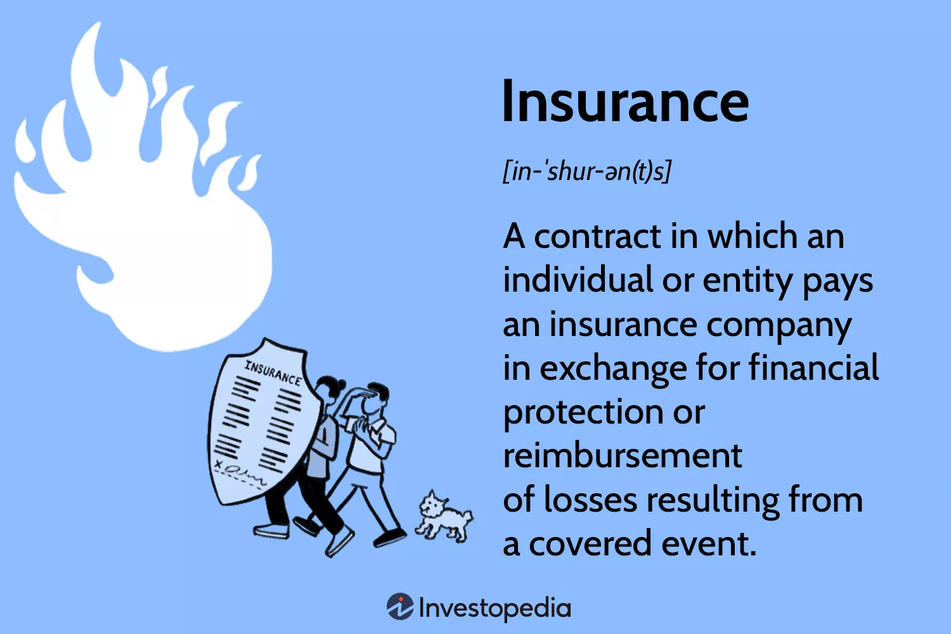
Investopedia / Daniel Fishel

How Insurance Works
Many insurance policy types are available, and virtually any individual or business can find an insurance company willing to insure them—for a price. Common personal insurance policy types are auto, health, homeowners, and life insurance. Most individuals in the United States have at least one of these types of insurance, and car insurance is required by state law.
Businesses obtain insurance policies for field-specific risks, For example, a fast-food restaurant's policy may cover an employee's injuries from cooking with a deep fryer. Medical malpractice insurance covers injury- or death-related liability claims resulting from the health care provider's negligence or malpractice. A company may use an insurance broker of record to help them manage the policies of its employees. Businesses may be required by state law to buy specific insurance coverages.2

Most insurance is regulated at the state level.
There are also insurance policies available for very specific needs, such as kidnap, ransom and extortion insurance (K&R), identity theft insurance, and wedding liability and cancellation insurance.

Insurance Policy Components
Understanding how insurance works can help you choose a policy. For instance, comprehensive coverage may or may not be the right type of auto insurance for you. Three components of any insurance type are the premium, policy limit, and deductible.

Premium
A policy’s premium is its price, typically a monthly cost. Often, an insurer takes multiple factors into account to set a premium. Here are a few examples:3
- Auto insurance premiums: Your history of property and auto claims, age and location, creditworthiness, and many other factors that may vary by state.
- Home insurance premiums: The value of your home, personal belongings, location, claims history, and coverage amounts.
- Health insurance premiums: Age, sex, location, health status, and coverage levels.
- Life insurance premiums: Age, sex, tobacco use, health, and amount of coverage.
Much depends on the insurer's perception of your risk for a claim. For example, suppose you own several expensive automobiles and have a history of reckless driving. In that case, you will likely pay more for an auto policy than someone with a single midrange sedan and a perfect driving record. However, different insurers may charge different premiums for similar policies. So finding the price that is right for you requires some legwork.

Policy Limit
The policy limit is the maximum amount an insurer will pay for a covered loss under a policy. Maximums may be set per period (e.g., annual or policy term), per loss or injury, or over the life of the policy, also known as the lifetime maximum.
Typically, higher limits carry higher premiums. For a general life insurance policy, the maximum amount that the insurer will pay is referred to as the face value. This is the amount paid to your beneficiary upon your death.
The federal Affordable Care Act (ACA) prevents ACA-compliant plans from instituting a lifetime limit for essential healthcare benefits such as family planning, maternity services, and pediatric care.4

Deductible
The deductible is a specific amount you pay out of pocket before the insurer pays a claim. Deductibles serve as deterrents to large volumes of small and insignificant claims.
For example, a $1,000 deductible means you pay the first $1,000 toward any claims. Suppose your car's damage totals $2,000. You pay the first $1,000, and your insurer pays the remaining $1,000.
Deductibles can apply per policy or claim, depending on the insurer and the type of policy. Health plans may have an individual deductible and a family deductible. Policies with high deductibles are typically less expensive because the high out-of-pocket expense generally results in fewer small claims.

Types of Insurance
There are many different types of insurance. Let’s look at the most important.

Health Insurance
Health insurance helps covers routine and emergency medical care costs, often with the option to add vision and dental services separately. In addition to an annual deductible, you may also pay copays and coinsurance, which are your fixed payments or percentage of a covered medical benefit after meeting the deductible. However, many preventive services may be covered for free before these are met.5
Health insurance may be purchased from an insurance company, an insurance agent, the federal Health Insurance Marketplace, provided by an employer, or federal Medicare and Medicaid coverage.
The federal government no longer requires Americans to have health insurance, but in some states, such as California, you may pay a tax penalty if you don't have insurance.6

If you have chronic health issues or need regular medical attention, look for a health insurance policy with a lower deductible. Though the annual premium is higher than a comparable policy with a higher deductible, less-expensive medical care year-round may be worth the tradeoff.

Home Insurance
Homeowners insurance (also known as home insurance) protects your home, other property structures, and personal possessions against natural disasters, unexpected damage, theft, and vandalism. Renter's insurance is another type of homeowners insurance.
Homeowner insurance won't cover floods or earthquakes, which you'll have to protect against separately.
Your lender or landlord will likely require you to have homeowners insurance coverage. Where homes are concerned, you don't have coverage or stop paying your insurance bill, your mortgage lender is allowed to buy homeowners insurance for you and charge you for it.7

Auto Insurance
Auto insurance can help pay claims if you injure or damage someone else's property in a car accident, help pay for accident-related repairs on your vehicle, or repair or replace your vehicle if stolen, vandalized, or damaged by a natural disaster.
Instead of paying out of pocket for auto accidents and damage, people pay annual premiums to an auto insurance company. The company then pays all or most of the covered costs associated with an auto accident or other vehicle damage.
If you have a leased vehicle or borrowed money to buy a car, your lender or leasing dealership will likely require you to carry auto insurance. As with homeowners insurance, the lender may purchase insurance for you if necessary.8

Life Insurance
A life insurance policy guarantees that the insurer pays a sum of money to your beneficiaries (such as a spouse or children) if you die. In exchange, you pay premiums during your lifetime.
There are two main types of life insurance. Term life insurance covers you for a specific period, such as 10 to 20 years. If you die during that period, your beneficiaries receive a payment. Permanent life insurance covers your whole life as long as you continue paying the premiums.9

Travel Insurance
Travel insurance covers the costs and losses associated with traveling, including trip cancellations or delays, coverage for emergency health care, injuries and evacuations, damaged baggage, rental cars, and rental homes.10 However, even some of the best travel insurance companies do not cover cancellations or delays due to weather, terrorism, or a pandemic. They also don't often cover injuries from extreme sports or high-adventure activities.

What Is Insurance?
Insurance is a way to manage your financial risks. When you buy insurance, you purchase protection against unexpected financial losses. The insurance company pays you or someone you choose if something bad occurs. If you have no insurance and an accident happens, you may be responsible for all related costs.1

Why Is Insurance Important?
Insurance helps protect you, your family, and your assets. An insurer will help you cover the costs of unexpected and routine medical bills or hospitalization, accident damage to your car or injury of others, and home damage or theft of your belongings. An insurance policy can even provide your survivors with a lump-sum cash payment if you die. In short, insurance can offer peace of mind regarding unforeseen financial risks.

Is Insurance an Asset?
Depending on the type of life insurance policy and how it is used, permanent or variable life insurance could be considered a financial asset because it can build cash value or be converted into cash. Simply put, most permanent life insurance policies have the ability to build cash value over time.11

The Bottom Line
Insurance helps to protect you and your family against unexpected financial costs and resulting debts or the risk of losing your assets. Insurance helps protect you from expensive lawsuits, injuries and damages, death, and even total losses of your car or home.
Sometimes, your state or lender may require you to carry insurance. Although there are many insurance policy types, some of the most common are life, health, homeowners, and auto. The right type of insurance for you will depend on your goals and financial situation.

ARTICLE SOURCES

Related Terms
Uninsured Motorist Coverage (UM): How It Works, Requirements
Uninsured motorist (UM) coverage may pay a policyholder's damages after an accident with a driver who does not have insurance or a hit-and-run.
more
What Is Comprehensive Insurance and What Does It Cover?
Comprehensive insurance is car insurance that covers damage to your car from causes other than a collision. Learn about comprehensive insurance costs.
more
Auto Insurance: Definition, How It Works, Coverage Types & Costs
Auto insurance is purchased by vehicle owners to mitigate costs associated with getting into an auto accident. Discover more about it here.
more
Casualty Insurance: Definition, Types, and Examples
Casualty insurance is a broad category of coverage against loss of property, damage or other liabilities. This includes workers' compensation.
more
Coinsurance: Definition, How It Works, and Example
Coinsurance is the claim amount an insured must pay after meeting deductibles and is also the level at which an owner must protect property.
more
Underinsured Motorist Coverage: Definition, Example, Benefits
Underinsured motorist coverage is a type of auto insurance that covers property damage and medical bills from an accident caused by a driver with insufficient insurance.
more



How insurance works
Insurance is a financial product sold by insurance companies to safeguard you and / or your property against the risk of loss, damage or theft (such as flooding, burglary or an accident).

Some types of insurance you have to take out by law such as motor insurance if you drive a vehicle; some you may need as a condition of a contract such as buildings insurance as a requirement of your mortgage; and others are sensible to take out such as life insurance or saving for a pension.
While it is a good idea to make sure you are not paying for insurance that you don’t need, you should always think about what would happen if disaster struck and you didn’t have cover to protect you.
You can buy insurance policies for many aspects of your life, for example for your health, home, car, business, or retirement.
An insurance policy is the contract that you take out with an insurer to protect you against specific risks under agreed terms.

How it works
When you buy a policy you make regular payments, known as premiums, to the insurer. If you make a claim your insurer will pay out for the loss that is covered under the policy.
If you don’t make a claim, you won’t get your money back; instead it is pooled with the premiums of other policyholders who have taken out insurance with the same insurance company. If you make a claim the money comes from the pool of policyholders’ premiums.
To decide on the type of insurance you need think about:
- why you need cover
- what you want to include in your cover
- how much you can afford
- how long you might need cover for
- whether you want cover for yourself and / or for loved ones
To buy insurance cover you can:
- contact an insurer directly, either online or over the phone
- seek professional advice through an insurance broker via the British Insurance Brokers' Association (BIBA)
- speak to an independent financial adviser through the Association of Professional Financial Advisors and / or unbiased.co.uk, a comprehensive website where you can find specialist, professional financial advisers
- check comparison websites to get the best deal on the type of policy you're looking for
- for more information see how to buy insurance

How premiums are calculated
Insurers use risk data to calculate the likelihood of the event you are insuring against happening. This information is used to work out the cost of your premium. The more likely the event you are insuring against is to occur, the higher the risk to the insurer and, as a result, the higher the cost of your premium.
An insurer will take two important factors into account when working out the premium they will charge.
- How likely is it in general terms that someone will need to make a claim?
- Is the person who wants to take out a policy a bigger or smaller risk than the ‘average’ policyholder (for example, a young person with a high-powered car may be charged a higher premium as they are statistically more likely to be involved in an accident than a mature, experienced driver)?
Only a proportion of policyholders will make a claim in any one year.

Standard policy conditions
Although policies have different terms and conditions, in general there are three main principles that are common across all insurance policies. These include:
- cover is provided for the actual value of the property or item that has been lost or damaged (its replacement value), but does not include any sentimental value
- there needs to be a large number of similar risks so that the likelihood of a claim can be spread among other policyholders. It must be possible for insurers to calculate the chance of loss so that a premium can be set which matches the risk
- losses must not be deliberate

For more information
- read our how to buy insurance page for information about shopping around
- read the ABI guide on insurance in the UK – the benefits of pricing risk (pdf 1.57MB) to find out more about how insurance works



How insurance works

Insurance is the main way for businesses and individuals to reduce the financial impact of a risk occurring
When things go wrong it can be expensive and so, for many of these eventualities, insurance is there to take the financial risk on our behalf.
A business that provides insurance agrees to take on risks on behalf of a company or individual, in exchange for a fee. It does this by providing the business or individual concerned with an insurance contract, sometimes called a ‘policy’.
This policy will cover a person or business for many of the costs they have to meet as a result of a risk occurring and provides the policyholder with some security should the worst happen.

The concept of risk
Running a business of any kind involves a certain amount of risk. Whether it’s the risk of fire, the risk of damage to exported goods or the risk of natural disasters, all these incidents will have a financial impact on your business if they occur. This is what is being referred to when we use the term ‘risk’.
Most businesses take small steps to manage the effects of risk. For example, by installing smoke alarms and sprinkler systems to reduce the damage caused by fire or by installing security alarms to deter thieves.
However, business owners also want to protect themselves against the financial consequences of something untoward happening, and this is where insurance comes in. In effect, the business can transfer the risk away from themselves and on to someone else.
This transfer of risk is the basis of all insurance, and is something that Lloyd’s has been doing since the 17th century.


How risk is placed
If you’re interested in obtaining insurance cover at Lloyd's you first need to contact a Lloyd’s broker. Our Market Directory tool can help you to find one.

Insurance premiums
The fee an insurer receives from a policyholder (in return for their policy) is called the insurance ‘premium’. This premium, and the terms and conditions of the policy, are based on the likelihood of the risk happening and its value.
The insurer collects premiums on a number of policies and pools these funds, which it then invests to increase the amount of money held. Should any insured person or business make a claim on a policy, the insurer will pay out on that claim from the pool of funds.
The insurer is in business to make a profit and will be hoping that the total premiums it receives in any one year, together with any money it can make through investments, will exceed the total claims it has to pay out.
Insurers are very closely supervised to make sure that they always have enough money to pay all their claims.
Here at Lloyd’s, the teams within the Corporation are responsible for making sure the level of capital is robust enough to ensure that policyholders are protected and all claims can be met.

Underwriters
Before deciding whether or not to provide insurance cover, the insurer will look at all the circumstances surrounding a risk, such as: the likelihood of it happening, the steps already taken to reduce the risk and the financial consequences.
This whole process is called ‘underwriting’. Underwriters are the specialists employed by the insurer to carry out this task.
The underwriters here at Lloyd’s are among the best in the world. They are experts at devising tailored and innovative solutions to new and complex problems.
Lloyd’s underwrites a wide range of businesses and projects all over the world. For example, greener energy, satellites, transport networks and large bespoke events including Wimbledon and The Oscars.


Insurance intermediaries
Lloyd's underwriters do not generally deal directly with policyholders. Instead, business is normally accepted through the following intermediaries:

Lloyd's brokers
Insurance business is generally brought in to the market by brokers that have undergone the Lloyd's broker registration process. These are known as Lloyd's Registered brokers and they are able to do business with any Lloyd's syndicate providing they have a Terms of Business Agreement.
Any broker may deal direct with an individual syndicate providing the managing agent has carried out a process equivalent to the Lloyd's registration process. These brokers are known as non-Lloyd's registered brokers.

Coverholders
Lloyd's underwriters may delegate their authority to enter into contracts of insurance to an intermediary known as a coverholder. The general principle is that the coverholder acts as agent of the Lloyd's underwriters (rather than as agent of the policyholder).

Registered open market correspondents
Certain brokers are registered as ‘open market correspondents’, which permits them to negotiate contracts of insurance with the Lloyd's market. This may be directly with Lloyd's, via a managing agent, or through a Lloyd's broker.
Intermediaries receive payments in a variety of ways, which may include the payment of commissions. Lloyd's strongly supports the disclosure and transparency of these commission arrangements.
Lloyd's also has risk management procedures in place in respect of the relationship between Lloyd's managing agents and any related companies that act as intermediaries.

The importance of reinsurance
Reinsurance is an extension of the concept of insurance, in that it passes on part of the risk for which the original insurer is liable.
Due to the size and complexity of some risks, some insurers take out their own, additional insurance - as added protection for themselves. When insurers insure a risk again, it’s called reinsurance.
Reinsurance is a large, specialist area of insurance and makes up a significant part of all business carried out at Lloyd’s.
Reinsurance is important for four main reasons:


To protect an insurer against very large claims
Insurers spread the costs of paying out on large risks by reinsuring part of what they have agreed to insure with other reinsurers. This ‘spread’ means that the loss incurred by each individual insurer is not as severe.


To reduce exposure to ‘peaks and troughs’
Insurers want a balanced set of underwriting results each year, without peaks and troughs. Because reinsurance covers them against unusually large losses, this keeps a cap on the claims the insurer has to pay.


To obtain an international spread of risk
This is important when a country is vulnerable to natural disasters and an insurer is heavily committed in that country. Insurance may be reinsured to spread the risk outside the country.


To increase the capacity of the direct insurer
Sometimes, insurers want to insure a very large risk but are unable to do this on their own. By using reinsurance, the insurer can accept the whole risk and then reinsure the parts it cannot keep with other insurers. Like the direct insurance market, reinsurance usually involves specialist brokers. The specialist reinsurance brokers here at Lloyd’s have expert knowledge of the market and the ability to access experienced reinsurance underwriters on behalf of their clients.



Insurance
From Wikipedia, the free encyclopedia
"Insure" redirects here. Not to be confused with Ensure.
For other uses, see Insurance (disambiguation).
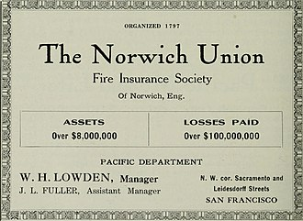An advertisement for a fire insurance company Norwich Union, showing the amount of assets in coverage and paid insurance (1910)
Insurance is a means of protection from financial loss in which, in exchange for a fee, a party agrees to compensate another party in the event of a certain loss, damage, or injury. It is a form of risk management, primarily used to protect against the risk of a contingent or uncertain loss.
An entity which provides insurance is known as an insurer, insurance company, insurance carrier, or underwriter. A person or entity who buys insurance is known as a policyholder, while a person or entity covered under the policy is called an insured. The insurance transaction involves the policyholder assuming a guaranteed, known, and relatively small loss in the form of a payment to the insurer (a premium) in exchange for the insurer's promise to compensate the insured in the event of a covered loss. The loss may or may not be financial, but it must be reducible to financial terms. Furthermore, it usually involves something in which the insured has an insurable interest established by ownership, possession, or pre-existing relationship.
The insured receives a contract, called the insurance policy, which details the conditions and circumstances under which the insurer will compensate the insured, or their designated beneficiary or assignee. The amount of money charged by the insurer to the policyholder for the coverage set forth in the insurance policy is called the premium. If the insured experiences a loss which is potentially covered by the insurance policy, the insured submits a claim to the insurer for processing by a claims adjuster. A mandatory out-of-pocket expense required by an insurance policy before an insurer will pay a claim is called a deductible (or if required by a health insurance policy, a copayment). The insurer may hedge its own risk by taking out reinsurance, whereby another insurance company agrees to carry some of the risks, especially if the primary insurer deems the risk too large for it to carry.

History
Main article: History of insurance

Early methods
Merchants have sought methods to minimize risks since early times. Pictured, Governors of the Wine Merchant's Guild by Ferdinand Bol, c. 1680.
Methods for transferring or distributing risk were practiced by Chinese and Indian traders as long ago as the 3rd and 2nd millennia BC, respectively.^{[1][2]} Chinese merchants travelling treacherous river rapids would redistribute their wares across many vessels to limit the loss due to any single vessel capsizing.
Codex Hammurabi Law 238 (c. 1755–1750 BC) stipulated that a sea captain, ship-manager, or ship charterer that saved a ship from total loss was only required to pay one-half the value of the ship to the ship-owner.^{[3][4][5]} In the Digesta seu Pandectae (533), the second volume of the codification of laws ordered by Justinian I (527–565), a legal opinion written by the Roman jurist Paulus in 235 AD was included about the Lex Rhodia ("Rhodian law"). It articulates the general average principle of marine insurance established on the island of Rhodes in approximately 1000 to 800 BC, plausibly by the Phoenicians during the proposed Dorian invasion and emergence of the purported Sea Peoples during the Greek Dark Ages (c. 1100–c. 750).^{[6][7][8]}
The law of general average is the fundamental principle that underlies all insurance.^{[7]} In 1816, an archeological excavation in Minya, Egypt produced a Nerva–Antonine dynasty-era tablet from the ruins of the Temple of Antinous in Antinoöpolis, Aegyptus. The tablet prescribed the rules and membership dues of a burial society collegium established in Lanuvium, Italia in approximately 133 AD during the reign of Hadrian (117–138) of the Roman Empire.^{[7]} In 1851 AD, future U.S. Supreme Court Associate Justice Joseph P. Bradley (1870–1892 AD), once employed as an actuary for the Mutual Benefit Life Insurance Company, submitted an article to the Journal of the Institute of Actuaries. His article detailed an historical account of a Severan dynasty-era life table compiled by the Roman jurist Ulpian in approximately 220 AD that was also included in the Digesta.^{[9]}
Concepts of insurance has been also found in 3rd century BC Hindu scriptures such as Dharmasastra, Arthashastra and Manusmriti.^{[10]} The ancient Greeks had marine loans. Money was advanced on a ship or cargo, to be repaid with large interest if the voyage prospers. However, the money would not be repaid at all if the ship were lost, thus making the rate of interest high enough to pay for not only for the use of the capital but also for the risk of losing it (fully described by Demosthenes). Loans of this character have ever since been common in maritime lands under the name of bottomry and respondentia bonds.^{[11]}
The direct insurance of sea-risks for a premium paid independently of loans began in Belgium about 1300 AD.^{[11]}
Separate insurance contracts (i.e., insurance policies not bundled with loans or other kinds of contracts) were invented in Genoa in the 14th century, as were insurance pools backed by pledges of landed estates. The first known insurance contract dates from Genoa in 1347. In the next century, maritime insurance developed widely, and premiums were varied with risks.^{[12]} These new insurance contracts allowed insurance to be separated from investment, a separation of roles that first proved useful in marine insurance.
The earliest known policy of life insurance was made in the Royal Exchange, London, on the 18th of June 1583, for £383, 6s. 8d. for twelve months on the life of William Gibbons.^{[11]}

Modern methods
Insurance became far more sophisticated in Enlightenment-era Europe, where specialized varieties developed.
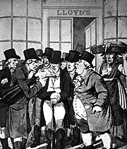Lloyd's Coffee House was the first organized market for marine insurance.
Property insurance as we know it today can be traced to the Great Fire of London, which in 1666 devoured more than 13,000 houses. The devastating effects of the fire converted the development of insurance "from a matter of convenience into one of urgency, a change of opinion reflected in Sir Christopher Wren's inclusion of a site for "the Insurance Office" in his new plan for London in 1667."^{[13]} A number of attempted fire insurance schemes came to nothing, but in 1681, economist Nicholas Barbon and eleven associates established the first fire insurance company, the "Insurance Office for Houses", at the back of the Royal Exchange to insure brick and frame homes. Initially, 5,000 homes were insured by his Insurance Office.^{[14]}
At the same time, the first insurance schemes for the underwriting of business ventures became available. By the end of the seventeenth century, London's growth as a centre for trade was increasing due to the demand for marine insurance. In the late 1680s, Edward Lloyd opened a coffee house, which became the meeting place for parties in the shipping industry wishing to insure cargoes and ships, including those willing to underwrite such ventures. These informal beginnings led to the establishment of the insurance market Lloyd's of London and several related shipping and insurance businesses.^{[15]}
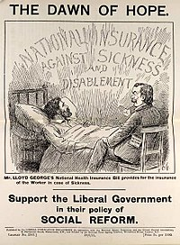Leaflet promoting the National Insurance Act 1911
Life insurance policies were taken out in the early 18th century. The first company to offer life insurance was the Amicable Society for a Perpetual Assurance Office, founded in London in 1706 by William Talbot and Sir Thomas Allen.^{[16][17]} Upon the same principle, Edward Rowe Mores established the Society for Equitable Assurances on Lives and Survivorship in 1762.
It was the world's first mutual insurer and it pioneered age based premiums based on mortality rate laying "the framework for scientific insurance practice and development" and "the basis of modern life assurance upon which all life assurance schemes were subsequently based."^{[18]}
In the late 19th century "accident insurance" began to become available.^{[19]} The first company to offer accident insurance was the Railway Passengers Assurance Company, formed in 1848 in England to insure against the rising number of fatalities on the nascent railway system.
The first international insurance rule was the York Antwerp Rules (YAR) for the distribution of costs between ship and cargo in the event of general average. In 1873 the "Association for the Reform and Codification of the Law of Nations", the forerunner of the International Law Association (ILA), was founded in Brussels. It published the first YAR in 1890, before switching to the present title of the "International Law Association" in 1895.^{[20][21]}
By the late 19th century governments began to initiate national insurance programs against sickness and old age. Germany built on a tradition of welfare programs in Prussia and Saxony that began as early as in the 1840s. In the 1880s Chancellor Otto von Bismarck introduced old age pensions, accident insurance and medical care that formed the basis for Germany's welfare state.^{[22][23]} In Britain more extensive legislation was introduced by the Liberal government in the 1911 National Insurance Act. This gave the British working classes the first contributory system of insurance against illness and unemployment.^{[24]} This system was greatly expanded after the Second World War under the influence of the Beveridge Report, to form the first modern welfare state.^{[22][25]}
In 2008, the International Network of Insurance Associations (INIA), then an informal network, became active and it has been succeeded by the Global Federation of Insurance Associations (GFIA), which was formally founded in 2012 to aim to increase insurance industry effectiveness in providing input to international regulatory bodies and to contribute more effectively to the international dialogue on issues of common interest. It consists of its 40 member associations and 1 observer association in 67 countries, which companies account for around 89% of total insurance premiums worldwide.^{[26]}

Principles
Insurance involves pooling funds from many insured entities (known as exposures) to pay for the losses that only some insureds may incur. The insured entities are therefore protected from risk for a fee, with the fee being dependent upon the frequency and severity of the event occurring. In order to be an insurable risk, the risk insured against must meet certain characteristics. Insurance as a financial intermediary is a commercial enterprise and a major part of the financial services industry, but individual entities can also self-insure through saving money for possible future losses.^{[27]}

Insurability
Main article: Insurability
Risk which can be insured by private companies typically share seven common characteristics:^{[28]}
- A large number of similar exposure units: Since insurance operates through pooling resources, the majority of insurance policies cover individual members of large classes, allowing insurers to benefit from the law of large numbers in which predicted losses are similar to the actual losses. Exceptions include Lloyd's of London, which is famous for insuring the life or health of actors, sports figures, and other famous individuals. However, all exposures will have distinct differences, which may lead to different premium rates.
- Definite loss: This type of loss takes place at a known time and place from a known cause. The classic example involves the death of an insured person on a life insurance policy. Fire, automobile accidents, and worker injuries may all easily meet this criterion. Other types of losses may only be definite in theory. Occupational disease, for instance, may involve prolonged exposure to injurious conditions where no specific time, place, or cause is identifiable. Ideally, the time, place, and cause of a loss should be clear enough that a reasonable person, with sufficient information, could objectively verify all three elements.
- Accidental loss: The event that constitutes the trigger of a claim should be fortuitous, or at least outside the control of the beneficiary of the insurance. The loss should be pure because it results from an event for which there is only the opportunity for cost. Events that contain speculative elements such as ordinary business risks or even purchasing a lottery ticket are generally not considered insurable.
- Large loss: The size of the loss must be meaningful from the perspective of the insured. Insurance premiums need to cover both the expected cost of losses, plus the cost of issuing and administering the policy, adjusting losses, and supplying the capital needed to reasonably assure that the insurer will be able to pay claims. For small losses, these latter costs may be several times the size of the expected cost of losses. There is hardly any point in paying such costs unless the protection offered has real value to a buyer.
- Affordable premium: If the likelihood of an insured event is so high, or the cost of the event so large, that the resulting premium is large relative to the amount of protection offered, then it is not likely that insurance will be purchased, even if on offer. Furthermore, as the accounting profession formally recognizes in financial accounting standards, the premium cannot be so large that there is not a reasonable chance of a significant loss to the insurer. Suppose there is no such chance of loss. In that case, the transaction may have the form of insurance, but not the substance (see the U.S. Financial Accounting Standards Board pronouncement number 113: "Accounting and Reporting for Reinsurance of Short-Duration and Long-Duration Contracts").
- Calculable loss: There are two elements that must be at least estimable, if not formally calculable: the probability of loss and the attendant cost. Probability of loss is generally an empirical exercise, while cost has more to do with the ability of a reasonable person in possession of a copy of the insurance policy and a proof of loss associated with a claim presented under that policy to make a reasonably definite and objective evaluation of the amount of the loss recoverable as a result of the claim.
- Limited risk of catastrophically large losses: Insurable losses are ideally independent and non-catastrophic, meaning that the losses do not happen all at once and that individual losses are not severe enough to bankrupt the insurer; insurers may prefer to limit their exposure to a loss from a single event to some small portion of their capital base. Capital constrains insurers' ability to sell earthquake insurance as well as wind insurance in hurricane zones. In the United States, the federal government insures flood risk in specifically identified areas. In commercial fire insurance, it is possible to find single properties whose total exposed value is well in excess of any individual insurer's capital constraint. Such properties are generally shared among several insurers or are insured by a single insurer which syndicates the risk into the reinsurance market.

Legal
When a company insures an individual entity, there are basic legal requirements and regulations. Several commonly cited legal principles of insurance include:^{[29]}
- Indemnity – the insurance company indemnifies or compensates the insured in the case of certain losses only up to the insured's interest.
- Benefit insurance – as it is stated in the study books of The Chartered Insurance Institute, the insurance company does not have the right of recovery from the party who caused the injury and must compensate the Insured regardless of the fact that Insured had already sued the negligent party for the damages (for example, personal accident insurance)
- Insurable interest – the insured typically must directly suffer from the loss. Insurable interest must exist whether property insurance or insurance on a person is involved. The concept requires that the insured have a "stake" in the loss or damage to the life or property insured. What that "stake" is will be determined by the kind of insurance involved and the nature of the property ownership or relationship between the persons. The requirement of an insurable interest is what distinguishes insurance from gambling.
- Utmost good faith – (Uberrima fides) the insured and the insurer are bound by a good faith bond of honesty and fairness. Material facts must be disclosed.
- Contribution – insurers, which have similar obligations to the insured, contribute in the indemnification, according to some method.
- Subrogation – the insurance company acquires legal rights to pursue recoveries on behalf of the insured; for example, the insurer may sue those liable for the insured's loss. The Insurers can waive their subrogation rights by using the special clauses.
- Causa proxima, or proximate cause – the cause of loss (the peril) must be covered under the insuring agreement of the policy, and the dominant cause must not be excluded
- Mitigation – In case of any loss or casualty, the asset owner must attempt to keep loss to a minimum, as if the asset was not insured.

Indemnification
Main article: Indemnity
To "indemnify" means to make whole again, or to be reinstated to the position that one was in, to the extent possible, prior to the happening of a specified event or peril. Accordingly, life insurance is generally not considered to be indemnity insurance, but rather "contingent" insurance (i.e., a claim arises on the occurrence of a specified event). There are generally three types of insurance contracts that seek to indemnify an insured:
- A "reimbursement" policy
- A "pay on behalf" or "on behalf of policy"^{[30]}
- An "indemnification" policy
From an insured's standpoint, the result is usually the same: the insurer pays the loss and claims expenses.
If the Insured has a "reimbursement" policy, the insured can be required to pay for a loss and then be "reimbursed" by the insurance carrier for the loss and out of pocket costs including, with the permission of the insurer, claim expenses.^{[30][note 1]}
Under a "pay on behalf" policy, the insurance carrier would defend and pay a claim on behalf of the insured who would not be out of pocket for anything. Most modern liability insurance is written on the basis of "pay on behalf" language, which enables the insurance carrier to manage and control the claim.
Under an "indemnification" policy, the insurance carrier can generally either "reimburse" or "pay on behalf of", whichever is more beneficial to it and the insured in the claim handling process.
An entity seeking to transfer risk (an individual, corporation, or association of any type, etc.) becomes the "insured" party once risk is assumed by an "insurer", the insuring party, by means of a contract, called an insurance policy. Generally, an insurance contract includes, at a minimum, the following elements: identification of participating parties (the insurer, the insured, the beneficiaries), the premium, the period of coverage, the particular loss event covered, the amount of coverage (i.e., the amount to be paid to the insured or beneficiary in the event of a loss), and exclusions (events not covered). An insured is thus said to be "indemnified" against the loss covered in the policy.
When insured parties experience a loss for a specified peril, the coverage entitles the policyholder to make a claim against the insurer for the covered amount of loss as specified by the policy. The fee paid by the insured to the insurer for assuming the risk is called the premium. Insurance premiums from many insureds are used to fund accounts reserved for later payment of claims – in theory for a relatively few claimants – and for overhead costs. So long as an insurer maintains adequate funds set aside for anticipated losses (called reserves), the remaining margin is an insurer's profit.

Exclusions
Policies typically include a number of exclusions, for example:
- Nuclear exclusion clause, excluding damage caused by nuclear and radiation accidents
- War exclusion clause, excluding damage from acts of war or terrorism.^{[31][32]}
Insurers may prohibit certain activities which are considered dangerous and therefore excluded from coverage. One system for classifying activities according to whether they are authorised by insurers refers to "green light" approved activities and events, "yellow light" activities and events which require insurer consultation and/or waivers of liability, and "red light" activities and events which are prohibited and outside the scope of insurance cover.^{[33]}

Social effects
Insurance can have various effects on society through the way that it changes who bears the cost of losses and damage. On one hand it can increase fraud; on the other it can help societies and individuals prepare for catastrophes and mitigate the effects of catastrophes on both households and societies.
Insurance can influence the probability of losses through moral hazard, insurance fraud, and preventive steps by the insurance company. Insurance scholars have typically used moral hazard to refer to the increased loss due to unintentional carelessness and insurance fraud to refer to increased risk due to intentional carelessness or indifference.^{[34]} Insurers attempt to address carelessness through inspections, policy provisions requiring certain types of maintenance, and possible discounts for loss mitigation efforts. While in theory insurers could encourage investment in loss reduction, some commentators have argued that in practice insurers had historically not aggressively pursued loss control measures—particularly to prevent disaster losses such as hurricanes—because of concerns over rate reductions and legal battles. However, since about 1996 insurers have begun to take a more active role in loss mitigation, such as through building codes.^{[35]}

Methods of insurance
According to the study books of The Chartered Insurance Institute, there are variant methods of insurance as follows:
- Co-insurance – risks shared between insurers (sometimes referred to as "Retention")
- Dual insurance – having two or more policies with overlapping coverage of a risk (both the individual policies would not pay separately – under a concept named contribution, they would contribute together to make up the policyholder's losses. However, in case of contingency insurances such as life insurance, dual payment is allowed)
- Self-insurance – situations where risk is not transferred to insurance companies and solely retained by the entities or individuals themselves
- Reinsurance – situations when the insurer passes some part of or all risks to another Insurer, called the reinsurer

Insurers' business model
Accidents will happen (William H. Watson, 1922) is a slapstick silent film about the methods and mishaps of an insurance broker. Collection EYE Film Institute Netherlands.
Insurers may use the subscription business model, collecting premium payments periodically in return for on-going and/or compounding benefits offered to policyholders.

Underwriting and investing
Insurers' business model aims to collect more in premium and investment income than is paid out in losses, and to also offer a competitive price which consumers will accept. Profit can be reduced to a simple equation:
Profit = earned premium + investment income – incurred loss – underwriting expenses.
Insurers make money in two ways:
- Through underwriting, the process by which insurers select the risks to insure and decide how much in premiums to charge for accepting those risks, and taking the brunt of the risk should it come to fruition.
- By investing the premiums they collect from insured parties
The most complicated aspect of insuring is the actuarial science of ratemaking (price-setting) of policies, which uses statistics and probability to approximate the rate of future claims based on a given risk. After producing rates, the insurer will use discretion to reject or accept risks through the underwriting process.
At the most basic level, initial rate-making involves looking at the frequency and severity of insured perils and the expected average payout resulting from these perils. Thereafter an insurance company will collect historical loss-data, bring the loss data to present value, and compare these prior losses to the premium collected in order to assess rate adequacy.^{[36]} Loss ratios and expense loads are also used. Rating for different risk characteristics involves—at the most basic level—comparing the losses with "loss relativities"—a policy with twice as many losses would, therefore, be charged twice as much. More complex multivariate analyses are sometimes used when multiple characteristics are involved and a univariate analysis could produce confounded results. Other statistical methods may be used in assessing the probability of future losses.
Upon termination of a given policy, the amount of premium collected minus the amount paid out in claims is the insurer's underwriting profit on that policy. Underwriting performance is measured by something called the "combined ratio", which is the ratio of expenses/losses to premiums.^{[37]} A combined ratio of less than 100% indicates an underwriting profit, while anything over 100 indicates an underwriting loss. A company with a combined ratio over 100% may nevertheless remain profitable due to investment earnings.
Insurance companies earn investment profits on "float". Float, or available reserve, is the amount of money on hand at any given moment that an insurer has collected in insurance premiums but has not paid out in claims. Insurers start investing insurance premiums as soon as they are collected and continue to earn interest or other income on them until claims are paid out. The Association of British Insurers (grouping together 400 insurance companies and 94% of UK insurance services) has almost 20% of the investments in the London Stock Exchange.^{[38]} In 2007, U.S. industry profits from float totaled $58 billion. In a 2009 letter to investors, Warren Buffett wrote, "we were paid $2.8 billion to hold our float in 2008".^{[39]}
In the United States, the underwriting loss of property and casualty insurance companies was $142.3 billion in the five years ending 2003. But overall profit for the same period was $68.4 billion, as the result of float. Some insurance-industry insiders, most notably Hank Greenberg, do not believe that it is possible to sustain a profit from float forever without an underwriting profit as well, but this opinion is not universally held. Reliance on float for profit has led some industry experts to call insurance companies "investment companies that raise the money for their investments by selling insurance".^{[40]}
Naturally, the float method is difficult to carry out in an economically depressed period. Bear markets do cause insurers to shift away from investments and to toughen up their underwriting standards, so a poor economy generally means high insurance-premiums. This tendency to swing between profitable and unprofitable periods over time is commonly known^{[by whom?]} as the underwriting, or insurance, cycle.^{[41]}

Claims
Claims and loss handling is the materialized utility of insurance; it is the actual "product" paid for. Claims may be filed by insureds directly with the insurer or through brokers or agents. The insurer may require that the claim be filed on its own proprietary forms, or may accept claims on a standard industry form, such as those produced by ACORD.
Insurance-company claims departments employ a large number of claims adjusters, supported by a staff of records-management and data-entry clerks. Incoming claims are classified based on severity and are assigned to adjusters, whose settlement authority varies with their knowledge and experience. An adjuster undertakes an investigation of each claim, usually in close cooperation with the insured, determines if coverage is available under the terms of the insurance contract (and if so, the reasonable monetary value of the claim), and authorizes payment.
Policyholders may hire their own public adjusters to negotiate settlements with the insurance company on their behalf. For policies that are complicated, where claims may be complex, the insured may take out a separate insurance-policy add-on, called loss-recovery insurance, which covers the cost of a public adjuster in the case of a claim.
Adjusting liability-insurance claims is particularly difficult because they involve a third party, the plaintiff, who is under no contractual obligation to cooperate with the insurer and may in fact regard the insurer as a deep pocket. The adjuster must obtain legal counsel for the insured—either inside ("house") counsel or outside ("panel") counsel, monitor litigation that may take years to complete, and appear in person or over the telephone with settlement authority at a mandatory settlement-conference when requested by a judge.
If a claims adjuster suspects under-insurance, the condition of average may come into play to limit the insurance company's exposure.
In managing the claims-handling function, insurers seek to balance the elements of customer satisfaction, administrative handling expenses, and claims overpayment leakages. In addition to this balancing act, fraudulent insurance practices are a major business risk that insurers must manage and overcome. Disputes between insurers and insureds over the validity of claims or claims-handling practices occasionally escalate into litigation (see insurance bad faith).

Marketing
Insurers will often use insurance agents to initially market or underwrite their customers. Agents can be captive, meaning they write only for one company, or independent, meaning that they can issue policies from several companies. The existence and success of companies using insurance agents is likely due to the availability of improved and personalised services. Companies also use Broking firms, Banks and other corporate entities (like Self Help Groups, Microfinance Institutions, NGOs, etc.) to market their products.^{[42]}

Types
Any risk that can be quantified can potentially be insured. Specific kinds of risk that may give rise to claims are known as perils. An insurance policy will set out in detail which perils are covered by the policy and which are not. Below are non-exhaustive lists of the many different types of insurance that exist. A single policy may cover risks in one or more of the categories set out below. For example, vehicle insurance would typically cover both the property risk (theft or damage to the vehicle) and the liability risk (legal claims arising from an accident). A home insurance policy in the United States typically includes coverage for damage to the home and the owner's belongings, certain legal claims against the owner, and even a small amount of coverage for medical expenses of guests who are injured on the owner's property.
Business insurance can take a number of different forms, such as the various kinds of professional liability insurance, also called professional indemnity (PI), which are discussed below under that name; and the business owner's policy (BOP), which packages into one policy many of the kinds of coverage that a business owner needs, in a way analogous to how homeowners' insurance packages the coverages that a homeowner needs.^{[43]}

Vehicle insurance
Main article: Vehicle insurance
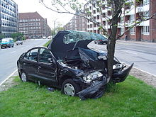
A wrecked vehicle in Copenhagen
Vehicle insurance protects the policyholder against financial loss in the event of an incident involving a vehicle they own, such as in a traffic collision.
Coverage typically includes:
- Property coverage, for damage to or theft of the car
- Liability coverage, for the legal responsibility to others for bodily injury or property damage
- Medical coverage, for the cost of treating injuries, rehabilitation and sometimes lost wages and funeral expenses

Gap insurance
Main article: Gap insurance
Gap insurance covers the excess amount on an auto loan in an instance where the policyholder's insurance company does not cover the entire loan. Depending on the company's specific policies it might or might not cover the deductible as well. This coverage is marketed for those who put low down payments, have high interest rates on their loans, and those with 60-month or longer terms. Gap insurance is typically offered by a finance company when the vehicle owner purchases their vehicle, but many auto insurance companies offer this coverage to consumers as well.

Health insurance
Main articles: Health insurance and Dental insurance

Great Western Hospital, Swindon
Health insurance policies cover the cost of medical treatments. Dental insurance, like medical insurance, protects policyholders for dental costs. In most developed countries, all citizens receive some health coverage from their governments, paid through taxation. In most countries, health insurance is often part of an employer's benefits.

Income protection insurance
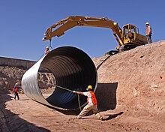
Workers' compensation, or employers' liability insurance, is compulsory in some countries.
- Disability insurance policies provide financial support in the event of the policyholder becoming unable to work because of disabling illness or injury. It provides monthly support to help pay such obligations as mortgage loans and credit cards. Short-term and long-term disability policies are available to individuals, but considering the expense, long-term policies are generally obtained only by those with at least six-figure incomes, such as doctors, lawyers, etc. Short-term disability insurance covers a person for a period typically up to six months, paying a stipend each month to cover medical bills and other necessities.
- Long-term disability insurance covers an individual's expenses for the long term, up until such time as they are considered permanently disabled and thereafter Insurance companies will often try to encourage the person back into employment in preference to and before declaring them unable to work at all and therefore totally disabled.
- Disability overhead insurance allows business owners to cover the overhead expenses of their business while they are unable to work.
- Total permanent disability insurance provides benefits when a person is permanently disabled and can no longer work in their profession, often taken as an adjunct to life insurance.
- Workers' compensation insurance replaces all or part of a worker's wages lost and accompanying medical expenses incurred because of a job-related injury.

Casualty insurance
Main article: Casualty insurance
Casualty insurance insures against accidents, not necessarily tied to any specific property. It is a broad spectrum of insurance that a number of other types of insurance could be classified, such as auto, workers compensation, and some liability insurances.
- Crime insurance is a form of casualty insurance that covers the policyholder against losses arising from the criminal acts of third parties. For example, a company can obtain crime insurance to cover losses arising from theft or embezzlement.
- Terrorism insurance provides protection against any loss or damage caused by terrorist activities. In the United States in the wake of 9/11, the Terrorism Risk Insurance Act 2002 (TRIA) set up a federal program providing a transparent system of shared public and private compensation for insured losses resulting from acts of terrorism. The program was extended until the end of 2014 by the Terrorism Risk Insurance Program Reauthorization Act 2007 (TRIPRA).
- Kidnap and ransom insurance is designed to protect individuals and corporations operating in high-risk areas around the world against the perils of kidnap, extortion, wrongful detention and hijacking.
- Political risk insurance is a form of casualty insurance that can be taken out by businesses with operations in countries in which there is a risk that revolution or other political conditions could result in a loss.

Life insurance
Main article: Life insurance
Amicable Society for a Perpetual Assurance Office, Serjeants' Inn, Fleet Street, London, 1801
Life insurance provides a monetary benefit to a decedent's family or other designated beneficiary, and may specifically provide for income to an insured person's family, burial, funeral and other final expenses. Life insurance policies often allow the option of having the proceeds paid to the beneficiary either in a lump sum cash payment or an annuity. In most states, a person cannot purchase a policy on another person without their knowledge.
Annuities provide a stream of payments and are generally classified as insurance because they are issued by insurance companies, are regulated as insurance, and require the same kinds of actuarial and investment management expertise that life insurance requires. Annuities and pensions that pay a benefit for life are sometimes regarded as insurance against the possibility that a retiree will outlive his or her financial resources. In that sense, they are the complement of life insurance and, from an underwriting perspective, are the mirror image of life insurance.
Certain life insurance contracts accumulate cash values, which may be taken by the insured if the policy is surrendered or which may be borrowed against. Some policies, such as annuities and endowment policies, are financial instruments to accumulate or liquidate wealth when it is needed.
In many countries, such as the United States and the UK, the tax law provides that the interest on this cash value is not taxable under certain circumstances. This leads to widespread use of life insurance as a tax-efficient method of saving as well as protection in the event of early death.
In the United States, the tax on interest income on life insurance policies and annuities is generally deferred. However, in some cases the benefit derived from tax deferral may be offset by a low return. This depends upon the insuring company, the type of policy and other variables (mortality, market return, etc.). Moreover, other income tax saving vehicles (e.g., IRAs, 401(k) plans, Roth IRAs) may be better alternatives for value accumulation.

Burial insurance
Burial insurance is an old type of life insurance which is paid out upon death to cover final expenses, such as the cost of a funeral. The Greeks and Romans introduced burial insurance c. 600 CE when they organized guilds called "benevolent societies" which cared for the surviving families and paid funeral expenses of members upon death. Guilds in the Middle Ages served a similar purpose, as did friendly societies during Victorian times.

Property
Main article: Property insurance

This tornado damage to an Illinois home would be considered an "Act of God" for insurance purposes.
Property insurance provides protection against risks to property, such as fire, theft or weather damage. This may include specialized forms of insurance such as fire insurance, flood insurance, earthquake insurance, home insurance, inland marine insurance or boiler insurance. The term property insurance may, like casualty insurance, be used as a broad category of various subtypes of insurance, some of which are listed below:

US Airways Flight 1549 was written off after ditching into the Hudson River.
- Aviation insurance protects aircraft hulls and spares, and associated liability risks, such as passenger and third-party liability. Airports may also appear under this subcategory, including air traffic control and refuelling operations for international airports through to smaller domestic exposures.
- Boiler insurance (also known as boiler and machinery insurance, or equipment breakdown insurance) insures against accidental physical damage to boilers, equipment or machinery.
- Builder's risk insurance insures against the risk of physical loss or damage to property during construction. Builder's risk insurance is typically written on an "all risk" basis covering damage arising from any cause (including the negligence of the insured) not otherwise expressly excluded. Builder's risk insurance is coverage that protects a person's or organization's insurable interest in materials, fixtures or equipment being used in the construction or renovation of a building or structure should those items sustain physical loss or damage from an insured peril.^{[44]}
- Crop insurance may be purchased by farmers to reduce or manage various risks associated with growing crops. Such risks include crop loss or damage caused by weather, hail, drought, frost damage, pests^{[45]} (including especially insects), or disease^{[46][45]}—some of these being termed named perils.^{[45]} Index-based insurance uses models of how climate extremes affect crop production to define certain climate triggers that if surpassed have high probabilities of causing substantial crop loss. When harvest losses occur associated with exceeding the climate trigger threshold, the index-insured farmer is entitled to a compensation payment.^{[47]}
- Earthquake insurance is a form of property insurance that pays the policyholder in the event of an earthquake that causes damage to the property. Most ordinary home insurance policies do not cover earthquake damage. Earthquake insurance policies generally feature a high deductible. Rates depend on location and hence the likelihood of an earthquake, as well as the construction of the home.
- Fidelity bond is a form of casualty insurance that covers policyholders for losses incurred as a result of fraudulent acts by specified individuals. It usually insures a business for losses caused by the dishonest acts of its employees.
Hurricane Katrina caused over $80 billion of storm and flood damage.
- Flood insurance protects against property loss due to flooding. Many U.S. insurers do not provide flood insurance in some parts of the country. In response to this, the federal government created the National Flood Insurance Program which serves as the insurer of last resort.
- Home insurance, also commonly called hazard insurance or homeowners insurance (often abbreviated in the real estate industry as HOI), provides coverage for damage or destruction of the policyholder's home. In some geographical areas, the policy may exclude certain types of risks, such as flood or earthquake, that require additional coverage. Maintenance-related issues are typically the homeowner's responsibility. The policy may include inventory, or this can be bought as a separate policy, especially for people who rent housing. In some countries, insurers offer a package which may include liability and legal responsibility for injuries and property damage caused by members of the household, including pets.^{[48]}
- Landlord insurance covers residential or commercial property that is rented to tenants. It also covers the landlord's liability for the occupants at the property. Most homeowners' insurance, meanwhile, cover only owner-occupied homes and not liability or damages related to tenants.^{[49]}
- Marine insurance and marine cargo insurance cover the loss or damage of vessels at sea or on inland waterways, and of cargo in transit, regardless of the method of transit. When the owner of the cargo and the carrier are separate corporations, marine cargo insurance typically compensates the owner of cargo for losses sustained from fire, shipwreck, etc., but excludes losses that can be recovered from the carrier or the carrier's insurance. Many marine insurance underwriters will include "time element" coverage in such policies, which extends the indemnity to cover loss of profit and other business expenses attributable to the delay caused by a covered loss.
- Renters' insurance, often called tenants' insurance, is an insurance policy that provides some of the benefits of homeowners' insurance, but does not include coverage for the dwelling, or structure, with the exception of small alterations that a tenant makes to the structure.
- Supplemental natural disaster insurance covers specified expenses after a natural disaster renders the policyholder's home uninhabitable. Periodic payments are made directly to the insured until the home is rebuilt or a specified time period has elapsed.
- Surety bond insurance is a three-party insurance guaranteeing the performance of the principal.
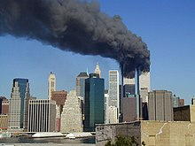
The demand for terrorism insurance surged after 9/11.
- Volcano insurance is a specialized insurance protecting against damage arising specifically from volcanic eruptions.
- Windstorm insurance is an insurance covering the damage that can be caused by wind events such as hurricanes.

Liability[edit]
Main article: Liability insurance
Liability insurance is a broad superset that covers legal claims against the insured. Many types of insurance include an aspect of liability coverage. For example, a homeowner's insurance policy will normally include liability coverage which protects the insured in the event of a claim brought by someone who slips and falls on the property; automobile insurance also includes an aspect of liability insurance that indemnifies against the harm that a crashing car can cause to others' lives, health, or property. The protection offered by a liability insurance policy is twofold: a legal defense in the event of a lawsuit commenced against the policyholder and indemnification (payment on behalf of the insured) with respect to a settlement or court verdict. Liability policies typically cover only the negligence of the insured, and will not apply to results of wilful or intentional acts by the insured.
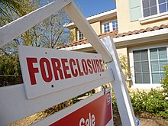
The subprime mortgage crisis was the source of many liability insurance losses.
- Public liability insurance or general liability insurance covers a business or organization against claims should its operations injure a member of the public or damage their property in some way.
- Directors and officers liability insurance (D&O) protects an organization (usually a corporation) from costs associated with litigation resulting from errors made by directors and officers for which they are liable.
- Environmental liability or environmental impairment insurance protects the insured from bodily injury, property damage and cleanup costs as a result of the dispersal, release or escape of pollutants.
- Errors and omissions insurance (E&O) is business liability insurance for professionals such as insurance agents, real estate agents and brokers, architects, third-party administrators (TPAs) and other business professionals.
- Prize indemnity insurance protects the insured from giving away a large prize at a specific event. Examples would include offering prizes to contestants who can make a half-court shot at a basketball game, or a hole-in-one at a golf tournament.
- Professional liability insurance, also called professional indemnity insurance (PI), protects insured professionals such as architectural corporations and medical practitioners against potential negligence claims made by their patients/clients. Professional liability insurance may take on different names depending on the profession. For example, professional liability insurance in reference to the medical profession may be called medical malpractice insurance.
Often a commercial insured's liability insurance program consists of several layers. The first layer of insurance generally consists of primary insurance, which provides first dollar indemnity for judgments and settlements up to the limits of liability of the primary policy. Generally, primary insurance is subject to a deductible and obligates the insurer to defend the insured against lawsuits, which is normally accomplished by assigning counsel to defend the insured. In many instances, a commercial insured may elect to self-insure. Above the primary insurance or self-insured retention, the insured may have one or more layers of excess insurance to provide coverage additional limits of indemnity protection. There are a variety of types of excess insurance, including "stand-alone" excess policies (policies that contain their own terms, conditions, and exclusions), "follow form" excess insurance (policies that follow the terms of the underlying policy except as specifically provided), and "umbrella" insurance policies (excess insurance that in some circumstances could provide coverage that is broader than the underlying insurance).^{[50]}

Credit
Main article: Payment protection insurance
Credit insurance repays some or all of a loan when the borrower is insolvent.
- Mortgage insurance insures the lender against default by the borrower. Mortgage insurance is a form of credit insurance, although the name "credit insurance" more often is used to refer to policies that cover other kinds of debt.
- Many credit cards offer payment protection plans which are a form of credit insurance.
- Trade credit insurance is business insurance over the accounts receivable of the insured. The policy pays the policy holder for covered accounts receivable if the debtor defaults on payment.
- Collateral protection insurance (CPI) insures property (primarily vehicles) held as collateral for loans made by lending institutions.

Cyber attack insurance
Cyber-insurance is a business lines insurance product intended to provide coverage to corporations from Internet-based risks, and more generally from risks relating to information technology infrastructure, information privacy, information governance liability, and activities related thereto.

Other types
- All-risk insurance is an insurance that covers a wide range of incidents and perils, except those noted in the policy. All-risk insurance is different from peril-specific insurance that cover losses from only those perils listed in the policy.^{[51]} In car insurance, all-risk policy includes also the damages caused by the own driver.

High-value horses may be insured under a bloodstock policy.
- Bloodstock insurance covers individual horses or a number of horses under common ownership. Coverage is typically for mortality as a result of accident, illness or disease but may extend to include infertility, in-transit loss, veterinary fees, and prospective foal.
- Business interruption insurance covers the loss of income, and the expenses incurred, after a covered peril interrupts normal business operations.
- Defense Base Act (DBA) insurance provides coverage for civilian workers hired by the government to perform contracts outside the United States and Canada. DBA is required for all U.S. citizens, U.S. residents, U.S. Green Card holders, and all employees or subcontractors hired on overseas government contracts. Depending on the country, foreign nationals must also be covered under DBA. This coverage typically includes expenses related to medical treatment and loss of wages, as well as disability and death benefits.
- Expatriate insurance provides individuals and organizations operating outside of their home country with protection for automobiles, property, health, liability and business pursuits.
- Hired-in Plant Insurance covers liability where, under a contract of hire, the customer is liable to pay for the cost of hired-in equipment and for any rental charges due to a plant hire firm, such as construction plant and machinery.^{[52]}
- Legal expenses insurance covers policyholders for the potential costs of legal action against an institution or an individual. When something happens which triggers the need for legal action, it is known as "the event". There are two main types of legal expenses insurance: before the event insurance and after the event insurance.
- Livestock insurance is a specialist policy provided to, for example, commercial or hobby farms, aquariums, fish farms or any other animal holding. Cover is available for mortality or economic slaughter as a result of accident, illness or disease but can extend to include destruction by government order.
- Media liability insurance is designed to cover professionals that engage in film and television production and print, against risks such as defamation.
- Nuclear incident insurance covers damages resulting from an incident involving radioactive materials and is generally arranged at the national level. (See the nuclear exclusion clause and, for the United States, the Price–Anderson Nuclear Industries Indemnity Act.)
- Over-redemption insurance is purchased by businesses to protect themselves financially in the event that a promotion ends up becoming more successful than was originally anticipated and/or budgeted for.
- Pet insurance insures pets against accidents and illnesses; some companies cover routine/wellness care and burial, as well.
- Pollution insurance usually takes the form of first-party coverage for contamination of insured property either by external or on-site sources. Coverage is also afforded for liability to third parties arising from contamination of air, water, or land due to the sudden and accidental release of hazardous materials from the insured site. The policy usually covers the costs of cleanup and may include coverage for releases from underground storage tanks. Intentional acts are specifically excluded.
- Purchase insurance is aimed at providing protection on the products people purchase. Purchase insurance can cover individual purchase protection, warranties, guarantees, care plans and even mobile phone insurance. Such insurance is normally limited in the scope of problems that are covered by the policy.
- Tax insurance is increasingly being used in corporate transactions to protect taxpayers in the event that a tax position it has taken is challenged by the IRS or a state, local, or foreign taxing authority^{[53]}
- Title insurance provides a guarantee that title to real property is vested in the purchaser or mortgagee, free and clear of liens or encumbrances. It is usually issued in conjunction with a search of the public records performed at the time of a real estate transaction.
- Travel insurance is an insurance cover taken by those who travel abroad, which covers certain losses such as medical expenses, loss of personal belongings, travel delay, and personal liabilities.
- Tuition insurance insures students against involuntary withdrawal from cost-intensive educational institutions
- Interest rate insurance protects the holder from adverse changes in interest rates, for instance for those with a variable rate loan or mortgage
- Divorce insurance is a form of contractual liability insurance that pays the insured a cash benefit if their marriage ends in divorce.

Insurance financing vehicles
- Fraternal insurance is provided on a cooperative basis by fraternal benefit societies or other social organizations.^{[54]}
- No-fault insurance is a type of insurance policy (typically automobile insurance) where insureds are indemnified by their own insurer regardless of fault in the incident.
- Protected self-insurance is an alternative risk financing mechanism in which an organization retains the mathematically calculated cost of risk within the organization and transfers the catastrophic risk with specific and aggregate limits to an insurer so the maximum total cost of the program is known. A properly designed and underwritten Protected Self-Insurance Program reduces and stabilizes the cost of insurance and provides valuable risk management information.
- Retrospectively rated insurance is a method of establishing a premium on large commercial accounts. The final premium is based on the insured's actual loss experience during the policy term, sometimes subject to a minimum and maximum premium, with the final premium determined by a formula. Under this plan, the current year's premium is based partially (or wholly) on the current year's losses, although the premium adjustments may take months or years beyond the current year's expiration date. The rating formula is guaranteed in the insurance contract. Formula: retrospective premium = converted loss + basic premium × tax multiplier. Numerous variations of this formula have been developed and are in use.
- Formal self-insurance (active risk retention) is the deliberate decision to pay for otherwise insurable losses out of one's own money.^{[55]} This can be done on a formal basis by establishing a separate fund into which funds are deposited on a periodic basis, or by simply forgoing the purchase of available insurance and paying out-of-pocket. Self-insurance is usually used to pay for high-frequency, low-severity losses.^{[56]} Such losses, if covered by conventional insurance, mean having to pay a premium that includes loadings for the company's general expenses, cost of putting the policy on the books, acquisition expenses, premium taxes, and contingencies. While this is true for all insurance, for small, frequent losses the transaction costs may exceed the benefit of volatility reduction that insurance otherwise affords.^{[56]}
- Reinsurance is a type of insurance purchased by insurance companies or self-insured employers to protect against unexpected losses. Financial reinsurance is a form of reinsurance that is primarily used for capital management rather than to transfer insurance risk.
- Social insurance can be many things to many people in many countries. But a summary of its essence is that it is a collection of insurance coverages (including components of life insurance, disability income insurance, unemployment insurance, health insurance, and others), plus retirement savings, that requires participation by all citizens. By forcing everyone in society to be a policyholder and pay premiums, it ensures that everyone can become a claimant when or if they need to. Along the way, this inevitably becomes related to other concepts such as the justice system and the welfare state. This is a large, complicated topic that engenders tremendous debate, which can be further studied in the following articles (and others):
  - National Insurance
  - Social safety net
  - Social security
  - Social Security debate (United States)
  - Social Security (United States)
  - Social welfare provision
- Stop-loss insurance provides protection against catastrophic or unpredictable losses. It is purchased by organizations who do not want to assume 100% of the liability for losses arising from the plans. Under a stop-loss policy, the insurance company becomes liable for losses that exceed certain limits called deductibles.

Closed community and governmental self-insurance
Some communities prefer to create virtual insurance among themselves by other means than contractual risk transfer, which assigns explicit numerical values to risk. A number of religious groups, including the Amish and some Muslim groups, depend on support provided by their communities when disasters strike. The risk presented by any given person is assumed collectively by the community who all bear the cost of rebuilding lost property and supporting people whose needs are suddenly greater after a loss of some kind. In supportive communities where others can be trusted to follow community leaders, this tacit form of insurance can work. In this manner the community can even out the extreme differences in insurability that exist among its members. Some further justification is also provided by invoking the moral hazard of explicit insurance contracts.
In the United Kingdom, The Crown (which, for practical purposes, meant the civil service) did not insure property such as government buildings. If a government building was damaged, the cost of repair would be met from public funds because, in the long run, this was cheaper than paying insurance premiums. Since many UK government buildings have been sold to property companies and rented back, this arrangement is now less common.
In the United States, the most prevalent form of self-insurance is governmental risk management pools. They are self-funded cooperatives, operating as carriers of coverage for the majority of governmental entities today, such as county governments, municipalities, and school districts. Rather than these entities independently self-insure and risk bankruptcy from a large judgment or catastrophic loss, such governmental entities form a risk pool. Such pools begin their operations by capitalization through member deposits or bond issuance. Coverage (such as general liability, auto liability, professional liability, workers compensation, and property) is offered by the pool to its members, similar to coverage offered by insurance companies. However, self-insured pools offer members lower rates (due to not needing insurance brokers), increased benefits (such as loss prevention services) and subject matter expertise. Of approximately 91,000 distinct governmental entities operating in the United States, 75,000 are members of self-insured pools in various lines of coverage, forming approximately 500 pools. Although a relatively small corner of the insurance market, the annual contributions (self-insured premiums) to such pools have been estimated up to 17 billion dollars annually.^{[57]}

Insurance companies
 | This section needs additional citations for verification. Please help improve this article by adding citations to reliable sources in this section. Unsourced material may be challenged and removed.  Find sources: "Insurance" – news · newspapers · books · scholar · JSTOR (January 2019) (Learn how and when to remove this template message)
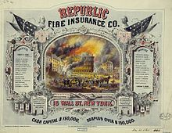
Certificate issued by Republic Fire Insurance Co. of New York c. 1860
Insurance companies may provide any combination of insurance types, but are often classified into three groups:^{[58]}
- Life insurance companies, that provide life insurance, annuities and pensions products and bear similarities to asset management businesses^{[58]}
- Non-life or property/casualty insurance companies, which provides other types of insurance.
- Health insurance companies, which sometimes provide life insurance or employee benefits as well
General insurance companies can be further divided into these sub categories.
- Standard lines
- Excess lines
In most countries, life and non-life insurers are subject to different regulatory regimes and different tax and accounting rules. The main reason for the distinction between the two types of company is that life, annuity, and pension business is long-term in nature – coverage for life assurance or a pension can cover risks over many decades. By contrast, non-life insurance cover usually covers a shorter period, such as one year.

Mutual versus proprietary
Main article: Mutual insurance
Insurance companies are commonly classified as either mutual or proprietary companies.^{[59]} Mutual companies are owned by the policyholders, while shareholders (who may or may not own policies) own proprietary insurance companies.
Demutualization of mutual insurers to form stock companies, as well as the formation of a hybrid known as a mutual holding company, became common in some countries, such as the United States, in the late 20th century. However, not all states permit mutual holding companies.

Reinsurance companies
Reinsurance companies are insurance companies that provide policies to other insurance companies, allowing them to reduce their risks and protect themselves from substantial losses.^{[60]} The reinsurance market is dominated by a few large companies with huge reserves. A reinsurer may also be a direct writer of insurance risks as well.

Captive insurance companies
Main article: Captive insurance
Captive insurance companies can be defined as limited-purpose insurance companies established with the specific objective of financing risks emanating from their parent group or groups. This definition can sometimes be extended to include some of the risks of the parent company's customers. In short, it is an in-house self-insurance vehicle. Captives may take the form of a "pure" entity, which is a 100% subsidiary of the self-insured parent company; of a "mutual" captive, which insures the collective risks of members of an industry; and of an "association" captive, which self-insures individual risks of the members of a professional, commercial or industrial association. Captives represent commercial, economic and tax advantages to their sponsors because of the reductions in costs they help create and for the ease of insurance risk management and the flexibility for cash flows they generate. Additionally, they may provide coverage of risks which is neither available nor offered in the traditional insurance market at reasonable prices.
The types of risk that a captive can underwrite for their parents include property damage, public and product liability, professional indemnity, employee benefits, employers' liability, motor and medical aid expenses. The captive's exposure to such risks may be limited by the use of reinsurance.
Captives are becoming an increasingly important component of the risk management and risk financing strategy of their parent. This can be understood against the following background:
- Heavy and increasing premium costs in almost every line of coverage
- Difficulties in insuring certain types of fortuitous risk
- Differential coverage standards in various parts of the world
- Rating structures which reflect market trends rather than individual loss experience
- Insufficient credit for deductibles or loss control efforts

Other forms
Other possible forms for an insurance company include reciprocals, in which policyholders reciprocate in sharing risks, and Lloyd's organizations.^{[61]}

Admitted versus non-admitted
Admitted insurance companies are those in the United States that have been admitted or licensed by the state licensing agency. The insurance they provide is called admitted insurance. Non-admitted companies have not been approved by the state licensing agency, but are allowed to provide insurance under special circumstances when they meet an insurance need that admitted companies cannot or will not meet.^{[62]}

Insurance consultants
There are also companies known as "insurance consultants". Like a mortgage broker, these companies are paid a fee by the customer to shop around for the best insurance policy among many companies. Similar to an insurance consultant, an "insurance broker" also shops around for the best insurance policy among many companies. However, with insurance brokers, the fee is usually paid in the form of commission from the insurer that is selected rather than directly from the client.
Neither insurance consultants nor insurance brokers are insurance companies and no risks are transferred to them in insurance transactions. Third party administrators are companies that perform underwriting and sometimes claims handling services for insurance companies. These companies often have special expertise that the insurance companies do not have.

Financial stability and rating
The financial stability and strength of an insurance company is a consideration when buying an insurance contract. An insurance premium paid currently provides coverage for losses that might arise many years in the future. For that reason, a more financially stable insurance carrier reduces the risk of the insurance company becoming insolvent, leaving their policyholders with no coverage (or coverage only from a government-backed insurance pool or other arrangements with less attractive payouts for losses). A number of independent rating agencies provide information and rate the financial viability of insurance companies.
Insurance companies are rated by various agencies such as AM Best. The ratings include the company's financial strength, which measures its ability to pay claims. It also rates financial instruments issued by the insurance company, such as bonds, notes, and securitization products.

Across the world
Advanced economies account for the bulk of the global insurance industry. According to Swiss Re, the global insurance market wrote $6.287 trillion in direct premiums in 2020.^{[63]} ("Direct premiums" means premiums written directly by insurers before accounting for ceding of risk to reinsurers.) As usual, the United States was the country with the largest insurance market with $2.530 trillion (40.3%) of direct premiums written, with the People's Republic of China coming in second at only $574 billion (9.3%), Japan coming in third at $438 billion (7.1%), and the United Kingdom coming in fourth at $380 billion (6.2%).^{[63]} However, the European Union's single market is the actual second largest market, with 18 percent market share.^{[63]}

Regulatory differences
Main article: Insurance law
In the United States, insurance is regulated by the states under the McCarran–Ferguson Act, with "periodic proposals for federal intervention", and a nonprofit coalition of state insurance agencies called the National Association of Insurance Commissioners works to harmonize the country's different laws and regulations.^{[64]} The National Conference of Insurance Legislators (NCOIL) also works to harmonize the different state laws.^{[65]}
In the European Union, the Third Non-Life Directive and the Third Life Directive, both passed in 1992 and effective 1994, created a single insurance market in Europe and allowed insurance companies to offer insurance anywhere in the EU (subject to permission from authority in the head office) and allowed insurance consumers to purchase insurance from any insurer in the EU.^{[66]} As far as insurance in the United Kingdom, the Financial Services Authority took over insurance regulation from the General Insurance Standards Council in 2005;^{[67]} laws passed include the Insurance Companies Act 1973 and another in 1982,^{[68]} and reforms to warranty and other aspects under discussion as of 2012.^{[69]}
The insurance industry in China was nationalized in 1949 and thereafter offered by only a single state-owned company, the People's Insurance Company of China, which was eventually suspended as demand declined in a communist environment. In 1978, market reforms led to an increase in the market and by 1995 a comprehensive Insurance Law of the People's Republic of China^{[70]} was passed, followed in 1998 by the formation of China Insurance Regulatory Commission (CIRC), which has broad regulatory authority over the insurance market of China.^{[71]}
In India IRDA is insurance regulatory authority. As per the section 4 of IRDA Act 1999, Insurance Regulatory and Development Authority (IRDA), which was constituted by an act of parliament. National Insurance Academy, Pune is apex insurance capacity builder institute promoted with support from Ministry of Finance and by LIC, Life & General Insurance companies.
In 2017, within the framework of the joint project of the Bank of Russia and Yandex, a special check mark (a green circle with a tick and 'Реестр ЦБ РФ' (Unified state register of insurance entities) text box) appeared in the search for Yandex system, informing the consumer that the company's financial services are offered on the marked website, which has the status of an insurance company, a broker or a mutual insurance association.^{[72]}

Controversies

Does not reduce the risk
Insurance is just a risk transfer mechanism wherein the financial burden which may arise due to some fortuitous event is transferred to a bigger entity (i.e., an insurance company) by way of paying premiums. This only reduces the financial burden and not the actual chances of happening of an event. Insurance is a risk for both the insurance company and the insured. The insurance company understands the risk involved and will perform a risk assessment when writing the policy.
As a result, the premiums may go up if they determine that the policyholder will file a claim. However, premiums might reduce if the policyholder commits to a risk management program as recommended by the insurer.^{[73]} It is therefore important that insurers view risk management as a joint initiative between policyholder and insurer since a robust risk management plan minimizes the possibility of a large claim for the insurer while stabilizing or reducing premiums for the policyholder.
If a person is financially stable and plans for life's unexpected events, they may be able to go without insurance. However, they must have enough to cover a total and complete loss of employment and of their possessions. Some states will accept a surety bond, a government bond, or even making a cash deposit with the state.^{[citation needed]}

Moral hazard[edit]
An insurance company may inadvertently find that its insureds may not be as risk-averse as they might otherwise be (since, by definition, the insured has transferred the risk to the insurer), a concept known as moral hazard. This 'insulates' many from the true costs of living with risk, negating measures that can mitigate or adapt to risk and leading some to describe insurance schemes as potentially maladaptive.^{[74]}

Complexity of insurance policy contracts
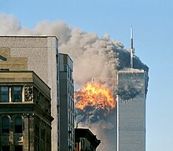
9/11 was a major insurance loss, but there were disputes over the World Trade Center's insurance policy.
Insurance policies can be complex and some policyholders may not understand all the fees and coverages included in a policy. As a result, people may buy policies on unfavorable terms. In response to these issues, many countries have enacted detailed statutory and regulatory regimes governing every aspect of the insurance business, including minimum standards for policies and the ways in which they may be advertised and sold.
For example, most insurance policies in the English language today have been carefully drafted in plain English; the industry learned the hard way that many courts will not enforce policies against insureds when the judges themselves cannot understand what the policies are saying. Typically, courts construe ambiguities in insurance policies against the insurance company and in favor of coverage under the policy.
Many institutional insurance purchasers buy insurance through an insurance broker. While on the surface it appears the broker represents the buyer (not the insurance company), and typically counsels the buyer on appropriate coverage and policy limitations, in the vast majority of cases a broker's compensation comes in the form of a commission as a percentage of the insurance premium, creating a conflict of interest in that the broker's financial interest is tilted toward encouraging an insured to purchase more insurance than might be necessary at a higher price. A broker generally holds contracts with many insurers, thereby allowing the broker to "shop" the market for the best rates and coverage possible.
Insurance may also be purchased through an agent. A tied agent, working exclusively with one insurer, represents the insurance company from whom the policyholder buys (while a free agent sells policies of various insurance companies). Just as there is a potential conflict of interest with a broker, an agent has a different type of conflict. Because agents work directly for the insurance company, if there is a claim the agent may advise the client to the benefit of the insurance company. Agents generally cannot offer as broad a range of selection compared to an insurance broker.
An independent insurance consultant advises insureds on a fee-for-service retainer, similar to an attorney, and thus offers completely independent advice, free of the financial conflict of interest of brokers or agents. However, such a consultant must still work through brokers or agents in order to secure coverage for their clients.

Limited consumer benefits
In the United States, economists and consumer advocates generally consider insurance to be worthwhile for low-probability, catastrophic losses, but not for high-probability, small losses. Because of this, consumers are advised to select high deductibles and to not insure losses which would not cause a disruption in their life. However, consumers have shown a tendency to prefer low deductibles and to prefer to insure relatively high-probability, small losses over low-probability, perhaps due to not understanding or ignoring the low-probability risk. This is associated with reduced purchasing of insurance against low-probability losses, and may result in increased inefficiencies from moral hazard.^{[75]}

Redlining
Main article: Redlining
Redlining is the practice of denying insurance coverage in specific geographic areas, supposedly because of a high likelihood of loss, while the alleged motivation is unlawful discrimination. Racial profiling or redlining has a long history in the property insurance industry in the United States. From a review of industry underwriting and marketing materials, court documents, and research by government agencies, industry and community groups, and academics, it is clear that race has long affected and continues to affect the policies and practices of the insurance industry.^{[76]}
In July 2007, the US Federal Trade Commission (FTC) released a report presenting the results of a study concerning credit-based insurance scores in automobile insurance. The study found that these scores are effective predictors of risk. It also showed that African-Americans and Hispanics are substantially overrepresented in the lowest credit scores, and substantially underrepresented in the highest, while Caucasians and Asians are more evenly spread across the scores. The credit scores were also found to predict risk within each of the ethnic groups, leading the FTC to conclude that the scoring models are not solely proxies for redlining. The FTC indicated little data was available to evaluate benefit of insurance scores to consumers.^{[77]} The report was disputed by representatives of the Consumer Federation of America, the National Fair Housing Alliance, the National Consumer Law Center, and the Center for Economic Justice, for relying on data provided by the insurance industry.^{[78]}
All states have provisions in their rate regulation laws or in their fair trade practice acts that prohibit unfair discrimination, often called redlining, in setting rates and making insurance available.^{[79]}
In determining premiums and premium rate structures, insurers consider quantifiable factors, including location, credit scores, gender, occupation, marital status, and education level. However, the use of such factors is often considered to be unfair or unlawfully discriminatory, and the reaction against this practice has in some instances led to political disputes about the ways in which insurers determine premiums and regulatory intervention to limit the factors used.
An insurance underwriter's job is to evaluate a given risk as to the likelihood that a loss will occur. Any factor that causes a greater likelihood of loss should theoretically be charged a higher rate. This basic principle of insurance must be followed if insurance companies are to remain solvent.^{[citation needed]} Thus, "discrimination" against (i.e., negative differential treatment of) potential insureds in the risk evaluation and premium-setting process is a necessary by-product of the fundamentals of insurance underwriting.^{[citation needed]} For instance, insurers charge older people significantly higher premiums than they charge younger people for term life insurance. Older people are thus treated differently from younger people (i.e., a distinction is made, discrimination occurs). The rationale for the differential treatment goes to the heart of the risk a life insurer takes: older people are likely to die sooner than young people, so the risk of loss (the insured's death) is greater in any given period of time and therefore the risk premium must be higher to cover the greater risk.^{[citation needed]} However, treating insureds differently when there is no actuarially sound reason for doing so is unlawful discrimination.

Insurance patents
 | This article needs to be updated. Please help update this article to reflect recent events or newly available information. (January 2018)
Further information: Insurance patent
New assurance products can now be protected from copying with a business method patent in the United States.
A recent example of a new insurance product that is patented is Usage Based auto insurance. Early versions were independently invented and patented by a major US auto insurance company, Progressive Auto Insurance (U.S. Patent 5,797,134) and a Spanish independent inventor, Salvador Minguijon Perez.^{[80]}
Many independent inventors are in favor of patenting new insurance products since it gives them protection from big companies when they bring their new insurance products to market. Independent inventors account for 70% of the new U.S. patent applications in this area.
Many insurance executives are opposed to patenting insurance products because it creates a new risk for them. The Hartford insurance company, for example, recently had to pay $80 million to an independent inventor, Bancorp Services, in order to settle a patent infringement and theft of trade secret lawsuit for a type of corporate owned life insurance product invented and patented by Bancorp.
There are currently about 150 new patent applications on insurance inventions filed per year in the United States. The rate at which patents have been issued has steadily risen from 15 in 2002 to 44 in 2006.^{[81]}
The first insurance patent to be granted was^{[82]} including another example of an application posted was.^{[83]} It was posted on 6 March 2009. This patent application describes a method for increasing the ease of changing insurance companies.^{[84]}

Insurance on demand
Insurance on demand (also IoD) is an insurance service that provides clients with insurance protection when they need, i.e. only episodic rather than on 24/7 basis as typically provided by traditional insurers (e.g. clients can purchase an insurance for one single flight rather than a longer-lasting travel insurance plan).

Insurance industry and rent-seeking
Certain insurance products and practices have been described as rent-seeking by critics.^{[citation needed]} That is, some insurance products or practices are useful primarily because of legal benefits, such as reducing taxes, as opposed to providing protection against risks of adverse events.

Religious concerns
Muslim scholars have varying opinions about life insurance. Life insurance policies that earn interest (or guaranteed bonus/NAV) are generally considered to be a form of riba (usury) and some consider even policies that do not earn interest to be a form of gharar (speculation). Some argue that gharar is not present due to the actuarial science behind the underwriting.^{[85][better source needed]} Jewish rabbinical scholars also have expressed reservations regarding insurance as an avoidance of God's will but most find it acceptable in moderation.^{[86]}
Some Christians believe insurance represents a lack of faith^{[87][88]} and there is a long history of resistance to commercial insurance in Anabaptist communities (Mennonites, Amish, Hutterites, Brethren in Christ) but many participate in community-based self-insurance programs that spread risk within their communities.^{[89][90][91]}

See also
- Agent of record
- DIRTI 5
- Earthquake loss
- Financial adviser
- Tertiary sector of the economy (sector of the economy to which insurance belongs)
- Geneva Association (the International Association for the Study of Insurance Economics)
- Global assets under management
- Insurance broker
- Insurance fraud
- Insurance Hall of Fame
- Insurance law
- Insurance Premium Tax (UK)
- Loss-control consultant
- Reinsurance
- Intergovernmental Risk Pool
- The Invisible Bankers: Everything the Insurance Industry Never Wanted You to Know (book)
- List of finance topics
- List of insurance topics
- List of United States insurance companies
- Social security
- Uberrima fides
- Universal health care
- Welfare state
Country-specific articles:
- Insurance in Australia
- Insurance in India
- Insurance in the United States
- Insurance in the United Kingdom
- Insurance industry in China

Notes
  - ^ However, the bankruptcy of the insured with a "reimbursement" policy does not relieve the insurer. Certain types of insurance, e.g., workers' compensation and personal automobile liability, are subject to statutory requirements that injured parties have direct access to coverage.

References

Citations
  - ^ Novi Dewan. Indian Life and Health Insurance Industry: A Marketing Approach. Springer Science & Business Media. p. 2.
  - ^ See, e.g., Vaughan, E. J., 1997, Risk Management, New York: Wiley.
  - ^ Hammurabi (1903). Translated by Sommer, Otto. "Code of Hammurabi, King of Babylon". Records of the Past. Washington, DC: Records of the Past Exploration Society. 2 (3): 86. Retrieved 20 June 2021. 238. If a skipper wrecks ... money to its owner.
  - ^ Hammurabi (1904). "Code of Hammurabi, King of Babylon" (PDF). Liberty Fund. Translated by Harper, Robert Francis (2nd ed.). Chicago: University of Chicago Press. p. 85. Retrieved 20 June 2021. §238. If a boatman sink ... one-half its value.
  - ^ Hammurabi (1910). "Code of Hammurabi, King of Babylon". Avalon Project. Translated by King, Leonard William. New Haven, CT: Yale Law School. Retrieved 20 June 2021. 238. If a sailor wreck ... its value in money.
  - ^ "The Civil Law, Volume I, The Opinions of Julius Paulus, Book II". Constitution.org. Translated by Scott, S.P. Central Trust Company. 1932. Retrieved 16 June 2021. TITLE VII. ON THE LEX RHODIA. It is provided by the Lex Rhodia that if merchandise is thrown overboard for the purpose of lightening a ship, the loss is made good by the assessment of all which is made for the benefit of all.
  - ^ Jump up to:ª ^{b} ^{c} The Documentary History of Insurance, 1000 B.C.–1875 A.D. Newark, NJ: Prudential Press. 1915. pp. 5–6. Retrieved 15 June 2021.
  - ^ "Duhaime's Timetable of World Legal History". Duhaime's Law Dictionary. Archived from the original on 24 June 2021. Retrieved 9 April 2016.
  - ^ The Documentary History of Insurance, 1000 BC–1875 AD. Newark, NJ: Prudential Press. 1915. pp. 6–7. Retrieved 15 June 2021.
  - ^ Tapas Kumar Parida, Debashis Acharya (2016). The Life Insurance Industry in India: Current State and Efficiency. Springer. p. 2. ISBN 9789811022333.
  - ^ Jump up to:ª ^{b} ^{c} Lewis, Charlton; Ingram, Thomas (1911). "Insurance" . In Chisholm, Hugh (ed.). Encyclopædia Britannica. Vol. 14 (11th ed.). Cambridge University Press. pp. 657–658.
  - ^ J. Franklin, The Science of Conjecture: Evidence and Probability Before Pascal (Baltimore: Johns Hopkins University Press, 2001), 274-277.
  - ^ Dickson (1960): 4
  - ^ Dickson (1960): 7
  - ^ Palmer, Sarah (October 2007). "Lloyd, Edward (c.1648–1713)". Oxford Dictionary of National Biography. Vol. 1 (online ed.). Oxford University Press. doi:10.1093/ref:odnb/16829. Archived from the original on 15 July 2011. Retrieved 16 February 2011. (Subscription or UK public library membership required.)
  - ^ Anzovin, Steven, Famous First Facts 2000, item # 2422, H. W. Wilson Company, ISBN 0-8242-0958-3 p. 121 The first life insurance company known of record was founded in 1706 by the Bishop of Oxford and the financier Thomas Allen in London, England. The company, called the Amicable Society for a Perpetual Assurance Office, collected annual premiums from policyholders and paid the nominees of deceased members from a common fund.
  - ^ Amicable Society, The charters, acts of Parliament, and by-laws of the corporation of the Amicable Society for a perpetual assurance office, Gilbert and Rivington, 1854, p. 4
  - ^ "Today and History:The History of Equitable Life". 26 June 2009. Retrieved 16 August 2009.
  - ^ "Encarta: Health Insurance". Archived from the original on 17 July 2009.
  - ^ F. L. Wiswall (2019), A Brief History (PDF), Comite Maritime International, archived from the original (PDF) on 14 August 2019
  - ^ Dr. Ruth Frendo, Archivist and Records Manager at the Institute of Advanced Legal Studies (PDF), ILA
  - ^ Jump up to:ª ^{b} E. P. Hennock, The Origin of the Welfare State in England and Germany, 1850–1914: Social Policies Compared (2007)
  - ^ Hermann Beck, Origins of the Authoritarian Welfare State in Prussia, 1815-1870 (1995)
  - ^ The Cabinet Papers 1915-1982: National Health Insurance Act 1911. The National Archives, 2013. Retrieved 30 June 2013.
  - ^ Bentley B. Gilbert, British social policy, 1914-1939 (1970)
  - ^ "About us", the Global Federation of Insurance Associations.
  - ^ Gollier C. (2003). To Insure or Not to Insure?: An Insurance Puzzle. The Geneva Papers on Risk and Insurance Theory.
  - ^ This discussion is adapted from Mehr and Camack's "Principles of Insurance", 6th edition, 1976, pp 34 – 37.
  - ^ Irish Brokers Association. Insurance Principles Archived 11 April 2009 at the Wayback Machine.
  - ^ Jump up to:ª ^{b} C. Kulp & J. Hall, Casualty Insurance, Fourth Edition, 1968, page 35
  - ^ Menapace, Michael (10 March 2019). "Losses From Malware May Not Be Covered Due To Your Policy's Hostile Acts Exclusion". The National Law Review. Retrieved 25 April 2019.
  - ^ Stock, Rob (19 March 2019). "Insurers waive terrorism exclusions for Christchurch shooting victims". Stuff. Retrieved 25 April 2019.
  - ^ California State PTA (2019), Insurance Guide, revised April 2019, accessed 19 December 2020
  - ^ Peter Zweifel; Roland Eisen (24 February 2012). Insurance Economics. Springer Science & Business Media. pp. 268–. ISBN 978-3-642-20547-7.
  - ^ Kunreuther H. (1996). Mitigating Disaster Losses Through Insurance Archived 20 June 2010 at the Wayback Machine. Journal of Risk and Uncertainty.
  - ^ Brown RL. (1993). Introduction to Ratemaking and Loss Reserving for Property and Casualty Insurance. ACTEX Publications.
  - ^ Feldstein, Sylvan G.; Fabozzi, Frank J. (2008). The Handbook of Municipal Bonds. Wiley. p. 614. ISBN 978-0-470-10875-8. Retrieved 8 February 2010.
  - ^ What we do ABI Archived 7 September 2009 at the Wayback Machine. Abi.org.uk. Retrieved on 18 July 2013.
  - ^ Feinman, Jay M. (2010). Delay, Deny, Defend : Why Insurance Companies Don't Pay Claims and What You Can Do About It. Portfolio. p. 16. ISBN 9781101196281. OCLC 883320058.
  - ^ Weir, Audrey A.; Hampton, John H. (March 1995). "Essentials of Risk Management and Insurance". The Journal of Risk and Insurance. 62 (1): 157. doi:10.2307/253703. ISSN 0022-4367. JSTOR 253703.
  - ^ Fitzpatrick, Sean, Fear is the Key: A Behavioral Guide to Underwriting Cycles, 10 Conn. Ins. L.J. 255 (2004).
  - ^ Berger, Allen N.; Cummins, J. David; Weiss, Mary A. (October 1997). "The Coexistence of Multiple Distribution Systems for Financial Services: The Case of Property-Liability Insurance" (PDF). Journal of Business. 70 (4): 515–46. doi:10.1086/209730. Archived from the original (PDF) on 19 September 2000. (online draft Archived 22 June 2010 at the Wayback Machine)
  - ^ Insurance Information Institute. "Business insurance information. What does a businessowners policy cover?". Retrieved 9 May 2007.
  - ^ "Builder's Risk Insurance: Specialized Coverage for Construction Projects". Adjusting Today. Adjusters International. Retrieved 16 October 2009.
  - ^ Jump up to:ª ^{b} ^{c} Ali, Williams; Abdulai, Awudu; Mishra, Ashok K. (6 October 2020). "Recent Advances in the Analyses of Demand for Agricultural Insurance in Developing and Emerging Countries". Annual Review of Resource Economics. Annual Reviews. 12 (1): 411–430. doi:10.1146/annurev-resource-110119-025306. ISSN 1941-1340. S2CID 225173762.
  - ^ US application 20,060,287,896 "Method for providing crop insurance for a crop associated with a defined attribute"
  - ^ Born, Lorna; Spillane, Charles; Murray, Una (20 December 2018). "Integrating gender into index-based agricultural insurance: a focus on South Africa". Development in Practice. 29 (4): 409–423. doi:10.1080/09614524.2018.1556608. hdl:10568/102499. ISSN 0961-4524. S2CID 158288729.
  - ^ Insurance Information Institute. "What is homeowners insurance?". Retrieved 11 November 2008.
  - ^ Miller, Nathan. "Insurance For Landlords: Protecting Your Investment". Forbes. Retrieved 27 October 2019.
  - ^ Seaman, S. M.; Kittredge, C. (Spring 1997). "Excess Liability Insurance: Law and Litigation". Tort & Insurance Law Journal. 32 (3): 653–714. JSTOR 25763179.
  - ^ Types of Business Insurance | SBA.gov Archived 29 June 2010 at the Wayback Machine. Business.gov. Retrieved on 18 July 2013.
  - ^ Breathe Insurance Brokers Ltd., Plant Hire Insurance, accessed 1 November 2020
  - ^ Blitz, Gary; Schoenberg, Daniel. "Private REITs: Facilitating a Cleaner Exit with Tax Insurance". Transaction Advisors. ISSN 2329-9134.
  - ^ Margaret E. Lynch, Editor, "Health Insurance Terminology", Health Insurance Association of America, 1992, ISBN 1-879143-13-5
  - ^ Lencsis, Peter M. (1998). Workers compensation : a reference and guide. Westport, Connecticut: Quorum Books. pp. 75–76. ISBN 9781567201741. Retrieved 30 December 2020.
  - ^ Jump up to:ª ^{b} Teale, John (2013). Insurance and Risk Management. Sydney, Australia: CCH/Wolters Kluwer. p. 40. ISBN 978-1-922042-88-0. Risk retention occurs when an individual or business firm retains all or part of a given risk. Risk retention is generally appropriate when the frequency of loss is low and its severity is low. Risk retention can also be appropriate for high-frequency, low-severity risks where potential losses are of low value. Risk retention can be either active or passive. Active risk retention refers to the situation where an individual recognises the risk and deliberately elects to retain all or part of that risk. This may be achieved by a firm or individual electing to carry the first $500 of any loss as a policy excess (or deductible). An excess (or deductible) is a provision in the policy whereby a specified amount is deducted from the loss payment otherwise payable to the insured. Alternatively, the risk manager may decide to self-insure the entire risk thereby saving what they would have paid as an insurance premium. Active risk retention is used because a policy excess will eliminate small policy claims and the administrative expense of adjusting these claims resulting in reduced premiums. It is also used where insurance is either unavailable or too expensive.
  - ^ Marcos Antonio Mendoza, "Reinsurance as Governance: Governmental Risk Management Pools as a Case Study in the Governance Role Played by Reinsurance Institutions", 21 Conn. Ins. L.J. 53, 55-60 (2014) https://ssrn.com/abstract=2573253
  - ^ Jump up to:ª ^{b} "The Industry Handbook: The Insurance Industry". Investopedia. 7 January 2004. Archived from the original on 7 September 2018. Retrieved 28 November 2018.
  - ^ David Ransom (2011). IF1 – Insurance, Legal & Regulatory. Chartered Insurance Institute. p. 2/5. ISBN 978-0-85713-094-5.
  - ^ Ross, Sean. "The Business Model of Reinsurance Companies". Investopedia. Retrieved 26 August 2021.
  - ^ Liberto, Daniel. "Lloyd's Organizations". Investopedia. Retrieved 26 August 2021.
  - ^ "Admitted Insurance". investopedia.com. 29 January 2018. Retrieved 15 January 2019.
  - ^ Jump up to:ª ^{b} ^{c} Federal Insurance Office (September 2021). Annual Report on the Insurance Industry (PDF). Washington, D.C.: U.S. Department of the Treasury. pp. 53–54.
  - ^ Randall S. (1998). "Insurance Regulation in the United States: Regulatory Federalism and the National Association of Insurance Commissioners". Archived 11 May 2011 at the Wayback Machine. Florida State University Law Review.
  - ^ J Schacht, B Foudree. (2007). "A Study on State Authority: Making a Case for Proper Insurance Oversight". Archived 10 May 2011 at the Wayback Machine. NCOIL
  - ^ C. J. Campbell, L. Goldberg, A. Rai. (2003). "The Impact of the European Union Insurance Directives on Insurance Company Stocks" Archived 23 November 2017 at the Wayback Machine. The Journal of Risk and Insurance.
  - ^ Haurant S. (2005). "FSA takes on insurance regulation". The Guardian.
  - ^ Adams J. (2012). "The impact of changing regulation on the insurance industry" Archived 5 October 2018 at the Wayback Machine. Financial Services Authority.
  - ^ "Reforming UK insurance contract law". Lloyd's. 30 August 2012. Archived from the original on 14 January 2013.
  - ^ "Insurance Law of the People's Republic of China – 1995". Lehman, Lee & Xu.
  - ^ Thomas JE. (2002). "The role and powers of the Chinese insurance regulatory commission in the administration of insurance law in China". Archived 11 May 2011 at the Wayback Machine. Geneva Papers on Risk and Insurance.
  - ^ "Insurers' websites receive first marks | Банк России". www.cbr.ru. Retrieved 21 May 2018.
  - ^ Libatique, Roxanne. "Senior broker on the importance of reducing clients' risk exposure". www.insurancebusinessmag.com. Retrieved 5 November 2020.
  - ^ O'Hare, Paul; White, Iain; Connelly, Angela (1 September 2015). "Insurance as maladaptation: Resilience and the 'business as usual' paradox" (PDF). Environment and Planning C: Government and Policy. 34 (6): 1175–1193. doi:10.1177/0263774X15602022. ISSN 0263-774X. S2CID 155016786.
  - ^ Schindler, R. M. (1994). Consumer Motivation for Purchasing Low-Deductible Insurance. In Marketing and Public Policy Conference Proceedings, Vol. 4, D. J. Ringold (ed.), Chicago, IL: American Marketing Association, 147–155.
  - ^ Gregory D. Squires (2003), "Racial Profiling, Insurance Style: Insurance Redlining and the Uneven Development of Metropolitan Areas", Journal of Urban Affairs Volume 25 Issue 4 pp. 391–410, November 2003
  - ^ Credit-Based Insurance Scores: Impacts on Consumers of Automobile Insurance, Federal Trade Commission (July 2007)
  - ^ Consumers Dispute FTC Report on Insurance Credit Scoring www.consumeraffairs.com (July 2007)
  - ^ Insurance Information Institute. "Issues Update: Regulation Modernization". Retrieved 11 November 2008.
  - ^ EP 0700009, Minguijon Perez, Salvador, "Individual evaluation system for motorcar risk", published 1996-03-06
  - ^ "(Source: Insurance IP Bulletin, December 15, 2006)". Archived from the original on 27 September 2007.
  - ^ US 6922720, Cianciarulo, Krys; Cardot, Stephen & Weiseth, Thomas, "Systems and methods for insuring data over the internet", published 2005-07-26, assigned to Portogo Inc.
  - ^ US patent 20090055227, Bakos, Thomas L., "Risk Assessment Company", published 2009-02-26
  - ^ Bakos, Nowotarski, "An Experiment in Better Patent Examination", Insurance IP Bulletin, 15 December 2008.
  - ^ "Life Insurance from an Islamic Perspective". Archived from the original on 22 May 2010. Retrieved 18 January 2010.
  - ^ "Jewish Association for Business Ethics – Insurance". Archived from the original on 19 April 2010. Retrieved 25 March 2008.
  - ^ "Insurance: A Christian Perspective - Faith in Business". www.faith-in-business.org. Retrieved 5 January 2021.
  - ^ "Should Christians Buy Insurance?". Crosswalk.com. Retrieved 25 December 2018.
  - ^ Rubinkam, Michael (5 October 2006). "Amish Reluctantly Accept Donations". The Washington Post. Retrieved 25 March 2008.
  - ^ Donald B. Kraybill (1989). The riddle of Amish culture. Baltimore : Johns Hopkins University Press. p. 277. ISBN 978-0-8018-3682-4.
  - ^ "Global Anabaptist Mennonite Encyclopedia Online, Insurance". Retrieved 18 January 2010.

Sources[edit]
- Dickson, P. G. M. (1960). The Sun Insurance Office 1710–1960: The History of Two and a half Centuries of British Insurance. London, England: Oxford University Press. p. 324.

Further reading[edit]
- Einav, Liran; Finkelstein, Amy; Fisman, Ray (2023). Risky Business: Why Insurance Markets Fail and What to Do About It. Yale University Press. ISBN 978-0-300-26855-3.
- Insurance Law and Regulation: Cases and Materials by Kenneth S. Abraham. New York, N.Y : Foundation Press, 2005. ISBN 9781587788826

External links[edit]
Insuranceat Wikipedia's sister projects
- Definitions from Wiktionary
- Media from Commons
- News from Wikinews
- Quotations from Wikiquote
- Texts from Wikisource
- Textbooks from Wikibooks
- Resources from Wikiversity
- Congressional Research Service (CRS) Reports regarding the US Insurance industry
- Federation of European Risk Management Associations
- Insurance at Curlie
- Insurance Bureau of Canada
- Insurance Information Institute
- National Association of Insurance Commissioners
- The British Library – finding information on the insurance industry (UK focus)



Best car insurance comparison sites 2023

We compare eight websites to see which is the best for ease of use and low prices
by: Toby Knight
3 Mar 2023

9
Whether you own a petrol, diesel, hybrid, or electric vehicle and no matter if it’s a supercar or an SUV, you need car insurance. So it’s important that you’ve got the right cover at the right price.
- 
Top 10 best first cars for new drivers 2024
For a long time, online comparison sites have provided a range of quotes. Over the years, they have become more sophisticated, enabling you to tailor a policy to your needs and taking the stress out of getting insurance. And because it’s so competitive, many sites offer rewards if you take a policy with one of their insurers.
But which is the best? We’ve compared eight to decide which you should use to find the right cover.

How we tested them
We ran an insurance quote for a 40-year-old father of two from Oxford, driving the UK’s biggest-selling car last year, the Nissan Qashqai, keeping all of the factors the same throughout the quote process.
We rated sites for their ease of use, wanting forms to be simple to fill in, looking for advice to be given on any jargon, and for it not to take all afternoon. Once completed, we compared prices – both the lowest and the total number of reasonably priced quotes.

Verdict
Our winner this year is a new entrant. Money Saving Expert uses the great pricing from MoneySuperMarket and combines it with incredibly useful tips and analysis of your quote to help you get the lowest price.
- Money Saving Expert
- Compare The Market
- MoneySuperMarket

Reviews

Money Saving Expert
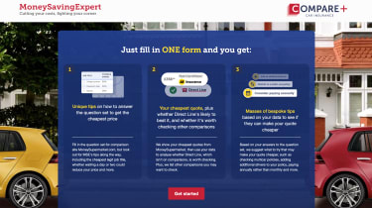9
- Website: moneysavingexpert.com
- Rating: 5 stars
The site backed by Martin Lewis – the UK’s go-to money-saving expert – has long offered advice on how to reduce your insurance premium. Now it’s also got a built-in comparison tool with handy tips as you build your quote.
For example, when typing your job title, it’ll offer legal alternatives that will save you money and tell you how much. It’s the best innovation in this market for years. MoneySuperMarket powers the quote engine, so its prices were the lowest here. Plus you benefit from price matching if you find cheaper elsewhere.

Compare the Market
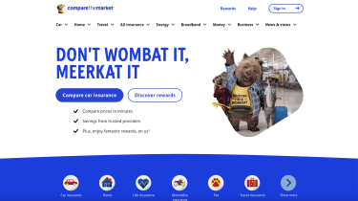9
- Website: comparethemarket.com
- Rating: 4.5 stars
Our long-standing winner Compare The Market is still ahead of most rivals. It’s easy to use and gives useful hints and tips on what each field means. A lot of the data auto-completes to speed up the process, too.
The number of results returned was the highest on test, and the majority of them were competitively priced. Its lowest was just a fraction more expensive than the best price we found. And don’t forget the rewards – take out a policy and you’ll get two-for-one movies or meals.

MoneySuperMarket
9
- Website: moneysupermarket.com
- Rating: 4.5 stars
We’ve mentioned MoneySuperMarket already because it’s the site that does the heavy lifting, searching for quotes for our test winner.
The interface on its own site is clean cut, with a tick system to show you when you’ve completed sections. The results page is one of the best around, with the ability to find out more about each quote and amend extras. And as with our winner, it offers a price match promise: it’ll match any quote you can find cheaper elsewhere and give you a voucher for your trouble.

Confused
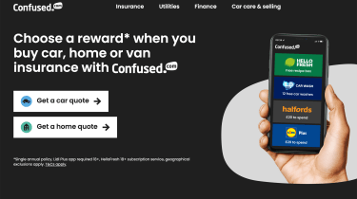9
- Website: confused.com
- Rating: 4 stars
Rated 'Excellent'  Trustpilot
Confused is another one of the biggest names in the market and it’s very similar to the highest-rated sites in this test for usability. There’s an easy-to-fill-in form on the website, plus helpful tips as you make your way through it.
That all means that it’s super-quick for anyone to pull a quote together. But what is a little disappointing is that the results it returned for us were some of the most expensive in this test – and that explains why it falls behind its rivals. On the other hand, if you do go on to take out a policy, you can choose from a range of rewards, including £20 to spend at Halfords.

Go.Compare
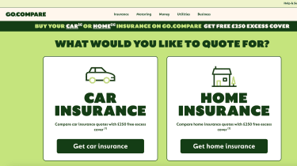9
- Website: gocompare.com
- Rating: 4 stars
Go.Compare is one of the big names in the market, thanks to its loud and proud advertising campaigns. It’s on a par with Confused or Compare The Market for usability, with an easy process.
A nice touch is that it shows you which questions will impact your premium, although unlike our winner, it doesn’t give any advice on what may help to cut the cost. You can also input your existing renewal price so insurers can match or better it.
The lowest policy was a little higher than the best, but there was a range of options at competitive prices. The sweetener here is that you’ll get a £250 excess if you take out a policy.

uSwitch
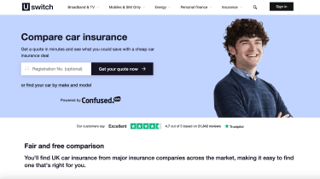9
- Website: uswitch.com
- Rating: 3.5 stars
uSwitch is a great resource for changing your contract across a whole wealth of products. Its car insurance tool is powered by Confused, and the process is simple, with a very basic design.
Because of the partnership with Confused, your final quotes will be similar, if not identical, to the results from that site. That wasn’t great for us because they were some of the more expensive.
Previously, we couldn’t find anything like the rewards other providers offer on uSwitch, but now you can take advantage of the Confused rewards even if you use uSwitch. We’re not sure why you wouldn’t just use Confused to start with, though.

Quotezone
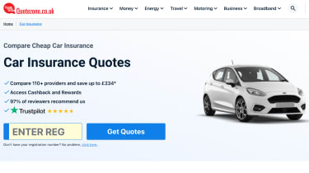9
- Website: quotezone.co.uk
- Rating: 3.5 stars
Quotezone has revamped its policy-building process with a new design that replaces the old basic form. It makes the whole journey much smoother, but still includes the handy tips on the questions that impact your premium.
The results page is really clear and neatly laid out, and Quotezone returned a large number of quotes from a variety of providers. Unfortunately, the lowest price was considerably higher than the best performers. It’s a shame, too, that one of our favourite parts of the old Quotezone site – the ability to compare four policies at once – seems to have been removed as part of the redesign.

Asda
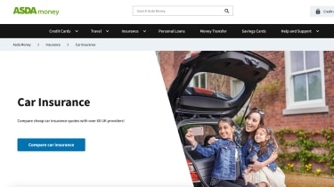9
- Website: carinsurance.asda.com
- Rating: 3 stars
The final spot in our 2023 rankings goes to a new entrant. We’ve previously tested Asda sites for the supply of online tyres and now it offers car insurance, too.
The process is the most basic of all the sites in this test, because there are fewer visuals, which makes it more of a form-filling exercise than a user-friendly click through. But what surprised us most, especially given the fact that the Asda brand is normally associated with budget products and services, was that the results were the most expensive in this test.
Let’s hope the company makes some improvements before the next time we test insurance comparison sites.
Want to make the biggest savings? Check out the cheapest cars to insure in the UK...

Money Saving Expert
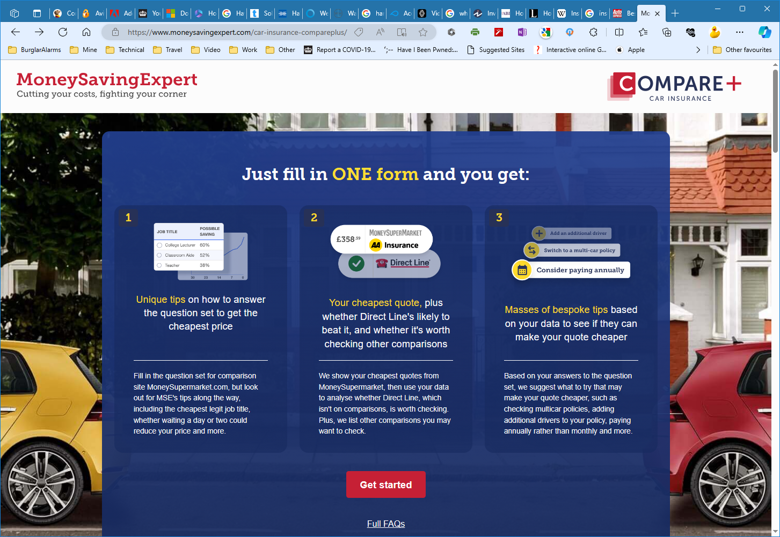
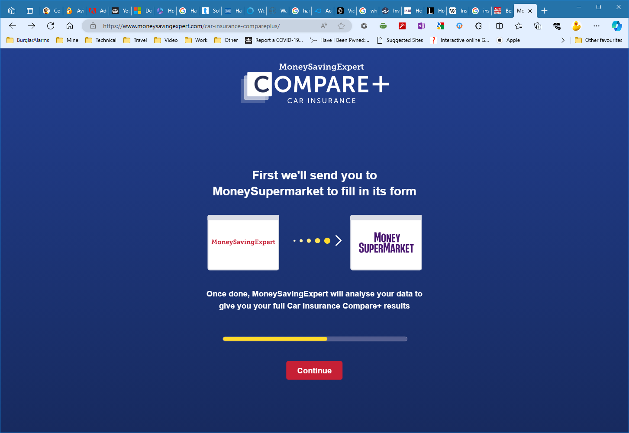
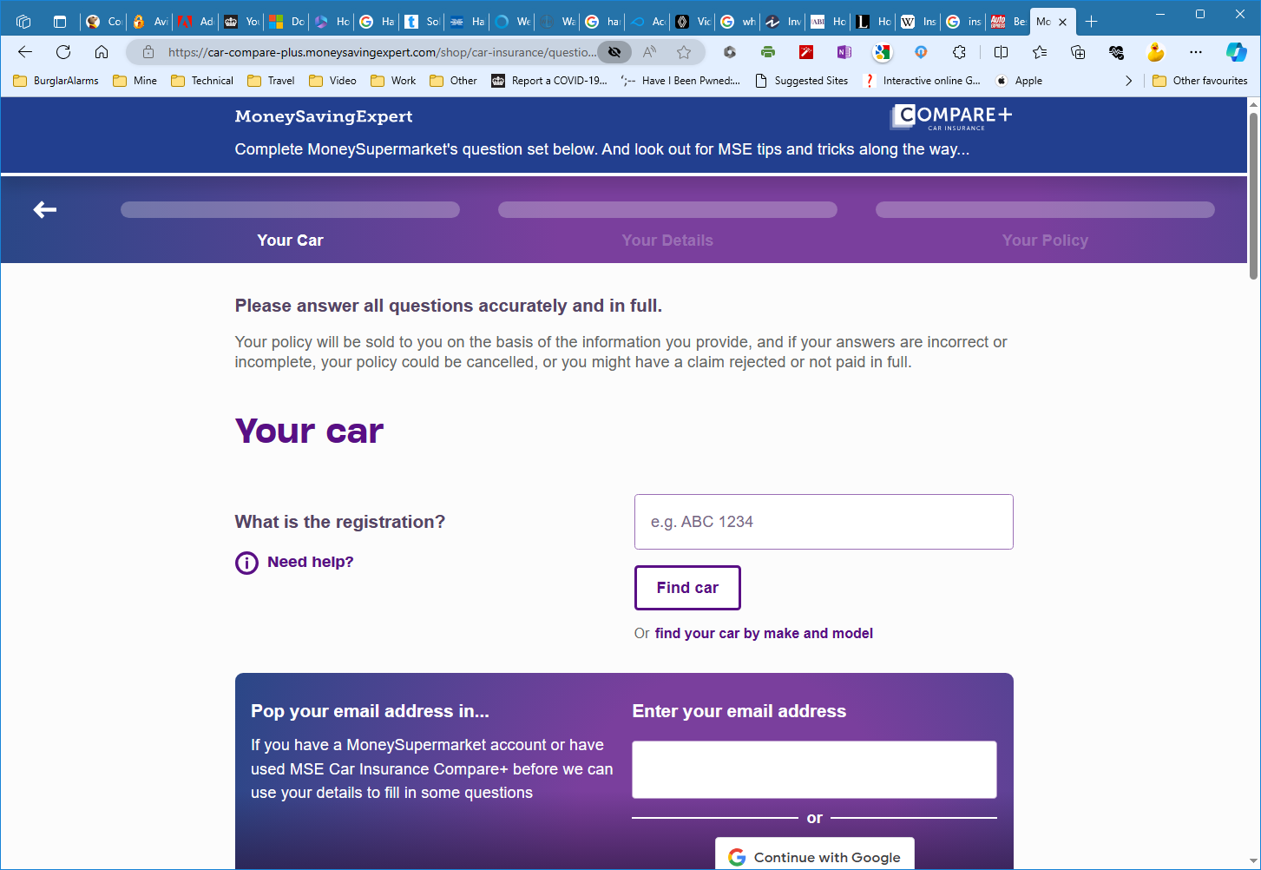
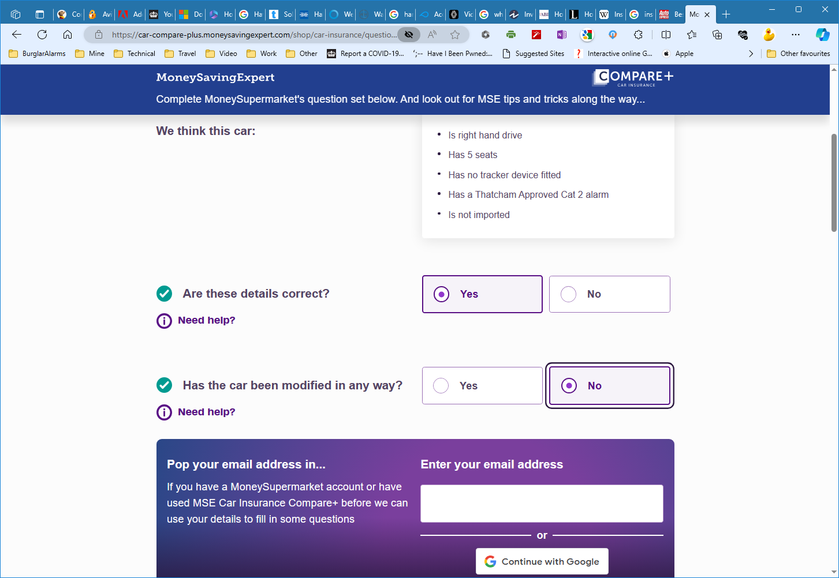
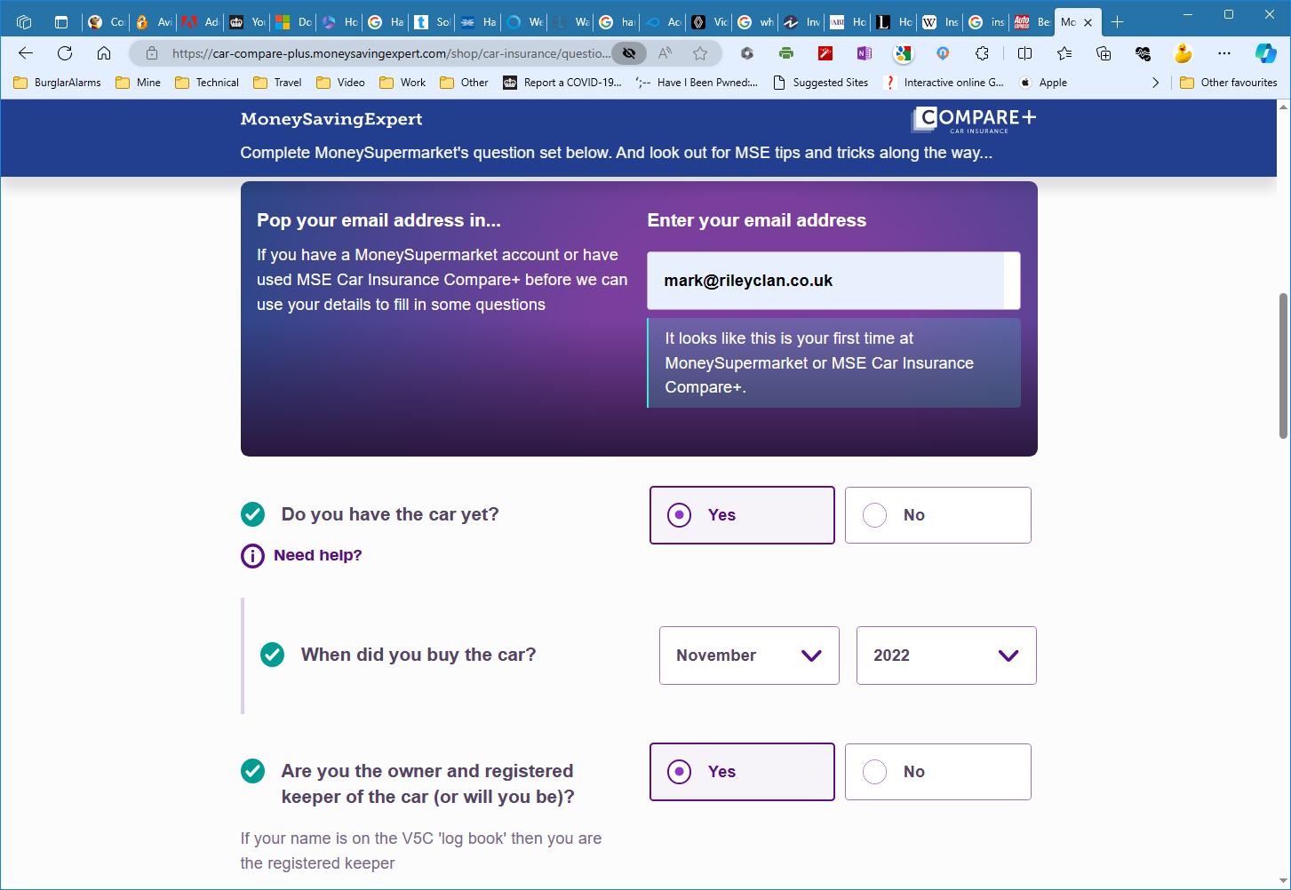
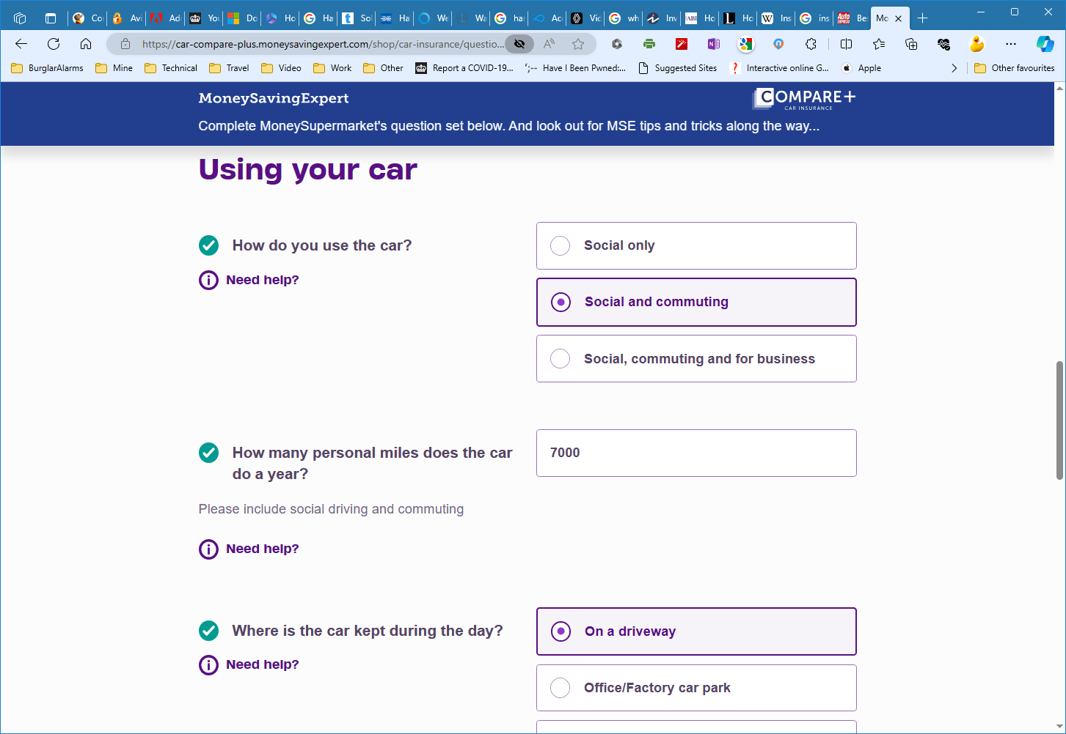
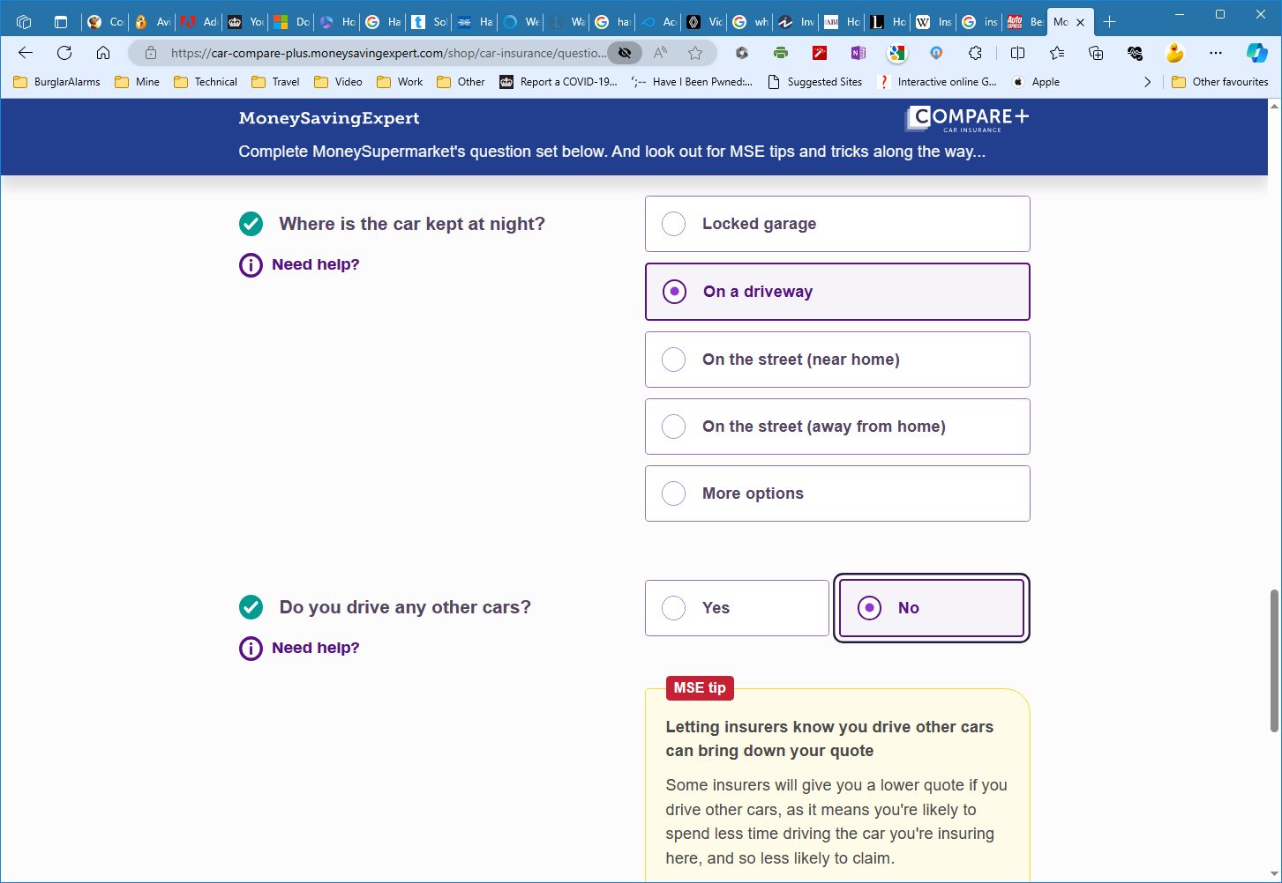
Then press continue button.
