# 17 Best Free Photo Editing Software for Windows PC in 2023



Are you tired of scrolling through social media and feeling envious of others' amazingly beautiful photos? Don't let a lack of photography experience or editing knowledge hold you back. **With the right free photo editing software, you can transform your pictures into works of art without spending a fortune**.

**We've done the research and gathered a list of the top 17 best free photo editing tools for Windows PC in 2023.** These software options range from beginner-friendly to advanced, allowing you to edit your pictures to your heart's desire. So why wait? Start sharing your memories on social media with confidence and join the photo editing revolution today!

* [**Snapshot of Our Top 3 Free Photo Editing Software**](https://www.cyberlink.com/prog/learning-center/html/12719/PDR19-YouTube-126_Free_Photo_Editing_Win/PDR19-YouTube-126_Free_Photo_Editing_Win.jsp)
* [**How to Choose the Best Free Photo Editing Software**](https://www.cyberlink.com/prog/learning-center/html/12719/PDR19-YouTube-126_Free_Photo_Editing_Win/PDR19-YouTube-126_Free_Photo_Editing_Win.jsp)
* [**How We Test the Free Photo Editing Software on Our List**](https://www.cyberlink.com/prog/learning-center/html/12719/PDR19-YouTube-126_Free_Photo_Editing_Win/PDR19-YouTube-126_Free_Photo_Editing_Win.jsp)
* [**17 Best Free Photo Editing Software for Windows PC in 2023**](https://www.cyberlink.com/prog/learning-center/html/12719/PDR19-YouTube-126_Free_Photo_Editing_Win/PDR19-YouTube-126_Free_Photo_Editing_Win.jsp)
* [**Best Free Photo Editing Software Comparison Chart**](https://www.cyberlink.com/prog/learning-center/html/12719/PDR19-YouTube-126_Free_Photo_Editing_Win/PDR19-YouTube-126_Free_Photo_Editing_Win.jsp)
* [**How to Edit Pictures**](https://www.cyberlink.com/prog/learning-center/html/12719/PDR19-YouTube-126_Free_Photo_Editing_Win/PDR19-YouTube-126_Free_Photo_Editing_Win.jsp)
* [**Download the Best Photo Editing Software for Free**](https://www.cyberlink.com/prog/learning-center/html/12719/PDR19-YouTube-126_Free_Photo_Editing_Win/PDR19-YouTube-126_Free_Photo_Editing_Win.jsp)
* [**Best Free Photo Editing Software FAQ**](https://www.cyberlink.com/prog/learning-center/html/12719/PDR19-YouTube-126_Free_Photo_Editing_Win/PDR19-YouTube-126_Free_Photo_Editing_Win.jsp)

## Snapshot of Our Top 3 Free Photo Editing Software

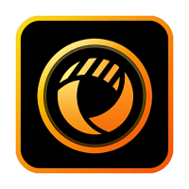

#### 1. PhotoDirector Essential - Best Overall

PhotoDirector Essential is the best free photo editing software available. It is an **all-in-one tool for organizing and editing images with an incredible mix of tools and unique features**. Although it offers advanced features, PhotoDirector Essential remains very easy to use, with a variety of AI-powered tools to apply complicated-looking edits with a single click. Use AI to remove photobombers from images, restore blurry photos, or apply facial retouching to cherished portraits. PhotoDirector also has guided edits and plenty of tutorials to provide extra help when editing images. [Detailed Review >](https://www.cyberlink.com/prog/learning-center/html/12719/PDR19-YouTube-126_Free_Photo_Editing_Win/PDR19-YouTube-126_Free_Photo_Editing_Win.jsp)

[**Edit a Photo for Free**](https://www.cyberlink.com/prog/trial/user-add.do?source=blog&ProductId=211)  
**Secure Download**

#### 2. MyEdit Image Editing Tool - Best for Online Editing

MyEdit is a free photo editing software found online. **It is easy to access and use and has AI-powered tools for fast and accurate results.** [Detailed Review >](https://www.cyberlink.com/prog/learning-center/html/12719/PDR19-YouTube-126_Free_Photo_Editing_Win/PDR19-YouTube-126_Free_Photo_Editing_Win.jsp)

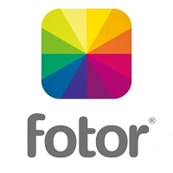

#### 3. Fotor - Best for Color Adjustment

Fotor is one of the **best free photo editing software for color adjustments**. It has a variety of color adjustments and color effects and is simple enough for first-time users to edit pictures with ease. [Detailed Review >](https://www.cyberlink.com/prog/learning-center/html/12719/PDR19-YouTube-126_Free_Photo_Editing_Win/PDR19-YouTube-126_Free_Photo_Editing_Win.jsp)

## How to Choose the Best Free Photo Editing Software

We’ve narrowed the field of suitable programs you can use to edit pictures, but how do you choose the very best free photo editing software for your needs? Below we have listed a few things to look out for in a free photo editor:

**Overall Features**

More is not always better. If you simply need free photo editing software to rotate and crop images, robust software with thousands of tools and design assets would be unnecessary. On the flip side, if you like to edit pictures with different filters and effects, you want free photo editing software that comes with those capabilities. The free photo editors on our list cover every type of need when it comes to editing images, whether you need social-media-friendly templates, layer editing, text tools, or only the most basic tools. Explore the features for each to make sure the one you choose allows you to edit pictures the way you want.

**Free Features**

Of the free photo editing software on our list, some are completely free, some offer slightly pared-back free versions, and others are intended more as “try before you buy.” If you need a free photo editor, make sure the tools and features you use the most to edit pictures are available in the free version. If you are testing different platforms with the intention of purchasing in the future, make sure the premium version is within your budget before you spend time learning the free photo editing software.

**Skill Level**

It’s important to choose the best free photo editing software for your skill level. Even if you have aspirations of using professional software to edit pictures, you need to start with a tool that is beginner-friendly. Otherwise, you could spend months trying to become familiar with a program and give up on your dreams of editing images in frustration. And if you have more experience editing images, don’t settle for a program that only offers easy, one-click solutions that allow little creative control.

## How We Test the Free Photo Editing Software on Our List

Why trust our opinion on the best free photo editing software? Below we discuss how we tested and ranked software to find the 17 best free photo editors.

**Test Key Features**

We edit pictures using all the key features of the software we review. We test the basic features found in every free photo editing software, so we can do a direct comparison. Then we try editing images with the tools that make the software unique.

**Compare Versions**

When we test free photo editing software, we compare the free and premium versions to see what is included and what is reserved for only paid subscribers.

**Analyze Reviews**

We read as many critic reviews and user reviews as we can to get a good idea of how others view the free photo editing software. This helps us verify our tests. We use reviews from trusted sites to compile our rankings of the best free photo editing software.

## 17 Best Free Photo Editing Software for Windows PC in 2023

### 1. PhotoDirector Essential - Best Overall

### 

**Pros** 

* **Easy to Use features for beginners:**Photo editing software with beginner-friendly features for intuitive and effortless editing.
* **Excellent photo management tools:**Organize and manage photos efficiently with photo management tools.
* **Low learning curve:**Quickly achieve professional-looking results with a low learning curve in this free photo editing software.

**Cons** 

* **Stock libraries only available in premium version:**Access to stock libraries may require upgrading to the premium version of the software.

**Key Features**

* **AI-powered tools**: Automatically enhance photos with AI-powered tools for professional-looking results with ease.
* **Photo retouching**: Reshape, repair, and enhance your complexion, figure, and overall appearance.
* [**Photo animations**](https://www.cyberlink.com/blog/photo-editing-best-software/248/how-to-animate-photos)**:** Create fun and creative animations with your photos using incredibly easy-to-use photo tools.
* **Automatic slideshow creator**: Quickly create dynamic slideshows with just a few clicks.

**Compatibility:** [Windows](https://www.cyberlink.com/prog/trial/user-add.do?source=blog&ProductId=211&ostype=Windows), [Mac](https://www.cyberlink.com/prog/trial/user-add.do?source=blog&ProductId=211&ostype=Windows)

[**PCMag**](https://www.pcmag.com/reviews/cyberlink-photodirector)**Rating:**4/5

**Beginner-Friendly Tools:** 5/5

**Price:**[**Free**](https://www.cyberlink.com/prog/trial/user-add.do?source=blog&ProductId=211&ostype=Windows)  
*\*Premium subscription available for $3.33/month*

**Who It’s For**

PhotoDirector Essential is the best free photo editing software because it **empowers creators of all experience levels to edit pictures into studio-quality masterpieces**. It combines Lightroom's photo processing and organization functions with Photoshop's powerful editing, enhancement, and altering tools. Guided modules lower the learning curve, which in turn will help you produce high-quality photo effects in just a few clicks.

**Why We Picked It**

**This free photo editing software comes with AI-powered tools that beginners and pros alike can use to quickly make edits that used to take hours to accomplish.** Remove pesky objects and people with AI object removal and content-aware fill - which automatically fills in the missing part of the picture once an item has been removed. Restore old photographs with one click, remove blemishes, whiten teeth, apply blur effects, and much more. There are also tons of guided edits that hold your hand through every advanced effect, such as editing images with layers or transforming 360° photos into panorama shots.

**Bottom Line**

**PhotoDirector Essential is the best free photo editing software on this list.** It is very beginner-friendly but also has all the advanced editing tools for more experienced editors. Not to mention, it’s always at the forefront of the latest photo trends and technology because of regular updates.

Download the best free photo editing software now and see why [PCMag](https://www.pcmag.com/reviews/cyberlink-photodirector" \t "_blank) said it gives, “Adobe a run for its money…”

Download from the App Store for [iOS](https://photodirector.page.link/TC6c) and [Android](https://play.google.com/store/apps/details?id=com.cyberlink.photodirector&referrer=utm_source%3Dclblog).

### Check out these related topics for photo editing:

* [15 Free Photoshop Alternatives With Similar Features in 2023](https://www.cyberlink.com/blog/photo-editing-best-software/162/best-photoshop-alternative)
* [Social Media Profile Picture Maker (Plus 10 Comparable Alternatives)](https://www.cyberlink.com/blog/photo-editing-best-software/1578/best-profile-picture-maker)
* [5 Best Online Cartoonizer Tools | Transform Your Photos into Cartoons for Free](https://www.cyberlink.com/blog/photo-editing-online-tools/2136/best-online-cartoonizer-tools)

### 2. MyEdit Image Editing Tool - Best for Online Editing

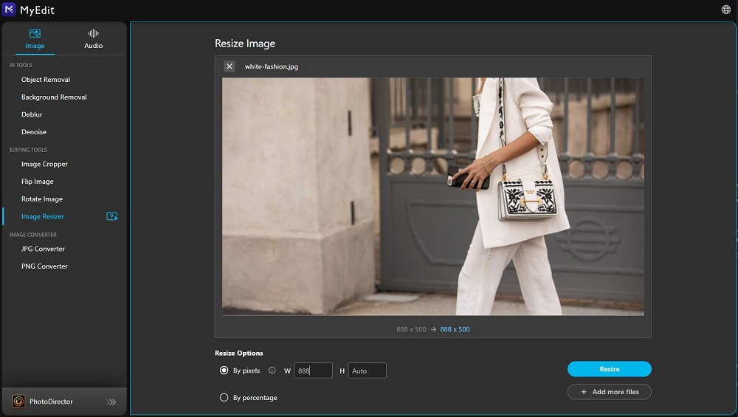

**Pros** 

* **Quick and easy:** Visit the site and start editing images with no download or sign-in required.
* **AI-Powered tools:**Powerful and accurate one-click tools make complicated-looking effects easy for beginners.

**Cons** 

* **File size limits:** The free photo editor will only allow files that are 50MB or under.

**Key Features**:

1. **Image Converter:**Convert images to JPG or PNG using this free photo editor.
2. **Cartoon Effects:** 11 different cartoon styles are available to transform your images with one click.
3. **Editing Tools:** Crop, flip, rotate, and resize images quickly using this free photo editing software.
4. **Deblur and Denoise:** Remove distracting grain and noise from images, and fix blurry photos with ease.

**Compatibility:** Web Browser

**Overall Rating:**4.5/5

**Beginner-Friendly Tools:** 4.5/5

**Price:**[Free](https://myedit.online/en/photo-editor)  
*\*Premium subscriptions available for $4/month for the Image Editor, and $6/month for the Image and Audio Editor*

**Who It’s For**

MyEdit is our pick for the best free photo editing software found online. **It offers powerful AI tools but is incredibly simple for beginners.** It has a clean user interface and includes only the best tools needed for a wide variety of uses. It includes an image converter, basic tools to edit pictures, and advanced features to remove distractions from your images. You can even create a fun anime profile picture for social media.

**Why We Picked It**

The background remover is very accurate and easy. Click a photo to import, and it automatically removes the background before the photo has finished uploading. It has tons of free backgrounds in fun and trending styles, or you can save your image with a transparent background. We were equally impressed with the object removal tool. Simply click on the object you want to remove and it automatically erases it and fills in the area. You’d never guess something had been removed!

**MyEdit is also a popular cartoonizer, allowing you to turn images into drawings in a number of styles.** It’s a great tool for creating unique profile pictures.

**Bottom Line**

You can use all of [MyEdit’s](https://myedit.online/en/photo-editor" \t "_blank) tools to edit pictures completely free. Some features only allow 1 download per day, and others offer more options with a paid subscription (such as an additional 6 cartoonizer styles and more backgrounds). In our research, we found it to be the best free photo editing software found online. Most online free photo editors don’t offer the quality or advanced features we have come to expect.**But MyEdit offered highly professional and accurate results in no time at all.**

### 3. Fotor - Best for Color Adjustment

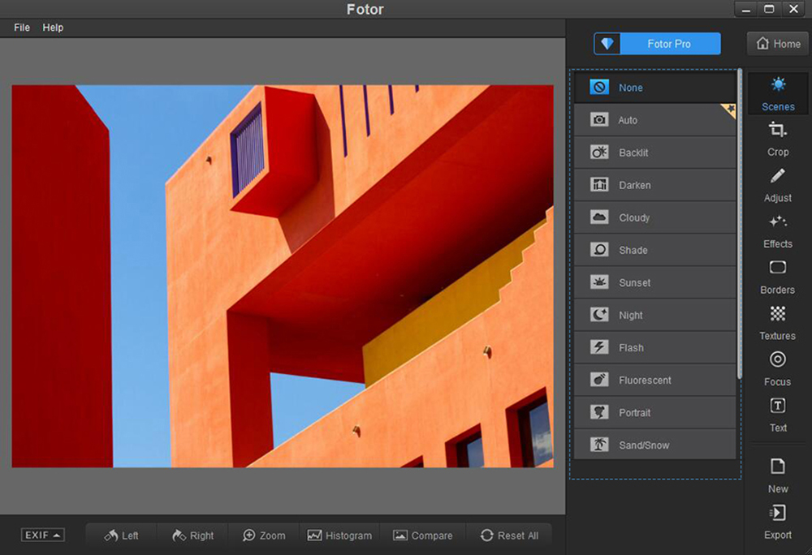

*Image from [Fotor](https://www.fotor.com/windows/user-guide.html" \t "_blank).*

**Pros** 

* **User-Friendly interface:** Enjoy a user-friendly interface that makes editing images accessible to everyone.
* **Batch edit pictures:** Editing multiple pictures simultaneously saves time and effort.

**Cons** 

* **Object selection is not automatic:**Object selection requires manual input, leading to a longer editing process.
* **Free version contains watermark and ads:** The free version has a watermark and ads, which can be removed by purchasing the premium version.

**Key Features**

* **RAW file converter:** Convert RAW files into a more usable format.
* **1-Tap skin retouch:**Instantly improve skin tones and remove blemishes with just one tap.
* **Batch processing:** Process multiple photos simultaneously, saving time and effort.
* **Blur tools:** Add depth and focus to your photos with various blur tools, including radial and tilt-shift blur.

**Compatibility:** Windows, Mac, Web Browser

[**GetApp**](https://www.getapp.com/website-ecommerce-software/a/fotor/reviews/)**Rating:**4.3/5

**Beginner-Friendly Tools:** 4.5/5

**Price:**Free  
*\*Premium subscriptions available for $8.99/month for Pro and $19.99/month for Pro+*

**Who It’s For**

We found Fotor to be **one of the best free photo editing software for its range of color adjustment tools**. Most of the color adjustment tools are available for free, including adjustments for shadows, temperature, tint, brightness, and even a few color splash effects. All of these tools are easy to use and offer adjustment sliders for precise edits. For those who prefer to edit pictures with one-click solutions, many of Fotor’s preset filters are also available for free.

**Why We Picked It**

**This free photo editing software is easy to navigate, and a first-time user would have no problem finding the features they need.** Every tool you click on has an informative box that pops up and explains what the tool is, and how you can edit pictures with it.

**Bottom Line**

It is being constantly updated, and we have seen an increase in positive scores online (which is why it has jumped in front of Photoscape on our updated list). We like that with this free photo editing software, you can **easily see which tools are free and which are Premium**. You can also try out all of the paid features, you just can’t download the image when you are done. In our test of all the features, we were disappointed with the image cutout and object removal tools. While many of the free photo editing software on our list, such as PhotoDirector, offer automatic versions of these tools, [Fotor](https://www.fotor.com/" \t "_blank) requires you to manually select the object, which ends in patchy results.

### 4. Photoscape X - Best for Batch Editing Images

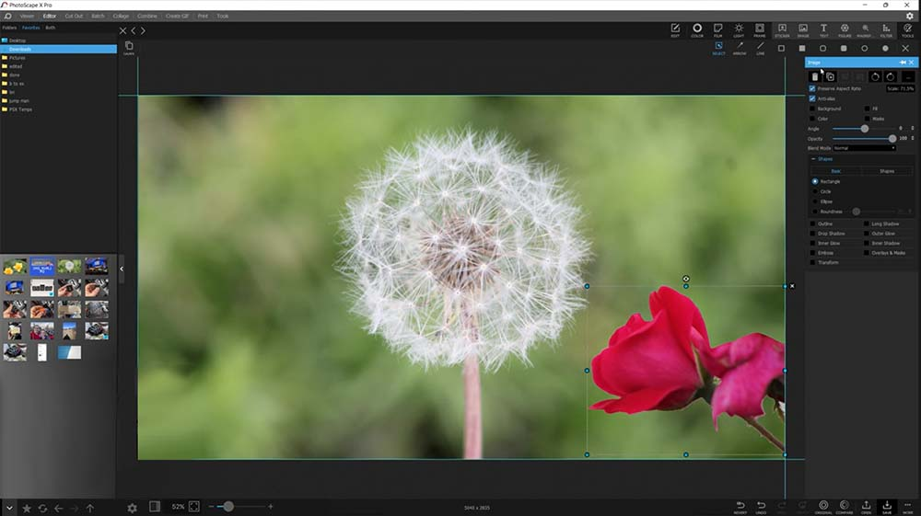

**Pros** 

* **Lots of tools in free version:** Enjoy a wide range of tools and features in the free photo editing software.
* **Beginner-Friendly:** With its user-friendly interface and easy-to-use features, the software is ideal for beginners interested in editing images.

**Cons** 

* **Freezes if handling multiple RAW files:**The software can freeze or become unresponsive when handling multiple RAW files, leading to a frustrating user experience.
* **Few manual options for experienced editors:** Experienced editors may find this free photo editing software lacking in manual options and customization.

**Key Features**

* **Panorama tool:** Create stunning panoramic photos with ease using a built-in panorama tool.
* **Spot healing brush:**Quickly and easily remove blemishes, spots, and other imperfections.
* **Filters and effects:** Enhance your photos with various filters and effects that can be easily applied to your images.
* **Light leaks:** Add a touch of vintage charm to your photos with light leak effects that emulate the look of old film cameras.

**Compatibility:** Windows, Mac

[**AlternativeTo**](https://alternativeto.net/software/photoscape/about/)**Rating:**4.2/5

**Beginner-Friendly Tools:** 4.5/5

**Price:**Free  
*\*Pro version available for $39.99*

**Who It’s For**

We think Photoscape X is the **best free photo editing software for anyone who needs to edit multiple images at once.** While you can batch edit pictures using any of Photoscape’s tools, it comes with dedicated tools for the most common batch tools, such as Batch Resize, Batch Rename, and Batch Format Change.

**Why We Picked It**

**This is not just a free photo editor, but also a photo viewer, GIF creator, screen capture device, RAW image converter, and more.** It comes with several automatic color effects for editing images, such as a color splash tool, selective color adjustments, and a color replacement effect.

**Bottom Line**

In our research, we found **most users like editing images with [Photoscape X](http://x.photoscape.org/" \t "_blank) because it is so quick to use.** However, the confusing layout makes it difficult to find the tools you need, adding extra time when editing images. We also found this free photo editor lacking in format support, and it froze when handling RAW files. That being said, this is very robust for free photo editing software, and beginner-friendly, as long as you put in the time to learn the layout.

### 5. Pixlr - Best for Beginners

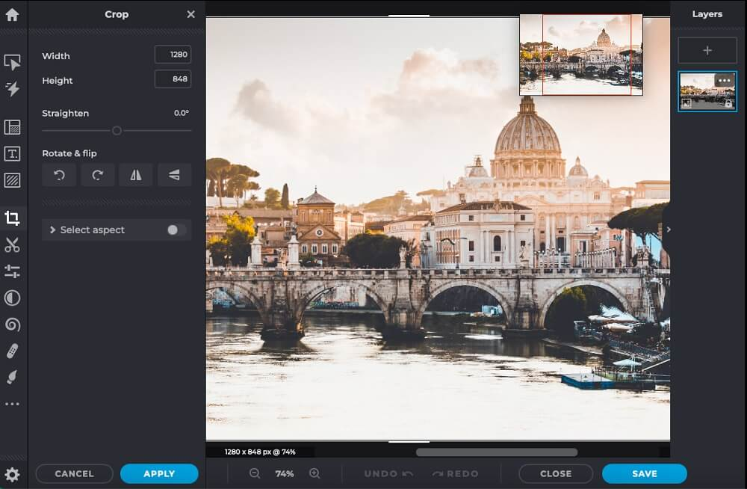

**Pros** 

* **No need to download software:** Use the free photo editing software directly from the web, eliminating the need to download software to your device.
* **Options for different skill levels:**The software offers features for beginners and experienced users, making it accessible to a wide range of skill levels.

**Cons** 

* **Lacks advanced features found in other software:** It needs more features for experienced users found in other free photo editing software.
* **Slow rendering:**The software has slow rendering times, leading to longer wait times for edited images to be processed.

**Key Features**

* **Design templates:** Create stunning designs with a variety of pre-made templates, perfect for a variety of projects.
* **Picture collage maker:**Easily create picture collages with a built-in collage maker in the free photo editing software.
* **Filters and effects:** Enhance your photos with a variety of filters and effects that can be easily applied to your images.
* **Skin retouch tools:** Improve skin tones and remove blemishes with a range of skin retouch tools, perfect for portrait photos.

**Compatibility:** Windows, Web Browser

[**G2**](https://www.g2.com/products/pixlr/reviews)**Rating:**4.4/5

**Beginner-Friendly Tools:** 4/5

**Price:**Free  
*\*Premium subscription available for $0.75/month for Plus, $4.90/month for Premium, and $9.91/month for Team*

**Who It’s For**

Pixlr's lightweight free photo editing software works well for beginners and more experienced editors in need of a quick solution for editing images. Without a fully-loaded editing suite to search through, you can easily locate tools like spot-healing brushes and stamps, or make minor adjustments to the photo's color and lighting. We found **Pixlr's streamlined layout and minimalistic array of tools help simplify the process of editing images for beginners.**

**Why We Picked It**

The software supports layers and masks and features several essential tools for editing images such as customizable brushes and visual effects. **Advanced users familiar with Photoshop will find the software’s toolbars familiar.**

**Bottom Line**

Though**the program rarely crashes**, ad-heavy banners and poorly navigable pages reduce the functionality and aesthetic appeal of the platform. You may also notice that the program renders slowly, resulting in frustrating, inconsistent movements of your mouse or touchpad.

Casual users may enjoy editing images with small tweaks or creating collages within [Pixlr's](https://pixlr.com/" \t "_blank)software, but if you need user-friendly free photo editing software with a more comprehensive array of tools, try PhotoDirector.

### 6. BeFunky - Best for Quick, Simple Edits

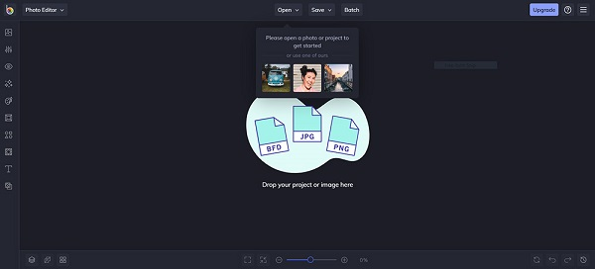

**Pros** 

* **Batch edit pictures:**Editing multiple photos simultaneously with batch processing saves time and effort.
* **Customizable design templates:** Create stunning designs with customizable templates that can be tailored to your specific needs.

**Cons** 

* **Lacks many useful features:** The software lacks many useful features found in other free photo editing software, limiting the editing experience.
* **Annoying Pop-Ups:**We appreciate that each tool has a tooltip attached to explain its use to beginners, however, we wish we could choose to click on it if we need help, and not see it pop up every time we use a feature.

**Key Features**

* **Collage making:** Easily create collages with a built-in collage maker in the free photo editing software.
* **Graphic design workflow:** Streamline your graphic design workflow with a range of tools and features designed for professional designers.
* **Unique filters:**Enhance your photos with a variety of unique filters that can add a touch of creativity to your images.
* **1 million+ free stock images:** Access over 1 million free stock images to use in your projects, including photos, graphics, and more.

**Compatibility:** Web Browser

[**G2**](https://www.g2.com/products/befunky/reviews)**Rating:**4.2/5

**Beginner-Friendly Tools:** 4/5

**Price:**Free  
*\*Premium subscription available for $5.99/month*

**Who It’s For**

When considering the best free photo editing software, Windows users can't forget BeFunky. **With ten photo editing modules, you can quickly browse through the software's editing interface to alter template layouts, upload images, and make minor tweaks.**

**Why We Picked It**

The free photo editor **offers many of the tools, features, and functions beginners need to enhance photos**, manually adjust color and lighting, and create customizable collages or graphics. While the free version will only allow you to edit pictures with about one-third of the platform's tools, novice users may enjoy the simplified functionality.

**Bottom Line**

**Proficient editors will likely wish for more options.** We found entire sections were paid-only, however, they weren’t labeled as such. We had to click on each individual tool to see if it was a premium feature or paid, taking up valuable time. Upgrading to [BeFunky's](https://www.befunky.com/" \t "_blank) premium subscription will unlock more tools to edit pictures such as cutout tools, background replacement, color replacement, and other highly impactful editing functions.

### 7. Darktable - Best for Professional Photographers

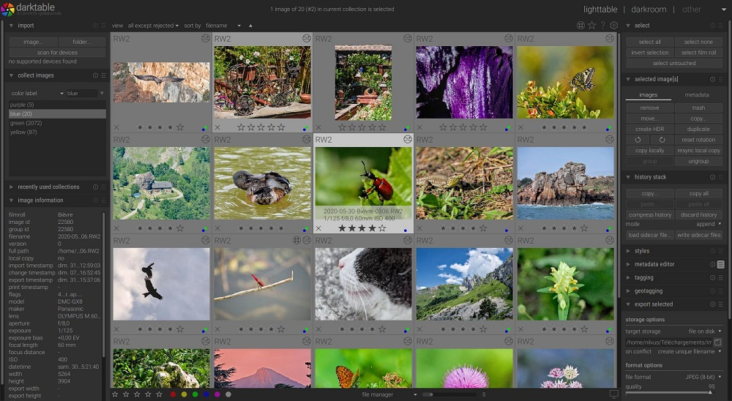

*Image from [Darktable](https://www.darktable.org/" \t "_blank).*

**Pros** 

* **A free photo editor professionals can use as an alternative to expensive software:** Achieve professional-looking results with a free photo editor, saving money compared to expensive alternatives.
* **Good quality RAW processing:**Process RAW files with high-quality results, making it an excellent option for professional photographers.

**Cons** 

* **Learning curve for beginners:** The software has a steeper learning curve, making it less accessible for those new to editing images.
* **Confusing groupings of features:**The software needs a clearer grouping of features, making it easier to find the tools you need.

**Key Features**

* **Retouching:** Easily retouch your photos to achieve professional-looking results, with tools that can fix exposure, color, and more.
* **Geotagging support:** Add location data to your photos with geotagging support, making it easy to organize and categorize your images.
* **Support for 21 languages:** Use the free photo editing software in your preferred language.
* **Denoise:** Reduce noise and improve image quality with denoise tools that can automatically remove unwanted grain and speckles from your photos.

**Compatibility:** Windows, Mac, Linux

[**Shotkit**](https://shotkit.com/darktable-review/)**Rating:**4.2/5

**Beginner-Friendly Tools:** 4/5

**Price:**Free

**Who It’s For**

Darktable is an open-source and completely free photo editor. **We think it’s the best free photo editing software for professional photographers because it offers support for tethered shooting and RAW image processing for over 400 cameras.** It also has some photo management tools and handles up to 10,000 images.

**Why We Picked It**

This free photo editing software is great for editing images with **professional-level color adjustment tools, hot pixel fixes, masking, and blending.**Darktable allows you to edit pictures with precise control over all tools and effects. We also found it to be extremely fast, thanks to GPU-accelerated image processing and OpenCL support.

**Bottom Line**

While [Darktable](https://www.darktable.org/" \t "_blank) **offers many learning tools like user forums, video tutorials, and instructional posts,** it will take time for beginners to get familiar with the free photo editing software. And even those familiar with Lightroom and other paid software will find the layout and groupings of some of the features confusing. Although BeFunky and Darktable have the same overall rating, we placed BeFunky on top because it is more beginner-friendly.

### 8. PhotoPad - Best for Resizing Images

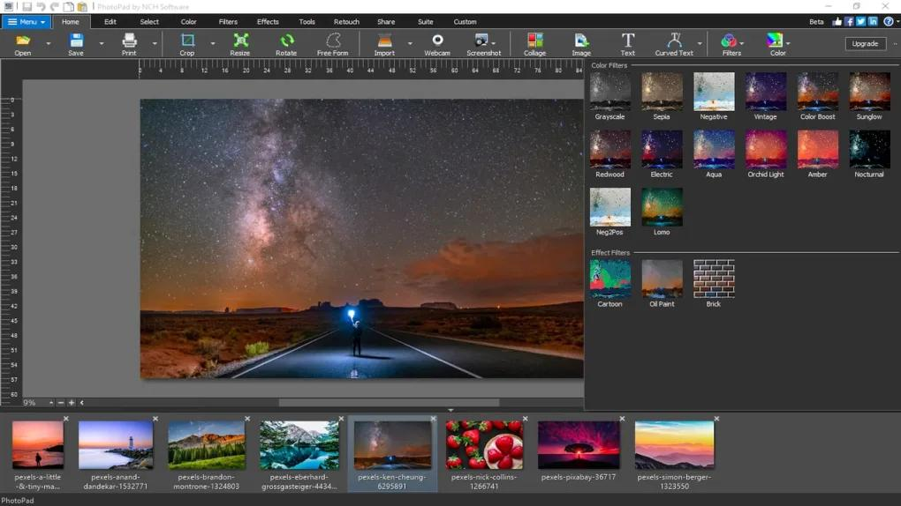

**Pros** 

* **Lots of beginner support:** The free photo editing software offers a lot of support for beginners, such as video tutorials and a help manual.
* **User-Friendly interface:** Enjoy a user-friendly interface that makes editing images accessible to everyone.

**Cons** 

* **Some tools require a lot of tweaking to get right:** Some of the tools in the software may require a lot of tweaking and adjustments to get the desired results, making it a time-consuming process.
* **Light on advanced features:** The software is light on advanced features, making it less appealing to experienced users looking to edit pictures with more control.

**Key Features**

* **Colorize tool for black-and-white images:**Add color to black-and-white images and bring new life to old photos.
* **Blemish remover:**Quickly and easily remove blemishes, spots, and other imperfections.
* **Selection of clipart and fonts:** Choose from a selection of clipart and fonts to add creative elements to your photos and designs.
* **Passport photo tool:** Create passport photos with ease.

**Compatibility:** Windows, Mac

[**G2**](https://www.g2.com/products/photopad/reviews)**Rating:**4.2/5

**Beginner-Friendly Tools:** 4/5

**Price:**Free  
*\*Premium versions available for $80 for Home, $99 for Pro, or $3.88/month for unlimited updates*

**Who It’s For**

We found PhotoPad to be **one of the best free photo editing software thanks to its image resizing and upscaling tools**. PhotoPad uses AI-powered tools to resize images without loss of quality. It comes with a liquid resize effect that will change the aspect ratio of your image with no distortion, and a Super Resolution tool to upscale images losslessly.

**Why We Picked It**

**PhotoPad has all the tools you’d expect from free photo editing software, including frames, color correction, crop, and rotation.** It also has some you would only expect in premium software, such as a blur tool, drawing tools, and creative effects such as warp, paint, and embroidery.

**Bottom Line**

[PhotoPad](https://www.nchsoftware.com/photoeditor/index.html) is **very beginner-friendly and comes with lots of learning tools such as a help manual, video tutorials, user forums, and technical support reps.**However, it has only very basic tools for editing images and is not meant for experienced editors or photographers. We prefer our choice for the best free photo editing software, PhotoDirector, because it offers beginner-friendly tools, lots of learning tools, and advanced features.

### 9. Ashampoo Photo Optimizer - Best for Perspective Correction

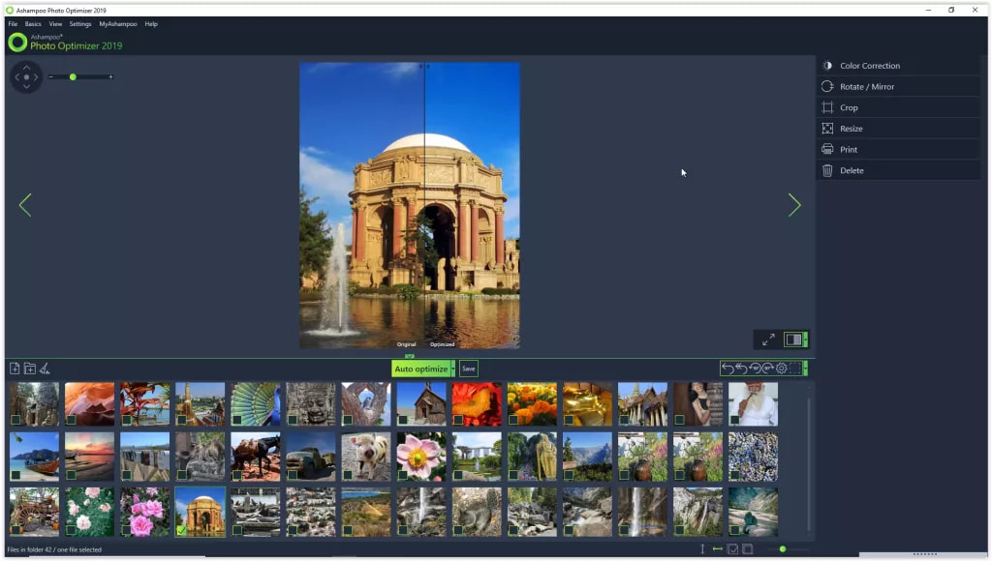

*Image from [TechRadar](https://www.techradar.com/reviews/ashampoo-photo-optimizer-2019" \t "_blank).*

**Pros** 

* **Batch editing:** Editing multiple photos simultaneously saves time and effort.
* **Lightweight:** With a lightweight software design, enjoy fast and efficient editing, even on older or less powerful devices.
* **Easy to use:**With its user-friendly interface and straightforward features, the software is easy to use for everyone.

**Cons** 

* **No layer editing:** The software does not have layer editing capabilities, making it difficult to achieve complex editing results.
* **Automatic tools don’t always work:**Automatic tools in the software may not always produce the desired results, requiring manual adjustments to achieve the desired outcome.

**Key Features**

* **Implosion/Explosion effects:** Add a touch of drama to your photos and create unique visual effects.
* **Tonal curve adjustments:** Fine-tune the tonality of your images by adjusting brightness, contrast, and more.
* **Crop/Rotate:**Easily crop and rotate your photos to perfect composition with this free photo editing software.
* **64-bit optimized:**Enjoy faster and more efficient editing with 64-bit optimization, designed to take advantage of the latest hardware.

**Compatibility:** Windows

[**CNET**](https://download.cnet.com/Ashampoo-Photo-Optimizer/3000-12511_4-10657920.html)**Rating:**4.1/5

**Beginner-Friendly Tools:** 4/5

**Price:**Free  
*\*Premium version available for $15*

**Who It’s For**

If you are editing images of landscapes or tall buildings with perspective distortions, give Ashampoo Photo Optimizer a try. **This is the best free photo editing software for fixing vertical and horizontal distortions and straightening horizons.** This program is quick and easy, and these edits can be made with a single click.

**Why We Picked It**

This **free photo editor instantly enhances your photos by optimizing colors, contrasts, and exposure times for single images or multiple images at once**. We like that it also has manual adjustments so you can edit pictures with precision. The UI is clean, and no tool is more than 2 clicks away, making it easy to find what you need.

**Bottom Line**

[Ashampoo Photo Optimizer](https://www.ashampoo.com/en-us/photo-optimizer) is one of the **best free photo editing software for beginners to optimize their photos**. This free photo editor allows you to edit pictures quickly, with super-fast importing and one-click solutions. In our test, we were grateful for manual sliders, because its namesake auto-optimization tool was hit-or-miss. It’s also missing advanced tools such as layer editing. We recommend PhotoDirector as a better quick and easy solution for editing images. While both programs offer one-click optimizations and manual sliders, only PhotoDirector has advanced features.

### 10. Paint.NET - Best for Layer Editing

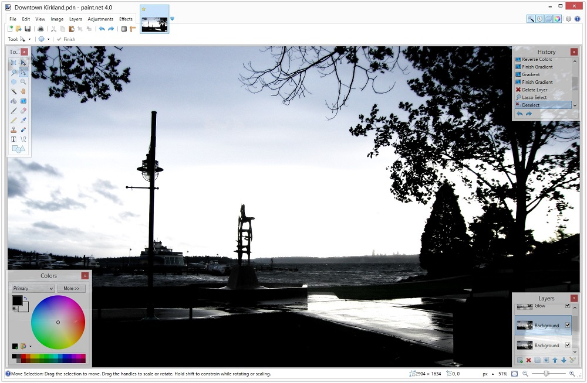

*Image from*[*Paint.net*](https://www.getpaint.net/)*.*

**Pros** 

* **Active community:** Benefit from an active community that provides tutorials, forums, and plug-ins to help you get the most out of the free photo editing software.
* **Advanced editing simplified:** Enjoy simplified versions of advanced editing tools, making them accessible for beginners.

**Cons** 

* **Not for professionals to edit pictures:** The software may not have the features and capabilities required by professional photographers for editing images, making it less appealing to those in the industry.
* **Limited control over text:**The software makes it difficult to achieve the desired text effects in your images.

**Key Features**

* **Supports user-created plug-ins:** Extend the capabilities of the free photo editing software by using user-created plug-ins, offering a nearly unlimited range of features.
* **Clone stamp:**Remove unwanted elements from your photos with the clone stamp tool, which allows you to copy and paste pixels from one part of an image to another.
* **Drawing tools for Bezier curves:**Draw smooth, precise shapes and lines with drawing tools for Bezier curves, making it easy to create custom graphics.
* **Powerful gradient tool:** Add depth and dimension when editing images by creating beautiful and complex color transitions.

**Compatibility:** Windows

[**TechRadar**](https://www.techradar.com/reviews/paintnet)**Rating:**4/5

**Beginner-Friendly Tools:** 4/5

**Price:**Free

**Who It’s For**

Paint.NET is one of the **best free photo editing software for anyone who needs a free solution for multi-level image editing.** Editable layers are typically reserved for paid software, but Paint.net offers this functionality for free. Even better, every edit to a layer is recorded, and you can go back and undo any change.

**Why We Picked It**

This free photo editing software also has **adjustment tools so you can tweak brightness, contrast, saturation, hue, and curves**. You can make an image sepia-toned or black-and-white, apply blur, or sharpen images. You can also edit pictures with perspective and tilting with the unique 3D Rotate/Zoom effect.

**Bottom Line**

This is not a replacement for more professional editing software like Photoshop, but [**Paint.NET**](https://www.getpaint.net/index.html)**is a good practice tool for beginners who want to learn more advanced editing techniques.** Our one major complaint when testing this free photo editing software was with the text tools. You can’t make changes to the text once it is added - something that almost every other free photo editor will allow.

### 11. Photo Pos Pro - Best for Text

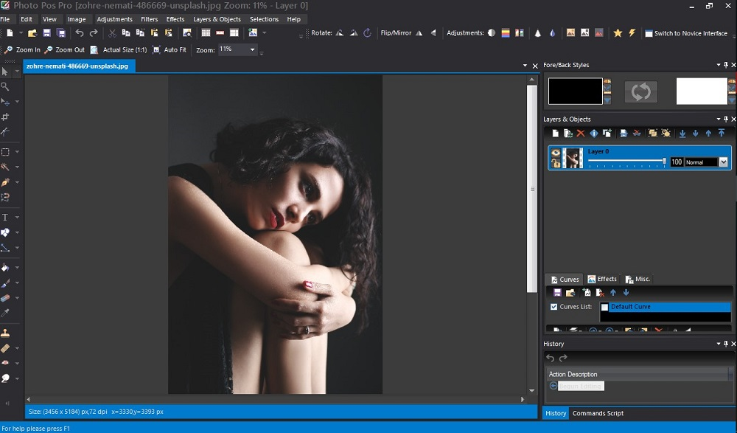

*Image from [fixthephoto](https://fixthephoto.com/photo-pos-pro-review.html" \t "_blank).*

**Pros** 

* **Excellent graphic design and text tools:**Achieve professional-looking results perfect for creating designs and social media posts.
* **Feature-Rich free version:** Enjoy a feature-rich free version that provides a lot of value compared to other free photo editing software.

**Cons** 

* **Difficult to switch between one-click and manual options:** The software makes it challenging to achieve the desired results.
* **Steep learning curve:**The free photo editing software has a steep learning curve, making it less accessible for those new to editing images.

**Key Features**

* **Background remover:** Remove unwanted backgrounds with a background remover tool, making it easy to isolate and edit specific elements in your photos.
* **RAW file support:**Process RAW files with high-quality results, making it a great option for professional photographers.
* **Frame and collage templates:** Choose from a variety of frame and collage templates to add creative elements to your photos and designs.
* **Red eye remover:**Quickly and easily remove red eye from your photos with a red eye remover tool, perfect for portrait photos.

**Compatibility:** Windows

[**TechRadar**](https://www.techradar.com/reviews/photo-pos-pro)**Rating:**4/5

**Beginner-Friendly Tools:** 4/5

**Price:**Free  
*\*Premium version available for $49.99*

**Who It’s For**

Photo Pos Pro is one of the best free photo editing software for its stunning text effects. It comes with an array of font styles and effects, including text over path effects, and textures such as gel, chrome, metal, etc. Photo Pos Pro isn’t just a free photo editor, but also a**program for graphic designers, with painting and drawing tools in addition to text.**

**Why We Picked It**

This free photo editing software has 2 modes - Novice and Expert. **Beginners can choose the Novice mode for easy one-click solutions, while experts can enjoy manual editing tools.** It comes with some fun special effects, such as dispersion, pencil sketch, motion effects, and a unique “pop-out of picture” effect.

**Bottom Line**

We like that [**Photo Pos Pro**](https://www.photopos.com/PPP3_BS/Default.aspx)**has options to edit pictures for any skill level**. However, the Novice mode lacks many important features for editing images such as layer editing, and the Expert mode has a steep learning curve. They are also very different in layout, so you can’t switch back and forth easily between the two. We prefer the functionality of our top free photo editor, PhotoDirector, where there is one easy-to-use mode, and every tool has both automatic and manual options.

### 12. Canva - Best for Graphic Design

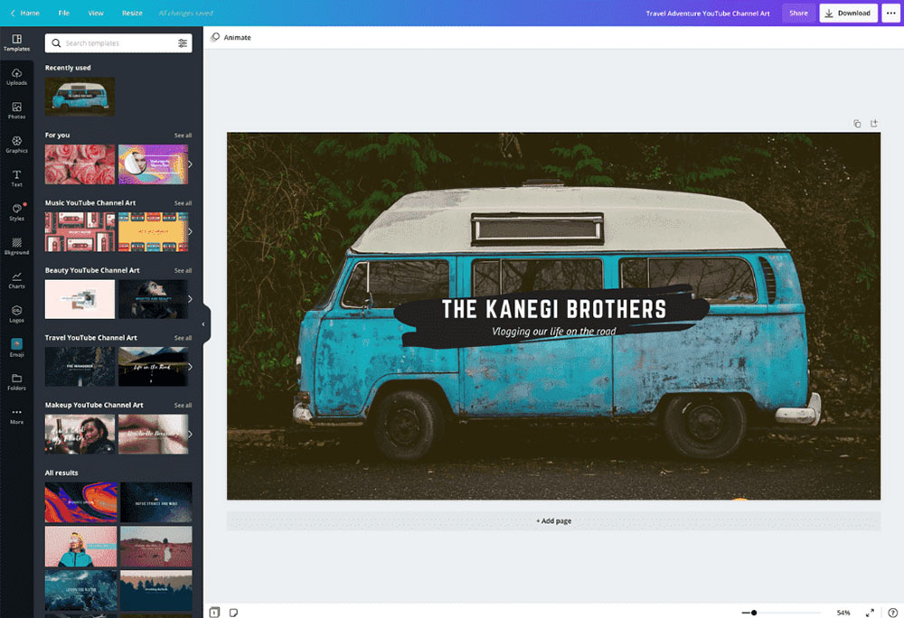

*Image from [Canva](https://www.canva.com/create/youtube-banners/" \t "_blank).*

**Pros** 

* **Professionally designed templates:**Create professional-looking designs with templates that make it easy to achieve great results.
* **Beginner-Friendly:** Enjoy an easy-to-use interface that makes this free photo editing software accessible for those with no design experience.

**Cons** 

* **Limited tools for editing images:**The software has limited tools for editing images, making it less appealing to those who need more control over their images.
* **Best tools are paid:**Team collaboration tools and brand kits are only available in the paid version, limiting the experience for free users.

**Key Features**

* **Free cloud storage:**Store your photos in the cloud with free cloud storage, making it easy to access your images from anywhere.
* **Meme creator:** Add text and graphics to your photos to create shareable content.
* **Brand kits:**Create professional-looking designs with brand kits that can provide you with templates, logos, and color schemes for your brand.
* **Background remover:** Remove unwanted backgrounds with a background remover tool, making it easy to isolate and edit specific elements in your photos.

**Compatibility:** Windows, Mac, Web Browser

[**PCMag**](https://www.pcmag.com/reviews/canva)**Rating:**4.5/5

**Beginner-Friendly Tools:** 3/5

**Price:**Free  
*\*Premium version available for $119.99/year*

**Who It’s For**

Canva is the best free photo editing software for making graphic design projects for social media. It comes with customizable templates for every popular platform. You can also create photo projects such as calendars, invites, flyers, and memes. **If you have no graphic design experience but need to create marketing materials or social media posts for your brand or company, this is the free photo editor for you.**

**Why We Picked It**

Start with a photo, then browse **Canva’s thousands of filters, frames, graphics, stickers, and text options to add some flair.** This free photo editing software also has an image enhancement tool that can brighten and sharpen images in one click, or you can fix individual elements with adjustment sliders.

**Bottom Line**

There are millions of design assets available in the free version, although [Canva](https://www.canva.com/" \t "_blank)saves the best stuff for premium subscribers. **While it’s a great tool for graphic design, it has very limited tools for editing images.** If you need a program to edit pictures and graphic design tools, try PhotoDirector. It has millions of design assets including social media templates and tons of pro-level tools to edit pictures in every way imaginable.

### 13. Adobe Express - Best for Social Media

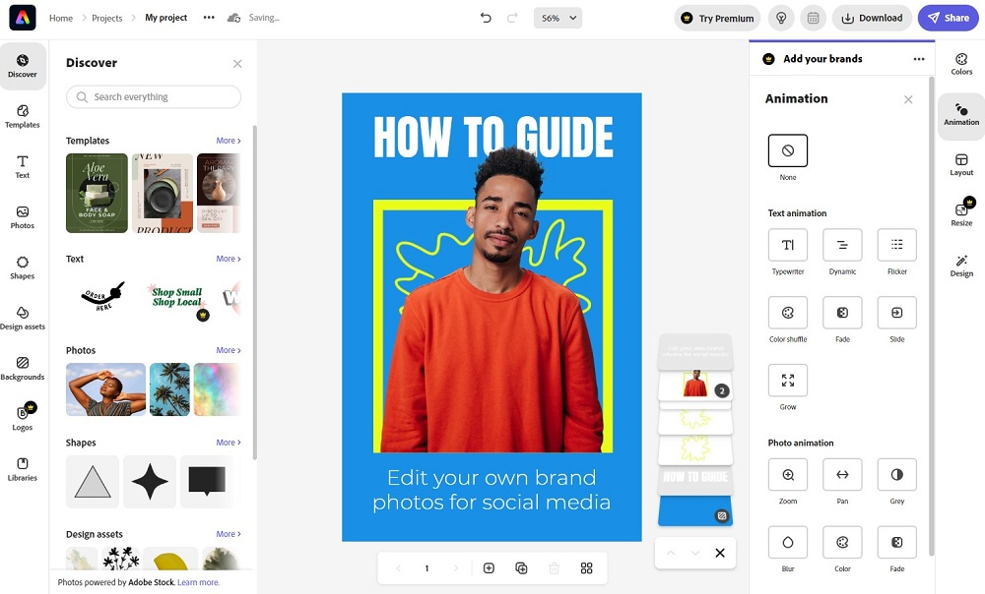

**Pros** 

* **Easy to use:**Enjoy an easy-to-use interface that makes it accessible for those with no experience editing images.
* **Tons of professionally-designed templates:** Choose from a large selection of professionally-designed templates to add creative elements to your photos and designs.

**Cons** 

* **No layer editing:** It does not have layer editing capabilities, making it less appealing to those who need more control over their images.
* **Requires Flash:**The software requires Flash, which may not be available on all computers.
* **Only supports JPG:**This free photo editing software only supports JPG format, limiting the types of images that can be edited.

**Key Features**

* **Crop tool:**Easily crop your photos to achieve the perfect composition.
* **Background remover:**Remove unwanted backgrounds with one click.
* **Photo collage maker:** Create photo collages that can combine multiple photos into a single image.
* **2GB of free storage:**Store your photos for free and access your images from anywhere.

**Compatibility:** Web Browser

[**TechRadar**](https://www.techradar.com/reviews/adobe-creative-cloud-express)**Rating:**4/5

**Beginner-Friendly Tools:** 3.5/5

**Price:**Free  
*\*Premium subscription available for $9.99/month*

**Who It’s For**

Visit the website for Adobe Express, and you are greeted with templates to **create any kind of social media post - such as YouTube banners, TikTok ads, Instagram posts, and Facebook Stories.** It also has an instant resize tool that is perfect for busy influencers who need to repurpose one post for many platforms. Spring for the Premium version and you’ll have access to branding kits and a content scheduler as well.

**Why We Picked It**

Adobe Express is an **all-in-one free photo editing software, graphic design tool, video editor, and PDF editor.** The free photo editor even includes a limited amount of Adobe Stock images and Adobe Fonts. But we like it most for its polished and fully customizable templates.

**Bottom Line**

**This free photo editor helps non-designers create professional-looking social media posts.**Although [Adobe Express](https://www.adobe.com/express/) is similar to Canva, we placed Canva on top because it offers more photo editing tools. Adobe Express also lacks support for layer editing, and only accepts JPG format.

### 14. Movavi Photo Editor - Best for Object Removal

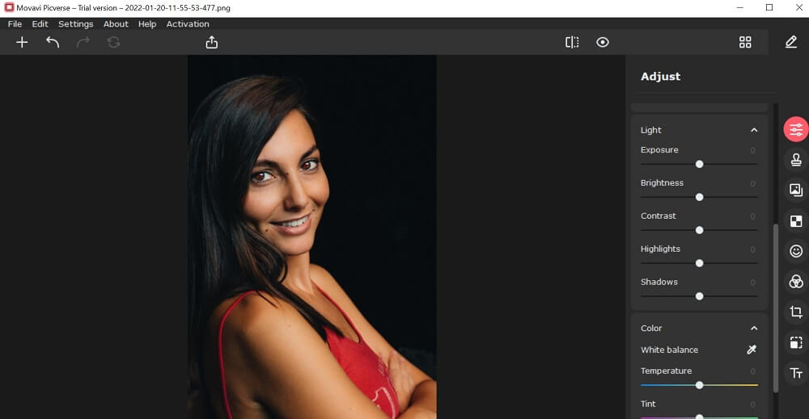

**Pros** 

* **AI background removal:**Easily remove backgrounds to isolate and edit specific elements in your photos.
* **Light and color correction:** Correct light and color in your photos with tools designed to adjust exposure, brightness, contrast, and more.

**Cons** 

* **Erase and stamp lacking in functionality:**The erase and stamp tools may not achieve the desired results.
* **Only contains basic effects:**The software only has basic effects, lacking more advanced and creative options found in other free photo editing software.

**Key Features**

* **Crop/Rotate:**Easily crop and rotate your photos to achieve the perfect composition.
* **AI restoration:**Restore old or damaged photos with AI restoration tools that can automatically fix exposure, color, and other issues.
* **Effects and filters:**Enhance your photos with a variety of effects and filters that can add a touch of creativity to your images.
* **Sharpness adjustment:**Improve the sharpness of your photos with sharpness adjustment tools that can automatically or manually enhance clarity and detail.

**Compatibility:** Windows, Mac

[**PCMag**](https://www.pcmag.com/reviews/movavi-video-editor-plus)**Rating:**4/5

**Beginner-Friendly Tools:** 3.5/5

**Price:**First 10 images are free, then $49.95/year or $69.95 for a lifetime license

**Who It’s For**

Movavi Photo Editor has built its reputation on one key function: quickly and easily removing unwanted objects from your pictures. **With this free photo editing software, you will get quality results with no editing residue.** The software also offers a simplified alternative to AI-powered background removal: users can upload images into the platform and then clip and insert elements from one photo onto another.

**Why We Picked It**

Movavi also provides users with a few photo adjustment options. It allows you to manually edit pictures by tweaking the color, brightness, contrast, and saturation of your photo. You can also **apply Magic Enhance for one-click edits, or add text, titles, and captions for fully customized photos.**

**Bottom Line**

**While beginners can cut distracting or disruptive elements from their photos, even the most inexperienced users may feel that [Movavi Photo Editor’s](https://www.movavi.com/photo-editor/" \t "_blank) actual editing features fall short of expectations**. When we originally added Movavi to our list, it was the free online editor Movavi Picverse we reviewed. However, Movavi recently changed Picverse to a mobile-only app and Movavi Photo Editor does not offer a free version. You can edit 10 photos for free, but they will be watermarked. This disappointing turn of events has moved Movavi down to #14 on our updated list.

### 15. InPixio Photo Studio - Best for Frames

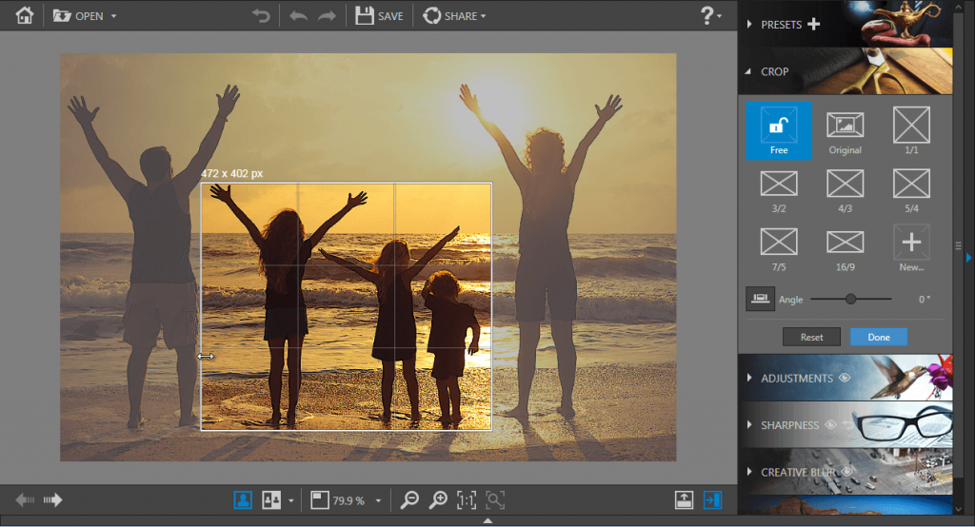

*Image from [inPixio Blog](https://www.inpixio.com/blog/photo-focus-tutorials/how-to-crop-a-photo/" \t "_blank).*

**Pros** 

* **Manual and automatic options:** Choose between manual and automatic options to achieve the desired results, providing flexibility and control.
* **Large selection of customizable frames:** Add creative elements to your photos and designs with a huge library of editable frames.

**Cons** 

* **Small selection of tools:** The software has few tools, limiting the editing experience compared to other free photo editing software.
* **Free version not available on Mac:** Mac users will have to pay a subscription to use the software.

**Key Features**

* **AI sky and background replacement:** Replace skies and backgrounds with ease using this free photo editor.
* **Denoise tool:**Reduce noise and improve image quality by removing unwanted grain and speckles from your photos.
* **Photo montage tools:**Create photo montages by blending multiple photos into a single image.
* **Object removal:**Remove unwanted objects from your photos and clean up cluttered scenes.

**Compatibility:** Windows, Mac

[**Capterra**](https://www.capterra.com/p/213175/inPixio-Photo-Studio/reviews/)**Rating:**3.9/5

**Beginner-Friendly Tools:** 3.5/5

**Price:**Free  
*\*Premium subscriptions available for $49.99/year for Studio, $59.99/year for Studio Pro, and $99.99/year for Studio Ultimate*

**Who It’s For**

InPixio is a free photo editor known for its one-click AI editing solutions. It is**one of the best free photo editing software for its collection of over 100 beautifully-designed frames**. There are frames for any number of occasions and holidays, and the frames can be customized by color and size.

**Why We Picked It**

The frames are included in the program’s limited free version, along with filters, textures, and vignettes. **All of InPixio’s tools are automatic, but you can edit pictures in manual mode for more precise control.** Crop, adjust brightness and contrast, and add text with this free photo editor.

**Bottom Line**

[InPixio Photo Studio](https://www.inpixio.com/free-photo-editor/) reserves most of its tools for the paid versions, but if you simply need to edit pictures by cropping, adjusting, or adding a frame or filter, then the free version will work for you. **InPixio’s premium versions still pale in comparison to many of the free photo editors on our list.** In our updated list, InPixio fell below Canva and Adobe Express due to a falling Capterra rating.

### 16. GIMP - Best for Advanced Users

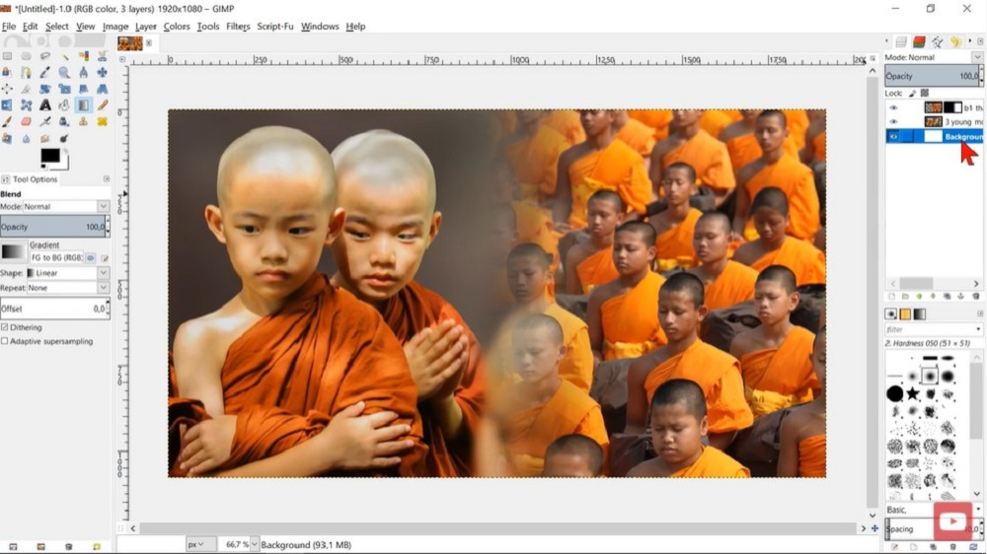

*Image from*[*Gimp Workshop*](https://www.youtube.com/watch?v=_YDFzvvjI4A&ab_channel=gimpworkshop)*on YouTube.*

**Pros** 

* **Adjustable brushes:** Enjoy greater control and precision in your digital painting with adjustable brushes that can be customized to fit your needs.
* **Custom color adjustment and gradient tools:** Adjust color and gradient with custom tools that can be tailored to your preferences.

**Cons** 

* **Hard to learn:**The software is hard to learn, making it less accessible for those new to editing images.
* **Clunky interface:** The interface is clunky and difficult to navigate, making it less enjoyable to use.

**Key Features**

* **Tone mapping:**Improve the tonality and dynamic range of your photos by adjusting exposure, brightness, and contrast.
* **Original artwork creation:** Create original artwork with tools designed for digital painting and illustration.
* **Graphic design elements:** Enhance your designs with a variety of graphic design elements, including brushes, shapes, and textures.
* **Parametric brushes:**Achieve greater control and precision in your digital painting with parametric brushes that can be customized to fit your needs.

**Compatibility:** Windows, Mac, Linux

[**G2**](https://www.g2.com/products/gimp/reviews)**Rating:**4.3/5

**Beginner-Friendly Tools:** 3/5

**Price:**Free

**Who It’s For**

GIMP – also known as the GNU Image Manipulation Program – is **a free photo editor that features a surprisingly well-rounded amassing of complex and basic tools to edit pictures that rival those of Photoshop and similar paid programs.**The base software comes well-stocked with advanced features like layer editing functions, masking, color management features, and effects.

**Why We Picked It**

For even more functionality, you can download free plugins created by other GIMP users. Further, the **software's customizable layout and ongoing developments ensure that it stays on pace with other free photo editors**.

**Bottom Line**

While you can access the platform's wide array of tools, [**GIMP**](https://www.gimp.org/)**falls short in one significant area: user optimization.** The loaded interface often feels overwhelming, and beginners and intermediate editors may struggle to find solutions for complicated editing techniques. Additionally, GIMP offers little help for its users outside of the community discussion panels.

### 17. Photopea - Best Photoshop Alternative

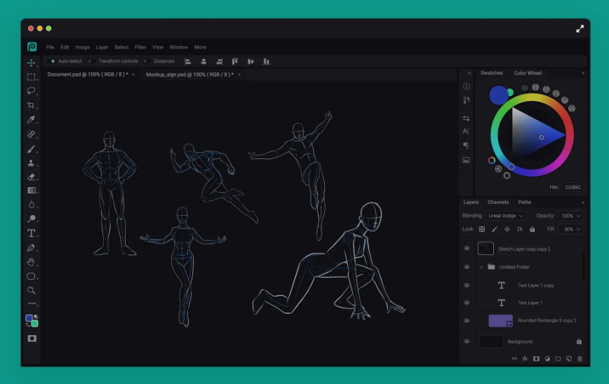

**Pros** 

* **Robust free version:** The site offers tons of tools that are completely free to use.
* **Wide format support:** Supports RAW image files, accepts files from other photo editors such as Photoshop and GIMP, and all popular file formats (PNG, TIFF, JPEG, GIF, etc).

**Cons** 

* **Learning curve:**The software is difficult for beginners and requires a lot of trial and error.
* **Glitches/Freezing:** You need a strong internet connection when using this free photo editing software, and even then you may have stability issues.

**Key Features**

* **Drawing tools:**This free photo editing software has a variety of drawing tools including pen/brushes, path selections, and an automatic rectangle tool.
* **Touch Up tools:** Remove blemishes and other imperfections with healing/spot brushes.
* **One-Click gradients:** Automatically create a lovely ombre effect.
* **Dodge/Burn tools:**Use these tools to lighten/darken parts of an image.

**Compatibility:** Web Browser

[**TrustPilot**](https://www.trustpilot.com/review/photopea.com)**Rating:**3.2/5

**Beginner-Friendly Tools:** 3/5

**Price:**Free  
*\*Premium version available for $10 for 30 days, $15 for 90 days, or $50 for one year (Teams pricing is also available for teams of 5, 20, and 50)*

**Who It’s For**

Photopea is one of the best free photo editing software for Photoshop users. It supports PSD files and has a similar feature set and interface, though slightly pared back (both the toolkit and interface are almost identical to Photoshop Elements).**This free photo editor is too complex for beginners, but a good choice for intermediate to advanced users looking for a budget-friendly Photoshop alternative.**

**Why We Picked It**

Edit pictures or create graphic designs from scratch using this free photo editing software. It comes with design assets such as stock images and templates and has a large selection of filters and adjustments. Photopea also has a wide variety of aspect ratios so **you can resize images for any purpose or platform.**

**Bottom Line**

**Every tool is available for free with** **[Photopea.](https://www.photopea.com/" \t "_blank)** If you opt for the premium version, it does not add any features, but enhances the editing experience by increasing storage, removing ads, providing email support, and keeping track of more steps in your history. While we highly recommend this free photo editor for anyone familiar with Photoshop/Photoshop Elements, it is not a good choice for beginners. During our test, we suffered through a lot of trial and error, because it lacks real-time previews of effects.

## Best Free Photo Editing Software Comparison Chart

| **Software** | **OS** | **Beginner-Friendly** | **Advanced Features** | **AI Tools** | **Organizational Tools** | **Free Download** |
| --- | --- | --- | --- | --- | --- | --- |
| PhotoDirector Essential | Windows, Mac | Yes | Tons of advanced effects and tools for editing images like layer editing, color adjustments, blur tools, chroma key, 360-degree editing, animation effects, panorama stitching, and more | Yes | Yes | [**Free Download**](https://www.cyberlink.com/prog/trial/user-add.do?source=blog&ProductId=211&ostype=Windows) **Secure Download** |
| MyEdit Image Editing Tool | Web Browser | Yes | Background and object removal, denoise, deblur, | Yes | No | [Download](https://myedit.online/en/photo-editor) |
| Fotor | Windows, Mac, Web Browser | Yes | Tilt-shift, blur tools | No | No | [Download](https://www.fotor.com/) |
| Photoscape X | Windows, Mac | Yes | Blur tools, brushes, photo stacking, special effects, masks, panorama stitching | No | No | [Download](http://x.photoscape.org/) |
| Pixlr | Windows, Web Browser | Yes | Advanced color tools, dispersion/liquefy effects, layer editing, masks | Yes | No | [Download](https://pixlr.com/) |
| BeFunky | Web Browser | Yes | No | No | No | [Download](https://www.befunky.com/) |
| Darktable | Windows, Mac, Linux | No | Advanced color adjustment tools, hot pixel fixes, masking, and blending. | No | Yes | [Download](https://www.darktable.org/) |
| PhotoPad | Windows, Mac | Yes | No | Yes | No | [Download](https://www.nchsoftware.com/photoeditor/index.html?ns=true&kw=photopad) |
| Ashampoo Photo Optimizer | Windows | Yes | Manual color temperature adjustments | Yes | No | [Download](https://www.ashampoo.com/en-us/photo-optimizer) |
| Paint.NET | Windows | Yes | Layer editing, special effects | No | No | [Download](https://www.getpaint.net/index.html) |
| Photo Pos Pro | Windows | Yes | Yes - In Expert Mode only (Special effects, motion effects, path text effects, layer editing) | No | No | [Download](https://www.photopos.com/PPP3_BS/Photo-Pos-Pro-Free-Photo-Editor.aspx) |
| Canva | Windows, Mac, Web Browser | Yes | No | No | Yes | [Download](https://www.canva.com/download/windows/) |
| Adobe Express | Web Browser | Yes | No | No | No | [Download](https://www.adobe.com/express/) |
| Movavi Photo Editor | Windows, Mac | Yes | No | Yes | Yes | [Download](https://www.movavi.com/photo-editor) |
| InPixio Photo Studio | Windows, Mac | Yes | No | No | No | [Download](https://www.inpixio.com/free-photo-editor/) |
| GIMP | Windows, Mac, Linux | No | Layer editing, masks, advanced color adjustments, brushes and drawing tools | Yes | No | [Download](https://www.gimp.org/) |
| Photopea | Web Browser | No | Photoshop-like tools for editing images with layers, healing brushes, dodge/burn, gradients | No | No | [Download](https://www.photopea.com/) |

## How to Edit Pictures

Here’s how to edit pictures using PhotoDirector’s color adjustment tools. Download it by clicking the link below and follow along:

Download from the App Store for [iOS](https://photodirector.page.link/TC6c) and [Android](https://play.google.com/store/apps/details?id=com.cyberlink.photodirector&referrer=utm_source%3Dclblog).

1. Launch PhotoDirector and choose **Organize and Adjust.** Under the **Library** tab, click **Import** in the bottom left of the screen, then **Photos.** Choose the photo you would like to edit and click **Open.**

You can also choose **Stock Photos** if you don’t have a photo of your own you wish to use.

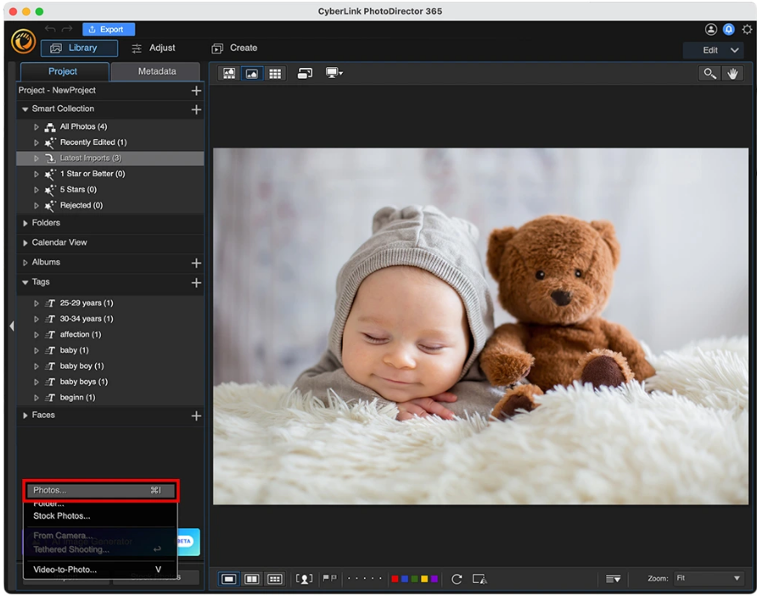

1. Click **Adjust** from the top menu, then navigate to **Global Adjustment Tools.**

From here you can edit pictures from color to Black and White, or adjust white balance, tone, shadows, sharpness, saturation, and more.

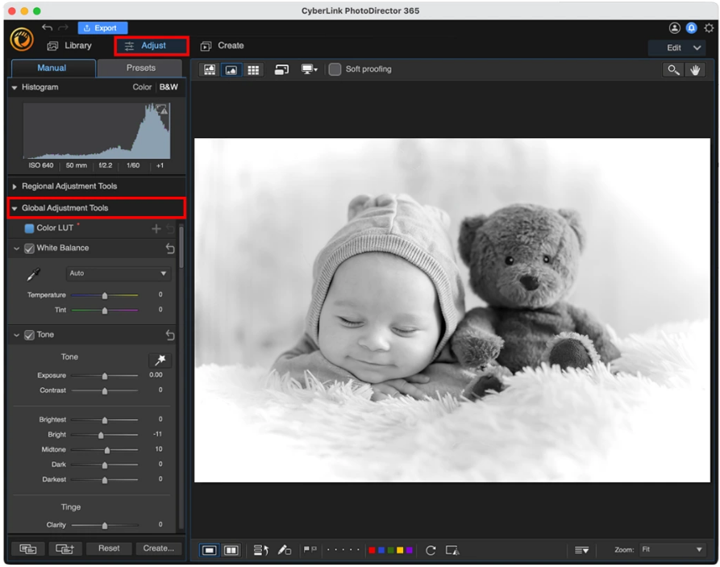

1. When you are done editing images, you can click **Create** in the bottom left to save your changes as a preset, or click the blue **Export** button to save your image.

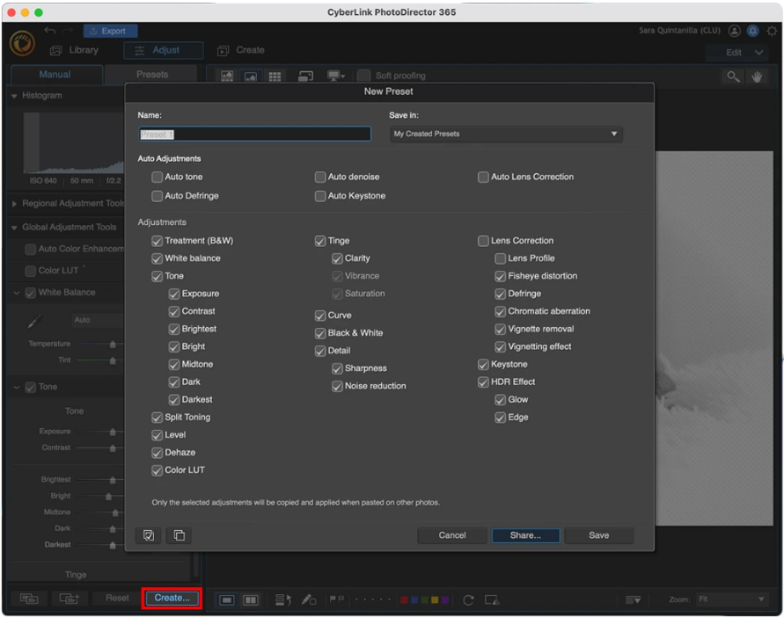

Using PhotoDirector’s Guided Tools makes editing images with advanced tools and adding visual effects effortless and straightforward. Anyone can edit pictures with these tools in a matter of minutes.

Here’s how to edit pictures with effects using PhotoDirector’s Guided Tools:

1. Launch PhotoDirector and choose **Edit.** Click on the **Guided** tab, then drag and drop your image onto the preview screen.

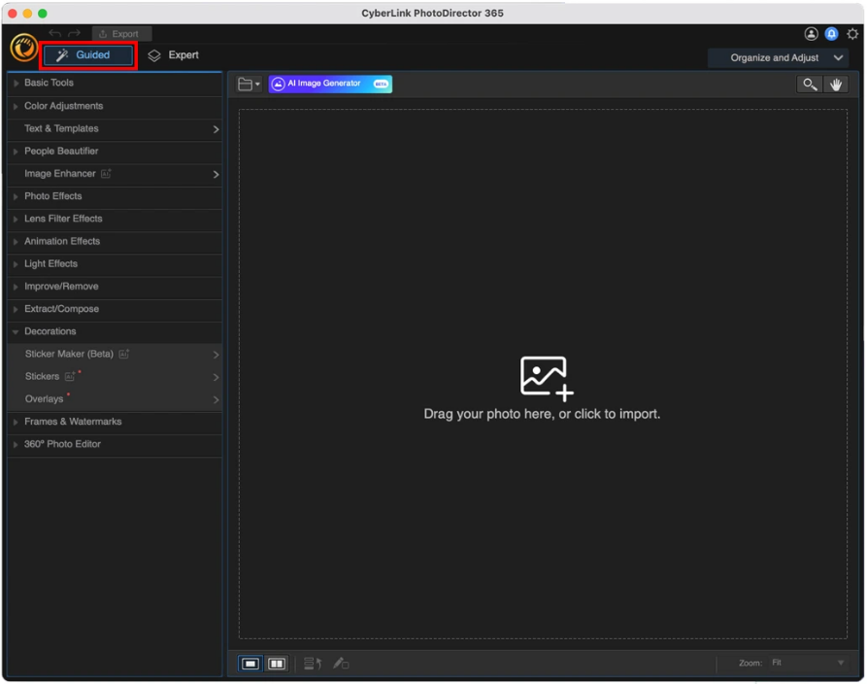

1. Scroll through all the categories and decide which tools you need to edit pictures. For this example, we will choose**Sky Replacement**.

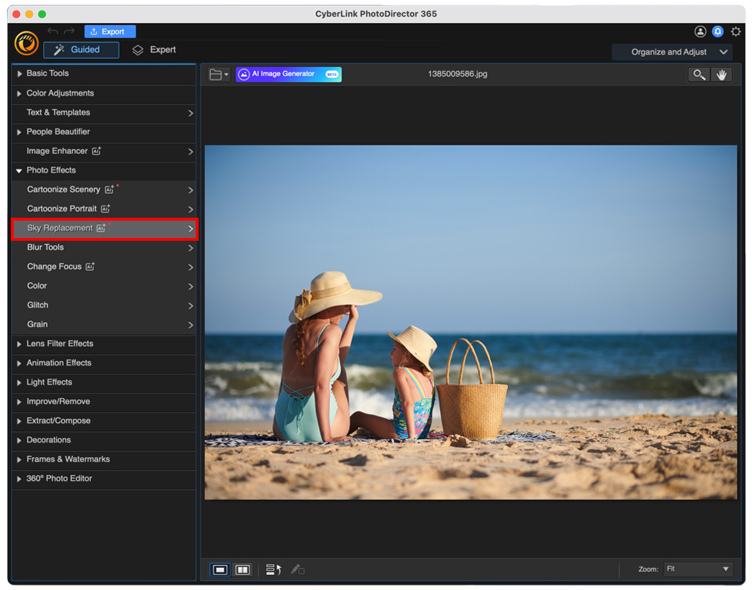

1. Select which sky template you would like to use. If you choose a sky with a cloud symbol in the bottom left corner, it will be animated. Click on any sky and it will automatically replace the sky in your photo. You can try out as many as you want.

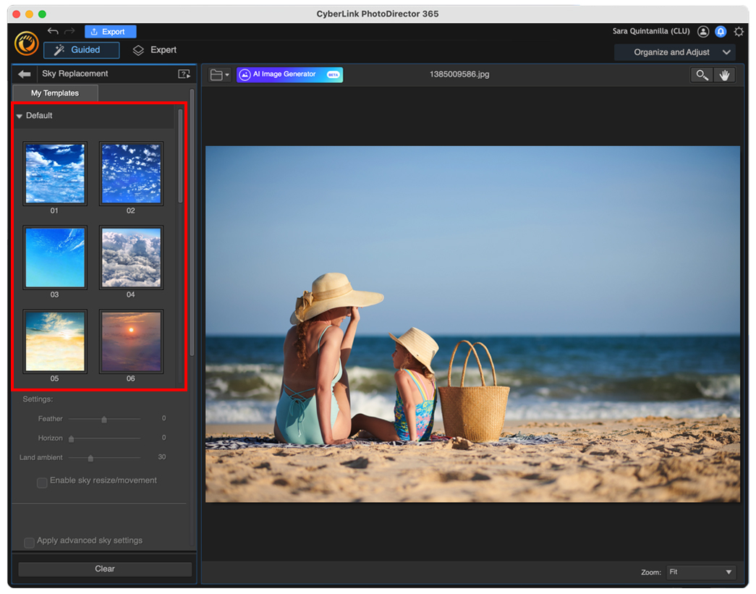

1. Use the**Sky Replacement Settings**to make any adjustments.

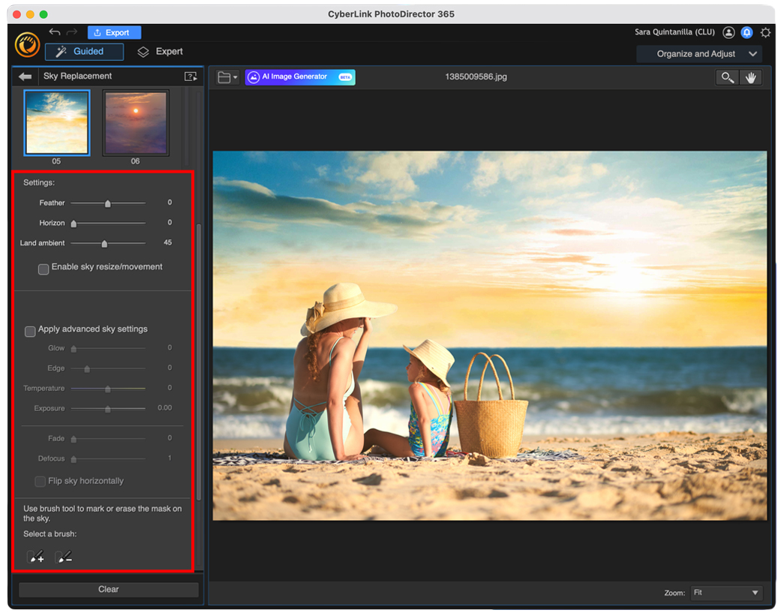

1. Click the blue **Export** button, then save your image as a **New Photo File** or **New Video/GIF File** if you used an animated sky.

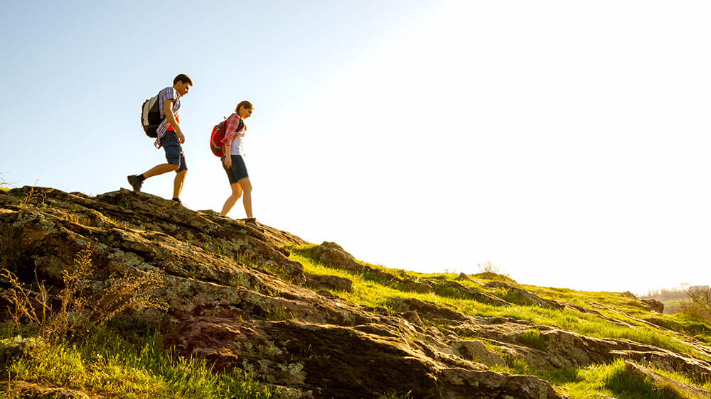

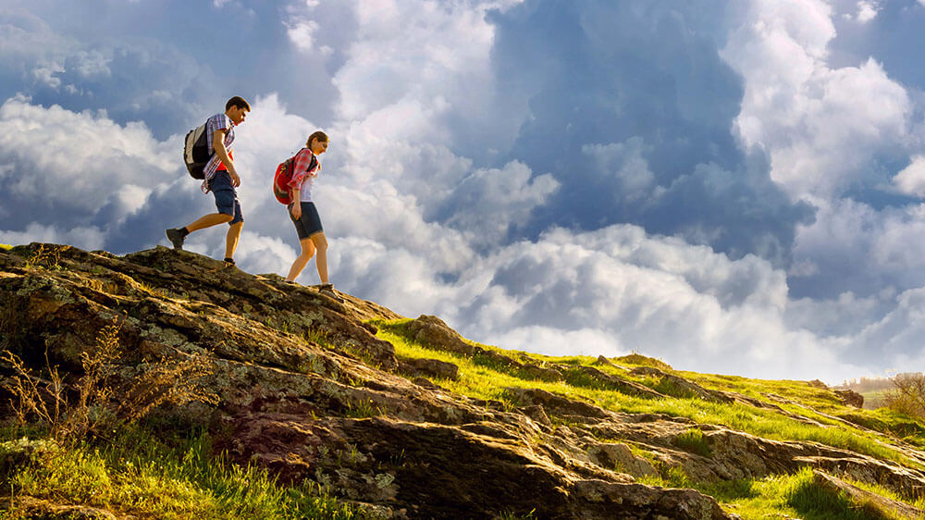

For more information on editing images with PhotoDirector, go to the [full tutorial here.](https://www.cyberlink.com/blog/5/10-easy-photo-editing-tips-for-pictures)

## Download the Best Photo Editing Software for Free

**Whether you enjoy snapping photos on your phone or have built a career as a professional photographer, you should demand the best from your free photo editing software.**Creating extraordinary Photoshop-like effects doesn't rely on having the most expensive, complex photo editing software around.

**PhotoDirector is the best free photo editor that allows you to animate photos, remove unwanted objects, change backgrounds, and edit with amazing special effects.**There are even beautification tools like body-slimming, skin smoothing, and teeth whitening. With so many tools and effects for editing images, PhotoDirector is surprisingly easy to use, with guided edits and tutorials when you need them.

No matter how much experience you have, PhotoDirector makes it easy to edit pictures with basic tools or advanced visual effects. From one-click corrections to AI-powered sky replacement and more, PhotoDirector guarantees an unmatched editing experience.

**Download PhotoDirector by clicking the link below and get started editing images for free today!**