**16 Best Free Photo Editing Apps for iPhone & Android in 2023**



We all try to take perfect photos right off the bat, but sometimes we just want to add that extra flash of pizzazz. Online photo editing software’s are great, but for most of us, using[**the best free mobile photo editor app for iPhone and Android**](https://www.perfectcorp.com/consumer/blog/photo-editing/best-free-photo-editing-apps-iphone-android#1650450323988-0-1) is the way to go.

Many good photo editing apps are free to use, allow you to edit your photos on the go with a mobile-friendly experience, and they make it easy to save and share your photos on your favourite social media app.

|  |
| --- |
| **Table of Contents**   * [**What Are the Best Free Photo Editing Apps**](https://www.perfectcorp.com/consumer/blog/photo-editing/best-free-photo-editing-apps-iphone-android#1650450323988-0) * [**Top 3 Free Photo Editing Apps Must Have**](https://www.perfectcorp.com/consumer/blog/photo-editing/best-free-photo-editing-apps-iphone-android#1650450323988-0-1) * [**16 Best Free Photo Editing Apps for iPhone & Android**](https://www.perfectcorp.com/consumer/blog/photo-editing/best-free-photo-editing-apps-iphone-android#1650450323989-4) * [**Why We Picked These Apps?**](https://www.perfectcorp.com/consumer/blog/photo-editing/best-free-photo-editing-apps-iphone-android#1650450323989-4-1) * [**Why Should You Edit Your Photos?**](https://www.perfectcorp.com/consumer/blog/photo-editing/best-free-photo-editing-apps-iphone-android#1650450323989-4-2) * [**Free Download the Best Photo Editing App**](https://www.perfectcorp.com/consumer/blog/photo-editing/best-free-photo-editing-apps-iphone-android#1650450323994-42) * [**How to Edit Photos on iPhone & Android**](https://www.perfectcorp.com/consumer/blog/photo-editing/best-free-photo-editing-apps-iphone-android#1650450323994-41) * [**FAQs**](https://www.perfectcorp.com/consumer/blog/photo-editing/best-free-photo-editing-apps-iphone-android#1650450323994-44) |

What Are the Best Free Photo Editing Apps?

Depending on your level of expertise, the best free photo editing app should make it easy to edit your photos exactly the way you want.

* For the **beginner editor**, that might mean **preset filters and fun animations**.
* For the **aspiring influencer**, it might mean **more advanced settings** and the ability to store your photos in the cloud.

Regardless of one’s aptitude and experience, the best photo editing app will cater to photo enthusiasts of all levels.

[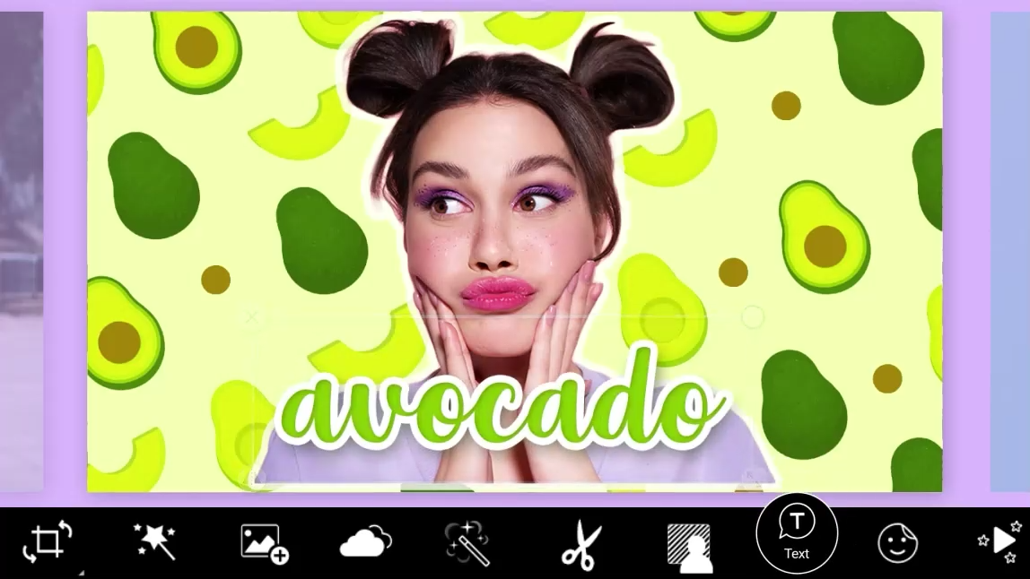](file:///D:\Applic\U3A\Groups\ComputerGroup\PhotoNPictureEditing\PhotoEditApps.mp4)

After taking several photo editing apps for a spin, we came to the conclusion that [YouCam Perfect](https://youperfect.page.link/PFwebsite_ycpblog" \t "_self) is the best app overall. It’s available for free download for both [iOS](https://youperfect.page.link/PFwebsite_ycpblog) and [Android](https://youperfect.page.link/PFwebsite_ycpblog), has a wide selection of photo editing and beautifying tools that don’t require professional skills, and is updated quite often with new features and materials. Its high rating calculated based on the opinions of other users further solidifies our opinion.

[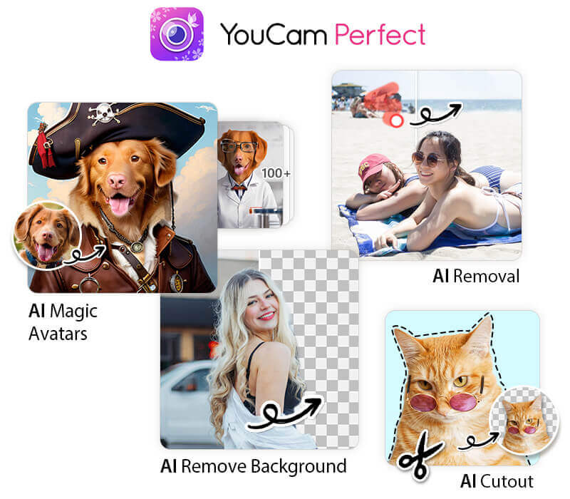](https://youperfect.page.link/PFwebsite_ycpblog)

[](https://youperfect.page.link/PFwebsite_ycpblog)

Top 3 Must-Have Free Photo Editing Apps

Check out three of our top picks for the best free photo editing apps for iPhone and Android users:

1. YouCam Perfect: Best Free Photo Editor App Overall

[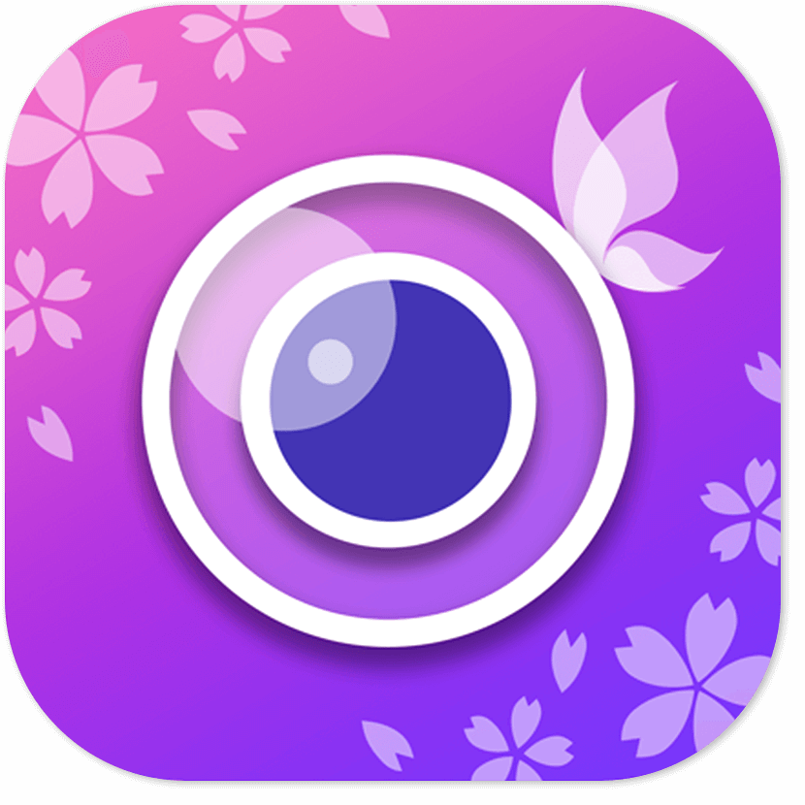](https://youperfect.page.link/PFwebsite_ycpblog)**YouCam Perfect is the best free photo editing app for iOS and Android users.** It provides all the powerful AI photo editing & beautifying tools you need. You can easily remove unwanted objects, remove and change backgrounds, apply aesthetic effects and filters, edit face shapes, and more!  
[Read Our Review >](https://www.perfectcorp.com/consumer/blog/photo-editing/best-free-photo-editing-apps-iphone-android#anchor_01)

[](https://youperfect.page.link/PFwebsite_ycpblog)

2. YouCam Makeup: Best Free Photo Editor App for Selfies

[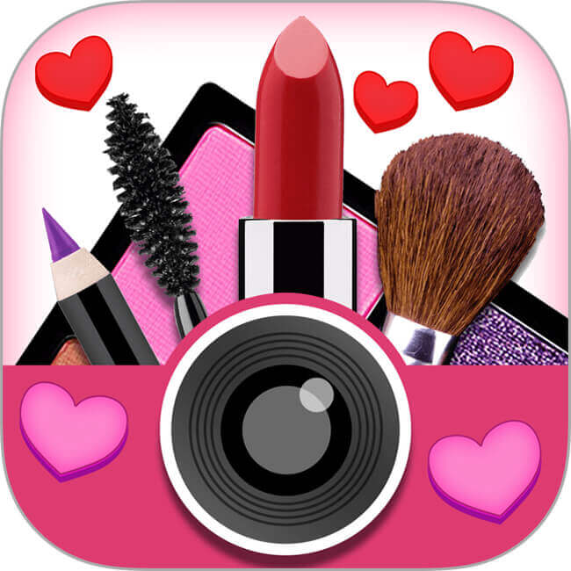](https://youmakeup.page.link/ycpblog_review)**YouCam Makeup is a popular selfie camera and face retouching app for iPhone and Android devices.** Users can apply makeup to their selfies and edit faces with numerous beauty filters, makeup tools, and face-shaping tools naturally and easily.  
[Read Our Review >](https://www.perfectcorp.com/consumer/blog/photo-editing/best-free-photo-editing-apps-iphone-android#anchor_02)

3. PhotoDirector: Best Free Photo Editor App for Animations

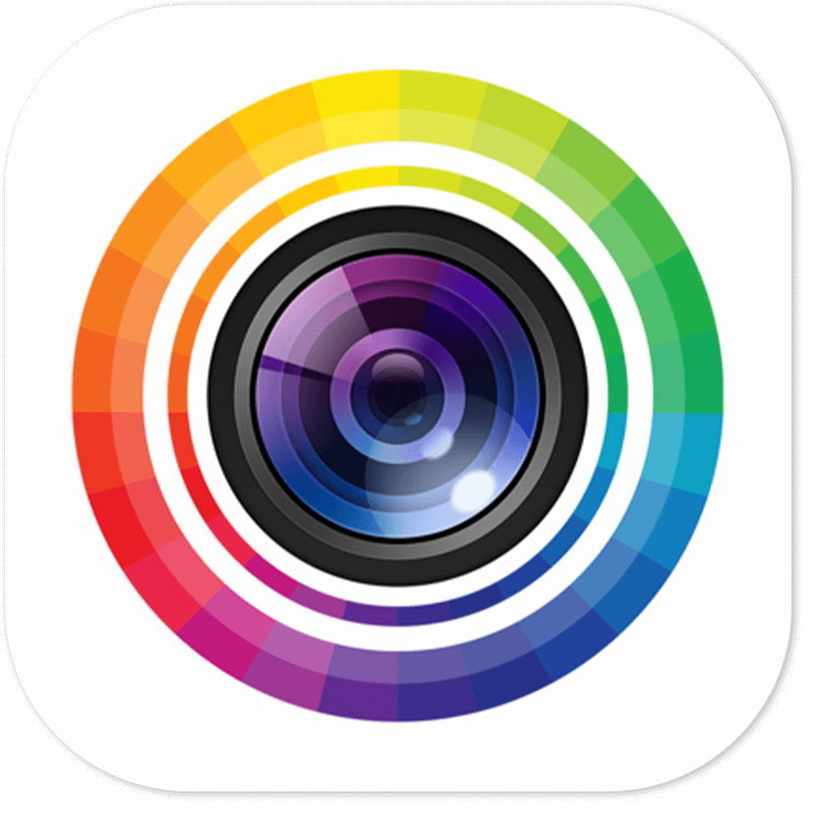**PhotoDirector** is a good photo editing app that lets you add animations to your photos with AI effects, collages, and other easy-to-use tools! [Read Our Review >](https://www.perfectcorp.com/consumer/blog/photo-editing/best-free-photo-editing-apps-iphone-android#anchor_03)

Discover Best Free Photo Editing Apps for iPhone & Android in 2023

Here’s our top list of the best free photo editing apps available for iPhone and Android in 2023:

1. [**YouCam Perfect**](https://www.perfectcorp.com/consumer/blog/photo-editing/best-free-photo-editing-apps-iphone-android#anchor_01)
2. [**YouCam Makeup**](https://www.perfectcorp.com/consumer/blog/photo-editing/best-free-photo-editing-apps-iphone-android#anchor_02)
3. [**PhotoDirector**](https://www.perfectcorp.com/consumer/blog/photo-editing/best-free-photo-editing-apps-iphone-android#anchor_03)
4. [**Adobe Lightroom Mobile**](https://www.perfectcorp.com/consumer/blog/photo-editing/best-free-photo-editing-apps-iphone-android#anchor_04)
5. [**Snapseed**](https://www.perfectcorp.com/consumer/blog/photo-editing/best-free-photo-editing-apps-iphone-android#anchor_05)
6. [**VSCO**](https://www.perfectcorp.com/consumer/blog/photo-editing/best-free-photo-editing-apps-iphone-android#anchor_06)
7. [**Picsart**](https://www.perfectcorp.com/consumer/blog/photo-editing/best-free-photo-editing-apps-iphone-android#anchor_07)
8. [**Photoshop Express Photo Editor**](https://www.perfectcorp.com/consumer/blog/photo-editing/best-free-photo-editing-apps-iphone-android#anchor_08)
9. [**Pixlr**](https://www.perfectcorp.com/consumer/blog/photo-editing/best-free-photo-editing-apps-iphone-android#anchor_09)
10. [**Afterlight**](https://www.perfectcorp.com/consumer/blog/photo-editing/best-free-photo-editing-apps-iphone-android#anchor_10)
11. [**Polarr**](https://www.perfectcorp.com/consumer/blog/photo-editing/best-free-photo-editing-apps-iphone-android#anchor_11)
12. [**Canva**](https://www.perfectcorp.com/consumer/blog/photo-editing/best-free-photo-editing-apps-iphone-android#anchor_12)
13. [**Prisma**](https://www.perfectcorp.com/consumer/blog/photo-editing/best-free-photo-editing-apps-iphone-android#anchor_13)
14. [**BeFunky**](https://www.perfectcorp.com/consumer/blog/photo-editing/best-free-photo-editing-apps-iphone-android#anchor_14)
15. [**Instasize**](https://www.perfectcorp.com/consumer/blog/photo-editing/best-free-photo-editing-apps-iphone-android#anchor_15)
16. [**Airbrush**](https://www.perfectcorp.com/consumer/blog/photo-editing/best-free-photo-editing-apps-iphone-android#anchor_16)

1. YouCam Perfect - Best Free Photo Editor & Selfie App

[](https://youperfect.page.link/PFwebsite_ycpblog)

**Price:**Free; provides photo editing & beautifying tools **Available:**[iOS and Android](https://youperfect.page.link/PFwebsite_ycpblog)  
**Overall Rating:**10/10 **Store Rating:** 4.8 on App Store; 4.4 on Google Play **Key Features:**

* AI Magic Avatar
* AI Cartoon Filter
* AI Object Removal
* AI Background Remover
* AI Body Tuner
* AI Fashion
* Aesthetic Effects and Filter
* Thousands of Collages & Templates
* Face Shaper

**YouCam Perfect** app is the best free photo editing app out there for all users. This free app allows you to edit photos and make collages, among many other creative features. Photos can be edited on either iPhone or Android with a wide variety of effects, animations, frames, and much more.

With YouCam Perfect's **Magic Avatar** feature, you can quickly create magical AI-generated avatars that reflect your personality and style. Additionally, you can effortlessly transform your photos into adorable cartoon-like images using the **AI Style** filters.

[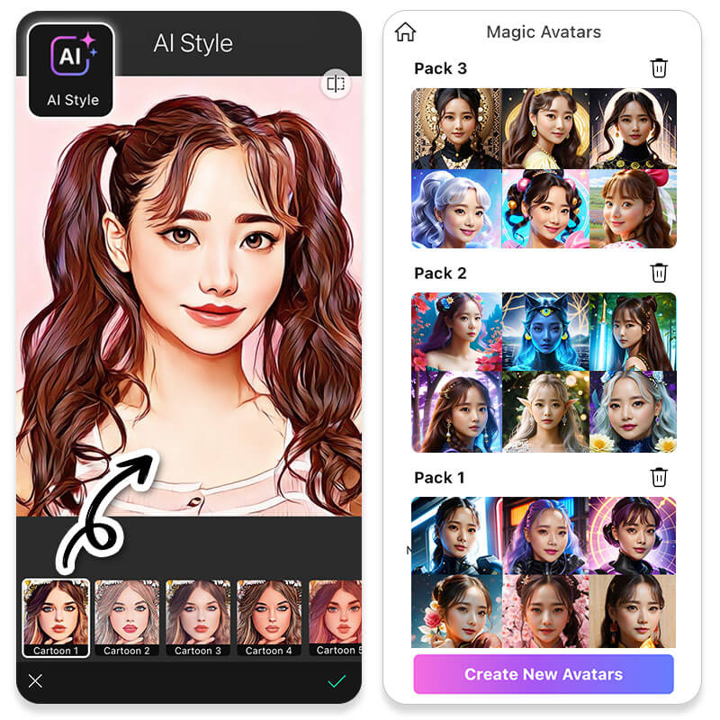](https://youperfect.page.link/PFwebsite_ycpblog)

With YouCam Perfect, you can [remove and change the background](https://www.perfectcorp.com/consumer/blog/photo-editing/how-to-remove-background-from-picture) of your photo or [replace the sky](https://www.perfectcorp.com/consumer/blog/photo-editing/skys-the-limit-best-app-for-dreamy-sky-editing) in your image with its advanced AI technology. If you need to make some [natural edits to your body](https://www.perfectcorp.com/consumer/blog/photo-editing/three-tips-on-how-to-retouch-a-photo-with-the-body-tuner-tool) due to bad angle or poor lighting, YouCam Perfect’s **Body Tuner** feature can help you with that. Have a person or object in the background of your photos that you’d rather have removed? Look no further than our **AI Object Removal** tool.

▼ Easy-to-use Editing Tools

YouCam Perfect offers **cartoon filters** to give photos a hand-drawn or cartoonish look. The **Remove BG** tool makes isolating subjects and adds new backgrounds easy. Combining these features allows users to add aesthetic backgrounds and cartoon effects with just a few taps.

[](https://youperfect.page.link/PFwebsite_ycpblog)

Pros

* [**Best all-in-one photo app for photo editing and collage maker**](https://www.perfectcorp.com/consumer/apps/ycp)
* Lots of ready-to-use editing content (i.e. [photo frames](https://www.perfectcorp.com/consumer/blog/photo-editing/best-free-photo-frame-app), [collages](https://www.perfectcorp.com/consumer/blog/photo-editing/the-best-free-app-for-creating-a-photo-collage), [stickers](https://www.perfectcorp.com/consumer/blog/photo-editing/ten-cute-free-animated-stickers-for-eye-catching-insta-pics), [filters](https://www.perfectcorp.com/consumer/blog/photo-editing/photo-filters-all-you-need-to-know) and more)
* Photo retouch features to [beautify selfies in a few taps](https://www.perfectcorp.com/consumer/blog/photo-editing/photo-retouch-tools-a-complete-guide-to-fixing-common-portrait-mistakes)
* [Remove and change background in 1 tap](https://www.perfectcorp.com/consumer/blog/photo-editing/remove-bg)
* Intuitive [multi-layer photo editing](https://www.perfectcorp.com/consumer/blog/photo-editing/how-to-add-photo)
* One-tap [AI object removal](https://www.perfectcorp.com/consumer/blog/photo-editing/How-to-Remove-Unwanted-Objects-in-Your-Photos)
* Create fun edits with [AI Cutout](https://www.perfectcorp.com/consumer/blog/photo-editing/how-to-use-the-cutout-tool-in-three-steps)tool
* Turn regular pics into[animated photo](https://www.perfectcorp.com/consumer/blog/photo-editing/Beginners-Guide-to-Photo-Animation)

Cons

* Not yet supports LUTs filter for professional photography usages
* Not yet supports split tone editing

Verdict

Lots of easy-to-use features allow users with little or no experience in photo editing to create amazing photos. Best for social buffs who always want their photos looking great on Instagram (or other social platforms). Adequate advanced editing features to help editing veterans to add the final touches to their pictures.

Explore More Photo Editing Tips:

* [Generate AI Magic Avatars](https://www.perfectcorp.com/consumer/blog/photo-editing/best-ai-magic-avatar-app)
* [Cartoonize a Picture](https://www.perfectcorp.com/consumer/blog/photo-editing/how-to-cartoonize-a-picture)
* [Make Image Transparent](https://www.perfectcorp.com/consumer/blog/photo-editing/transparent-background-maker)

2. YouCam Makeup – Best Face Editing App for Selfies

[](https://youmakeup.page.link/ycpblog_review)▲ YouCam Makeup app interface

**Price:** Free; provides trendy makeup looks & retouching tools **Available**: [iOS and Android](https://youmakeup.page.link/ycpblog_review) **Overall Rating:** 9/10  
**Store Rating:** 4.8 on App Store; 4.4 on Google Play

[YouCam Makeup](https://www.perfectcorp.com/consumer/apps/ymk) is a virtual makeover and selfie retouch editing app. You can change your hair color for a salon haircare experience and use tools for a complete makeover, including lip plumpers, teeth whitening, airbrush skin, etc. YouCam Makeup is an AR makeup camera app and selfie editor more than it’s a photo editing app. If you’re looking to retouch your photos like celebrities, this app is excellent.

Pros

* Several instant filter options
* Detailed editing options for all facial features
* Easy-to-use interface with little to no learning curve

Cons

* Mainly focus on selfie editing

Verdict

YouCam Makeup is a complete and fun-to-use makeup editor app. Most of the editing options are around beautifying or editing makeup. However, if you’re looking for a more advanced and comprehensive photo editing app, YouCam Perfect is the way to go.

3. PhotoDirector - Best & Creative Photo Editing App

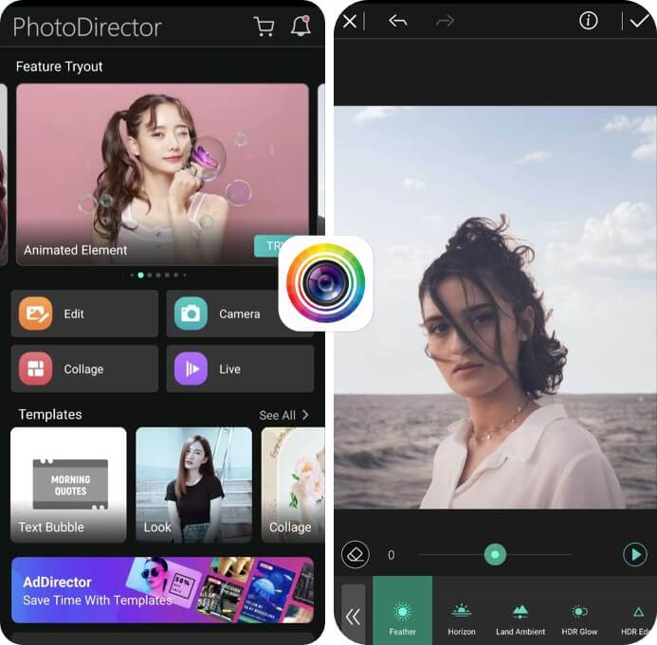▲ PhotoDirector app interface

**Price:** Free; $4.99 per month for premium features **Available:** [iOS](https://apps.apple.com/app/apple-store/id907366587?pt=352121&ct=pfblog&mt=8) and [Android](https://play.google.com/store/apps/details?id=com.cyberlink.photodirector&referrer=utm_source%3Dpfblog) **Overall Rating:**10/10 **Store Rating:** 4.6 on App Store; 4.4 on Google Play

**PhotoDirector** combines complete creative control, a user-friendly interface, and built-in royalty-free stock library provided by Shutterstock and iStock. No matter your experience level with PhotoDirector's professional-quality tools you can transform a quick snap into a stunning image in seconds.

It has all the basic editing tools you'll ever need like color grading, customizable collage templates, and [object removal](https://www.cyberlink.com/blog/photo-effects/368/remove-object-from-photo) tools. Advanced tools include [AI-powered sky replacement](https://www.cyberlink.com/blog/photo-effects/321/sky-replacement-photoshop) that lets you add flawless sunsets to your images. Or animate photos by drawing motion lines and placing anchor points for a customized animation or add already [animated stickers](https://www.cyberlink.com/blog/photo-effects/510/how-to-add-photo-animation-stickers) and decor to delight your followers. PhotoDirector also makes the most [popular Instagram effects](https://www.cyberlink.com/blog/photo-effects/294/photo-effects-instagram) easy to apply.

Pros

* Light and color adjustment tools
* Quick apply filters and effects
* AI sky replacement and light ray tools
* Photo and beauty retouch tools
* Animation tools and animated overlays
* AI technology
* Built-in stock libraries

Cons

* No teeth whitening feature
* No LUTs filter support

Verdict

PhotoDirector's user-friendly interface and straightforward functions simplify the editing process. No matter if you're editing one photo or hundreds, you can quickly upload, adjust, and create on the go with your phone or seamlessly transition to your Chromebook or tablet for edits at home.

**Download to bring your snaps to life.**

4. Adobe Lightroom - Best Pro Photo Editing App

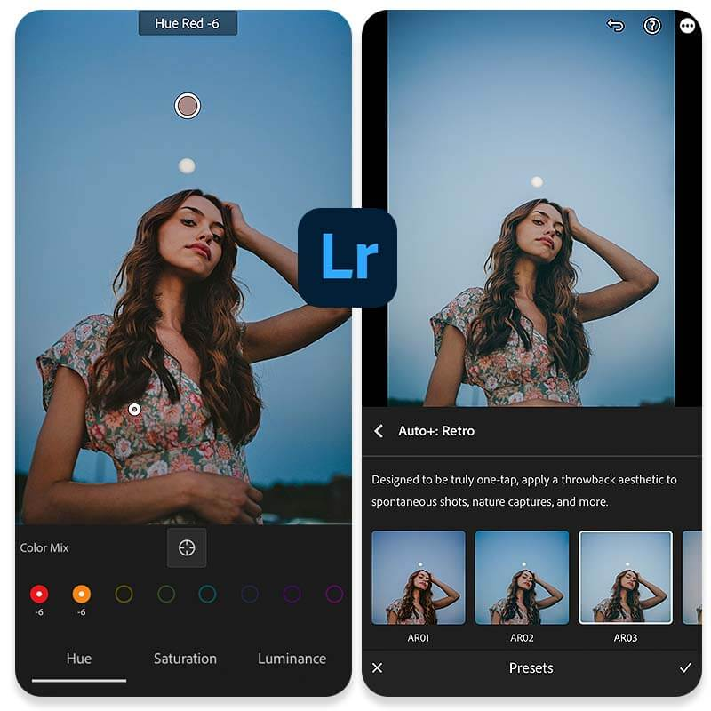▲ Lightroom app interface

**Price:** Free; $4.99 per month for premium features & 100GB cloud storage **Available:** iOS and Android  
**Overall Rating:**8/10  
**Store Rating:** 4.8 on App Store; 4.6 on Google Play

Professional photographers who are already integrated with the Adobe suite of software — Photoshop, [Lightroom](https://www.adobe.com/products/photoshop-lightroom.html" \t "_blank), and more — will find no learning curve with the Adobe Lightroom app. If you’re already familiar with Adobe products, this might be a good product for you, but newbies will want to explore one of the previous options.

Pros

* Pro-level camera (manual adjustments for ISO, Exposure, and more)
* Pro-level photo editing features (requires good levels of photography knowledge to make good use of it)

Cons

* Beautify and retouch features are absent
* Lack of photo collage, stickers, templates, backgrounds. Most decorative elements are absent in Lightroom

Verdict

Lightroom app is obviously targeting the highest skill level users. Professional photographers will find it right at home when using the editing app. Average users may find editing features in Lightroom difficult to understand.

👉 [**Click here to find 4 Best Free Lightroom Alternative Apps**](https://www.perfectcorp.com/consumer/blog/photo-editing/best-free-lightroom-alternative-apps)

5. Snapseed - Free Photo Editing App for Quick Edits

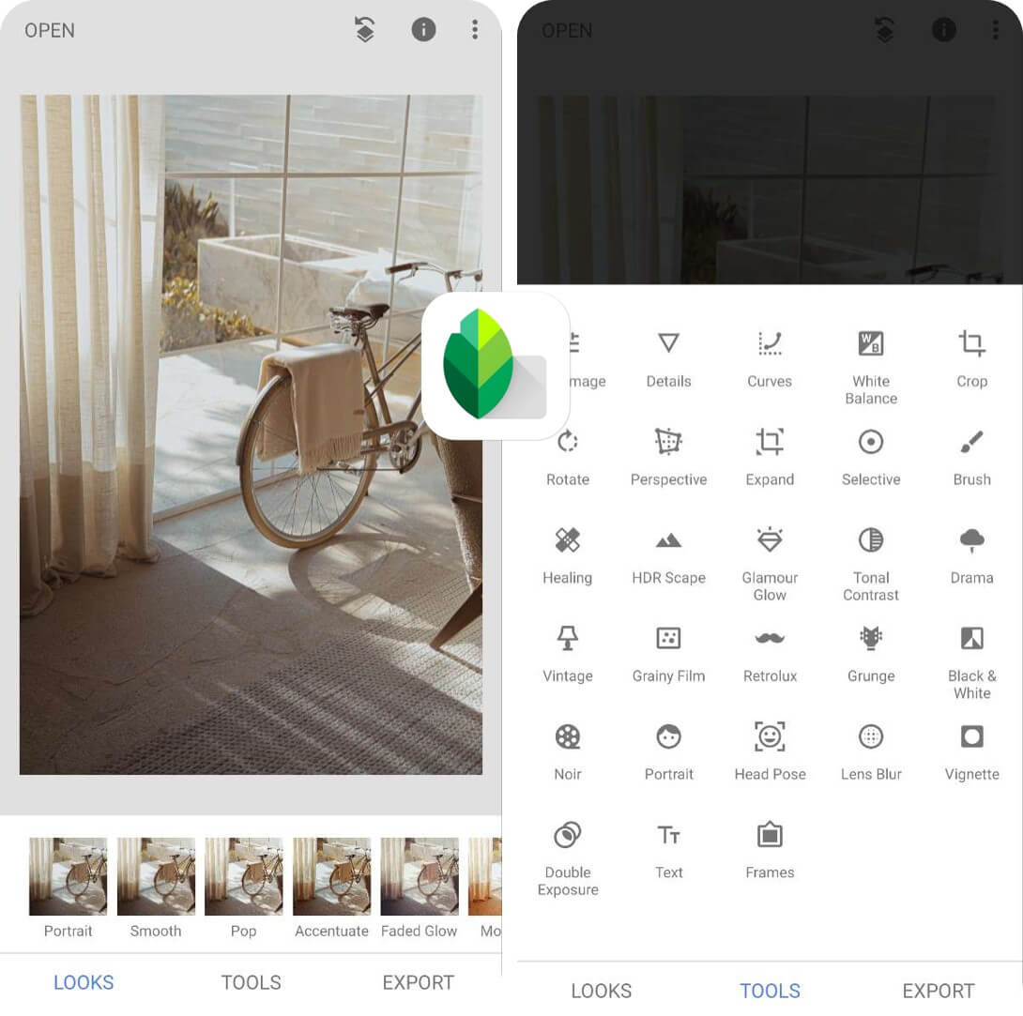▲ Snapseed app interface

**Price:** Free **Available:** iOS and Android  
**Overall Rating:**8.5/10  
**Store Rating:**3.6 on App Store; 4.4 on Google Play

If you want a quick and easy way to edit your pictures that doesn’t require too much trial and error, Snapseed is a great option for iPhone and Android users. This free photo editor app with no in-app purchases is a product of Google, even allowing users to create “ **presets**” that can then be saved and used for future picture edits.

Pros

* Pro-level editing tools with color curves, RAW editing, de-noise and more
* Great selection of color filters for photos

Cons

* Plain selection of editing elements (i.e. photo frames)
* Lack of photo collage, stickers, templates. Most decorative elements are absent in Snapseed

Verdict

Snapseed provides lots of picture editing tools derived from the more traditional photography usages. If you are a user with some levels of professional photography knowledge, you’ll certainly find the tools in Snapseed highly familiar.

6. VSCO - Best Photo Editing App for Filters

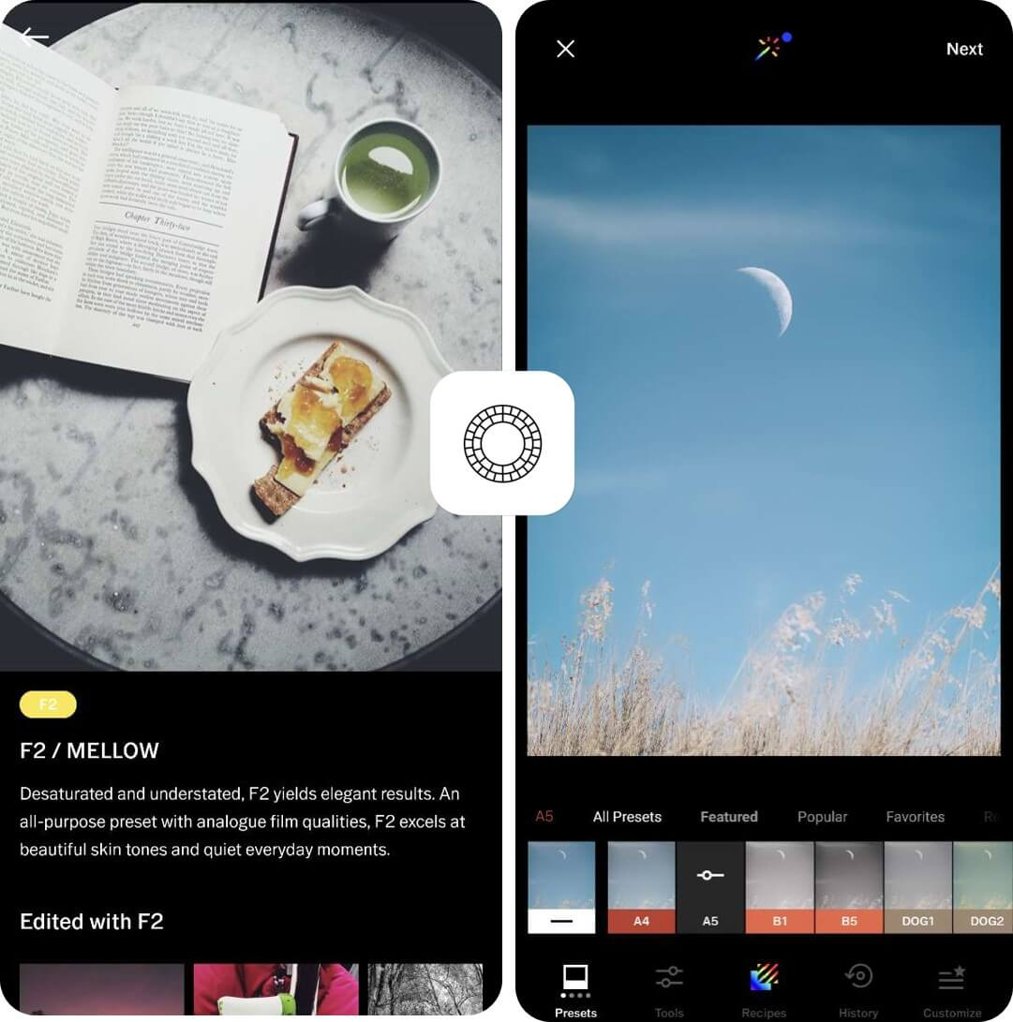▲ VSCO app interface

**Price:** Free; $7.99 per month for premium features **Available:** iOS and Android  
**Overall Rating:**7.5/10  
**Store Rating:** 4.7 on App Store; 3.4 on Google Play

While [VSCO](https://www.vsco.co/) app became very popular for the “**VSCO girl**” vibe, its success came more from the ability to offer editors easy and trendy photo editing options. This best free photo editing app is a good choice for iPhone or Android users who have their own unique style, and who know how they want to show it in their photos.

Pros

* Excellent LUT filter support
* Great selection of color filters for photos and videos
* Good split tone tool
* Include basic video editing features (available for paid users only)

Cons

* Lack of other photo editing features besides color filters

Verdict

VSCO is made to target users with a very specific need for color filtering (for photo and video). If you want more picture editing features than color filters, [look elsewhere](https://www.perfectcorp.com/consumer/blog/photo-editing/best-free-photo-editing-apps-iphone-android#anchor_01).

7. Picsart - Best Photo & Video Editing App

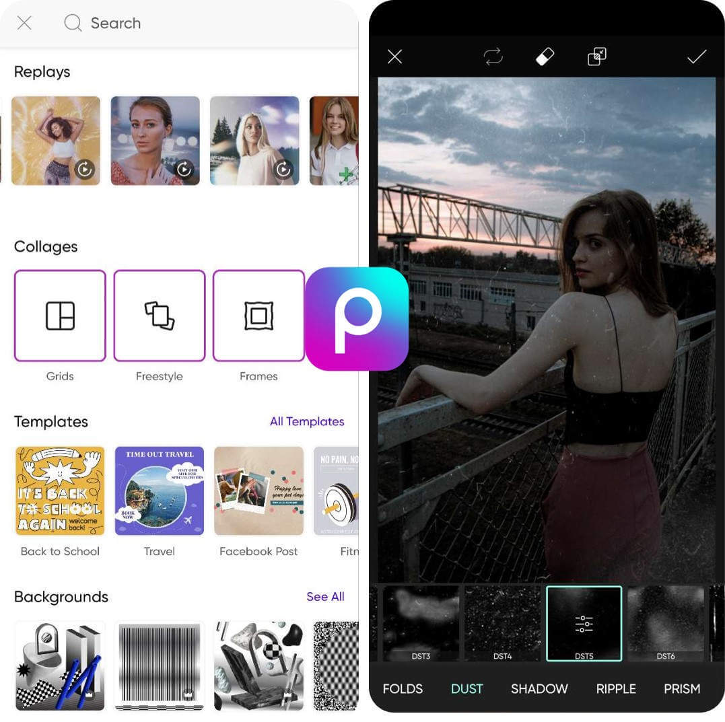▲ Picsart app interface

**Price:** Free; $7.99 per month for premium features **Available:** iOS and Android  
**Overall Rating:**8/10  
**Store Rating:** 4.7 on App Store; 4.1 on Google Play

For those iPhone or Android users who are looking for a bolder and striking picture editing app, [Picsart](https://picsart.com/" \t "_blank) is a good bet. With over 100 fonts, templates, and stickers available for free, and more than 1,000 with the paid subscription, there is no shortage of ways you can customize your photos.

Pros

* Lots of downloadable content for photo editing
* Great selection of tools for photo editing and portrating retouch
* Easy-to-use with pre-made templates

Cons

* Most free downloadable content are not professionally made
* Live retouch is not available in camera mode

Verdict

Picsart a good all-round photo editing app for everyday uses. However, if you are looking for a more advanced and more sophisticated camera mode with **live retouch capabilities**, there are better options to choose (e.g. [YouCam Perfect](https://youperfect.page.link/PFwebsite_ycpblog" \t "_self)).

8. Photoshop Express Photo Editor - Best Photo Editing App for Advanced Edits

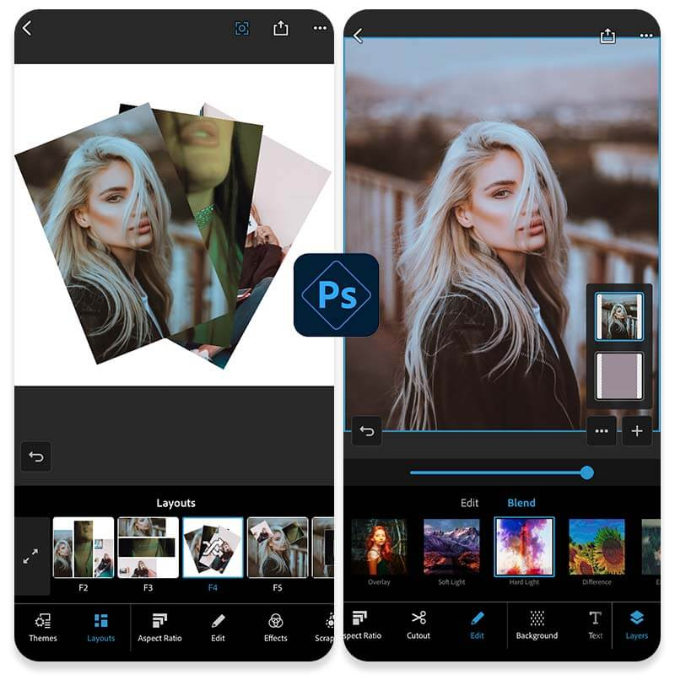▲ Photoshop app interface

**Price:** Free; $4.99 per month for premium features **Available:** iOS and Android  
**Overall Rating: 9**/10  
**Store Rating:** 4.4 on App Store; 4.3 on Google Play

The mobile version of the popular photo editing software packs a lot of features and is a logical choice for frequent [Photoshop](https://www.adobe.com/products/photoshop.html) users. However, to gain access to all of its features, you will need to purchase a PS Express Premium subscription. The mobile editing app offers such handy picture editing tools as selective editing, background replacement, themes for photos and collage, scrapbook for collage, retouch and more.

Pros

* Wide selection of professional photo editing tools to enhance and adjust your images
* User-friendly interface
* Can edit RAW files

Cons

* Limited retouch options
* Need to pay to access a lot of features

Verdict

If you’re a devoted Photoshop fan, this app might be for you as it is closely related to the desktop version. Photoshop Express Photo Editor offers a decent selection of photo editing tools that go beyond most basic features, so you can freely express your creativity. However, if you’re not too familiar with Adobe Photoshop suite, there’s a bit of a learning curve and you might opt for a simpler photo editing app instead.

👉 [Click here to find](https://www.perfectcorp.com/consumer/blog/photo-editing/best-lightroom-alternatives-for-nobile-photo-editing)[**5 Best Photoshop Alternative Tools to Edit Your Photos**](https://www.perfectcorp.com/consumer/blog/photo-editing/top-five-alternatives-to-popular-photoshop-photo-editing-tools)

9. Pixlr - Best Photo Editing App for Easy Editing

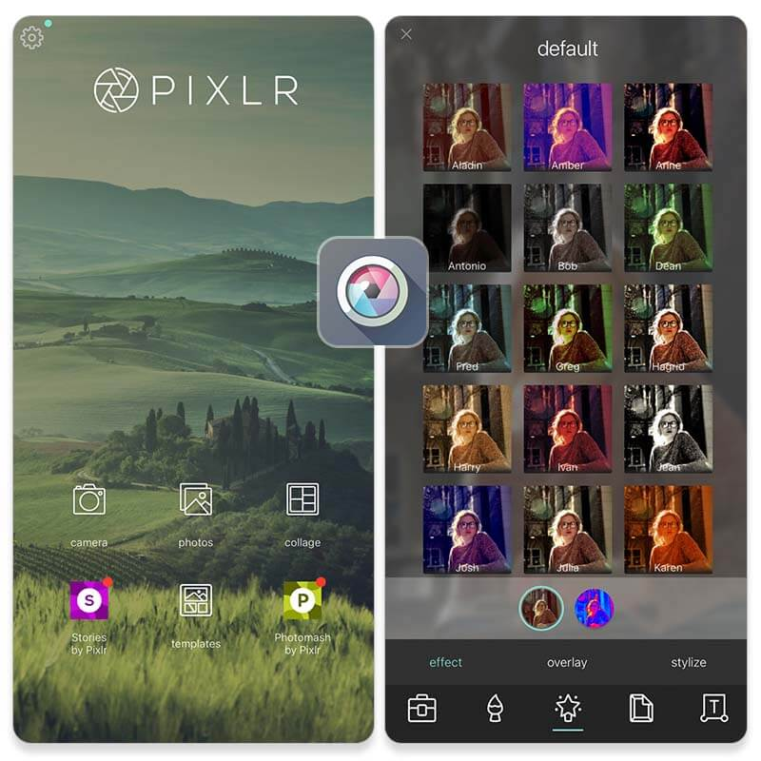▲ Pixlr app interface

**Price:** Free; $1.99 per month for premium features **Available:** iOS and Android **Overall Rating:** 6/10  
**Store Rating:** 3.6 on App Store; 4.1 on Google Play

[Pixlr](https://pixlr.com/) (formerly Pixlr Express) is one of the best free photo editing apps available for both iOS and Android. It offers a wide range of features, including auto lighting controller and blur tool. The app can provide quick and easy editing results while also preserving image quality.

Pros

* User-friendly interface
* Auto lighting adjustment

Cons

* The app isn’t as comprehensive as the desktop version
* Infrequent updates to app content
* Need to pay for premium version

Verdict

With a range of editing tools and an easy-to-use interface, Pixlr allows you to quickly enhance your photos.

10. Afterlight - Best Free Photo Editing App with Film Filters

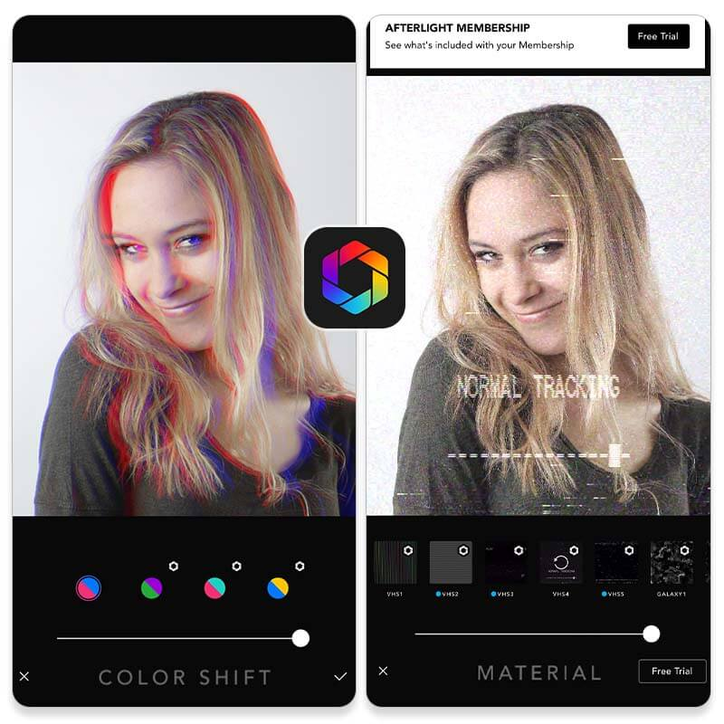▲ Afterlight app interface

**Price:** Free; $2.99 per month for premium version

**Available:**iOS and Android

**Overall Rating:** 7/10

**Store Rating:** 4.7 on App Store; 3.7 on Google Play

Afterlight is one of the best free photo editing apps available for both iPhone and Android users. It has a wide selection of features and tools to help you edit your photos, from basic color corrections to more advanced image manipulation and aesthetic filters.

Pros:

* Easy-to-use interface
* Hundreds of unique preset filters
* No Internet access is required

Cons:

* May not have as many features as more advanced photo editing apps.
* Need to pay for premium version

Verdict:

Afterlight provides a range of editing tools that you can use to quickly enhance your photos. With full access to the Afterlight filter library, you can quickly find a filter you like and create stunning images in no time.

11. Polarr - Best Photo Editing App with Trending Filters

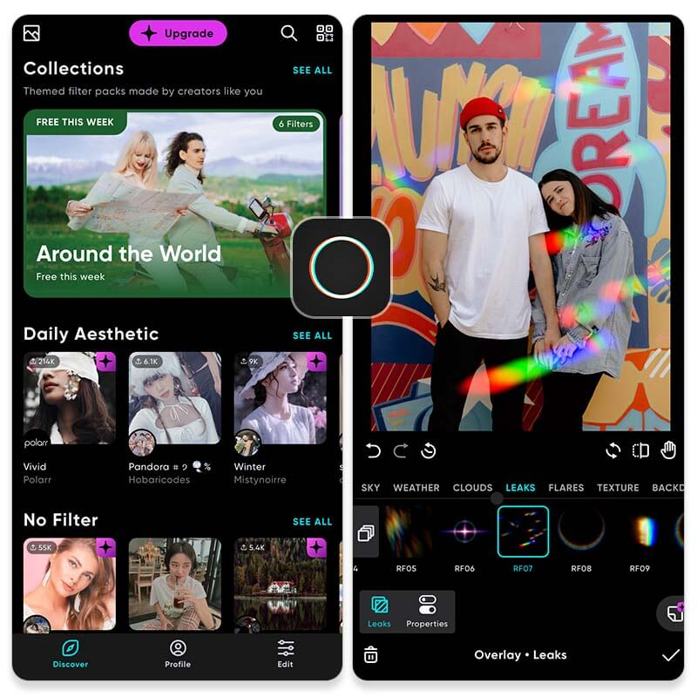▲ Polarr app interface

**Price:** Free; $3.99 per month for premium version **Available:** iOS and Android **Overall Rating:**7/10  
**Store Rating:** 4.7 on App Store; 3.6 on Google Play

[Polarr](https://www.polarr.com/) Photo Editor has a wide range of tools to enhance and adjust your images, making it one of the best free photo editing apps on the market. It has an impressive selection of photo editing tools and effects and is equipped with a user-friendly interface. With the mobile version, you can do basic color correction, add text, apply filters, and more.

Pros

* User-friendly interface and design
* Wide selection of features and tools to edit photos
* Ability to create and share your own filters

Cons

* May have a steep learning curve for those who are new to photo editing.
* Some features may require a paid subscription.

Verdict

Polarr Photo Editor is great for both beginner and advanced photographers. This powerful photo editing app offers an impressive range of editing tools, including filters, adjustments, and masks, as well as an intuitive user interface.

12. Canva – Free Photo Editing App for Graphics

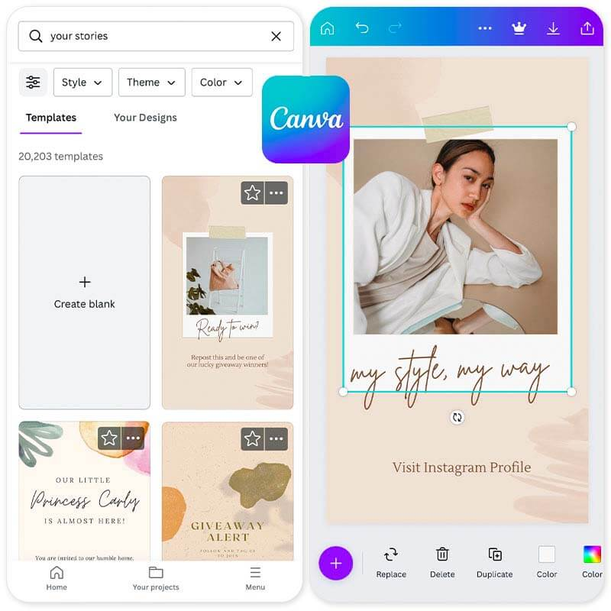▲ Canva app interface

**Price:** Free; $12.99 per month for premium content **Available:** iOS and Android  
**Overall Rating:**6.8/10  
**Store Rating:** 4.9 on App Store; 4.8 on Google Play

[Canva](https://www.canva.com/en/) is a free photo and video editor app focused on graphic design. You can create anything from social media posts, videos, flyers, photo collages, etc. Canva features thousands of templates to help you edit your photos. The photo editing feature lets you crop, flip, and adjust details in a few steps. Canva was created to make everyone feel like a graphic designer, so don’t be discouraged if you don’t find many photo editing features like you would in most apps.

Pros

* Several template options to choose from
* Free text, graphic, and photo options

Cons

* Limited photo editing options
* Several premium-only features
* The mobile app is challenging to use

Verdict

Overall, Canva is a fantastic graphic design tool for non-professionals. However, when it comes to photo editing, the options are limited. Besides adjusting brightness, saturation, and other fundamental elements, Canva lacks many of the features available in popular photo editing apps.

👉 [**Click here to find 4 Apps Like Canva for Photo Collage**](https://www.perfectcorp.com/consumer/blog/photo-editing/best-apps-like-canva)

13. Prisma - Best Free Photo Editing App with AI Art Effect

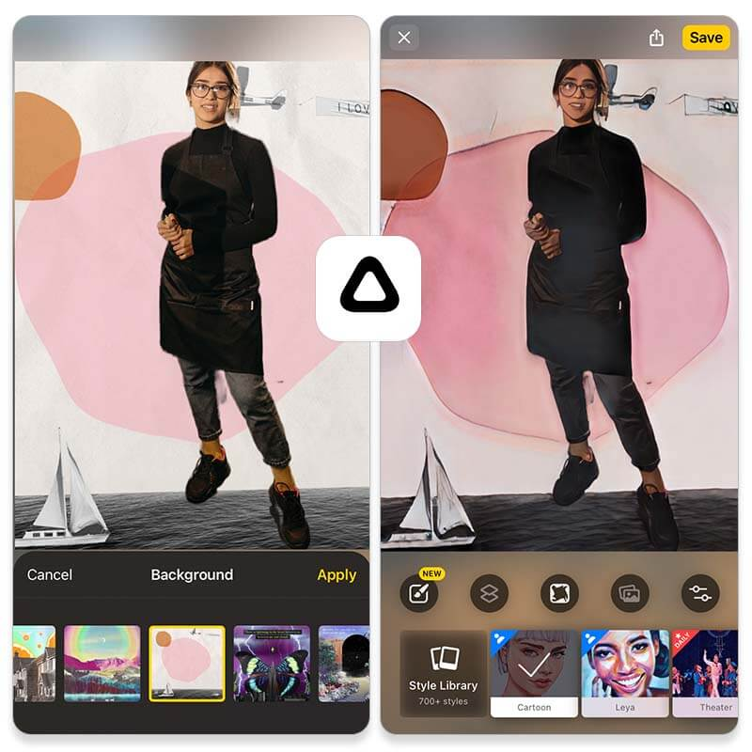▲ Prisma app interface

**Price:** Free; $2.99 per month for premium version

**Available:** iOS and Android

**Overall Rating:** 6.8/10

**Store Rating:** 4.7 on App Store; 4.5 on Google Play

Prisma Photo Editor is one of the best free photo editing apps. It has hundreds of unique filters allowing you to transform your photos into works of art with its filters and effects.  The best thing about Prisma Photo Editor is that it has a very straightforward and easy-to-use interface and can be used by both beginners and experienced photographers alike.

Pros:

* Easy-to-use interface
* Turn photos into paintings with AI

Cons:

* Some filters include ads.
* No before-and-after view while editing
* Only supports square images

Verdict:

Prisma is a fun photo editing app that's all about creativity. With its wide range of filters and effects, you can easily transform your photos into works of art.

14. BeFunky - Best Photo Editing App with Unique Features

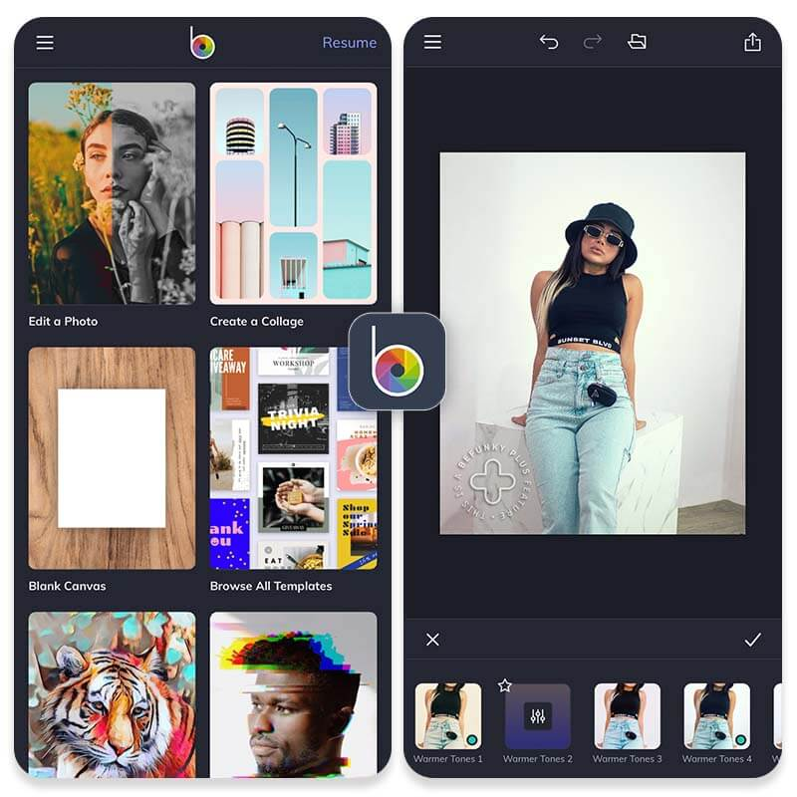▲ BeFunky app interface

**Price:** Free (with in-app purchases); basic editing is free

**Available:** iOS and Android

**Overall Rating:** 7.5/10

**Store Rating:** 4.6 on App Store; 4.3 on Google Play

[BeFunky](https://www.befunky.com/) is a free photo editing app with unique features that allow you to add color splash effects, design your own graphics, and create custom collages. Basic editing is free, but some features require a subscription.

Pros:

* Unique editing features
* Customizable collages
* Photo enhancer

Cons:

* Some features require a subscription

Verdict:

If you're looking for an easy to use photo editor with some unique features, BeFunky is a great option. The downside is that some of the best features require a subscription.

15. Instasize - Best Social Photo Editing App

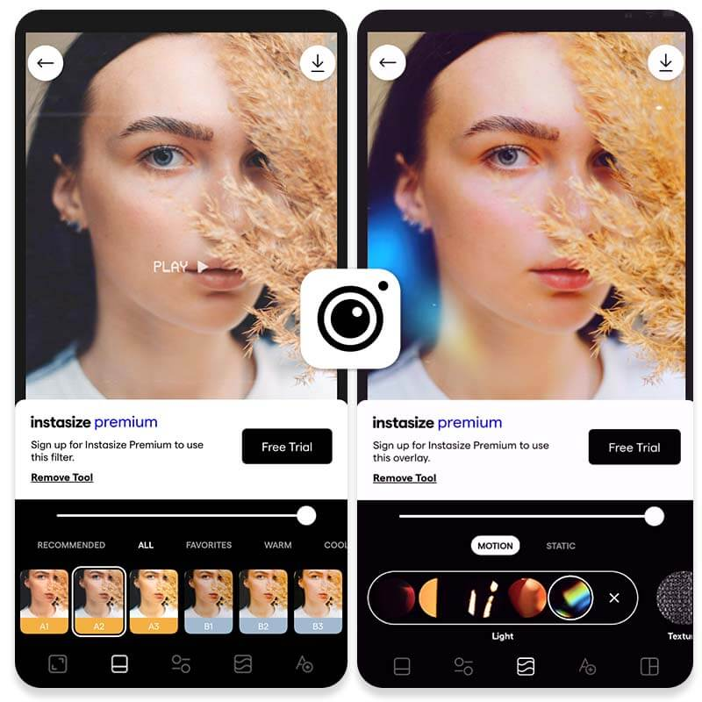▲ Airbrush app interface

**Price:** $4.99 per month for all features and tools **Available:** iOS and Android  
**Overall Rating:**6.5/10  
**Store Rating:** 4.6 on App Store; 4.3 on Google Play

Some of you might have used this photo editor app when you were trying to post a full-sized photo on Instagram without cropping it. In addition to resizing options, [Instasize](https://instasize.com/" \t "_blank) offers a variety of filters, common adjustment and beautifying tools, text feature, collages, and basic frames. However, in order to access some of the app’s best features, you need to purchase a premium subscription. Also, Instasize allows you to edit videos as well, which is a nice bonus.

Pros

* Works equally well for photos and videos
* Simple and straightforward user interface
* Quick and easy social content creation

Cons

* A lot of features require premium subscription
* No stickers, object removal, or animation features

Verdict

Instasize is a useful app when you need to quickly edit your photos or videos for social media and, most importantly, make sure that they fit the required dimensions without cropping. The app delivers good user experience, but in terms of editing features, there are many apps out there that offer more advanced and versatile editing & beautifying capabilities.

16. AirBrush - Best Photo Retouch Editing App

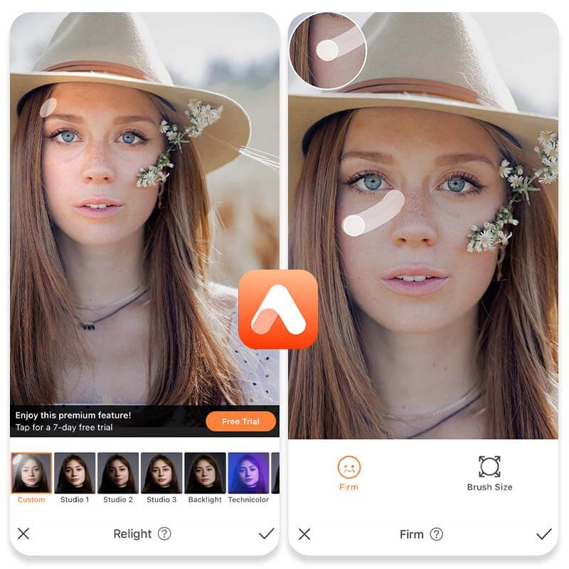▲ Airbrush app interface

**Price:** Free; $3.99 per month for all features **Available:**iOS and Android **Overall Rating:**6.5/10 **Store Rating:**4.9 on App Store; 4.3 on Google Play

[AirBrush](https://appairbrush.com/) is a versatile photo editing app ideal for selfies and portraits. It offers a bundle of picture editing and beautifying tools that will help you create aesthetically pleasing selfies. There are some unique features, such as Relight and Prism, as well as classic retouch tools and even virtual makeup and hair options. You can also erase objects from your photos and choose an alternate background. Similarly to the apps mentioned above, premium subscription is required to access a lot of features.

Pros

* Quick and easy selfie photo editing with retouch and makeup tools
* My Kit option for faster access to favorite editing tools
* User-friendly interface

Cons

* Works best for portraits and selfies; general photo editing tools are quite limited
* Many features require premium subscription

Verdict

If you’re looking for a free photo editor app to enhance your selfies on iPhone or Android phones, AirBrush could be a good choice. It has a wide selection of beautifying tools that will take your portraits and selfies to the next level. Also, you can easily share edited photos on your favorite social media platforms. However, if you need a more advanced photo editor to work on different types of images, you might want to explore other options.

Why We Picked These Apps?

No photo editing app is created equal and there seems to be more options to choose from than stars in the sky. Undoubtedly, finding the right photo editing app for your needs can be time consuming and overwhelming. So, when compiling our list, we decided to focus on certain criteria that we hope will make the decision making process much easier. We took into consideration such indicators as:

* **User interface and how easy it is to navigate the app**
* **Frequency of app updates**
* **Rating**
* **Cost**
* **Number of photo editing features and app’s versatility**

Why Should You Edit Your Photos?

When it comes to photography, it’s hard to get it right on the first try. That’s why photo editing is so important. It allows you to **fix common camera errors**, **correct colors**, **change the background**, **add a personal touch**, as well as develop personal style and aesthetic, which is particularly important in the age of social media.

Download YouCam Perfect: Best Free Photo Editing App for iPhone & Android

If you find yourself unsure of which photo editing app to go with, our pick is YouCam Perfect. With its variety of [effects](https://www.perfectcorp.com/consumer/blog/photo-editing/photo-filters-all-you-need-to-know), [templates](https://www.perfectcorp.com/consumer/blog/photo-editing/best-free-template-maker-app), [animations](https://www.perfectcorp.com/consumer/blog/photo-editing/Beginners-Guide-to-Photo-Animation), [frames](https://www.perfectcorp.com/consumer/blog/photo-editing/best-free-photo-frame-app), and more, everyone who wants to jazz up their photos can do so with the YouCam Perfect app. Perfect for beginners, experts, and everyone in between, this app is the ideal photo editor choice for making your photos the most beautiful they can be. Start creating amazing photos today by [**downloading the YouCam Perfect app for mobile photo editing**](https://youperfect.page.link/PFwebsite_ycpblog).

How to Edit Photos on iPhone & Android

[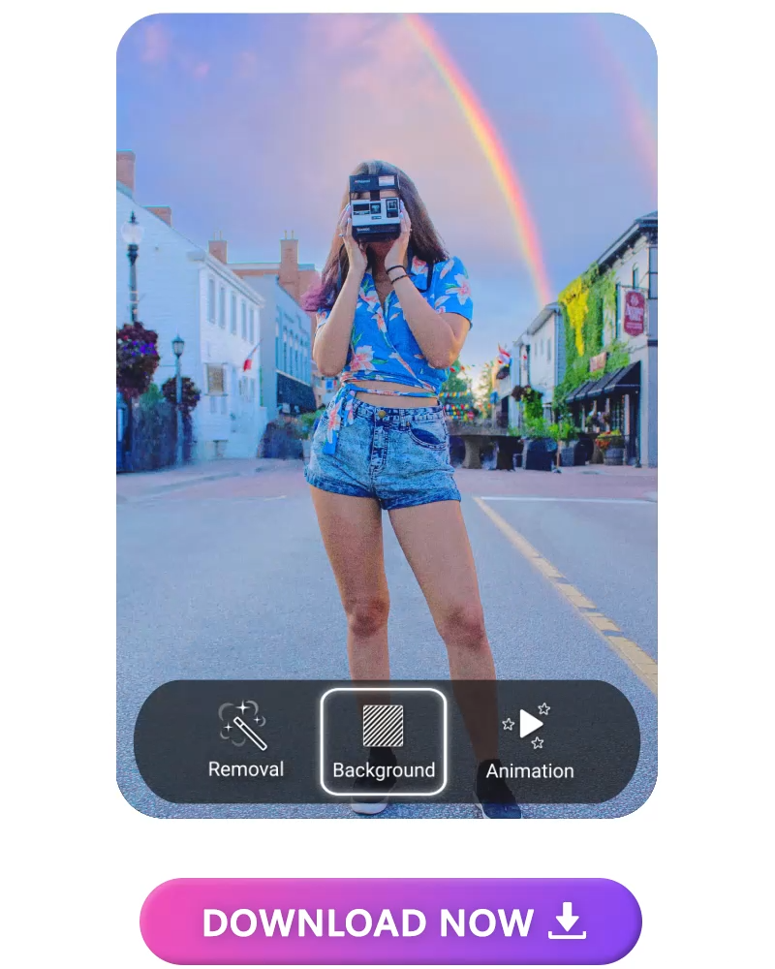](file:///D:\Applic\U3A\Groups\ComputerGroup\PhotoNPictureEditing\PhotoEditing2.mp4)

Learn how to edit photos with filters, frames, and more on your mobile device.

* Step 1. [Download a best free photo editing app like YouCam Perfect](https://youperfect.page.link/PFwebsite_ycpblog)
* Step 2. Open the photo you want to edit.
* Step 3. Click **Photo Edit**.
* To add a filter, click **Filter** in **Effects**.
* To manually adjust exposure, lighting, color, or contrast, click **Adjust**.
* To remove unwanted objects or person in your photo, click **Removal**.
* Step 4. At the top right, click **Save**.

More Best Free App Posts:

* [**Best Object Removal Apps for iPhone & Android**](https://www.perfectcorp.com/consumer/blog/photo-editing/best-object-removal-apps)
* [**Best Image Background Removers for iPhone & Android**](https://www.perfectcorp.com/consumer/blog/photo-editing/best-free-image-background-removers)
* [**Best Lightroom Apps for iOS & Android**](https://www.perfectcorp.com/consumer/blog/photo-editing/best-free-lightroom-alternative-apps)
* [**Best Photo Filter Apps for iPhone & Android**](https://www.perfectcorp.com/consumer/blog/photo-editing/best-photo-filter-apps)
* [**Best Photoshop Apps for iPhone & Android**](https://www.perfectcorp.com/consumer/blog/photo-editing/best-photoshop-apps)
* [**Best Photo Collage Apps for iPhone & Android**](https://www.perfectcorp.com/consumer/blog/photo-editing/best-photo-collage-apps)

Best Free Photo Editor App FAQs

Which is the No 1 photo editing app?

Here are our top picks of the best photo editing apps in 2023:

* [**YouCam Perfect**](https://www.perfectcorp.com/consumer/blog/photo-editing/best-free-photo-editing-apps-iphone-android#anchor_01)
* [**YouCam Makeup**](https://www.perfectcorp.com/consumer/blog/photo-editing/best-free-photo-editing-apps-iphone-android#anchor_02)
* [**PhotoDirector**](https://www.perfectcorp.com/consumer/blog/photo-editing/best-free-photo-editing-apps-iphone-android#anchor_03)

Which app is best for photo editing?

Check out all of our recommendations for the best photo editing apps:

1. [**YouCam Perfect**](https://www.perfectcorp.com/consumer/blog/photo-editing/best-free-photo-editing-apps-iphone-android#anchor_01)
2. [**YouCam Makeup**](https://www.perfectcorp.com/consumer/blog/photo-editing/best-free-photo-editing-apps-iphone-android#anchor_02)
3. [**PhotoDirector**](https://www.perfectcorp.com/consumer/blog/photo-editing/best-free-photo-editing-apps-iphone-android#anchor_03)
4. [**Adobe Lightroom Mobile**](https://www.perfectcorp.com/consumer/blog/photo-editing/best-free-photo-editing-apps-iphone-android#anchor_04)
5. [**Snapseed**](https://www.perfectcorp.com/consumer/blog/photo-editing/best-free-photo-editing-apps-iphone-android#anchor_05)
6. [**VSCO**](https://www.perfectcorp.com/consumer/blog/photo-editing/best-free-photo-editing-apps-iphone-android#anchor_06)
7. [**Picsart**](https://www.perfectcorp.com/consumer/blog/photo-editing/best-free-photo-editing-apps-iphone-android#anchor_07)
8. [**Photoshop Express Photo Editor**](https://www.perfectcorp.com/consumer/blog/photo-editing/best-free-photo-editing-apps-iphone-android#anchor_08)
9. [**Pixlr**](https://www.perfectcorp.com/consumer/blog/photo-editing/best-free-photo-editing-apps-iphone-android#anchor_09)
10. [**Afterlight**](https://www.perfectcorp.com/consumer/blog/photo-editing/best-free-photo-editing-apps-iphone-android#anchor_10)
11. [**Polarr**](https://www.perfectcorp.com/consumer/blog/photo-editing/best-free-photo-editing-apps-iphone-android#anchor_11)
12. [**Canva**](https://www.perfectcorp.com/consumer/blog/photo-editing/best-free-photo-editing-apps-iphone-android#anchor_12)
13. [**Prisma**](https://www.perfectcorp.com/consumer/blog/photo-editing/best-free-photo-editing-apps-iphone-android#anchor_13)
14. [**BeFunky**](https://www.perfectcorp.com/consumer/blog/photo-editing/best-free-photo-editing-apps-iphone-android#anchor_14)
15. [**Instasize**](https://www.perfectcorp.com/consumer/blog/photo-editing/best-free-photo-editing-apps-iphone-android#anchor_15)
16. [**Airbrush**](https://www.perfectcorp.com/consumer/blog/photo-editing/best-free-photo-editing-apps-iphone-android#anchor_16)

What features should I look for in a photo editing app?

Excellent photo editing apps can upload photos and work with your camera. They should have built-in filters, the option to rotate and change image sizes, and an option to create collages or add frames. Having options to adjust balances, exposure, color vibrancy, saturation, and sharpness is key too. Then, you get premium features like object removal, AI filters, skin retouching, body shaper, etc.

How to choose the best free photo editor for you?

The best free photo editor is the one that does the most for you. You might prefer a makeup editing app if you’re more interested in beautifying tools like face retouching, teeth whitening, and skin smoother. On the other hand, if you’re looking for a photo editor app with features like [AI object removal](https://www.perfectcorp.com/consumer/blog/photo-editing/How-to-Remove-Unwanted-Objects-in-Your-Photos), [background removal](https://www.perfectcorp.com/consumer/blog/photo-editing/how-to-remove-background-from-picture), filters, effects, etc., you might need a comprehensive app like **[YouCam Perfect](https://youperfect.page.link/PFwebsite_ycpblog" \t "_self)**.

What is the best free photo editor for iPhone and Android?

[YouCam Perfect](https://youperfect.page.link/PFwebsite_ycpblog)is the best free photo editor. Whether you’ve just embarked on the process of photo editing or you’re already a seasoned professional, YouCam Perfect is the ideal free photo editing app.

Which photo editor app is best for free?

There are [many free apps on the market](https://www.perfectcorp.com/consumer/blog/photo-editing/best-free-photo-editing-apps-iphone-android#anchor_01) that you can use for photo editing, but [YouCam Perfect](https://youperfect.page.link/PFwebsite_ycpblog" \t "_self)is the best of them all. It offers an [extensive selection of photo editing features](https://www.perfectcorp.com/consumer/blog/photo-editing/best-free-photo-editor-with-top-five-editing-features) that will take your photos from boring to amazing with just a few taps.

What is the most common photo editing tool used?

YouCam Perfect is one of the most popular photo editing tools and it’s easy to see why. It offers a versatile editing toolkit that includes such popular editing features as [background replacement](https://www.perfectcorp.com/consumer/blog/photo-editing/how-to-change-photo-background-in-seconds), [animated elements](https://www.perfectcorp.com/consumer/blog/photo-editing/Beginners-Guide-to-Photo-Animation), [aesthetic filters](https://www.perfectcorp.com/consumer/blog/photo-editing/best-five-aesthetic-filters-for-photo-editing), [face retouch](https://www.perfectcorp.com/consumer/blog/photo-editing/photo-retouch-tools-a-complete-guide-to-fixing-common-portrait-mistakes), [body tuner](https://www.perfectcorp.com/consumer/blog/photo-editing/three-tips-on-how-to-retouch-a-photo-with-the-body-tuner-tool), [virtual tattoos](https://www.perfectcorp.com/consumer/blog/photo-editing/how-to-add-tattoo-to-picture), and more.

What Is the best Photoshop app for smartphone?

Here's our top list of the [best Photoshop apps](https://www.perfectcorp.com/consumer/blog/photo-editing/best-photoshop-apps) for iPhone and Android users:

1. **YouCam Perfect**
2. **Picsart**
3. **Fotor**
4. **Darkroom**
5. **PicMonkey**

Is there a free app to edit photos for iPhone and Android?

There are several free apps to edit photos available for both iOS and Android, including [YouCam Perfect](https://youperfect.page.link/PFwebsite_ycpblog" \t "_self), PhotoDirector, VSCO, Picsart, Snapseed, Photoshop, and others. **The YouCam Perfect app is by far the best option among all.**

How do you edit pictures on your phone?

In order to edit pictures on your phone, you need to install a best photo editing app. We suggest [**downloading the free YouCam Perfect app**](https://youperfect.page.link/PFwebsite_ycpblog)**.** It will suit [all your photo editing and creative needs](https://www.perfectcorp.com/consumer/apps/ycp).

Edit Photos With Best Free Photo Editing Apps Now

*Subscribe to*[*our YouTube channel*](http://bit.ly/YouTube_ycpblog)*, and*[*follow us on Instagram*](http://bit.ly/followIG_ycpblog)*to get more creative editing ideas and awesome selfie tips!*