11 Best Free AI Art Generator Apps for Text to Image Creation
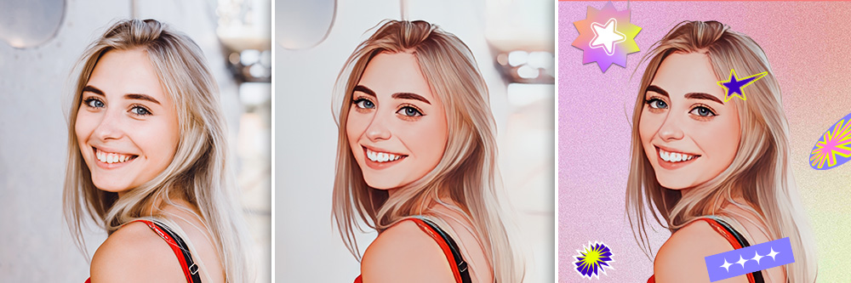
With AI on the rise, AI art generator apps have sparked a trend that gives people a chance to get creative without going through all the time and effort it takes to learn to draw and edit art. Of course, AI-generated images aren’t a replacement for human-created art, but they’re a fun way to explore designs and styles.
Choosing the best AI art generator app for the job can get overwhelming, especially as the AI trend ramps up. Keep reading to discover the 11 best AI art generator apps that can create new images with your text!

- What Is an AI Art Generator?
- How To Choose the Best AI Art Generator App
- Snapshot of 3 Best AI Art Generator Apps
- 11 Best AI Art Generators for iPhone & Android
- How To Turn Text to Image with the Best AI Art Generator
- Download Vivid AI: The Best Free AI Art Generator App To Turn Text to Images
- FAQs for AI Image Generators

What Is an AI Art Generator?
An AI image generator uses a type of machine learning called artificial neural networks that takes your text input and turns it into an image. The apps give many people a way to see their selfies or generate images in various styles using keywords. These models use existing art to tailor their images and produce varied styles, so it’s important to use them ethically.

How To Choose the Best AI Art Generator App
Aside from creating AI-generated images from text, your app’s other features matter. Not all AI image generator apps include the same tools or quality level. Here are a few things to consider before you tap the download button:
- Quality and clarity of generated images
- Ease of use and ability to navigate
- Plan pricing
- AI styles and variety
- Additional features beyond generating images
With PhotoDirector, you not only get clear images, but you can use many of its AI text to image features for free, like its text to sticker tool. Plus, it gives you control over your images and styles, so you get the looks you want.

Snapshot of 3 Best AI Art Generator Apps
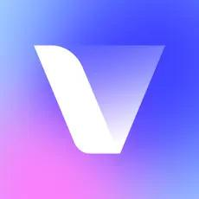

1. Vivid AI
Vivid AI is a professional AI Art Generator that allows you to turn text to images, generate AI Avatar, replace background with AI. You can also change clothes in styles you want or use AI Scene to complete AI interior design. Detailed Review >
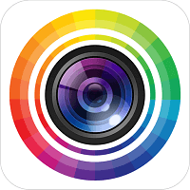

2. PhotoDirector
PhotoDirector has a variety of tools to turn your text to images and stickers, and with this free platform, you have lots of options for exploring AI text to image styles. Detailed Review >
Learn More
Generate AI Images
Secure Download
Download from the App Store for iOS and Android.
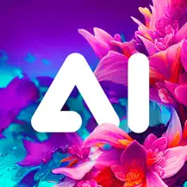

3. AI Arta
AI Arta lets you generate avatars, create AI image sketches, and even get inspired by its gallery images generated by other people. Detailed Review >

11 Best AI Art Generators for iPhone & Android

1. Vivid AI
Free Download
Secure Download
Download from the App Store for iOS and Android.
Available: iOS/Android
Key Features:
- Text to Image Generator
- AI Scene
- AI Outfit
- AI Background
Vivid AI's Text-to-Image Generator converts text into captivating images with diverse artistic styles, from cartoon, pop to steampunk, enabling users to create four unique visuals from a single text input. It's a versatile and effortless tool for unleashing creativity.
The "AI Scenes" feature of Vivid AI transforms your photos into AI artwork. It offers 8 art styles, from fairy, vector art, to graffiti. Moreover, you can even customize the background by typing .The feature is also great for sparking interior design ideas.
Vivid AI's AI Outfit Feature utilizes AI to curate unique clothing combinations, considering user preferences, weather conditions, and fashion trends. It simplifies outfit choices and inspires creativity effortlessly.

2. PhotoDirector
Learn More
Free Download
Secure Download
Download from the App Store for iOS and Android.
Available: iOS/Android
Rating: 4.8/4.5
Key Features:
- AI Avatar Maker
- Text to Stickers with AI
- AI Cartoonize Yourself
- AI Object Removal
PhotoDirector’s variety of AI features makes it one of the most versatile text to image generator apps out there. Its all-in-one platform gives you everything you need to edit all in one place, so you can generate stylized photos and edit your snaps with the help of smart tools. Generate avatars for social media, turn yourself into a cartoon character, create your own stickers, and clean up your photos with the object remover.
AI Avatar Maker
PhotoDirector has 13 AI avatar styles that you can use to make an avatar for your profile. By uploading several selfies, you let the AI use them to generate images of you in the styles you choose. You can try classic looks or give your avatar a fantasy look!
Turn Text to Stickers with AI
PhotoDirector’s free text to sticker feature has five styles, including 3D, realistic, pop art, watercolor, and hand-drawn, that you can apply to create stickers up to five times each day. If you need inspiration for how to turn text to images, tap the lightbulb to get sticker prompts before you get started.
Cartoonize Yourself
Who doesn’t want to become their favorite cartoon character now and then? With PhotoDirector, you can choose from 20 cartoon filters that turn you into art with one tap. It can even transform your background!
AI Object Removal
Sometimes you have unwanted people or objects in your photo, and PhotoDirector gives you a quick way to remove people from a photo. Its smart tool makes it easy to identify and erase people or create a cleaner, less cluttered image. It also has manual tools that you can use to get every last detail!

AI Image Generator Related Articles:
- 10 Best AI Avatar Maker Apps To Create AI Artwork in Minutes
- How To Create Your Own Custom AI Avatar with PhotoDirector: A Step-by-Step Guide
- 11 Best Cartoonizer Apps To Generate Magic Avatars in Seconds
- 10 Best Apps To Remove People from Photos on iPhone & Android

3. AI Arta
AI Arta has several art styles you can choose from with different levels of complexity. It gets more specific when you put in your keywords, and its realistic sketches create a fun way to discover different art styles, even with simple pencil sketches.

4. Lensa
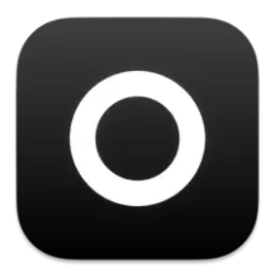
Lensa generates a collection of avatars from the photos you upload. You can choose from various styles, and the app creates new images of you with the looks you choose. Unfortunately, Lensa isn’t free, so you do have to pay to generate your AI art.

5. WOMBO Dream
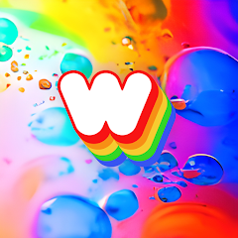
WOMBO Dream gives you plenty of room to explore different art styles when you tell it what to generate. When you input a string of keywords, changing even one of them can totally alter the look of the art for a custom look that corresponds with lyrics, poems, zodiac signs, and more.

6. Wonder
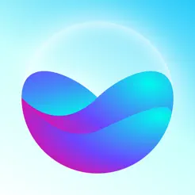
With Wonder, you can put in a single word or use a keyword phrase for your text to image AI generation. Like other apps, you can choose from a lot of styles before you describe the image you want, but Wonder also lets you generate art with no style, so you get a creative surprise!

7. UniDream AI
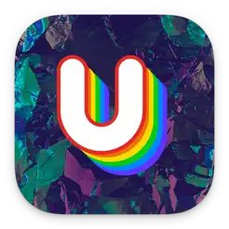
UniDream AI works well if you’re looking for a quick and easy AI art model. It’s less realistic and not as high-quality as PhotoDirector and other AI art apps, but it still lets you give it simple prompts. It mainly generates anime-style avatars, too, so if you’re looking for variety, a different app may work better.

8. starryai
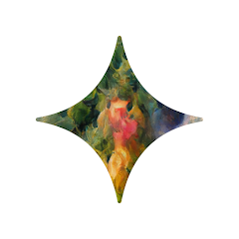
While other apps require keywords, starryai can give you a new AI image from emojis alone. It works best for scenery, and while it can’t turn your photos into AI avatars the way PhotoDirector can, it does generate stunning scenes, from futuristic streets to bright, colorful surrealist images.

9. Fotor
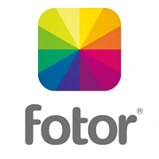

10. Imgit
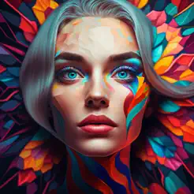
Imgit uses keywords to generate your AI art, but beyond that, it lets you put in song lyrics to see what vibes your favorite music creates. It works well for making your next wallpaper for your phone, and you can choose from 8 different styles.
Fotor’s AI art effects have trendy styles, including cyberpunk, to generate your next image. With your keywords and phrases, it generates art based on famous artists, including Picasso and Van Gogh. It even has other AI tools, like retouch and photo enlarger, to help you make other improvements to your images.

11. Airt
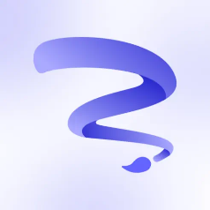
Airt has over 100 AI avatar styles and 10 art styles that you can discover and experiment with your text to image generator. When you upload your selfies, you can get dozens of unique avatars to put on social media, and each time you use the app, you’ll get something totally new.

How To Turn Text to Image with the Best AI Art Generator
Vivid AI’s AI image generator allows you to turn text to images by simply typing out your fantasy. With it, you can create the most unique art work within seconds!

1. Download Vivid AI
Free Download
Secure Download
Download from the App Store for iOS and Android.
Go to the App Store and Google Play Store to download Vivid AI. Then, open it to get started!

2. Tap “Text to Image”
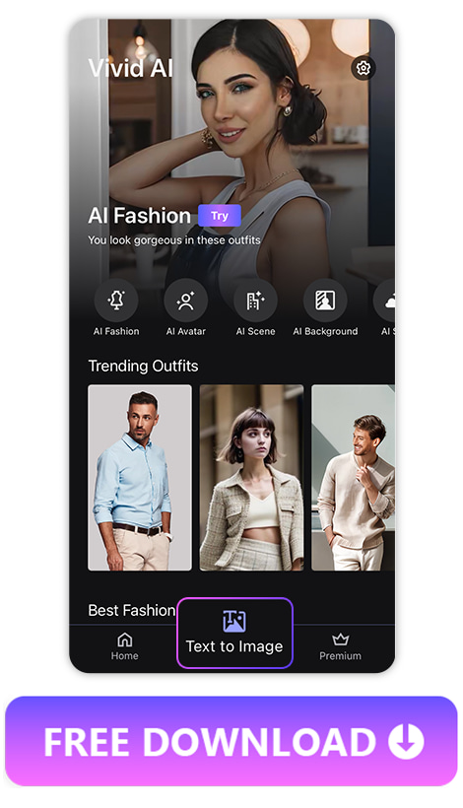
On the main screen, choose “Text to Image” from the toolbar at the bottom to start creating yours. There are Cartoon, Pop Art, Neon and 8 other styles awaiting you.

3. Type Your Text and Turn Text to Images with AI
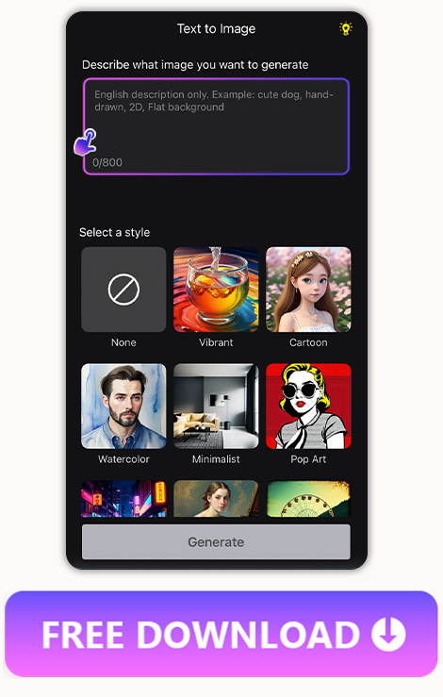
In the box at the top of the screen, describe the image you want Vivid AI to create for you. You can put in 800 words. If you need more inspiration, you can tap the light bulb at the upper right side and apply the preset prompt generated by Vivid AI.

4. Download Images and Share With Your Friends
When Vivid AI finishes generating your images, you can tap “Generate More” to get more AI generated images. Once you are satisfied with the generated images, you can select them and download them to your phone or share them with your friend directly.
For Vivid AI’s premium users, you can get generated images without watermarks, and even get 40% off on AI Avatars and 30% off on AI Fashion features.

Download Vivid AI: The Best Free AI Art Generator App To Turn Text to Images
Free Download
Secure Download
Download from the App Store for iOS and Android.
Vivid AI’s Text to Image generator lets you turn text to images fast to get hundreds of generated images in seconds. You can customize prompts for free and select from more than 10 styles to generate high-quality AI images, even if you’re not an artist and don’t have design skills. Download Vivid AI free for iOS or Android to turn your imaginations into stylistic images!

FAQs for AI Image Generators

1. What Can an AI Image Generator Do?
AI image generators use machine learning to offer many art styles that you can use to generate art. By learning from many existing art styles, they can use your photos or text to make a new image for you.
Free Download
Secure Download

2. How Many Text to Image Styles Can I Choose From in Vivid AI?
There are 11 styles you can choose from to turn text to images with AI. The most popular styles are Cartoon, Pop Art, and Neon. You can also choose not to apply any style and describe the image prompt by yourself.
Free Download
Secure Download

3. How Many AI Avatar Styles Can I Choose from in PhotoDirector?
You can choose from 13 AI avatar styles, and PhotoDirector will release 6 more in the coming weeks. PhotoDirector updates its styles often to give you the most high-quality images you’ll find in an AI image generator app.
Free Download
Secure Download

4. How Many Sticker Styles Can I Choose from in PhotoDirector To Turn Text into Images?
PhotoDirector offers 5 sticker styles, but you can also choose no style. No style gives you more freedom in your sticker design by letting you describe what you want in the text box and generate it that way.
Free Download
Secure Download

5. What Is the Best AI Image Generator?

Free Download
Secure Download
Download from the App Store for iOS and Android.
Vivid AI is the best AI image generator because it offers an array of styles, a free text to image generator, and it always gives you a high-quality image. You can turn selfies into cartoon or AI avatars or change clothes in different styles with AI! It is also a useful AI interior app that allows you to describe the interior style so it can show you your fantasy!

